To: James Remmington, Planning Services, Camden Town Hall, Argyll Street, London WC1H 8EQ

***APPLICATION FOR TREE WORKS***

***Notice of work to a tree in a conservation area (Town and Country Planning Act 1990)***

***Applicants name and address*:** J. Gammack, 4 Rochester Terrace London NW1 9JN

***Tree Ownership:*** Applicant *(as above)*

***Tree location***: 4 Rochester Terrace NW1 9JN *(as above)* at the corner of front garden, next to pavement and neighbours wall/railings/hedge.

***Tree species:*** Tilia [Common Lime]

***What we are applying for:*** Notice of work to a tree in a conservation area

***Description of proposed works:*** Fell one Tilia

***Note:*** Previously we gave notice to fell this tree, this was acceptable to Camden Council, but before we could arrange it to be felled, the time allowed elapsed. The Tree Officer at that time was Kevin Fisher.

***Reasons:***

1. Tilia are the tallest broad-leaved trees in Britain reaching more than 25m and are appropriate for parks or large gardens, but front gardens in Rochester Terrace are small and shallow.
2. Previous owners removed garden walls, railings and gates and concreted over the small front garden for car parking - in fact only compact cars can park on it without overhanging the pavement.
3. Our goal is to restore the front garden with permeable surfaces, shrubs and flowerbeds – the Tilia would take other plants’ nutrients, water and light.
4. We also hope to reinstate boundary walls, railings/gates to match the rest of the street but the base of the tree trunk already reaches the street pavement slabs, making this problematic also. *Please refer to Photo 2 and Photo 3.*
5. The Tilia already overhangs our neighbours [No 3] front garden and hedge and would if unrestrained encroach on both our houses and obscure windows. *Please refer to Photo 1*.
6. Tilia have an aphid honey-dew problem, so pavements, and front gardens and nearby cars get coated in sticky black mould.
7. Tilia have arching lower branches which if not constantly tidied up, hang out over the pavement [which is two and a half slabs wide] and would obstruct people on foot.
8. So unfortunately the tree offers excessive shading and limited amenity value.

**Finally,** there are numerous trees in the vicinity and we face Rochester Terrace Gardens which offers notable amenity (*Photo 1and 4) but I am* ***more than happy to plant a replacement tree in the front garden*** and we have propagated a Myrtus Luma (which is a good all-year-round performer, max height 7m, which bees love). It’s in a large pot, ready to plant, if this is acceptable.

**Declaration – Trees** I hereby apply for consent as described in this letter and the accompanying plans/drawings and additional information/photographs. I confirm that, to the best of my knowledge, any facts stated are true and accurate and any opinions given are my genuine opinions and that I am not an Authority member or employee.

Applicant Date

13/08/2015

J.Gammack

***Photo 1***

GOOGLE PHOTO 1 The tree we propose to cut is at the corner of our house [4 Rochester Terrace - painted white] next to the hedge and overhanging our neighbours’ front garden [painted yellow-cream] and footpath.

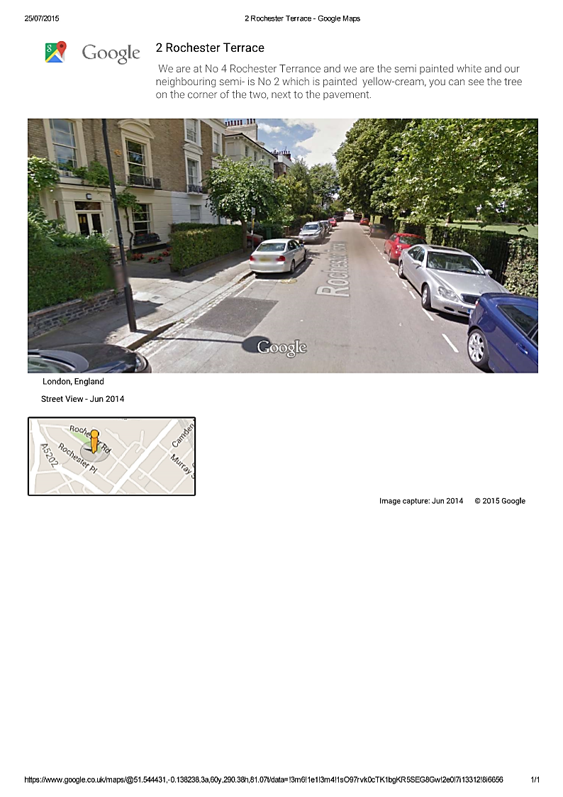

GOOGLE PHOTOS 2 & 3 below - showing the base of the tree trunk which reaches the street pavement slabs.

***Photo 2 showing tree, line of pavement & garden wall***

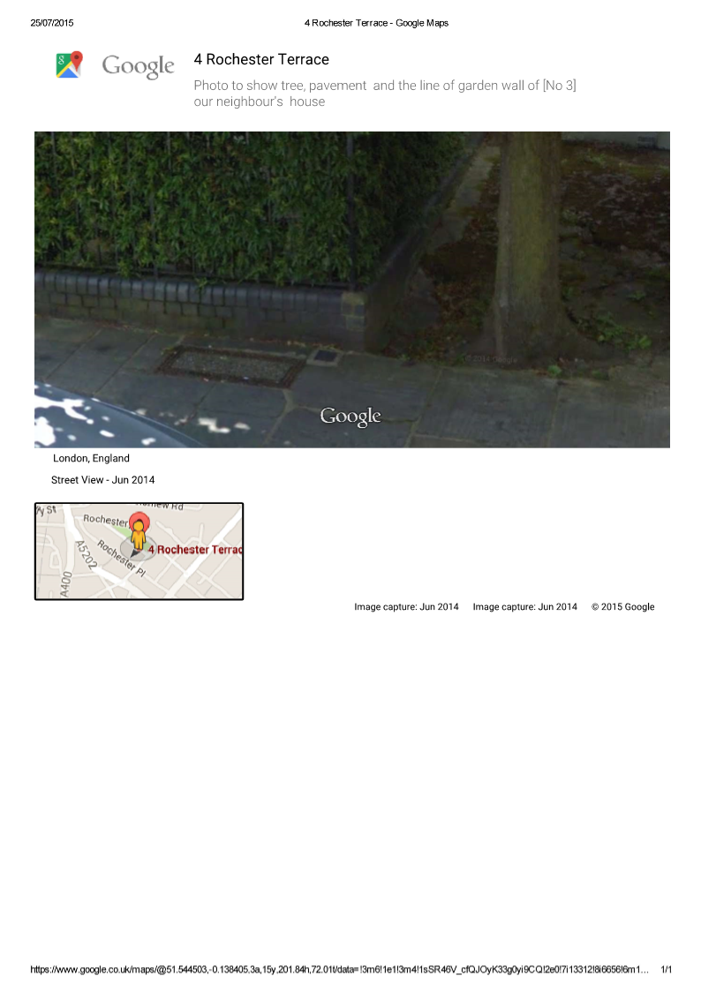

***Photo 3***

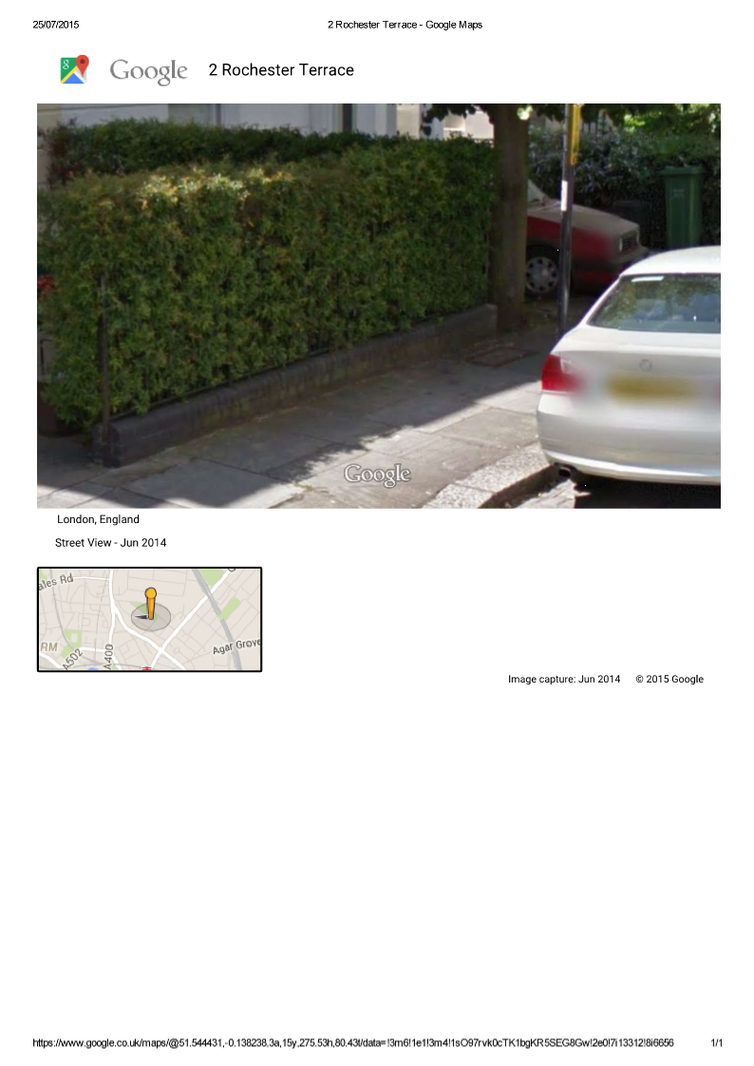

**Photo 4**

**Aerial view of 4 Rochester Terrace, showing Rochester Terrace Gardens**

