 

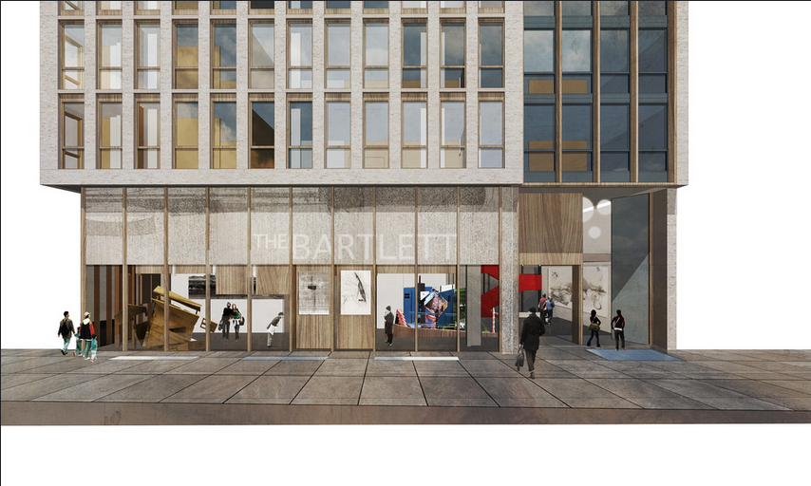**WATES HOUSE UCL, London**

**Project Description:**

Gilbert-Ash is delighted to be involved in the

Refurbishment of this existing building for UCL.

Wates House is an existing 6 storey Building constructed in 1975

located at the junction off Gordon Street and Endsleigh

Gardens.

The project involves the structural alterations of the

external facade, additional 7th Floor, new 7 storey extension and

internal areas to provide increased student accommodation.

The main construction elements of the project include:

* Demolitions
* Structural alterations
* Installation of feature staircase
* Lift installations
* Facade works inc glazing & roofing
* M&E services installations
* Internal fit-out

The project is due to complete in August 2016.

**Progress to Date:**

* Site establishment and pre-planning
* Condition surveys

**Works Scheduled during the next month:**

* Erect Hoarding
* Erect Scaffolding to South Side ( Internal courtyard )
* Remove walkways and platforms to South side

**Actions to be taken to reduce the Impact of the Construction Works on the Local Community:**

* Erection of solid hoardings to site boundary
* Noisy operations within limited periods to reduce impact on neighbours
* Implementation of weekly schedules for noisy operations
* Daily management of site deliveries to reduce traffic impact

Gilbert-Ash aim’s to bring as little disruption as possible to our neighbours, but if you have any particular enquiry on how this project may affect you, please feel free to contact, Mr Aaron Coffey, our Site Manager, on his mobile phone: 07736 270 895, or by email: [Aaron.coffey@gilbert-ash.co.uk](mailto:Aaron.coffey@gilbert-ash.co.uk).

Aaron will do his best to answer your queries or resolve any issue.