UCL Logistics
Contractors Information Pack
Revision 3 – 06.01.15



Version History
Rev | Effective Date | Changes Overview | Authorised by
1 | 20.10.14 | Deliveries / Collections / Hoardings | S Robbins
2 | 11.11.14 | Revised Hoardings Section / Revised Contacts | S Robbins
3 | 06.01.15 | Added section on Small Tools and Parcels | S Robbins

UCL Contractors information Pack

Contents

- Our Key Objectives

- Definitions

- Wilson James Service Provision

- Safety Management

- Delivery Process

- Service Restrictions and Requirements

- Delivery Options

- Material and Equipment Delivery Process Map

- Material and Equipment Collection Process Map

- Datascope Delivery Request

- General Information – Receiving Deliveries

- Hoarding Service

- Process

- Contacts

- Appendix 1 – The Logistics Zone

- Appendix 2 – Driver Induction

- Appendix 3 – LCCC Driver Rules

Our Key Objectives for Wilson James

Key objectives are to;
- Support Construction Projects at UCL by facilitating efficient construction logistics on Campus, minimise its impact on the Universities core business and ensure the safety of the Public, Staff and Students.

- Centralise the construction material delivery function by implementing a ‘Delivery Management System’ (DMS) to reduce construction vehicle movements within the central campus and local borough by utilising ‘consolidation’ methods and controlling the timing of construction deliveries.

- Measure individual projects on their material delivery patterns to develop understanding of trends for future projects.

Definitions:

- Wilson James is the UCL Logistics Contractor.

- Contractor is the UCL appointed contractor employed to deliver construction services.

- Principal contractor is the over aching responsibility for a project.

- LCCC is the ‘London Construction Consolidation Centre’.

- DMS (Delivery Management System).

- Datascope is the provider of the DMS.

- Consolidated Deliveries – whereby material / equipment is delivered to site via the LCCC (London Construction Consolidation Centre). Multiple Contractors materials are ‘consolidated’ into a single load to make more efficient use of resource and place less demand on the system.

- Direct to Site (Deliveries) – whereby material is delivered directly to site by the supplier.

- Logistics Zone- The compound on the North side of Gordon Square.

- Vehicle Holding Zone – The ‘loading only’ bay along the length of Endsleigh Place.

Wilson James Service Provision

Wilson James will provide the following services;

- Material and Equipment Deliveries
- Waste Management
- Hoarding Service
- Temporary Way finding and Signage

In addition we have been given the responsibility for allocating space in shared areas of the Campus.

This version of the Contractor Information Pack covers construction deliveries and hoarding services only. Revised versions will be circulated when the additional services are added.

Safety Management

It is our responsibility to manage a safe interface between construction logistics activity and the staff and students at UCL in the shared / public space.

We aim to improve safety on campus by reducing the numbers of vehicles delivering directly to site by providing an alternative ‘ logistics model’ which all Contractors will be mandated to use. This pack details the procedures for this.

The Photograph below is a typical access road on the UCL Campus. Narrow access with no feasible method of segregation, limited turning points and extremely busy with staff and students between lectures, it illustrates the need for a robust delivery strategy and the provision of an alternative logistics model.

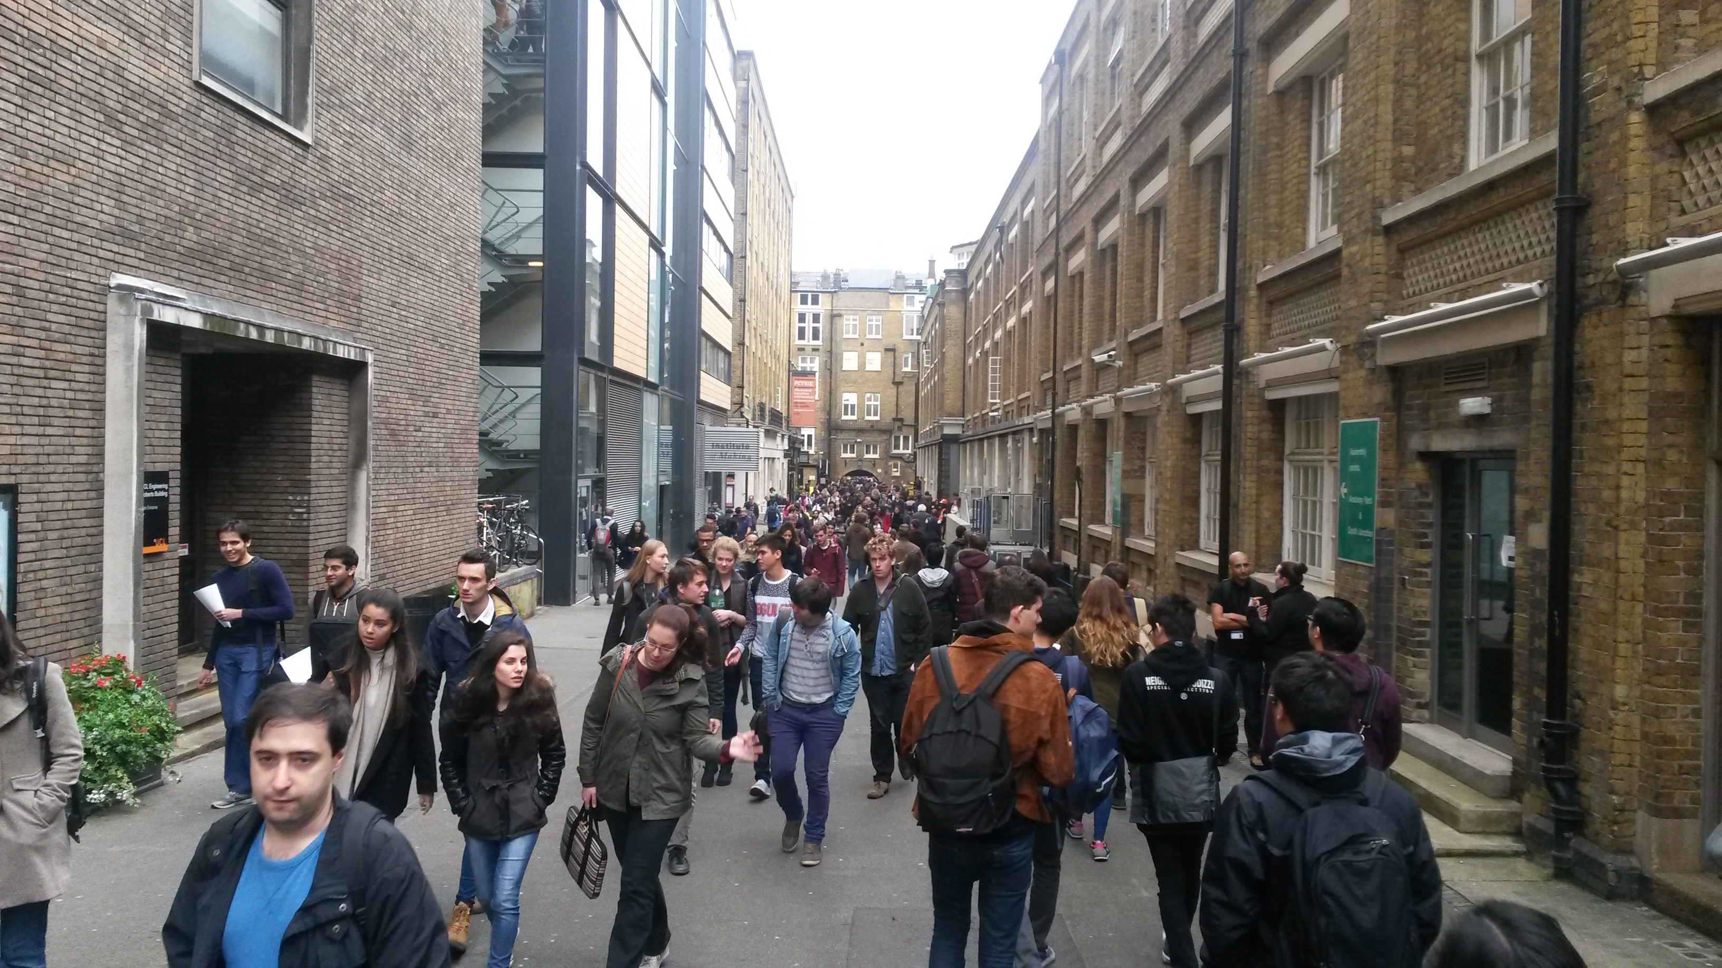

All deliveries must be booked in by the Contractor via Datascope when they will receive a unique booking reference. We will work closely with UCL Security to control delivery access onto Campus. All delivery vehicles must report to the LZ in the first instance when they arrive at UCL. The delivery driver will need to provide the booking reference on arrival at the LZ and the gate. Access will be denied without this reference.

WJ will be able to limit the number of vehicle slots available per hour in support of UCL’s Traffic Management Plan and ‘business as usual’ deliveries.

When delivery vehicles are on Campus, Wilson James Traffic Marshals will supervise them at all times. No driver is permitted to manoeuvre their vehicle unless a Wilson James Traffic Marshal is present.

Due to the volume of pedestrians accessing the ‘shared space between lectures, no vehicle movements are permitted between 10 to and 10 past the hour. This rule applies from Monday to Friday between the hours of 8am to 6pm. Please see UCL Traffic Management Plan for more information.

We have a zero tolerance of unsafe behaviour and practice. We have the authority to stop work and turn deliveries away if we feel there is any risk of an accident or incident.

Delivery Process

This section provides details of the four options available for a Contractor arrange a direct or consolidated delivery.

To clarify the use of Datascope, all Contractors working for UCL under a PSO / PSM reference must book deliveries using this process, regardless of the project location and unloading area.

If you require a login, please contact Wayne Hail – details provided below.

Further site specific Training on the DMS will be provided by the Logistics Team as required. This will be determined at the pre start up meeting.

The DMS will work on a first come first served basis, therefore good planning will provide you with greater opportunities to obtain delivery slots.

Use of Datascope is closely monitored by the logistics team and any abuse of the system, such as ‘contingency’ bookings ‘ just in case’ will be apparent. Likewise, deliveries that arrive direct at site without having been booked on the DMS or do not have an approved delivery number, will be turned away at the Security gate. This includes drop offs at site entrances and materials being manually carried onto a project.

When booking a delivery, you must consider the right option to use. The four options for delivery are;
- Direct deliveries for vehicles <3500kgs.
- Direct deliveries for vehicles >3500kgs.
- Deliveries to LCCC.
- Deliveries from stock at LCCC to UCL.

As detailed in the illustration below;

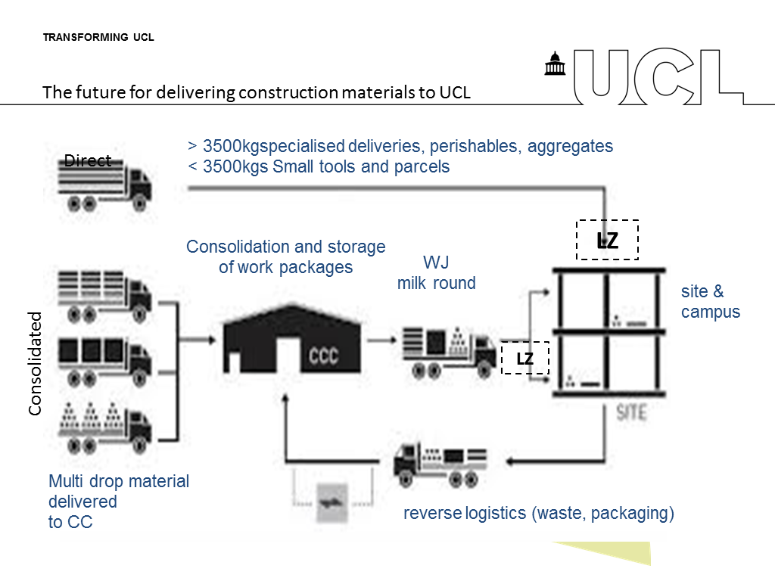

Consolidation offers two major benefits to Contractors at UCL;
- Firstly it reduces the number of vehicles on site by enabling multiple contractor materials to be delivered on the same vehicle. This is essential at UCL.
- Secondly, it enables contractors to optimise their space on site by providing an alternative location to store materials. This is essential at UCL.

Storage at the LCCC is not finite and is chargeable for periods which exceed 3 weeks. Deliveries to site on LCCC vehicles is also not finite and good planning will provide you with better opportunities. Contractors delivery requests will be dealt with on a first come first serve basis.

Important Service Restrictions and Requirements

Please note;

- The Datascope system will be carefully monitored for block booking and excessive cancellations which cause disruption to the entire operation. If this occurs then it will be reported for further action to be taken.

- Continual misuse of the DMS process will result in the contractor being reported to the UCL Estates team with the possibility of them having their access suspended until retraining has taken place.

- You can not log into the same account from the same computer at one time but you can make multiple bookings to the same account from different computers at the same time.

- It must be made clear where a Contractor wants to book a larger than normal pallet, (standard pallet 1.0m x 1.2m). Datascope will provide the facility to input the ‘number’ of pallets and the ‘pallet equivalent’, the pallet equivalent figure allows us to plan space more effectively, it should provide an indication of the equivalent number of pallet spaces a large pallet is worth. For example, you have a pallet that is 2m x 1.2m then you need to populate the ‘pallet equivalent’ box with ‘2’.

- The delivery driver will be expected to have the Booking Reference when they arrive (at either the LCCC or on site). If they don’t, their processing will be delayed and the vehicle maybe turned away.

- When you are arranging for a delivery vehicle to deliver directly to site and you need the driver to delivery to multiple locations on the UCL Campus, you must make individual bookings for each drop and the driver will need to have to access the Campus via the LZ each time.

- Contractors have to book a different line item for each product type. For example, if you have a delivery of ten pallets of bricks, but there are four different colours of bricks, if you want the system to differentiate between them so that you can call off a particular colour of brick, you need to book them in separately so that they have a separate line item so that Datascope identifies them individually.

- The Contractors site contact must provide an email address. You will receive email notifications from other people’s bookings within the same company.

- Deliveries booked from the LCCC to site will be delivered to site at some point the same day.

- Direct deliveries and deliveries to the LCCC will be turned away if they turn up on the wrong day.

- Storage at the LCCC is free for the first 21 days.

- Whilst every effort is made to check deliveries when they arrive at the LCCC, we only inspect the external packaging for damage. We are not responsible for checking material against delivery notes.

- If you have arranged a delivery on site at UCL, you must be available to sign for the goods when they arrive. WJ accept no responsibility for material left in the LZ or at UCL which has not been signed for on the day it was due to arrive.

- Deliveries that are non-standard and fall into a category of high value, fragile or require specialist handling must be identified clearly on the booking request so that specific handling requirements can be planned. Failure to clarify these conditions will result in the load being refused.

- Abnormal or special loads need additional planning as they may not be able to use the main roads or campus thorough fares. Please notify us as soon as you are aware of special loads.

- Steel being delivered should be securely bound / strapped to a pallet. Pallet weights should not exceed 1200kg, however the makeup of the pallet with quantity and shape of the sections should be considered for safe transit.
- We will not accept unsafe loads but will inform you before any decision is made to turn the delivery away.

- We will not manually unload large quantities of material that arrive loose.

- DMS bookings are REQUESTS only. Until approved by the UCL Logistics Team they have no automatic right to proceed. You will receive a response within 30 minutes of you request during normal working hours.

- No material is to be stored in shared areas, outside of the project site unless previously applied for. It is the Contractors responsibility to ensure sufficient space within their site is available to accept the delivery.

- WJ are responsible for shared areas and are authorised to clear materials.

- Contractors must ensure they are aware of the site Weight / Height Limits, and Vertical access dimensions.

- Contractor representatives must be available at the unloading bay to check and sign for the load and at their agreed delivery point on completion of the delivery.

- Contractors must complete DMS with full descriptions of their delivery items.

- Plant operators must prove they are qualified for the piece of equipment they are collecting e.g. MEWP.

Delivery Options

Option 1 – Direct to Site <3500kg (Small Tools and Parcels)

You will request a delivery to site on Datascope, this is allocated a reference but its status is still pending approval by WJ (seen in ‘Pending Deliveries’). Once Wilson James has approved the request it can now access the LZ and UCL site.

If the delivery is refused you will be contacted with the reasons and be able to adapt the delivery to gain approval. The System Administrator is your contact for this, please see contact list below.

When the delivery arrives at the Logistics Zone (See appendix 1) the vehicle is booked in by Wilson James and held until the next available gap appears for it to proceed to site. During this period the contact on the booking reference will be called to ensure they are available to receive the goods. If the contact is not available and an alternative is not identified, the vehicle will not be allowed onto site.

The delivery is then marshalled to a point where the materials are received by the contractor. If a contractor has booked a delivery, they must be available to sign for it when it arrives on site.

Vehicles cannot remain on site for longer than 15 minutes. If you require more time, please make this apparent when booking the delivery by selecting the ‘fragile / high value’ option and commenting on the time you require.

Wilson James reserve the right to escort vehicles off site if the Contractor is not present within 15 minutes.

You also have the option of delivering small tools and parcels to the Logistics Zone, where it can be signed for by Wilson James and placed in the stores. You need to make it clear on the initial booking that this is you preferred option by selecting the ‘Gate’ as ‘Logistics Zone Drop Off – for Collection’ in the drop down menu. You also need to ensure that all items are collected from the Logistics Zone the same day. The person collecting the consignment will need to provide the Datascope booking reference and be prepared to sign for them when they are collected. Any items not collected the same day will be returned to the Consolidation Centre.

This option is ideal if you have smaller deliveries and your supplier is unable to commit to a firm delivery time, or you can not guarantee that will be available to receive the delivery when it arrives e.g. you are working in an area where it is difficult to contact you or you are in meetings etc. This service is limited to the following;
- No more than 5 units per booking,
- Each unit will weigh no more than 20kgs,
- The unit size will not exceed 600mm x 600mm.

Please see delivery process map below for both options outlined above.
Option 2 – Direct to Site >3500kg (Large deliveries / full loads / perishables)

You will request a delivery to site on Datascope, this is allocated a reference but its status is still pending approval by WJ (seen in ‘Pending Deliveries’). If you require WJ to assist in off loading the material, please make this clear when booking the delivery. Once Wilson James has approved the request it can now access the LZ and UCL site.

If the delivery is refused you will be contacted with the reasons or be able to adapt the delivery to gain approval.

When the delivery arrives at the Logistics Zone (See appendix 1) the vehicle is booked in by Wilson James and held until the next available gap appears for it to proceed to site. During this period the contact on the booking reference will be called to ensure they are available to receive the goods. If the contact is not available and an alternative is not identified, the vehicle will not be allowed onto site.

The delivery is then marshalled to a point where the materials are unloaded. If assistance has been identified WJ will transfer that materials to the nearest access point to the site (horizontal movement only).

Vehicles cannot remain on site for longer than the booking duration. If you require more time, please make this apparent to the Logistics Team.

Wilson James reserves the right to escort vehicles off site if the Contractor is not present within 15 minutes.

Please see delivery process map below.

Option 3 – Deliveries into the London Construction Logistics Consolidation Centre

The LCCC provides short term storage (up to 21 days) for materials and equipment for UCL Projects. It is located in Silvertown, approximately 10 miles to the South East of Gordon Square.

If you opt for the LCCC, you will instruct your supplier to deliver the address below;

London Construction Consolidation Centre Thames Road Silvertown E16 2EZ

The contact number is 0207 474 7412

Operational hours: 0800hrs – 1700hrs.

When the delivery arrives at the LCCC, the material will be signed for (by Wilson James) and stored. If there are any obvious signs of damage we will record this and inform you immediately, however we do not check each item and can not be responsible for checking conformance with delivery notes or serviceability of items. (Please see appendix 3 for LCCC Driver Rules)

You are free to visit the LCCC to check your material at any time – (by prior arrangement only).

Option 4 – Stock Requests from LCCC to UCL

When you require the material on site you make a stock request on ‘Datascope’. You must ensure that you identify the exact line items required. The material will be selected by the Wilson James Logistics Team and delivered, in bulk with other contractors material to the logistics zone where it is off loaded and placed onto smaller vehicles for delivery to the respective locations.

Option 4 deliveries at transported using Wilson James vehicles that are booked onto Datascope by the Logistics Team.

All you need to do is select the date and the materials required.

Material and Equipment Delivery Process Map

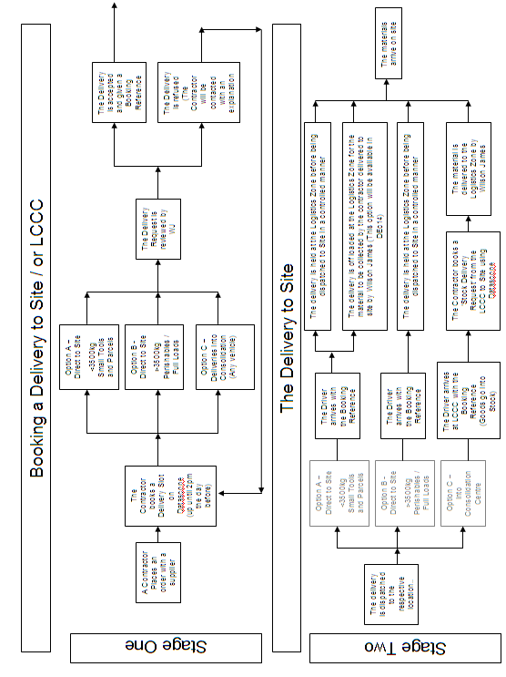
Material and Equipment Collection Process Map

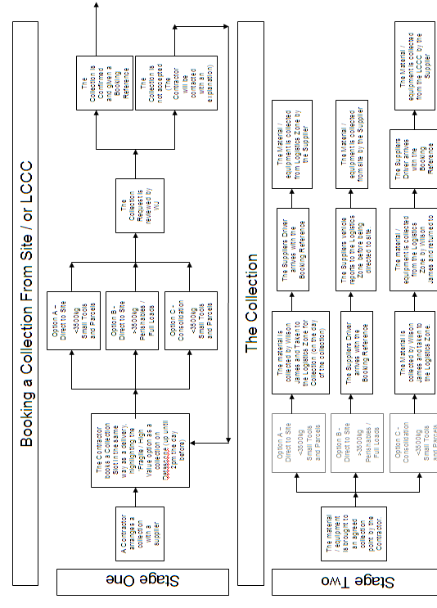

Datascope – Delivery Request

Booking Requests

Every time you login to Datascope you will see the main screen pictured below. The functionality of each tab is listed below;

- Important information and updates relating to your delivery and planning process.
- To book a delivery by your supplier. You will have the choice here for a delivery direct to site or into the Consolidation Centre.
- To request a delivery from your stock being stored at the LCCC.
- To view previous deliveries that have been requested and are still ‘pending’.
- To view a summary of all of your completed deliveries.
- To view a list of stock items held at the LCCC.

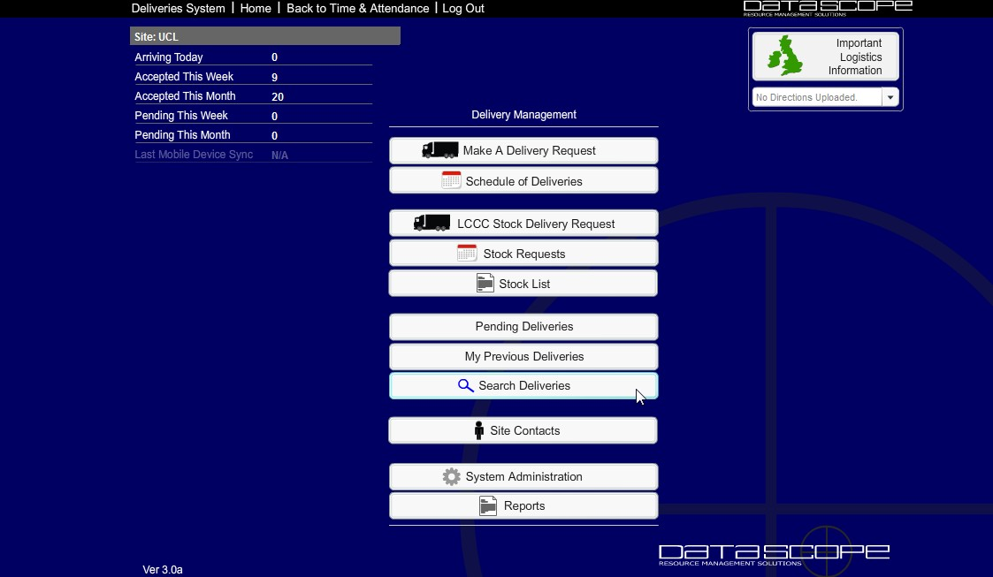
1
2
3
4
5
6

When you click option ‘2’ above, the screen will change to the one illustrated below. This is the screen you will need to arrange a ‘goods in’ delivery from your supplier. Before your complete the form you will have three options;

- Direct to UCL LGV (>3500kg)
- Direct to UCL Vans (<3500kg)
- Into Consolidation Centre

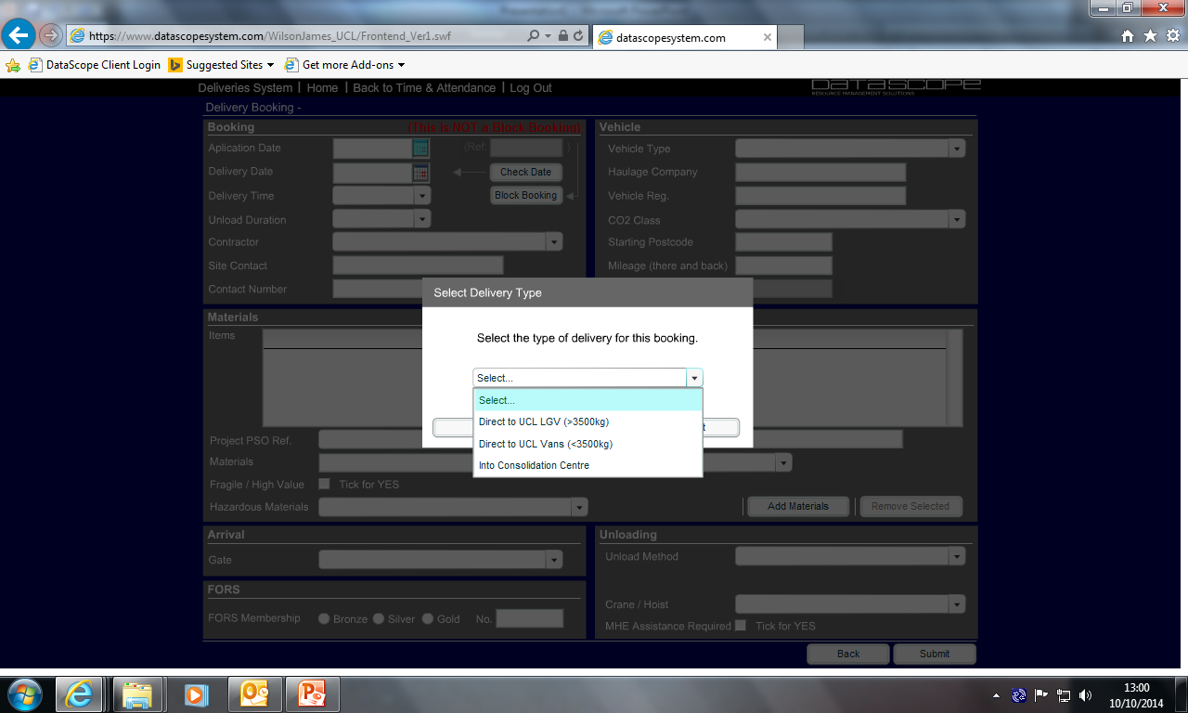
1
2
3

Once you have selected from the options above the pop up box will disappear and you will see the screen below. You will use this screen to tell us all the information we need to know about the delivery, including; the delivery vehicle, the type of materials and quantities, along with other essential information such as your contact details etc.

We have self populated many of the boxes in the <3500kg UCL option and used a ‘drop down menu’ to try to make this as user friendly and efficient as possible, but it is important that the information you provide is accurate and complete.

The information required in the areas highlighted below relate to;
- Dates / times / and contact details.
- Vehicle Type and Class / Registration / Supplier or Haulage Company Name / Distance travelled.
- Material description / Supplier Name / Number of Pallets or Stillages etc. / You also have the options to warn us if the materials are of high value or of a hazardous nature. Please use this if necessary so that we can make the necessary preparation before the delivery arrives.
- You will indicate which gate the delivery will access the site through here.
- Off loading – whether or not you need assistance from Wilson James and indication of the type of assistance you need.
- Once you have completed the form, press submit. This will send your request to the system administrator. The request will be reviewed and accepted or refused. A booking reference will be generated at this stage.

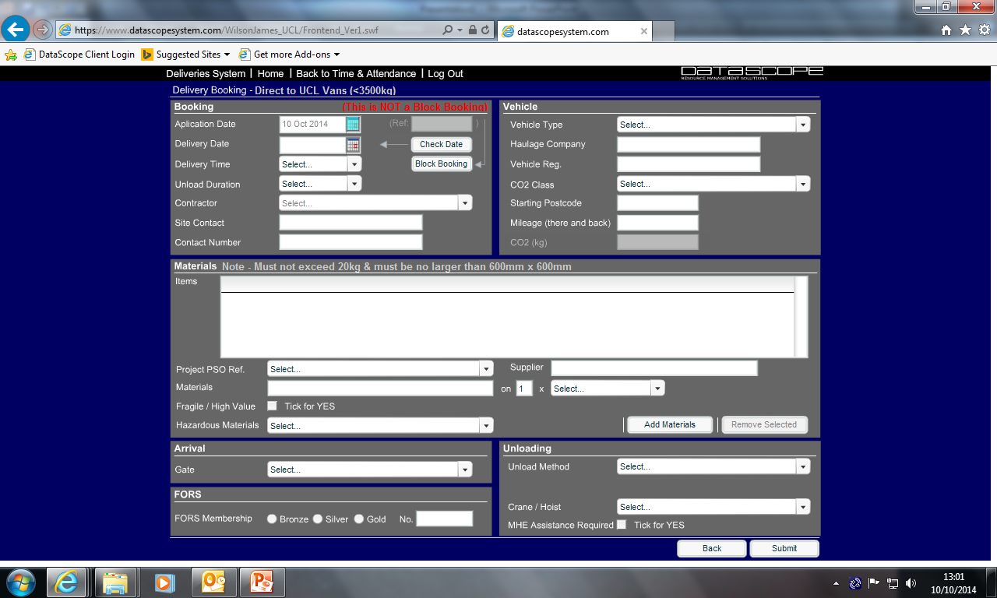
1
2
3
3
4
5
6

If you have stock that you’d like to call off from the LCCC, you will select ‘LCCC Stock Delivery Request’ from the main menu. This will open the page below.

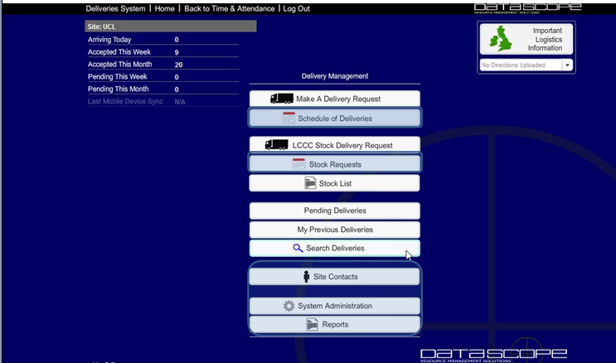

This will open the screen below;
Complete the form using the steps below;
- Select the delivery date – allowing D-2 e.g. by 2pm on Monday for delivery to the LZ on Wednesday. You will get the delivery to site at some point the same day but should plan to use them the following day (as we can not guarantee times).
- Check that your company name is correct.
- Select the Project location from the PSO drop down menu .
- Search for the material using the material search and select the option required.
- Input the quantity you need
- And ‘Submit Request’.

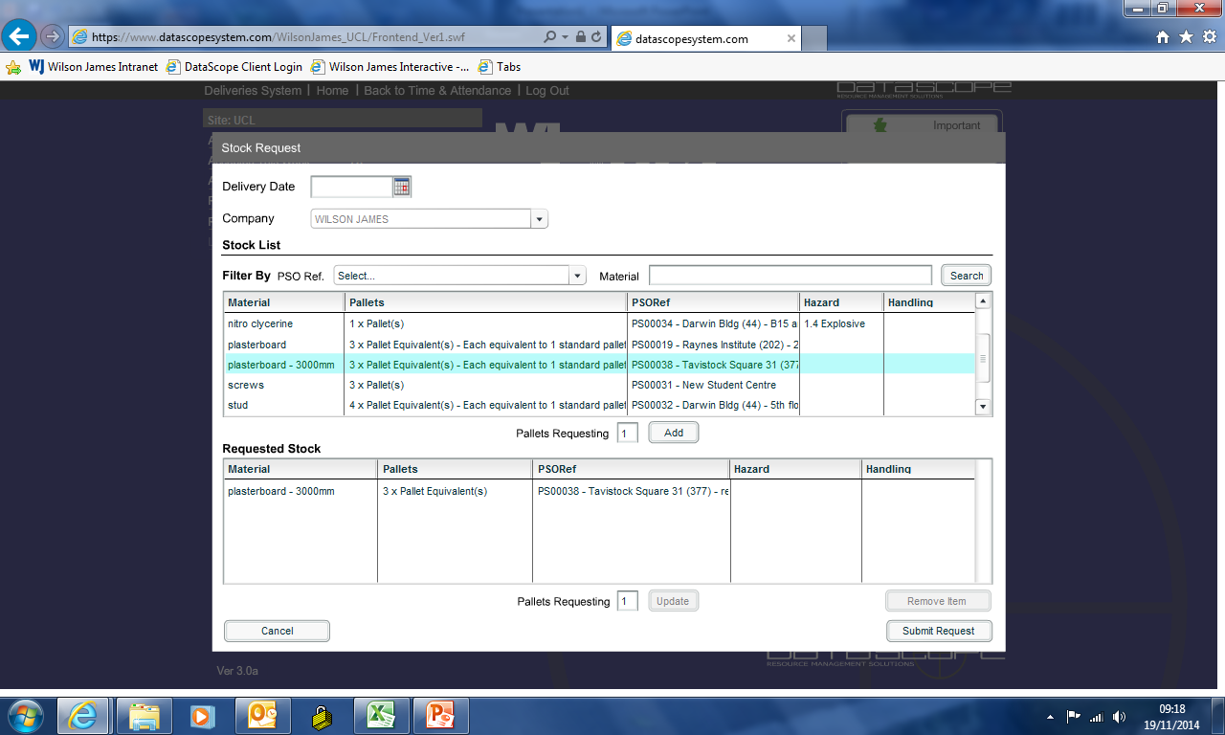

General Information – Receiving Deliveries

Timings for creating booking requests are critical and require a high level of advanced planning to ensure a successful delivery – don’t leave it until the last minute. The delivery time allocation slot on DMS identifies the time you want the delivery to arrive at the LZ or the time it will arrive at the LCCC for storage and consolidation.

The timings for planning booking requests are as follows:
- D-1 for material direct to site.
- D-2 for Stock Delivery Requests

NB: D Day = day required at LCCC or Site.
Latest booking request time in all cases is 1400hrs.
The - refers to the minus days you are required to enter the booking.

Contractors must ensure their suppliers clearly label goods and this label relates to the line item wording if they are of a similar nature. Poorly labelled items may delay delivery due to inability to identify the correct material.

It is critical that you provide the full detail of each delivery in each Datascope screen. This will allow the Logistics team to manage your delivery efficiently and assist you with any special handling requirements or load security.

When your material arrives at the Logistics Zone, you will be notified. You can attend to ensure that the material being delivered is correct and the quantity is correct. The contractor has the opportunity to refuse the load at this point should the delivery not be what is expected i.e. damaged, wrong goods etc.

If a supplier does not arrive on time then a decision will be made by the Logistics Manager about the load and whether it is accepted. This may mean returning it to the LCCC or sending the supplier’s vehicle away to be re booked. Further action may be taken in taken in these circumstances. We will do our best to avoid turning vehicles away without consulting the Contractor first.

If the contractor or Logistics team are aware of any impending delays for that day’s delivery then these will be discussed during the course of the day.

All deliveries will be directed to the gate and marshalled into an unloading area. The Contractor must be present and is responsible for receiving the delivery and its movement onto the site. The Contractor must sign the ‘Proof of Delivery’ Form to confirm receipt of the delivery. If there are any issues, these should be recorded on the form at the time. No material will be stored outside of the site hoarding. The Contractor must make separate bookings where multiple drop offs are required to different site locations.

It is the Contractors responsibility to inform Wilson James on any special requirements relating to the material or access to site. If the delivery is not possible the delivery will be returned to the Logistics Zone and the contractor informed.

All plant and equipment, such as MEWPS, will also need to be booked in through DMS as a direct delivery. The Logistics contractor will assist with marshalling the offload and will escort and bank plant to a suitable and safe area.

When plant is delivered, the contractor’s operator must prove that they have the correct qualification to operate the equipment before it will be allowed to move from the unloading area.

If the escort deems the movement of the piece of equipment to be unsafe at any time they are permitted to stop the process and wait for the Logistics manager to make a decision on how to resolve the problem.

Deliveries that contain COSHH items are to have the Safety Data Sheets made available when the delivery is booked. If we do not have the safety data sheet we will refuse to accept the delivery.

Refused loads that have been generated through the LCCC consolidation process will be returned to the LCCC and must be re booked. Contractors should be aware that this maybe charged for by UCL.

Refused loads using the Direct to site process will go back with the Contractors supplier vehicle and will need to be re booked.

Surplus materials are to be booked as a collection. Contractor can either return them to the LCCC for onward collection by their supplier or they can book their supplier’s vehicle to come to site for loading.

Hoarding:

Wilson James will provide the following hoarding services;

- Installation.

- Adaptations (to Wilson James installed hoardings) – including; extensions, reductions and alterations.

- Repairs (to Wilson James installed hoardings).

- Removal (of Wilson James installed hoardings).

Process
Before a request for any of the above is submitted to Wilson James, the Contractor is responsible for; obtaining a hoarding license from the Local Authority (if necessary), gaining the authorisation for the UCL Project Manager, providing a setting out drawing with dimensions and completing the request form (See appendix 4), Submissions will be accepted by email. Wilson James may request a meeting on the site. The Contractor is responsible for setting out the hoarding line. Work will only proceed when the Contractor is on site.

Forms that are partially or incorrectly completed, will be returned to the Contractor with an explanation. This may cause a delay in hoardings being erected.

ALL REQUESTS MUST BE RETURNED BY 15.00 - 14 DAYS PRIOR TO THE HOARDING INSTALLATION DATE.

As much notice as possible is appreciated.

Hoarding Service

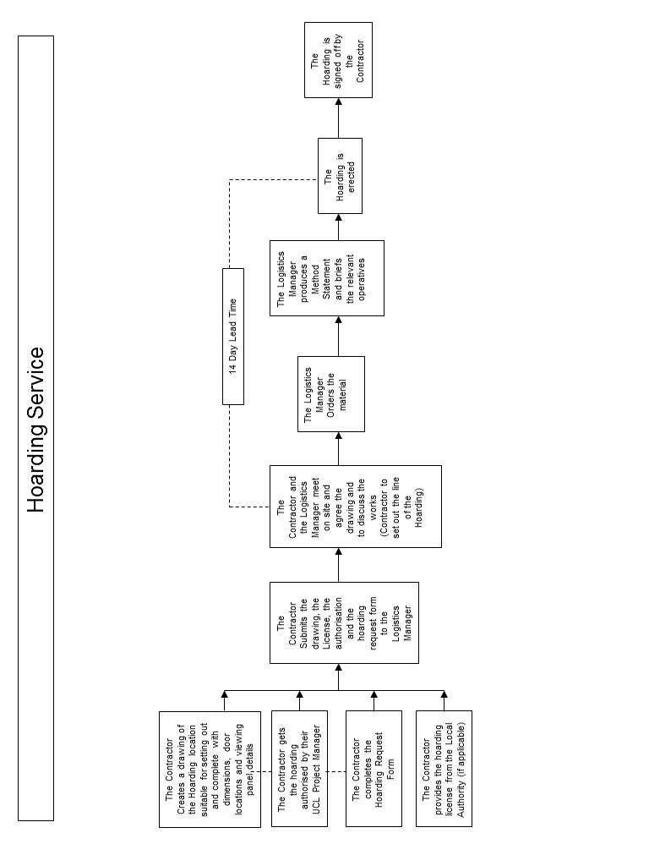

Contact Details

If you have any queries regarding the logistics Service please contact;

Stephen Robbins 07525 732874
Operations Manager

Malcolm Woolley
Logistics Manager 07912598875 malcolm.woolley@wilsonjames.co.uk

Wayne Hail wayne.hail@wilsonjames.co.uk

Appendix 1 – The Logistics Zone

All vehicles will report to the LZ to be checked in and then unloaded or released to site ,Wilson James will meet the delivery vehicle at the requested gate and marshal the vehicle to the unload point, we will then set up an exclusion zone for the unload process and if requested unload the vehicle using MHE appropriate for the task, WJ will then drop off the materials at the pre-agreed delivery point, The contractor may unload the vehicle himself as long as it is conducted in a safe manor and included in any site method statements, with no risk to personnel or staff and students.

An overview of the delivery timings and strategy for Bloomsbury site as follows:

- LZ Delivery bay open between 0800 – 1800hrs
- 4 consolidated load booking slots (AM/ PM)
- 2 slots per hour on each gate for WJ and Direct to site deliveries (subject to Business as usual and emergencies

Appendix 2 – Driver Induction

- The Driver must report to the Logistics Zone when delivering to UCL.
- Under no circumstances should the Driver proceed directly to a campus gates.
- The driver must be able to provide a Booking Reference for each delivery when arriving at the Logistics Zone.
- The driver must ensure the vehicle is driven at walking speed whilst on Campus Property.
- The driver must follow the instruction provided by the Wilson James Traffic Marshal.
- Under no circumstances should the vehicle move between 10 to and 10 past – this is when students move between lectures and the access roads and forecourts are extremely busy.
- The driver must remain with their vehicle at all times.
- Threatening or abusive behaviour will not be tolerated.

Appendix 3 – LCCC Driver Rules

To access LCCC all Drivers MUST have a copy of the booking to present at Security for verification. If this cannot be presented LCCC reserve the right to deny access.
Once access is granted the following must be observed at all times:

- Yard Speed Limit 10mph.

- Warehouse Speed Limit 5mph.
- Road Speed Limit outside of the yard area is 15mph.
- ALL persons in the yard and warehouse MUST wear:
- HARD HAT
- SAFETY SHOES
- HIVIS
- No Shorts
- ALL drivers must report to the Drivers Reception located in front of the warehouse.
- Passengers, children and pets are not permitted on the LCCC site.
- No tractor units can be left anywhere on the LCCC site.
- No persons must climb on the back of trailers.
- Any load left in the yard must remain secured to the trailer.
- THE YARD AND WAREHOUSE IS A NO SMOKING AREA
- Abuse of site facilities will not be accepted.
Appendix 4 – Hoarding Request

UCL Hoarding Request
Please Note:
Requests must be submitted to Logistics Manager a minimal of 14 days before the hoarding is required.
*Means mandatory completion use - Incomplete forms will be rejected

Request Details

Project
Project Reference
Contractor Name
Contractor on Site | Yes / No
Requisition Made by
Contact email address
Contact Number

Hoarding Details
Requisition Date
Completion Date
Type of request (Delete as appropriate) | Erection / Adaption / Repair / Removal
Length of Hoarding (Meters)

Information Required
Please confirm that you have attached the following information with this request.
Hoarding License from the Local Authority (if Req’d) | Yes / No
Setting out drawing with dimensions (inc. location of doors, viewing panels etc) | Yes / No

UCL Project Manager Name:
Project Manager Signature:

Please submit this application to; Stephen.robbins@wilson james.co.uk

