

**CONSTRUCTION MANAGEMENT PLAN**

86 CANFIELD GARDENS LONDON NW6 3EE November 2014

Revision B (April 2015)

**Scope of Construction Management Plan**

This Construction Management Plan (CMP) has been produced by Zibi & Jack Ltd. in partial discharge of the Section 106 Agreement of the Town and Country Planning Act 1990 pursuant to the Planning Permission granted by London Borough of Camden ref 2014/2282/P between:

Hemal Patel Ltd. and

The Mayor and Burgesses of the London Borough of Camden

and applies to the construction of a new basement under an existing building to form two new self-contained apartments on two floors, (basement & Ground) including associated structural works to support the existing floors above. The works are anticipated to last for nine months.

Clause 4.1.1 requires the owner to provide the council with a draft CMP for approval before commencing works. This CMP addresses the issues set out at Schedule 1 of the Section 106

Agreement and follows the format proscribed in Camden Pro-Forma Construction Management

Plan.

**Section 1 Site Contacts**

**1.1 Site Address:**

86 Canfield Gardens

London NW6 3EE

Planning Application Reference:

2014/2282/P

**1.2 Person responsible for submitting CMP:**

Hemal Patel

Flat 6

86 Canfield Gardens

London NW6 3EE

T. 07786 802 831

[E. hemalpatel@talktalk.net](mailto:hemalpatel@talktalk.net)

**1.3 Main Contractor responsible for undertaking the works:**

Zibi & Jack Ltd.

99 Chamberlayne Road

Lnodon NW10 3ND

T. 020 8960 3336

[E. info@znjcontractors.co.uk](mailto:info@znjcontractors.co.uk)

**1.4 Site / Project Manager responsible for day-to –day management of the works:**

Zibi Gondek

T. 020 8960 3336

[E. info@znjcontractors.co.uk](mailto:info@znjcontractors.co.uk)

**1.5 Person responsible for dealing with complaints from local residents, businesses and community liaison:**

Hemal Patel

Flat 5

86 Canfield Gardens

London NW6 3EE

T. 07786 802 831

[E. hemalpatel@talktalk.net](mailto:hemalpatel@talktalk.net)

**1.6 Address where main contractor accepts receipt of legal documents for the person responsible for the implementation of the CMP**

Zibi & Jack Ltd.

99 Chamberlayne Road

Lnodon NW10 3ND

T. 020 8960 3336

[E. info@znjcontractors.co.uk](mailto:info@znjcontractors.co.uk)

**Section 2 About the Site**

**2.1 Location**

The site is located on the north side of Canfield Gardens, and is occupied by a three storey

semi-detached property which has been converted into five flats. The proposed works relate to the

ground floor flat known as Flat 1.

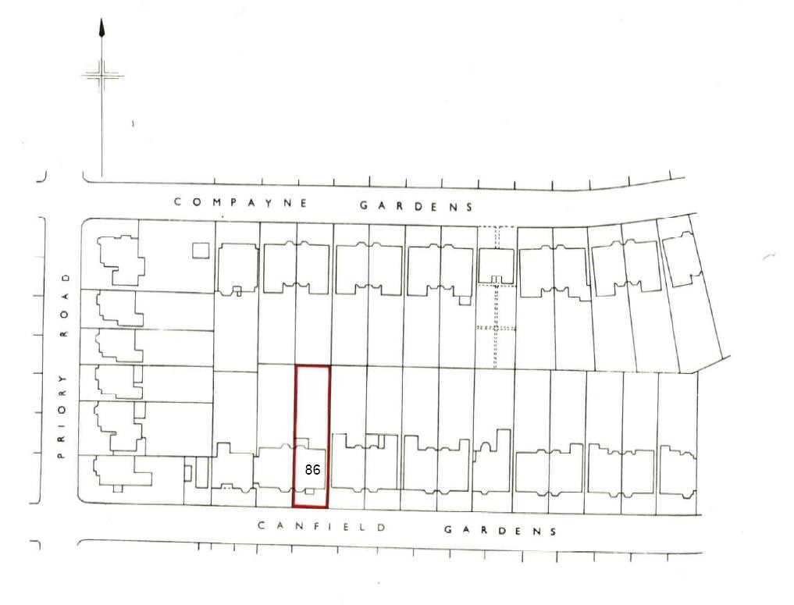

**2.2 Brief Description of the Works**

The works comprise of the construction of a single storey basement under an existing semi-detached property plus the construction of a two storey rear extension (basement and ground floor). The rear extension will be half width of the building (approx.. 6mtres) and will extend approx.

5.5mtres into the rear garden.

The main challenges for the construction team will be to ensure that the residents and members of the public are protected and not inconvenienced during the works. Potential problems include traffic management due to the one-way traffic, public bus route and residential parking; control of noise, dust, vibration or other environmental pollution especially during piling and excavations.

**2.3 Nearest Potential Receptors**

88 Canfield Gardens, which is the other half of the semi-detached building and is located to the west side. This is a residential house converted into flats.

84 Canfield Gardens which is approximately 2 metres away on the east side. This is a residential

house converted into flats.

115 Canfield Gardens, located on the opposite side of the public highway directly in front of the site. This is a residential house converted into flats.

113 Canfield Gardens, located on the opposite side of the public highway to the east. This is a

residential house converted into flats.

117 Canfield Gardens, located on the opposite side of the public highway to the west. This is a residential house converted into flats.

**2.4 Local Highway Network**

Canfield Gardens is restricted to one-way traffic only flowing from east to west and forms part of a controlled parking zone. The site occupies a relatively accessible location within walking distance of local shops, public transport and other services at both West Hampstead and Finchley Road. Drawing No CG.AD.02 at Appendix X indicates the Local Highway Network in the vicinity of the site including on-street parking bay locations.

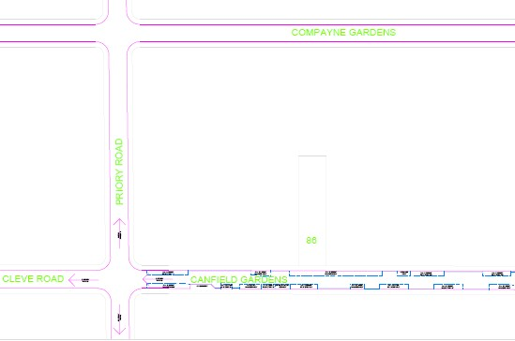

**2.5 Construction Programme**

The works including in this CMP are scheduled to last 39 weeks from commencement. The GANT

chart below indicates the main work phases.

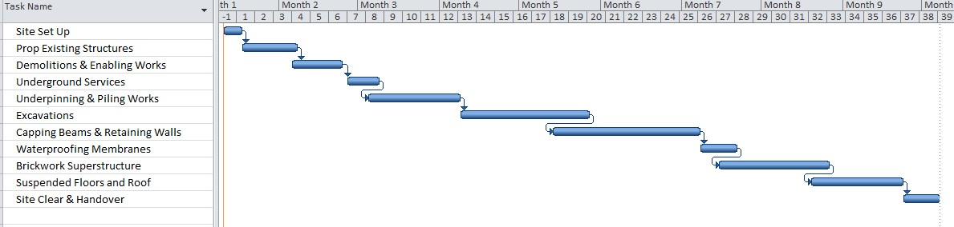

**2.6 Standard Working Hours** Monday to Friday 8am to 6pm Saturdays 8am to 1pm

No working on Sundays or Public Holidays

**2.7 Public Utilities/Services**

No changes to services are proposed

**2.8 Asbestos Survey**

Preliminary surveys indicate that no asbestos is present.

**Section 3 Transportation Issues Associated with the Site**

**3.1 Working Hours for Vehicle Visiting the Site**

Arrival and Departure times of vehicles shall be arranged between 9.30am to 4.30pm on weekdays and between 8.00am and 1.00pm on Saturdays. The site will be closed on Sundays.

All heavy/wide loads will shall be delivered and removed from site within the above times.

Deliveries for piling rigs and cranes shall be under the control of Zibi & Jack and Neil Piling and critical personnel shall be in attendance at all times.

Movement outside of these times shall be agreed with all adjacent neighbours. Any parking bays which may need to be closed off will be carried out by with full consultation of London Borough of Camden

**3.2 Size and Frequency of Vehicular Traffic**

Anticipated delivery vehicles for materials to and from the site to include:

Grab lorries up to 20 cu. metre capacity.

Ready mix concrete lorries. (approx size 8.25m long and 2.45m wide).

Flatbed delivery vehicles for the delivery of various materials including scaffolding, steelwork, reinforcement, bricks/blocks, timber, roofing materials, plaster, joinery etc. (approx size 11.5m long and

2.45m wide.

Appropriate Licences will be obtained for lifting over the highway. The projected vehicle movements are approximately 1 per day during the enabling works and up to 4 per day during the main contract works period.

**3.3 Hoardings, Temporary Structures and Parking Bay Suspensions**

The site area and the contractor’s compound will be enclosed with a 2.4m high plywood hoarding.

This will be adapted as necessary, will be painted as agreed with SCCS/LBC and include a hoarded off passageway for residents.

For the duration of the works hoarding panels shall be regularly checked and fully maintained. Should it become necessary, from time to time, to extend the hoarding over the public footway and suspend parking bays an application to Camden Highways Management Team will be made.

Scaffolding will be erected on the site only. The scaffolding will be enclosed with a hoarding and we will ensure that the footways are not affected or obstructed at any time. The Site Manager will be responsible for checking the perimeter regularly to ensure that any debris is removed and the public footway and highway are kept clear at all times.

Drawing No CG.AD.01 at Appendix X shows the proposed temporary works including suspension of parking bays for removal of excavated material from site.

**Section 4 Traffic Management for the Site**

**4.1 Pedestrian/cyclist safety measures**

A trained Traffic Marshall will control the delivery procedure which will be applied to ensure that pedestrian and cyclist safety is maintained and Canfield Gardens is not congested with site and delivery vehicles. The Traffic Marshall will ensure that traffic flow on the one way system is maintained at all times subject to crane safety requirements.

No vehicles will enter the site. Loading or unloading of vehicles will take place in restricted parking bays suspended as necessary and supervised by a Traffic Marshall (See Drg. No. CG.AD.01). The site gates will be kept locked shut and opened only during pre-arranged delivery times when safety barriers, manned as appropriate, will be used to prevent access to the adjacent footway by pedestrians. During loading or unloading cones will be used to direct cyclists around the affected area.

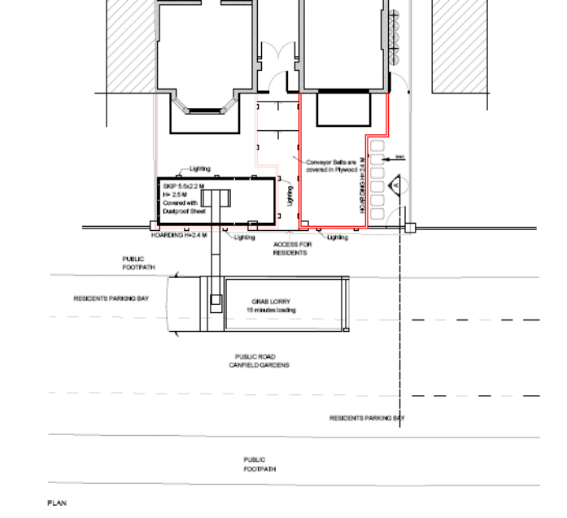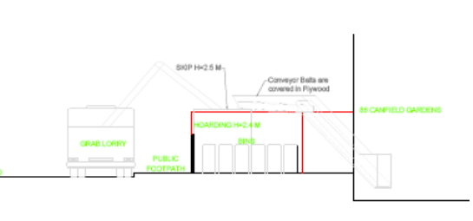

**4.2 Vehicular Access and Egress from the Site**

Vehicular access for the site will be directed from Finchley Road (A41 TLRN north sub-region corridor) into Greencroft gardens and then into Canfield Gardens. Egress will be along Canfield Gardens and Cleve Road to West End Lane, following the B510 into Quex Road, and right into Kilburn High Street (A5 TLRN west sub-region corridor). This will avoid weight / height restrictions and major traffic generators to reduce traffic impact.

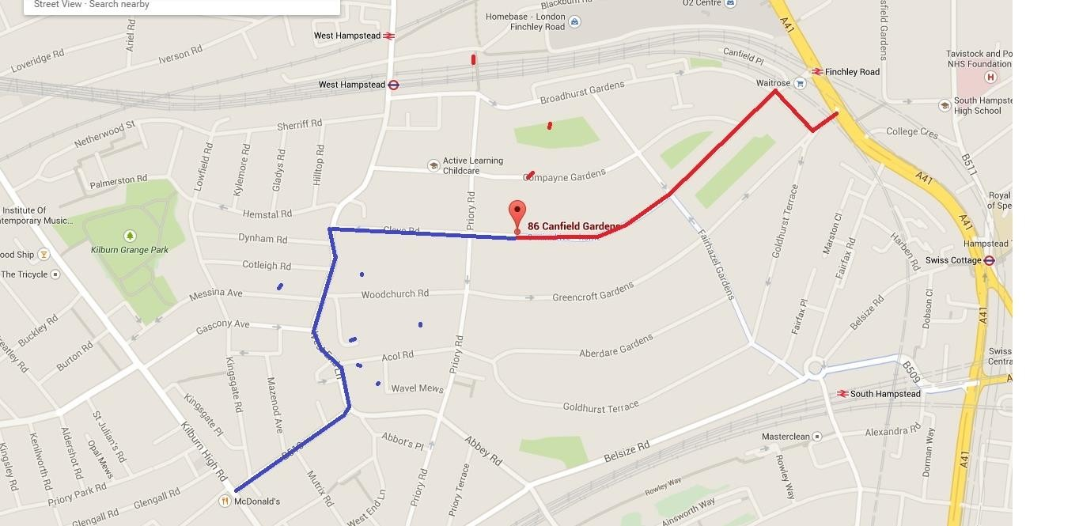

**4.3 Loading / Unloading Arrangements**

Where a crane (HIAB) is used to transfer materials from suspended bays in Canfield Gardens directly into the site, the footway will be closed off and pedestrians will be directed to use the footway opposite. See also Section 5.6.

**Section 5 Environmental Issues**

**5.1 Noise Generating Operations & Construction Procedure**

Operations on site will take place from 08.00 – 17.00 Monday to Friday and 08.00 – 13.00 on Saturday. The construction sequence is outlined below:

• Remove and cart away existing rear conservatory.

• Provide any necessary temporary beams and vertical props to support the existing first floor and structure above to maintain stability during progress of the works.

• Re direct existing soil vent pipe/manhole and surface water down pipes temporarily into the existing drainage system to public sewer.

• Excavate sequentially to approx. 4 metres below existing Ground Floor level to rear elevation at party wall junction, flank wall, internal spine wall to form mass concrete bases as described, including all necessary planking and strutting.

• Pour mass concrete bases allow 24 hours setting and build required piers in engineering brickwork/plain concrete C35 grade up to ground floor level.

• Leave 48 hours and install steel needles and props to support rear elevation above 1st. floor over required new openings as described and demolish existing brickwork under.

• Build new piers in engineering brickwork up to bearing of new steel beams over openings and allow to cure for 48 hours.

• Erect steel beams and pack up to underside of existing rear elevation brickwork with 1-1 cement/sand dry mortar packing and allow to cure for 48 hours and remove needles and props.

• Excavate for new mass concrete base at end of existing ground floor spine wall between new basement utility and bedroom 3 as described, including all necessary planking and strutting.

• Pour new mass concrete base as shown and allow to set for 24 hours and build new plain concrete pier in C.35 grade to ground floor level.

• Place new steel beams each side of spine wall spanning between new piers from basement level and make good bearings. Allow 50mm from ground floor level to top of steel beam flanges.

• Insert 32mm thick hardwood needles under each load bearing timber stud in sequence and make good until existing stud wall is fully supported on new steel beams.

• Cut away faces of existing steel column sufficient to pass through a solid 20mm thick x

70mm steel needle and pack up tight to column base and cut away remaining column faces.

• Install contiguous bored piling to external rear basement perimeter, rear and front open light-well areas.

• Provide formwork for capping beam to piling, fix reinforcement and pour concrete C35 grade properly vibrated.

• Excavate under party wall and external walls sequentially in 1metre wide panels to 4M below existing ground floor for new underpinning strip foundation, including all necessary planking and strutting. Panels may be excavated concurrently a minimum of 4 metres apart.

• Place starter reinforcement bars and pour strip foundation panels in C35 grade concrete.

• After 24 hours fix wall reinforcement as described including placing T25 dowels bars pushed in adjacent soil at 400mm c/c vertically.

• Cut back underside of existing brickwork to sound material, cut brick spreaders from existing foundation and cut out three 50x60 grooves in existing wall face and grout in T16 reinforcement using Ronafix 1-1 cement /sand mix and flush off face.

• Place facing shutter and pour concrete wall in C35 grade to 75mm form underside of existing wall and leave for 48 hours.

• Remove shuttering and solidly ram 1-1 cement /sand dry mortar packing between top of new RC wall and underside of existing brickwork.

• Leave panels for 48 hours and progress to next sequence of underpinning panels and repeat procedure as described, including cleaning off soil from dowel bars and casting into the adjacent concrete wall.

• Provide temporary horizontal propping as required to top of concrete wall.

• After completion of the underpinning to the party and external walls progress to the internal load bearing walls and proceed in1M wide panels sequentially as previously described.

• Excavate for new rear basement area and front and rear light wells including all necessary temporary propping, planking and strutting.

• After completion of the underpinning excavate remaining basement under the building to formation level and place 200mm consolidated type 2 fill to level surface.

• Excavate trenches for new foul and surface water drainage to new pump chamber as described. Place flexibly jointed pipework surrounded in pea shingle to required falls, test and backfill to receive new basement ground slab.

• Drill and resin grout T20 x 400mm long dowel bars @ 400mm c/c into new underpinning walls all around new basement slab perimeter and to contiguous piling.

• Place 1200 gauge polythene membrane on type 2 fill, fix mesh reinforcement as required and pour 200mm thick concrete slab in C35 grade concrete. Place polythene curing membrane onto slab surface and leave for 7 days to cure.

• Clear soil from between contiguous piles to half diameter depth and fix A252. mesh reinforcement to piling face and place formwork to 150mm thick facing wall and pour concrete C35 grade to underside of projecting capping beams.

• Place and make good tight to retaining wall new ground floor joists, as described, and 20mm ply floor boarding screwed to joists.

• Fix Delta internal waterproofing membrane to basement slab and face of all walls and cast

100mm loading slab/screed with D49 fabric.

• Remove any temporary propping and make good as required.

**5.2 Noise Survey**

If requested the developer will carry out an acoustic survey to determine the background noise

levels at each boundary at locations agreed with the LPA.

**5.3 Predicted Noise & Vibration Levels**

There will be no use of pile driving, dynamic compaction, blasting or operation of other heavy construction equipment. Details of proposed piling rig with noise levels are included at S 5.4.

Noise and vibration generated during the site preparation, groundwork and construction phases and associated ancillary operations of the use hereby permitted shall meet the following criteria:

MAXIMUM PREDICTED NOISE LEVELS OF CONSTRUCTION PLANT AND EQUIPMENT TAKEN AT THE BOUNDARY OF THE SITE

|  |  |  |  |  |
| --- | --- | --- | --- | --- |
| Period | Hours | No. of hours over  which1Hourly *L*eq is applicable | Noise dB(A)  1 hour | Peak Noise  dB(A) |
| Monday to Friday | 0800 to 1800 | 10 | 72 | 75 |
| Saturday | 0800 to 1300 | 5 | 72 | 75 |

No working Sundays/bank holidays unless prior approval

Note: a) Peak Noise Levels refer to levels recorded on a BS5969 Type 1 precision sound level meter set to slow response.

b) *L*eq Noise values are the equivalent continuous sound level values, measured at the site boundary.

MAXIMUM PREDICTED VIBRATION LEVELS OF CONSTRUCTION PLANT AND EQUIPMENT TAKEN AT THE BOUNDARY OF THE SITE

|  |  |
| --- | --- |
| Type of Building | Maximum Vibration PPV (mm/s) 1- 100 Hz |
| Any permanently occupied residential  building, medical facility or school. | 1.0 |
| Any occupied hotel or  commercial/industrial building | 3.0 |

Note: a) Table based upon multiples of the vertical velocity base curve from BS 6472 – Guide to

Evaluation of Human Exposure to Vibration in Buildings – Pt.1: 2008.

b) BS7385: Evaluation and Measurement of Vibration in Buildings: Guide to Damage Levels from Ground Borne Vibration – Pt. 2: 1993 notes that the risk of damage (even cosmetic damage) to buildings from transient vibration tends to zero below 12.5mm/s PPV.

If predicted noise or vibration levels are exceeded the source will be isolated and shut down until preventive measures are agreed with neighbours and LPA including relocation of plant, the use of acoustic enclosures or anti vibration mountings.

**5.4 Details of Mitigation Measures**

Best Practicable Means (BPM) as defined in Section 72 of the Control of Pollution Act 1974

shall be employed at all times. The quietest and newest available vehicles/plant machinery shall be used at all times. All vehicles and mechanical plant used for the purpose of the works shall be fitted with effective exhaust silencers, shall be maintained in good and efficient working order and operated in such a manner as to minimise noise emissions.

An evaluation of chosen plant and technique for each phase of work shall be added to The CMP as an addendum to demonstrate BPM.

Noise attenuation screening will be used if deemed appropriate and noise monitoring will be carried out at the start and at regular intervals during each task period. Any mobile screens shall have sufficient mass so as to be able to resist the passage of sound across the barrier and to be free of significant holes or gaps between or under any acoustic panels or board materials as far as reasonably practical.

The workforce are/will be trained in accordance with BS 5228: 2009 to employ appropriate techniques to keep site noise to a minimum, and will be effectively supervised to ensure that best working practice in respect of noise reduction is followed including:

• the proper use and maintenance of tools and equipment;

• the positioning of machinery on site to reduce the emission of noise to the neighbourhood and to site personnel;

• the avoidance of unnecessary noise when carrying out manual operations and when operating plant and equipment;

• the protection of persons against noise;

• the operation of sound measuring equipment (selected personnel).

Special attention will be given to the use and maintenance of sound-reduction equipment fitted to power tools and machines

Piling will be open auger bored using hydraulic powered T15000 Rig shown below to minimise vibration.

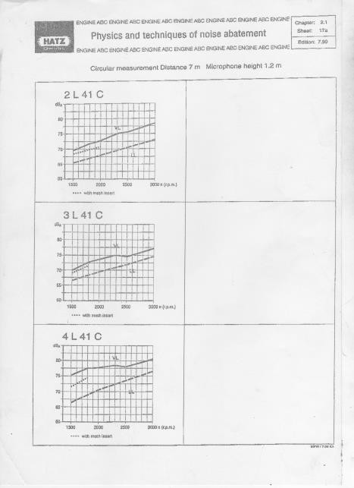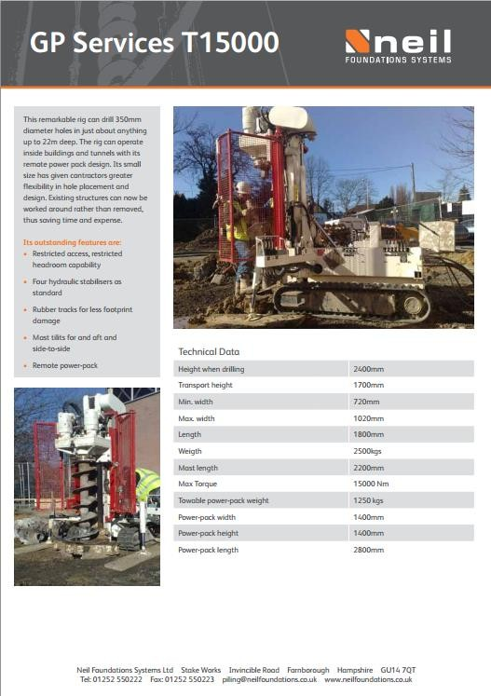

Hydraulic plant will be located away from the perimeter of the site.

If predicted noise or vibration levels are exceeded the source will be isolated and shut down until preventive measures are agreed with neighbours and LPA including relocation of plant, the use of acoustic enclosures or anti vibration mountings.

**Dust Management**

**5.5 Prevention measures**

Generally debris and mud shall be minimised on the road and cleaned up immediately as required.

A washing bay area will be impermeable and isolated from the surrounding area by a raised kerb or roll over bund to contain solids, with effluent directed to the foul sewer (subject to discharge consents).

**5.6 Suppression measures**

Fine spray will be used to suppress dust on the following:

• Structures and building during demolition.

• Unpaved areas that are subject to traffic or wind.

• Sand, spoil and aggregate stockpiles.

• During loading/unloading of dust generating materials.

**5.7 Containment measures**

Excavated material will be transferred to a 5.5 X 2.2m skip covered with a dust proof sheet located within the site boundary in a fully hoarded 2.5m enclosure adjacent to the footway. Grab lorries will park in suspended parking bays for 10 minutes to load and remove spoil. All muck away lorry's to be fully sheeted to minimise the risk of any mud over-spilling onto the highway.

**5.8 Monitoring Noise, Vibration and Dust Levels**

Noise monitoring will be undertaken using a combination of semi-permanent and attended methods at locations and frequency agreed with the LPA.

Vibration levels will be monitored by measuring Peak Particle Velocity (PPV) during demolition and piling operations using a vibrograph with a tri-axial geophone pack fixed to the adjoining structures in accordance with BS 7385.

Deformation Monitoring consisting of fixing semi-permanent reflectors to existing structures to allow regular monitoring of possible movement is being undertaken by independent monitoring surveyors.

Air quality (both dust and PM10 emissions) will be checked periodically using handheld meters producing real time dust readings combined with sticky pad method to measure and monitor soiling rates.

**5.9 Dust Risk Assessment**

The likely impact of the works based on evaluation guidelines set out in the Best Practice Guidance, GLA Control of Dust indicates a Low Risk. The site area is less than 1000m2; the development involves a single property; and the potential for emissions and dust will have an infrequent impact on sensitive receptors.

**5.10 Relevant Mitigation Measures to Control Air Quality**

• Effective barriers will be erected around dusty activities and on the site boundary adjacent to Canfield Gardens.

• No bonfires will be permitted.

• Machinery and dust causing activities will be located away from sensitive receptors.

• Vehicles will switch off engines while waiting loading / unloading.

• Vehicles will be effectively washed or cleaned before leaving the site if close to sensitive receptors.

• All loads entering and leaving site will be covered.

• No site run-off of water or mud will be permitted (see 5.5 above).

• All non-road mobile machinery (NRMM) will use ultra low sulphur tax-exempt diesel (ULSD)

where available.

• On-road vehicles will comply with the requirements of a possible future Low Emission Zone

(LEZ) as a minimum.

• Water will be used as dust suppressant during demolition works.

• Cutting equipment will use water as suppressant or suitable local exhaust ventilation systems.

• Skips will be securely covered and drop heights minimised.

• Waste materials will be removed from site promptly.

**5.11 Rodent Control**

The site will be regularly monitored and kept free as far as is reasonably practicable from rodents by preventing access to food, water, shelter or nesting sites.

The destruction of rodents will be controlled by the limited use of anticoagulant rodenticides and bait stations. Carcasses, bait stations and uneaten bait will be disposed of carefully and hygienically according to current legislation and the advice on rodenticide product labels.

In persistent cases the use of ultra-sonic repellant devices may need to be considered.

A survey will be carried out to identify and record the presence and extent of any infestations. Where infestations are identified, appropriate treatments will be implemented to eliminate infestation before commencing work. Temporarily open soil pipes resulting from alterations will be capped using a proprietary expanding drainage stoppers.

Exposed manholes and drains will be inspected and flushed through with high pressure water jet before final connection.

The developer will comply with the requirements of Section 4 of the Rats and Mice (Destruction) Act 1919

and implement the recommendations contained in Building Research Establishment Digest 415, May

1996: Reducing the risk of pest infestations in buildings.

**Section 6 Monitoring, Compliance, Reporting and Consultation**

**6.1 Details of Traffic Management**

A delivery procedure will be implemented by trained road marshall who will control and ensure all deliveries are fully in accordance with our defined delivery procedures. This will ensure that Canfield Gardens is not congested with site and delivery vehicles.

The appointed road marshal will ensure that traffic flow is maintained at all times, subject to crane safety requirements.

All subcontractors and suppliers will be required to give 24 hours notice of deliveries. The movement of materials, particularly in the main contract works stage, will also be controlled by the road marshal, who will be responsible for the control and coordination of all aspects of material deliveries/collection and movement.

Vehicles will pull into the suspended parking bays for unloading wherever possible.

A mobile crane will be provided to facilitate easy and quick unloading of heavy goods from site delivery vehicles and to lift mini piling rig and excavator over to the rear of the building. The crane will be up to

40m in radius including fly jib and traverse over adjacent buildings.

Materials shall be stored within the boundary of the site and suspended parking bays. No parking will be permitted on site except motor cycles.

Please also refer to Section 4

**6.2 Community Liaison Proposals**

The developer will have direct responsibility for fostering good community relations with all neighbouring residents and businesses.

Individuals directly involved in the management of the site will be identified as being specifically responsible for community relations (Community Liaison Representative). This single point of contact will be established for all liaisons with the general public and residents.

We will initiate early and honest communications to establish a good rapport with the community through the Project Manager that will help reduce problems that may arise during the construction process. This will include providing clear, advance notice, relating to potential disturbances from unavoidable noise, dust or disruption of traffic.

Neighbouring residents will be notified at least one week before commencement of the nature and likely duration of the works together with a telephone number (including out of hours) and address to which any enquiries should be directed.

We will ensure that any particularly sensitive works or issues are dealt with in a professional and

accountable manner, with the public and local community kept informed at all times through the

Project Manager. This may include things like out of hour's delivery of large items.

A Site Contact Board will be displayed on the site hoarding. This will indicate:

• The title – Contacts Board;

• Name of the Main Contractor, address and person to whom correspondence should be addressed;

• Name of the Site Manager;

• Month and year of anticipated completion of the works;

• Names and telephone numbers of staff who can take immediate action, so that contact can be made at any time.

A manned telephone line will be maintained and communicated to both the local residents and the LPA Noise and Licensing Enforcement Team during the works to deal with enquiries and complaints from the local community. Any complaints arising from the works shall be recorded in a Complaints Register recording the day, time and details of the complaint; details of any monitoring carried out and any additional mitigation actions. The register is to be made available to the LPA if requested.

**6.3 Additional Measures to Mitigate Impact of Construction**

A Site Waste Management Plan will be implemented to ensure the efficient use of materials and minimise the production of waste and its handling. The objectives of the plan are to ensure that

the creation of waste is minimised wherever possible, all rubbish, debris and spoil will be sorted for recycling, segregated on site and collected from a central point.

The contractor will ensure that all access routes, fire escapes and staircases are swept and kept clear of debris on a regular basis to maintain high standards of health and safety on the project. All general areas of the project will be swept clean on a daily basis.

The CMP fully endorses the Construction Industry Board’s “Considerate Constructors Scheme”. In

particular we will ensure that:

• The needs of all those affected by the construction process and its effect on the environment are considered with special consideration for the needs of people with sight, hearing or mobility difficulties.

• When choosing and using resources awareness of the environment is borne in mind. In particular attention to managing waste, avoiding pollution, using local resources wherever possible, and keeping noise as low as possible.

• The site, footpaths and surrounding area affected by the work is kept clear of mud, spillage, litter and any unnecessary rubbish. The site, hoardings, scaffolding and other features are kept in a clean, tidy and safe condition.

• Neighbours are kept informed and consulted about site activity before the work starts to final handover.

• Respectable and safe standards of behaviour and dress are promoted among the workforce using disciplinary action where necessary to deal with rudeness or poor behaviour

• All construction work and vehicle movements are carried out with care for the safety of passers-by, neighbours, and site personnel.

• The contractor takes responsibility for making sure that the workforce understands and complies with the CMP.

• The contractor remains accountable to the public by providing site contact details and being available to deal with their concerns and develop good local relations.

**6.4 Compliance with TFL Construction Logistics and Cyclists Safety (CLOCS) Standard**

All companies providing site delivery and removal services with vehicles over 3.5 tonnes gross vehicle weight will be required to:

• Provide evidence of current certification from an approved independent audit body (such as the Fleet Operator Recognition Scheme (FORS), Van Excellence, RHA Standard or other FORS equivalent standard.

• Maintain a log of all collisions including details of all evidence required to investigate an incident, lessons learned and remedial measures identified to help prevent re-occurrence of similar incidents.

• Adhere to site routing and access requirements set out in the CMP.

• Display external pictorial stickers and markings to warn vulnerable roads users not to get too close to the vehicle.

• Be fitted with appropriate vision aids and driver audible alerts.

• Be fitted with equipment to audibly warn vulnerable road users when a vehicle is turning left.

• Provide evidence that drivers have undertake approved theoretical training which includes safety of vulnerable road users.

• Provide evidence that drivers employed by the company hold a valid licence and any risks presented through an accumulation of endorsements are effectively monitored and managed

and such verification is verified through a service that directly accesses current Driver and

Vehicle Licensing Agency (DVLA) data. and other requirements of CLOCS Section 3.3.

The Developer shall ensure that:

• The CMP is fully complied with and that contractors are aware of and understand their obligations under the Plan.

• Effective traffic management principles are adhered to.

• An appropriate person is nominated to manage all deliveries and collections to site and supervise the loading and unloading process.

• A suitable ‘offloading area’ is identified and that approved loading and unloading plans are in place.

• Options to reduce peak hour deliveries to a site have been considered and where identified, arrangements to minimise peak hour deliveries implemented.

• The circumstances (if any) under which drivers may deviate from a specified route such as a temporary road closure, or road traffic accidents are clearly specified.

and other requirements of CLOCS Section 3.4

**The agreed contents of this Construction Management Plan must be complied with unless otherwise agreed with the Council. The project manager shall work with the Council to review this Construction Management Plan if problems arise in relation to the construction of the development. Any future revised plan must be approved by the Council and complied with thereafter.**

**It should be noted that any agreed Construction Management Plan does not prejudice further agreements that may be required such as road closures or hoarding licences.**

**Signed:** …………………………………………… **Date:** ……………………

**Print Name:** ……………………………………… **Position:** …………………

Appendix 1

Basis for calculation of noise and vibration predictions

The construction noise levels reported in the CMP have been calculated using the methods contained within Annex F of BS 5228-1 and using source data contained within Annex C and Annex D of BS 5228-1.

Appendix 2

Rodent control measures

A one year contract has been undertaken which will more than cover the construction phase. Details of the contract are given below and treatment receipts will be forwarded as they are undertaken.