List entry
- Back to results
- Refine your search
- Printable Version

List entry Summary
This building is listed under the Planning (Listed Buildings and Conservation Areas) Act 1990 as amended for its special architectural or historic interest.
Name: NUMBER 64 AND ATTACHED RAILINGS
List entry Number: 1379334

Location
NUMBER 64 AND ATTACHED RAILINGS, 64, LINCOLNS INN FIELDS
The building may lie within the boundary of more than one authority.
County | District | District Type | Parish
Greater London Authority | Camden | London Borough
National Park: Not applicable to this List entry.
Grade: II
Date first listed: 14-May-1974
Date of most recent amendment: Not applicable to this List entry.

Legacy System Information
The contents of this record have been generated from a legacy data system.
Legacy System: LBS
UID: 478713

Asset Groupings
This list entry does not comprise part of an Asset Grouping. Asset Groupings are not part of the official record but are added later for information.

List entry Description

Summary of Building
Legacy Record - This information may be included in the List Entry Details.

Reasons for Designation
Legacy Record - This information may be included in the List Entry Details.

History
Legacy Record - This information may be included in the List Entry Details.

Details
CAMDEN
TQ3081SE LINCOLN'S INN FIELDS 798-1/106/1061 (West side) 14/05/74 No.64 and attached railings
GV II
House. Early C19. Stucco front. 4 storeys and basement. Square-headed doorway with fanlight and double panelled doors. Corbels at sides of entrance below stone 1st floor balcony with iron balustrade. Recessed sash windows, most with original glazing bars, segmental-arched to ground floor. Ionic pilasters through 1st and 2nd floor carrying entablature with dentil cornice. 4th storey an attic with sunk panel pilasters between windows. INTERIOR: square balusters to plain close string stairs. Original fireplaces and cornices. SUBSIDIARY FEATURES: attached cast-iron railings to areas.
Listing NGR: TQ3062981378

Selected Sources
Legacy Record - This information may be included in the List Entry Details

National Grid Reference: TQ 30629 81378

Map
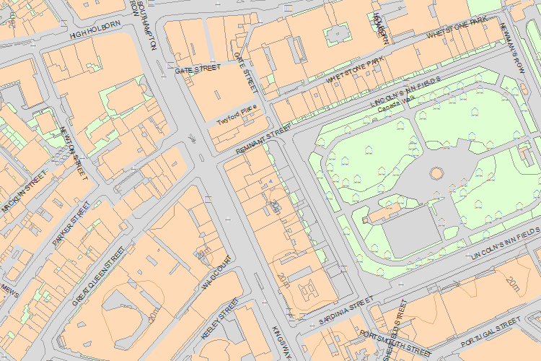
© Crown Copyright and database right 2015. All rights reserved. Ordnance Survey Licence number 100024900.
© British Crown and SeaZone Solutions Limited 2015. All rights reserved. Licence number 102006.006.
The above map is for quick reference purposes only and may not be to scale. For a copy of the full scale map, please see the attached PDF - 1379334.pdf - The pdf will be generated from our live systems and may take a few minutes to download depending on how busy our servers are. We apologise for this delay.
This copy shows the entry on 03-Aug-2015 at 02:44:26.
- Back to results
© Historic England 2015

