PBA

DESIGN & ACCESS STATEMENT accompanying full planning application for
Flat 6 THE GREEN, 19 ROCHESTER TERRACE, LONDON NW1 9JN

As far as they apply, this statement has been prepared in accordance with the headings and guidelines issued by DC-CABE.

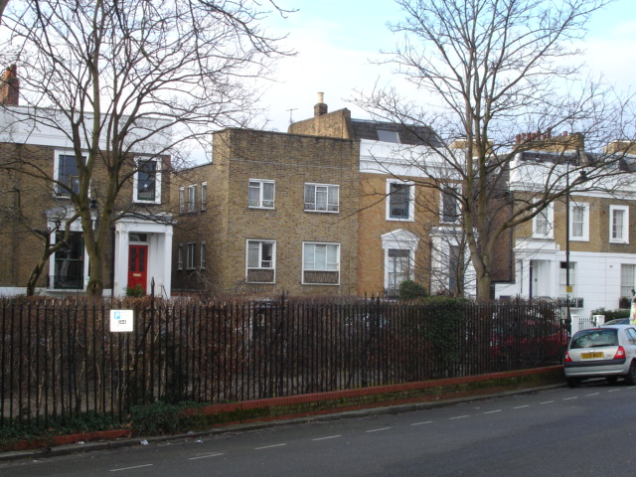

www.peterbradesarchitects.co.uk tel: 020 7226 3884
Peter Brades Architects, 42 Colebrooke Row, London N1 8AF

- USE

  - This is the rear 2nd floor studio flat in a block of six identical flats built in 1958 as part of the Day Flats initiative.

  - The proposal is to enlarge the flat into a new 3rd floor covering the entire 2nd floor, to create a 2-bed unit for the owner.

  - No other changes to the building are proposed.

- AMOUNT

  - The proposal adds 40 sqm to the existing 22.5 sqm floor area..

- LAYOUT

  - The existing flat is converted into a bedroom and bathroom and has an internal staircase leading to the new top floor with second bedroom, living/dining room and kitchen.

- SCALE

  - The scale is in keeping with its neighbours.

- LANDSCAPE

  - The communal garden is not affected by the proposals.

- APPEARANCE

  - The new top floor is designed as a slate mansard roof, matching the adjoining house and infilling a gap in the terrace.

  - The new dormers will be clad in lead and have steel windows to match the original Crittall ones below.

- ACCESS

  - Unaffected by the proposals.

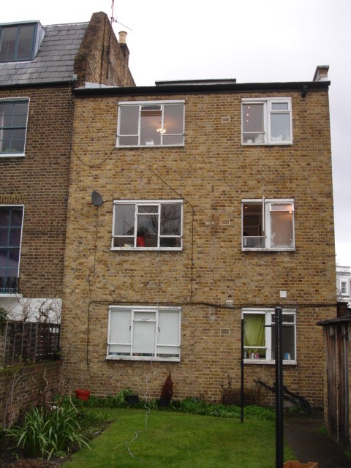

view of rear elevation from communal garden

1685/PEB/March 2015

