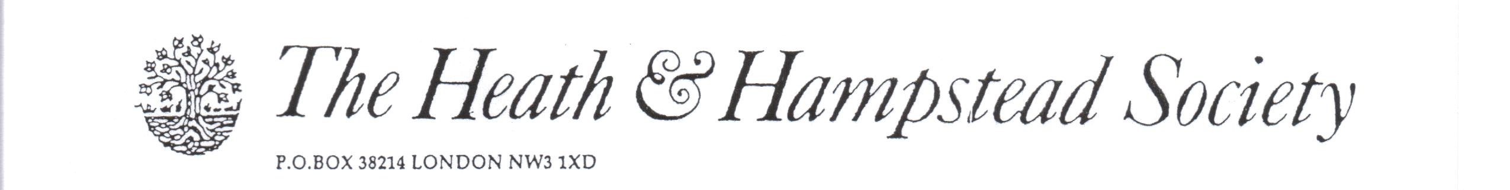
The Society examines all Planning Applications relating to Hampstead, and assesses them for their impact on conservation and on the local environment.

To London Borough of Camden, Development Control Team

Planning Ref: 2015/3208/P
Address: 14 Hollycroft Avenue, NW3
Description: Rear extension, and parking space.
Case Officer: Kate Phillips Date 18 July 2015

We raise objections to this application, as follows:

1. The extension, although following the footprint of the existing projection to be demolished, is grossly out of scale and character with the existing house.
The existing house is Locally Listed, and follows in style and detail the character of other Quennell houses in the area. We believe that statutory listing is justified for it; all the features characteristic of Quennell architecture are present.
The proposed enormous 3-story expanse of glass would be completely alien in style and scale to the existing architecture, and very damaging to the appearance of the house and its neighbours.
It is also clear that there would be substantial heat loss in winter, and heat gain in summer, leading inevitably to the need for maximum areas of blinds and/or curtains. What is the point of attracting nuisance and expense on this scale?
The provisions of Policy DP22 would be flouted.

2. Parking
We always object to the destruction of front gardens for the purposes of car parking, and we do so here. No justification is offered for this loss of green space, planting and flowers.

Pleas refuse.

