Re 61 Rochester Place

Application 2015/2697/P

Dear Mr Thuaire

I wish to object to the above planning application for the following reasons.

The LDF recognises the importance of protecting the amenity of Camden’s residents and visitors and seeks to protect and enhance our environment. The addition of a second floor of office space on top of the permitted but unbuilt extension to the B1c first floor, recently allowed at appeal, will due to its bulk, massing, height and proximity result in unacceptable damage to the character, amenity values and appearance of two conservation areas that include a noted and a listed terrace. As Planning officer for this site you peviously considered the addition of one floor (2013/0643/P) to be detrimental – it would be entirely illogical then to consider that two floors are not.

The proposed extension, by reason of its bulk, size, location, design and materials, would be detrimental to the character and appearance of the immediate area and adjoining conservation areas, contrary to policy CS14 of the London Borough of Camden Local Development Framework Core Strategy and policies DP24 and DP25 of the London Borough of Camden Local Development Framework Development Policies.

The proposed extension, by reason of its size, location and design, would result in loss of outlook to neighboring properties in Reeds Place to the detriment of their residential amenities, contrary to policy CS5 of the London Borough of Camden Local Development Framework Core Strategy and policy DP26 of the London Borough of Camden Local Development Framework Development Policies.

We have always asserted that the applicant has been attempting to establish a footprint for later development. The applicant has already incrementally and stealthily achieved a vast amount of development on the site, which, as has been illustrated over the large number of previous applications and appeals, would never have been possible had all these elements been included in one large application. Furthermore we suggest that the proposed 2nd floor extension is clearly designed to be turned at a later date into accommodation (the applicant’s original stated intention for that floor) Why would an extension to a B1c business space unit require roof terraces and balconies – which compromise the privacy and amenity of Numbers 59 and 57 Rochester Place? The footprint of the proposed extension is larger than the previous application for second floor accommodation (withdrawn by the applicant so the first floor was more likely to get approval) and is set closer to the listed terrace of St Pancras Way and closer to the properties in Reeds Place.

The drawing below illustrates this increased proximity with the new application in green superimposed over the previous (withdrawn) application.

In addition the height of the proposed business extension reaches the height of the roof gullies in St.Pancras Way and is higher than the roof lines and chimneys in Reeds Place. In combination with the granted first floor extension it eclipses any vista from 120 and 118 St.Pancras Way and 3,4,5,6 and 7 Reeds Place. The degree of enclosure has a particularly unacceptable impact on 59 Rochester Place.

The development has large areas with unusable working head heights, further indication that this scheme may be intended as land grab to establish a foot print for future development.

Why does the proposal contain a disabled WC but not provide disabled access to that floor?

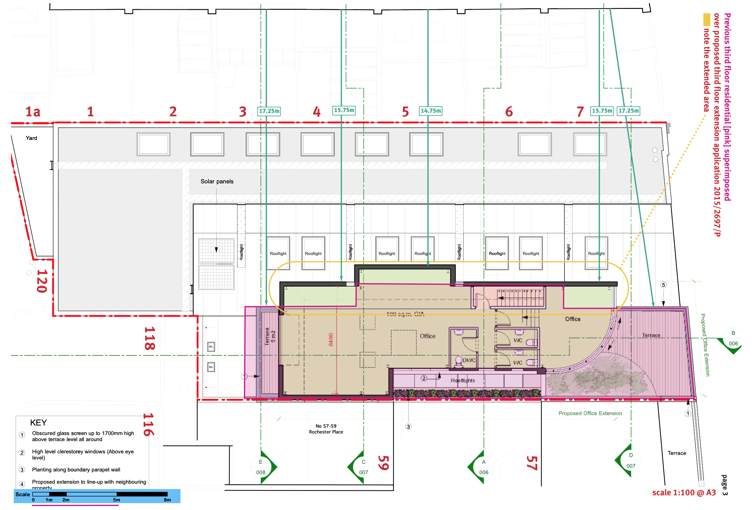

The Rochester Conservation area Statement states that, “not all development has been successful in contributing to the character of the Conservation area…. Where development has detracted from the character and appearance of the Conservation area it is often through lack of respect for **historic context** – the following themes recur, **use of inappropriate materials and inappropriate bulk, massing or height**.” Historically Rochester Place is a street of two floored industrial buildings following the original street levels. Previous applicants have been invited to angle their build lines away from the listed terrace at the rear of the site, and to follow, not extend the building and roof lines of the industrial streetscape

Previous applicants have been invited and encouraged to **consult** with neighbours, CAC’s and relevant local groups – why is that not the case here, when it is clear from the numbers of unsuccessful previous applications and the sheer volume of local opinion that this is a very sensitive site?

The supplied proposals do not ‘preserve and enhance’ the Conservation area, they will also damage and compromise the amenity and setting of the listed terrace. Paragraph JS17 of the Conservation Area statement states that ‘New development should be seen as an opportunity to enhance the Conservation areas and should respect existing features such as building lines, roof lines, elevational design and where appropriate, architectural characteristics, detailing, profile and the materials of adjoining buildings.’ This application by no means accomplishes that aim.

The current LDF states that it is ‘important to ensure that all development takes place in a way that minimises the impact on the environment and protects and enhances the existing environment.’ It states that it seeks to improve our surroundings through good design in new development. **S7** states thatthe Council will seek to protect and enhance the Borough's historic environment and ensure that all development is designed to the highest standards and protects and enhances its surroundings.

What is now proposed is a solid mass using inappropriate utilitarian modern industrial metal work, of no visual merit which fails to take into account or reference its setting within an early nineteenth century industrial and residential enclave. The final build height will be over two meters higher than **any** previous failed application for the site.

We believe that the new proposal fails to achieve the bare minimum of the standards set out in the LDF and will severely compromise the character and amenity values of the surrounding properties.

This development in an area enclosed on three sides will be clearly visible and dominate the outlook from 23 surrounding properties, an outlook that has been preserved and protected by the rejection of 9 inappropriate applications for this site over the last 7 years. Whilst I am delighted that the original light industrial space has been preserved within this scheme I am concerned that the addition of two additional floors of workspace above it represents a dramatic and severely damaging overdevelopment of the site. I am also concerned that now the footprint of the extra first floor workspace is established, pressure may be subsequently applied to convert this too into accommodation – the materials used and access points to the office space on the two new floors suggest that this may be their ultimate intention. This would represent the cynical erosion in increments of the character and identity of this highly sensitive site.

In summation I believe that the proposed application, due to its bulk massing and height will result in the gross overdevelopment of a sensitive site and fails to ‘preserve and enhance’ the Conservation area it adjoins. Its design and scale disregards the context of the Conservation Areas and adjoining Listed Terrace and employs poor design with inappropriate and ill specified materials. The development will result in an unacceptable loss of amenity due to infringements of visual privacy and overlooking, the reduction of sunlight and daylight levels in neighboring properties and gardens, pollution from artificial light sources and increased noise pollution and vibration levels from extraction.

In conclusion I would suggest that the council has a duty of care to reject this application. If this matter goes to committee I would like to be informed of the date of that committee.

I would therefore request that it is recorded that I OBJECT to the proposed application for 61-63 Rochester Place 2015/2697/P

CHRISTOPHER WOODS

120 St Pancras Way NW1 9NB