ADDENDUM TECHNICAL REPORT

Crawford Reference: SU1401214

LHA London Ltd
Belsize
38-40 Belsize Park Gardens
London
NW3 4NA

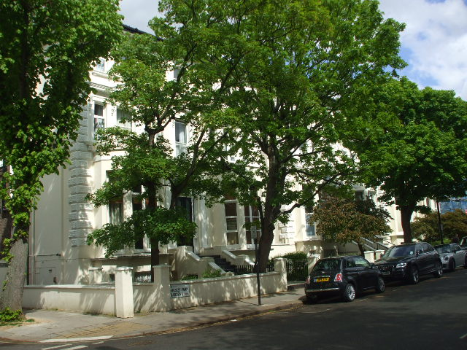

prepared for

Ecclesiastical Insurance Group
Beaufort House
Brunswick Road
Gloucester
GL1 1JZ

Claim Reference 000310041

SUBSIDENCE CLAIM

DATE 21 July 2014


Specialist Property Services UK
2nd Floor, Sunningdale, The Belfry Business Park,
Colonial Way, Watford,
WD24 4WH
Tel: 01923 471755
Fax: 01923 471720
E Mail subsidence@crawco.co.uk
Site Plan |  |  |  | This plan is Not to Scale
This plan is diagrammatic only and has been prepared to illustrate the general position of the property and its relationship to nearby trees etc. The boundaries are not accurate, and do not infer or confer any rights of ownership or right of way. Position of utilities is only indicative and contractors must satisfy themselves regarding actual location before commencing works.
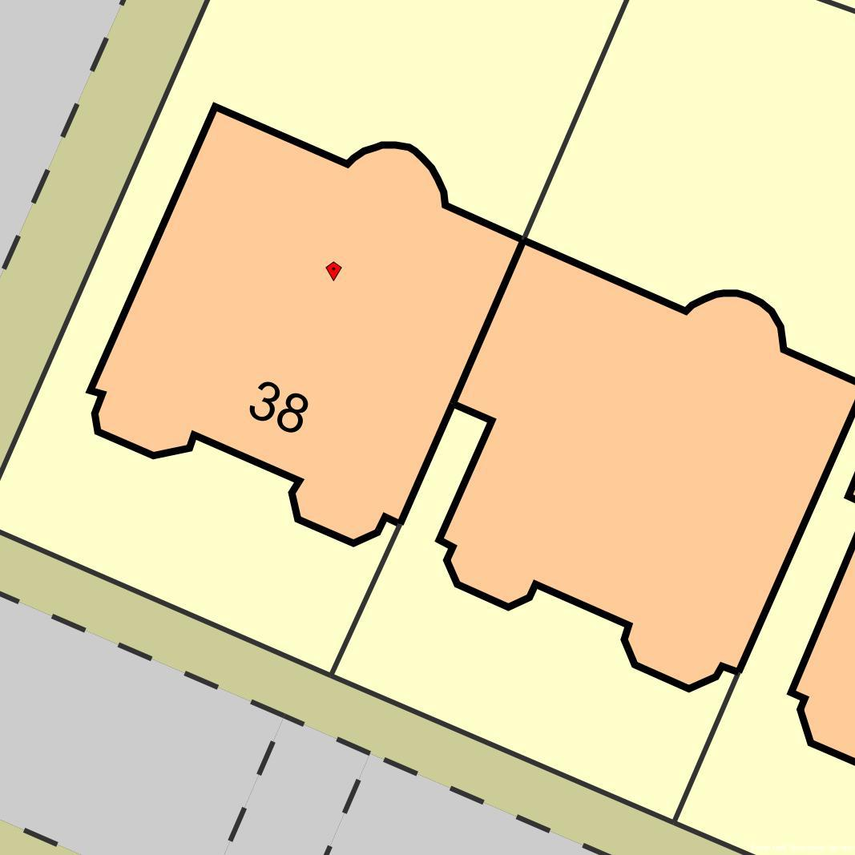
Glenilla Road
Failing retaining walls
Sycamores
Lime
TBM at this corner
TP/BH 1
TP/BH 2
40
Belsize Park Road
© Bluesky International & © Infoterra 2006.
Map Reproduced with the Permission of Ordnance Survey License Number ########
Key:
 | Tree: Deciduous |  | Tree: Conifer |  |  | Shrub
 | Hedge |  | Area of Damage |  |  | Bore Hole
 | Trial Hole |  | Trial & Bore Hole |  |  | Level Monitoring
 | Rain Water Manhole |  | Rain Water Gulley |  |  | Rain Water Pipe
 | Waste Water Manhole |  | Waste Water Gulley |  |  | Toilet Pipe
 | Rain Water Drain |  | Waste Water Drain |  |  | Electricity Cable

INTRODUCTION

We have been instructed by insurers to investigate a claim for subsidence at the above property. The area of damage, timescale and circumstances are outlined in our initial Technical Report. This report should be read in conjunction with that report.

To establish the cause of damage, further investigations have been undertaken and these are described below.

INVESTIGATIONS
The following investigations were undertaken to identify the cause of movement.

TRIAL HOLES
Two trial holes were excavated to expose the foundations - see site plan for location and the diagram below for details.

a
c
b

Foundation Details

No. Borehole Depth Footing (a) Underside (b) Thickness (c)
TH1 3.00 m. 200 mm. 600 mm. 600 mm.
TH2 3.00 m. 200 mm. 500 mm. 500 mm.

Trial Hole 1 against the front corner of the main building revealed a brick corbel footing founded at a depth of 0.6m below ground level which bears onto stiff brown CLAY.

Trial Hole 2 against the front left corner of the left hand bay revealed a brick corbel footing founded at a depth of 0.5m below ground level which bears onto stiff brown CLAY.

Root activity of live appearance was noted to the underside of the foundations

AUGERED BOREHOLES
A 50mm diameter hand auger was sunk - see site plan for location(s).

Borehole 1 confirmed the continuation of the clay subsoil encountered within the trial pit, with roots to a depth of 0.7m below ground level. The borehole remained dry and open upon completion.

Borehole 2 confirmed the continuation of the clay subsoil encountered within the trial pit, with roots to a depth of 0.6m below ground level. The borehole remained dry and open upon completion.

In-situ shear vane testing confirmed the clay subsoil to be firm to stiff in nature.

SOIL SAMPLES
Soil samples were retrieved from the bore, wrapped in clingfilm before being bagged and deposited with a testing laboratory the same day. The laboratory have instructions to test the samples to determine if there is evidence of root induced desiccation.

The following laboratory tests were carried out on soil samples retrieved from the boreholes :-

Moisture Content
Values ranged from 29% to 32% over the depth of Borehole 1
Values ranged from 29% to 31% over the depth of Borehole 2

Atterberg Limits
Results indicate that the clay subsoil can be classified as a very high plasticity clay in accordance with the Casagrande chart.

Oedometer Tests
Oedometer testing on disturbed samples is a recognised method of assessing clay desiccation.

The results in Borehole 1 indicate evidence of severe desiccation between a depth of 1.0m and 3.0m.

The results in Borehole 2 indicate evidence of very severe desiccation between the underside of the foundation and a depth of 1.0m, with severe desiccation below.

ROOTS
Roots were retrieved from the trial hole and have been submitted to a botanist for identification.

Roots in both borehole were identified as the Species Acer which includes sycamores. These roots extended to a depth of 0.7m. Starch was present which indicates that the roots were alive at the time of retrieval

DRAINS
A CCTV survey of drainage in the vicinity of damage was carried out at the time of initial site investigations. This revealed the drain runs surveyed to be in a serviceable condition, apart from the run across the front of the left hand bay and the run passing under the left hand path up to the front left corner of the main house. Both these runs were infested with tree roots. It is recommended that these roots are removed and the drain runs lined.

DISCUSSION
The results of the site investigations confirm that the cause of subsidence is root-induced clay shrinkage. The clay is plastic and thus will shrink and swell with changes in moisture content. Roots have extracted moisture below the depth of the footings, thus causing differential foundation movement to occur. This is supported by the following investigation results :-

- The foundations are at a depth of 0.5m which is below the level that normal seasonal movement would occur.
- The moisture content profile indicates a reduction in moisture content at the underside of the foundations in both trial pits which is indicative of desiccation at this level. This is also co-incident with the depth of root activity.
- Atterberg limit testing indicates that the soil has a very high plasticity and hence will shrink and swell with changes in moisture content.
- Oedometer tests indicate severe desiccation in borehole 1 and very severe esiccation in borehole 2. The desiccation in borehole 2 is coincident with the depth of root activity.
- Roots were found to a depth of 0.7m.
- Shear vane readings indicate an increase in shear strength of the clay at the underside of the foundation in borehole 1, and between the underside of the foundation and to a depth of 1.5m in borehole 2, indicating desiccation at these depths.

RECOMMENDATION
The cause of the movement needs to be dealt with first. From the results of the site investigation, we are satisfied that the Local Authority sycamores can be removed. Based on our analysis, we are satisfied there is no adverse heave risk to the property.

Our Mitigation Unit will liaise with the Local Authority or their advisers in this respect.

Following completion of the tree management works, we will undertake a suitable period of monitoring to confirm stability has been achieved before undertaking repairs to the property.

It is also recommended that the root infested drain runs are dealt with.

The level monitoring will continue to assess the degree of movement that is develops over the coming months. We will also commence crack monitoring at several locations were gaps have developed to the garden walls.

HISTORY & TIMESCALE

Date of Construction Circa 1900
Purchased not established
Policy Inception Date 22/06/2001
Damage First Noticed March 2014
Claim Notified to Insurer 26/03/2014
Date of our Inspection 07/05/2014
Issue of Report 31/07/2014
Anticipated Completion of Claim December 2016
Anticipated Duration of Works 3 weeks
Anticipated Completion of Works December 2016

Yours faithfully,

Philip Gardner BSc, MIStructE, CEng, Cert CILA
Specialist Property Services - Subsidence Division
Direct Dial : 01923 471729
subsidence@crawco.co.uk

21July 2014

