Design and Access Statement

Replacement windows Barnes House, 9 – 15 Camden Road NW1 9LQ

Introduction

Barnes House consists of a purpose built block of flats believed to date from the 1950s. The block consists of 22 flats. The retail units on the Ground Floor are excluded from this planning proposal.

The properties retain their original wooden frame vertical slider and casement windows which have exceeded their design life-span.

Camden Council are required to refurbish their housing stock in order to improve their living conditions for residents and one aspect of meeting the standard is to increase the thermal comfort level within a property by installing double glazed replacement windows.

Proposed Design

It is proposed to replace all of the windows to the Camden Road and right-hand return elevations with timber framed, double glazed windows as produced by Messrs. Arden Windows Limited. For details of these windows refer to drawing no. 0615/426-02 and accompanying sectional details, plus a photograph of a recent installation. All window patterns with regards to mullion/glazing bar configuration are as per existing.

- The replacement windows will be fitted with multi-point locking mechanisms and will increase the level of security available to residents.
- The double glazing will increase the SAP ratings of the dwellings by approximately 5 points.

Layout

No changes are proposed to the external layout, orientation etc.

Scale

Details of the dimensions are shown on the drawings.

Landscaping

No changes are proposed to any landscaping.

Appearance

No changes are proposed to the exterior fabric of the Building other than the replacement of the windows.

Use

No change of use is proposed

Access

No changes to the existing access are proposed.

Photographs

Aerial View

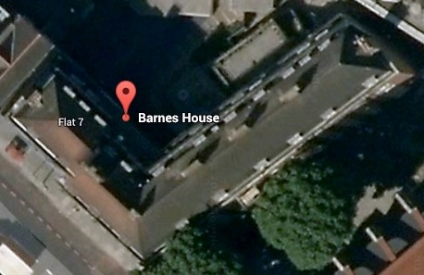

Front Elevation

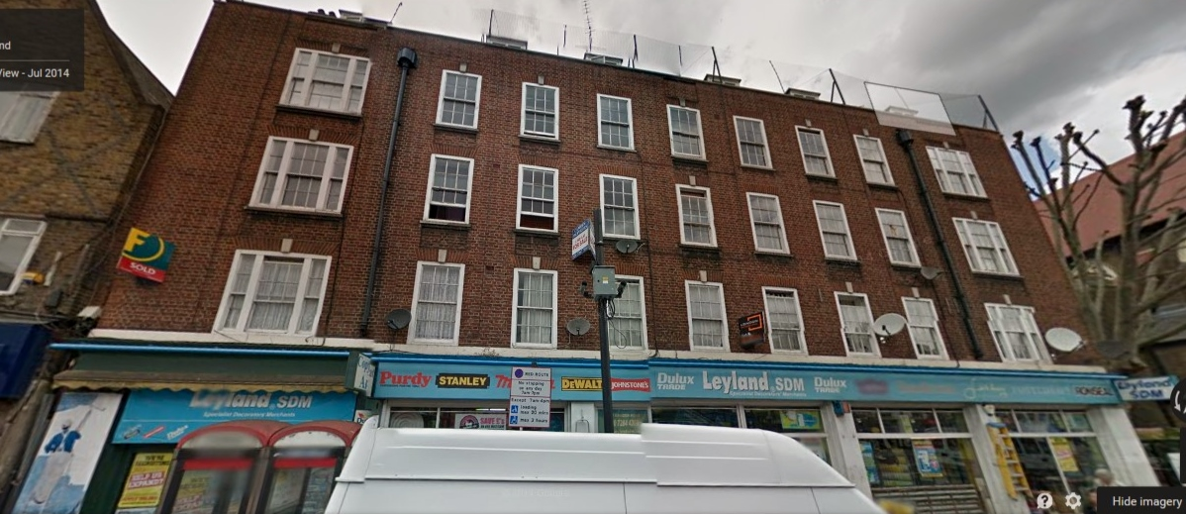

Side Elevation

