29 May 2015

Appendix 01 – Photographs of existing site

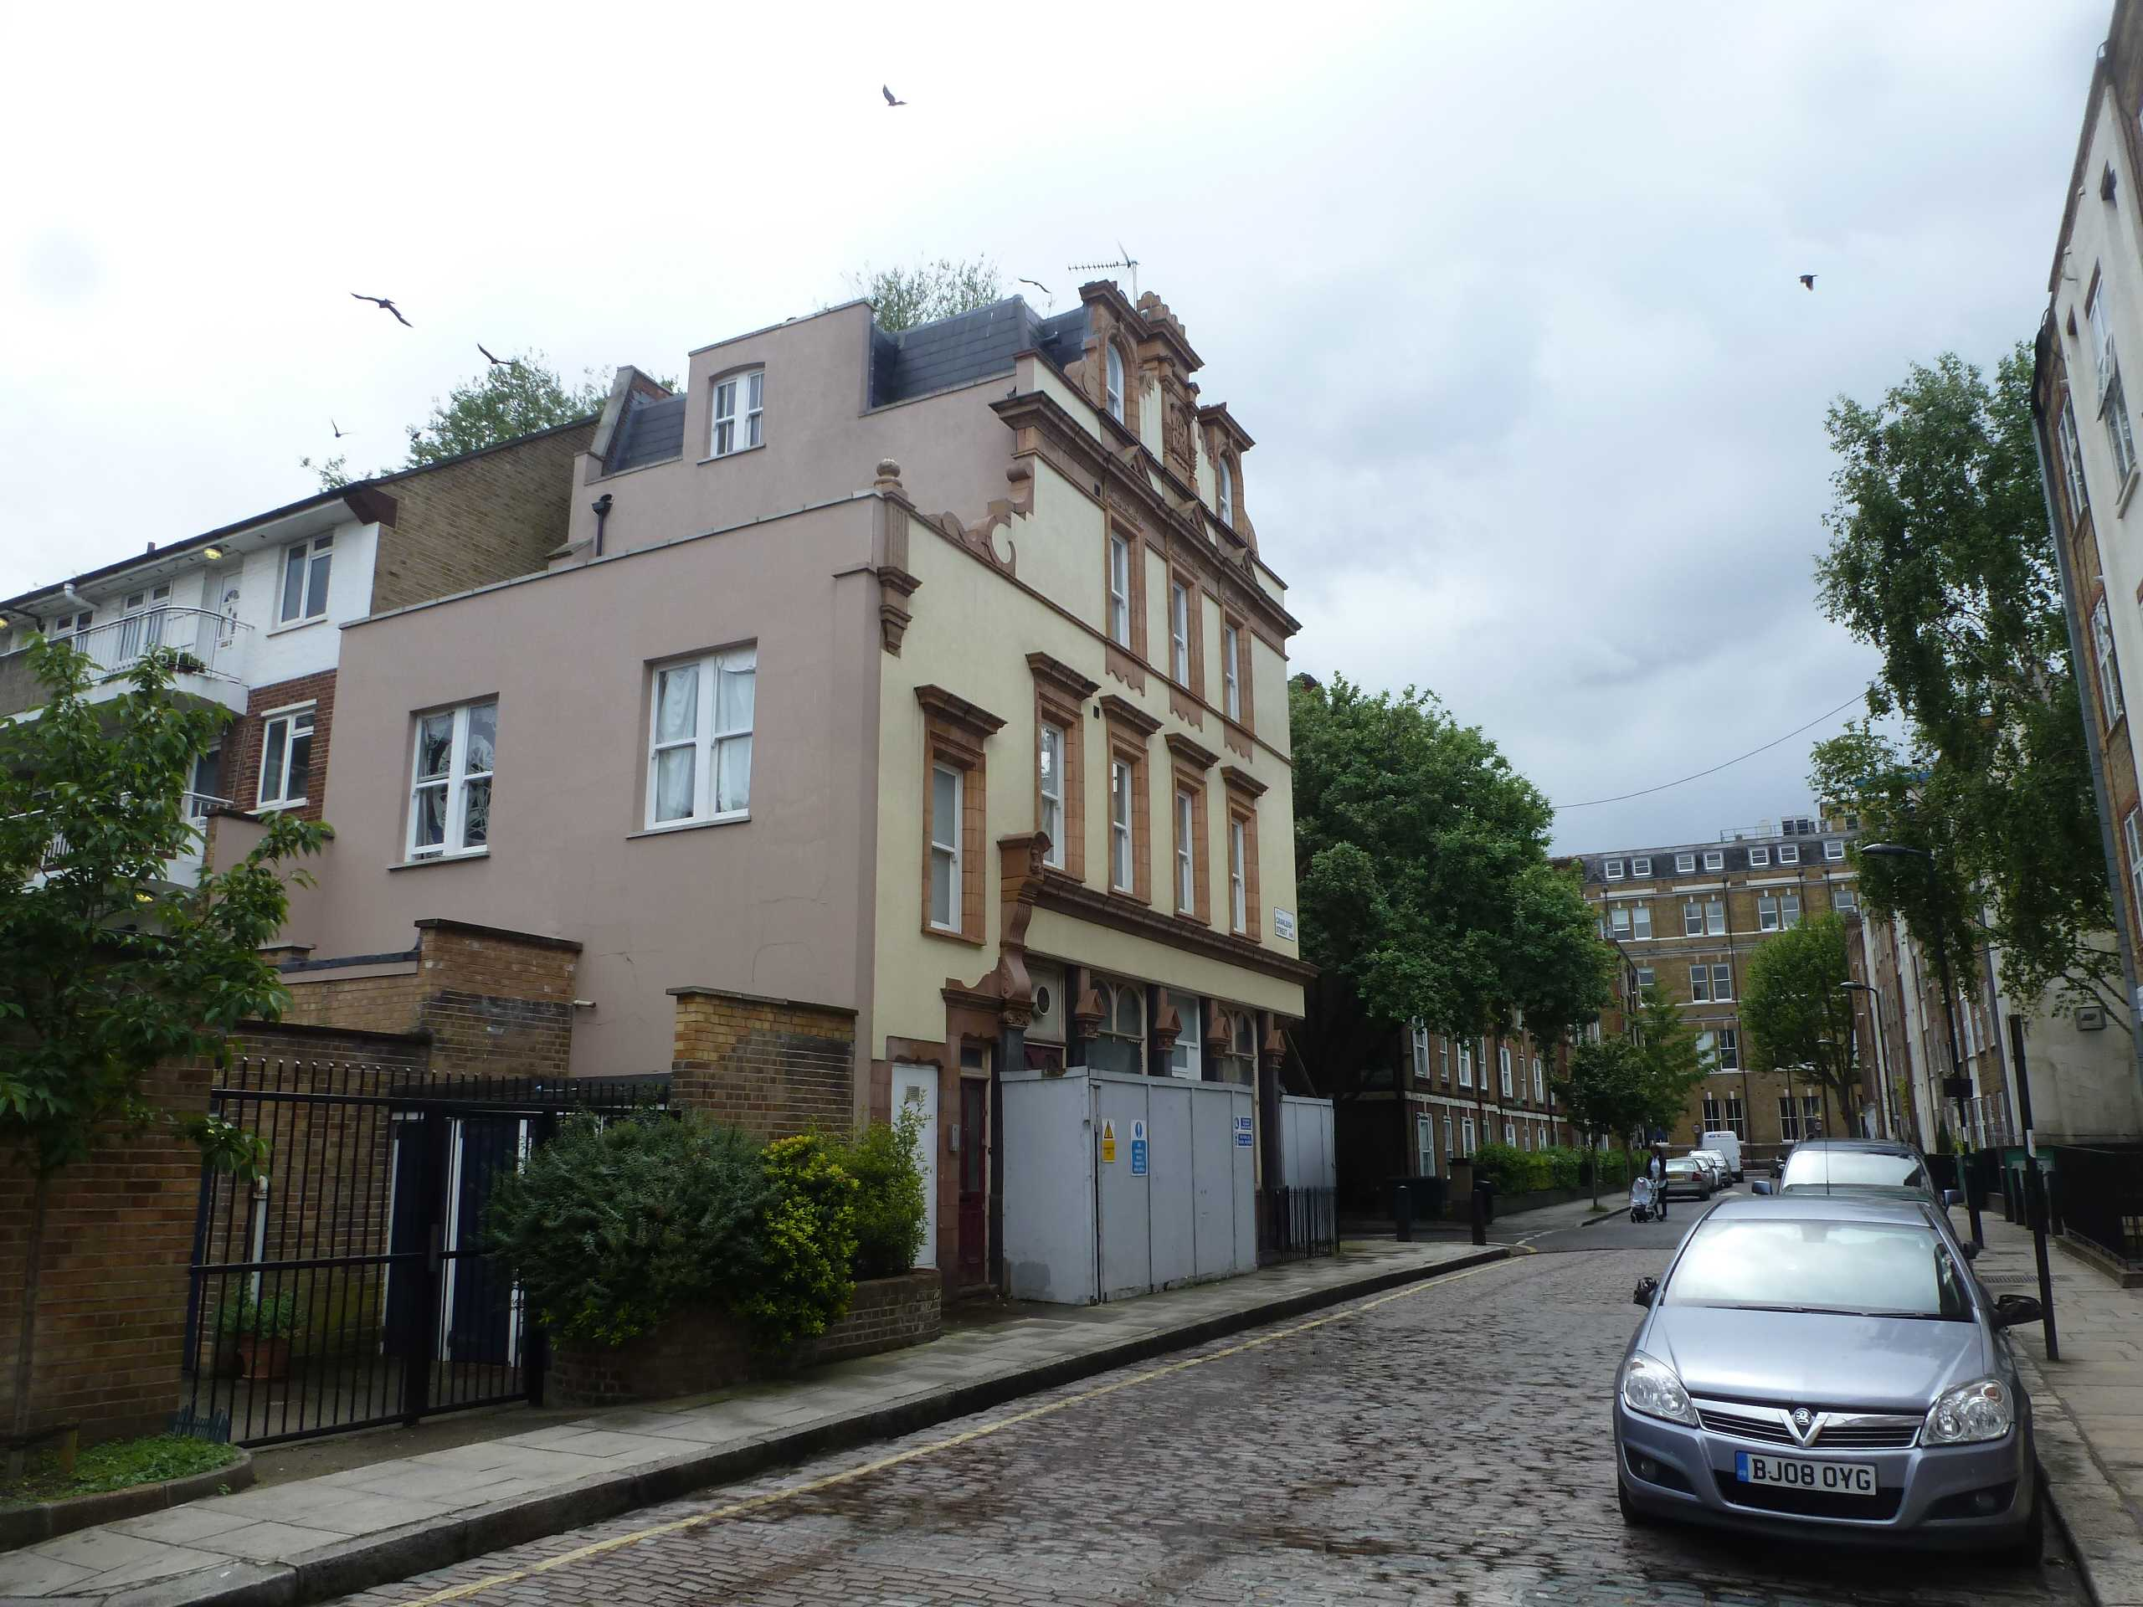
View towards application site from North-East of the site on Cranleigh Street

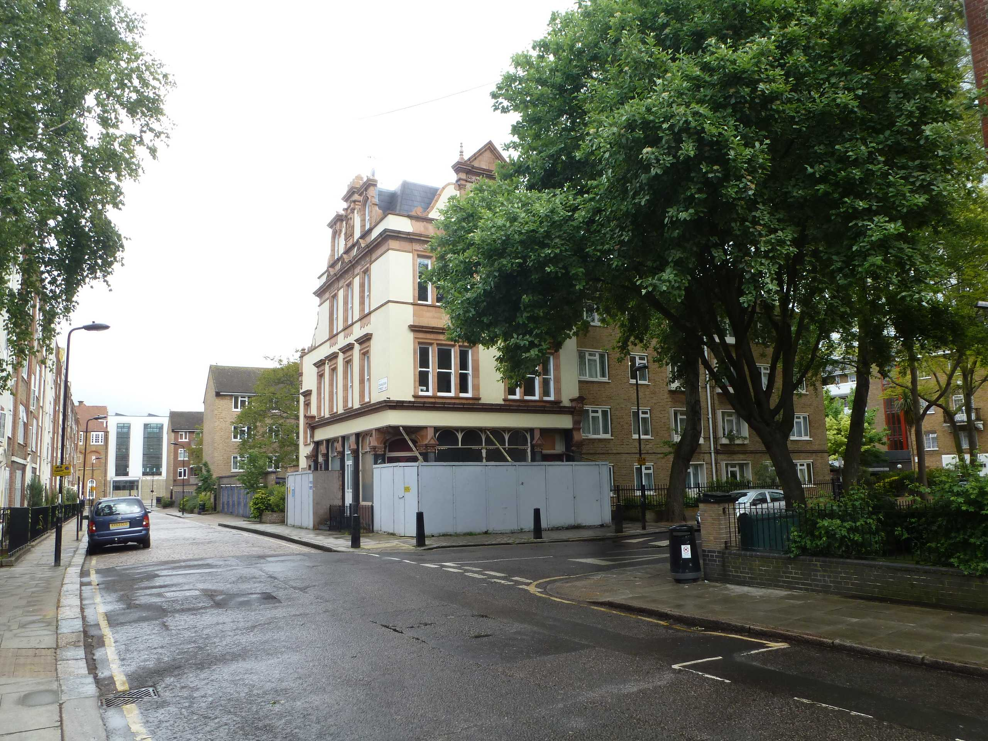
View towards application site from South-West of the site on Cranleigh Street

