Contents:

Introduction p 1

Context/ Conservation area p 2

The Site p 2

The Existing House p 2

The Proposal p 3

Design p 3

Materials p 4

Impact on neighbour p 4

Environmental Considerations p 4

Access p 4

Heritage p 4

Introduction :

This Design and Access Statement has been produced by Marie-Louise Martin on behalf of my clients Sarah Owens and Nigel Price.

It aims to describe the design for proposed alterations to 7 Tanza Road in support of our Planning Application made to the London Borough of Camden.

Site:

7 Tanza Road

London NW3 2UA

Agent:

Marie-Louise Martin

10 Francis Terrace

London N19 5PY

Tel: 020 7272 8057

Email: [munch.mart@btinternet.com](mailto:munch.mart@btinternet.com)

Applicant:

Sarah Owens and Nigel Price

7 Tanza Road

London NW3 2UA

Context/ Conservation area:

7 Tanza Road is a Victorian semi-detached property in the Parliament Hill, Tanza Road and Nassington Park Sub Area of the South Hill Park Conservation area. Tanza Road was originally laid out in 1890.

The area is characterized by substantial red brick semi-detached houses in the Victorian Gothic Revival Style with steeply pitched roofs, tudor chimneys and rustic porches

The Site:

Tanza Road is on slope. The front door is a half storey above street level.

The site slopes down to the rear and there are steps down along the side elevation of the property to lower ground level where there is a second entrance door. The front garden has a flowerbed sloping down to a retaining wall in front of the lower ground bay window. The rear garden is at lower ground floor level and is mainly lawn with some flowerbeds

The back garden backs on to Hampstead Heath, which can be accessed through a gate in the garden wall.

Existing House:

7 Tanza Road is a well maintained 4 storey red brick semi-detached house.

The front façade has a three storey bay and steps up to the front door. The rear façade also has a three storey bay. The roof is tiled in grey slate.

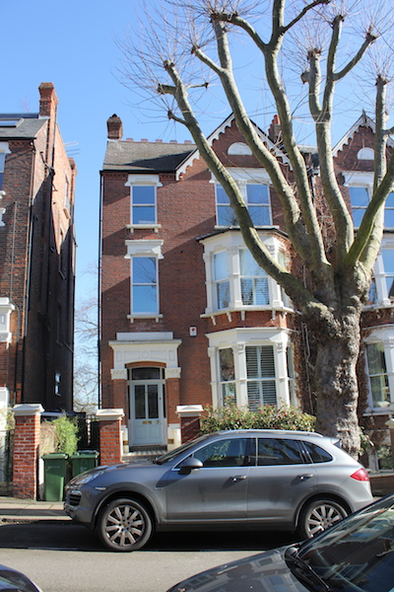

Front of 7 Tanza Road. The proposed extension will not

be visible from the street

The Proposal:

We are proposing the following:

1. Enlargement of existing rear window
2. Erection of a single storey lean-to shed at lower ground floor level in passageway between side of house and boundary wall.

Design:

Our aim is to improve the amenity of the lower ground floor by lowering the sill of the existing window, thereby increasing the amount of natural light in the lower ground floor. We are proposing to lower the sill to line it up with the sill of the bay window.

We feel that in addition to the increased natural light, the rear elevation will look more balanced as a result. The window will be a white painted timber sash window to match existing. We are not proposing to change the width.

The proposed infill shed in the passageway between the house and the boundary wall will provide storage for bicycles and garden equipment and furniture. It will be subordinate in height to the existing garden wall.

It is modest in size, 1.1m wide and 5.9m long and will be set back from both rear and front facades.

It will have timber doors at either end with a glazed panel above. The zinc roof will slope down from the side of the house to the boundary wall where a gutter will drain away rainwater. 3 flush roof lights will bring natural light in to the shed. We are proposing to paint the timber facades at either end grey to match the zinc roof. Being at lower ground floor level it is largely hidden from view from the street as shown in drw no 15.

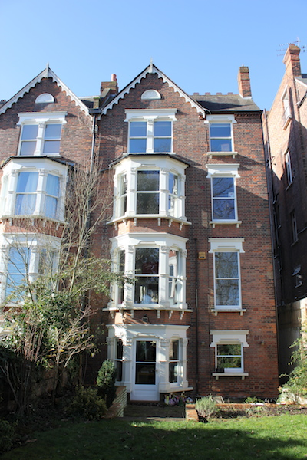

Rear Elevation

Materials:

The window in the rear façade of the house will be a white painted timber sash window to match existing.

The shed will have white-painted timber doors at either end with a glazed panel above. The roof will be grey zinc and slope down from the side of the house to the boundary wall, where a gutter will drain away rainwater. 3 glass roof lights will be inserted in the roof. The two facades of the shed are identical, but the front façade will only be partially visible from the street as it is at lower ground floor level.

Impact on neighbours:

The proposed alterations will have no impact on the neighbours

Environmental considerations:

No loss of planting/biodiversity as the shed is sited where it is currently paved.

Access:

We are not proposing any changes to access to the house from the street. It will still be possible to walk through the proposed shed from street to back garden.

Heritage:

Our choice of materials, the scale and detailing of our proposal has been informed by local policies and guidance including South Hill Park Estate Conservation Area Statement

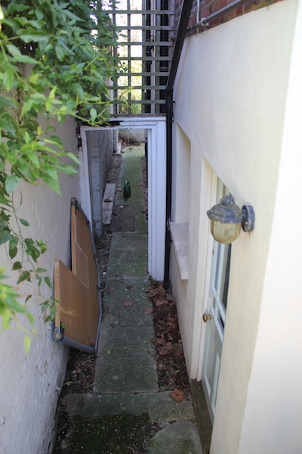

Passageway