Context

The existing property is a two storey lower ground and raised ground 3 bedroom unit of a 3 storey dwelling located on 26A Leighton road, Nw5 2QE.

The maisonette has a garden with sole use. At the moment the garden access is possible via walking through a long corridor on the raised ground level, down a staircase, a walk trough a corridor on lower ground floor and then through (a child’s) bedroom 3 where a patio door opens onto a flight of stairs leading up to the garden. This makes the access very awkward and considerably puts limitation where access could be much more simple.
The garden is kept in great condition and very well looked in order for the children and the adults to spend as much time as possible outside.
The building is grade 2 listed and therefore works carried out will need to take that into account to make sure the integrity of the building and overall looks are preserved.
It is our intention to provide a balcony and stair to the rear of the property from our raised ground floor level to access the rear garden. The proposal is to open up the kitchen window (raised ground) and convert it into a door.

Stairs to the garden
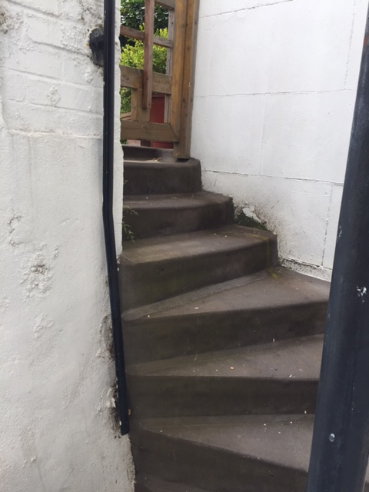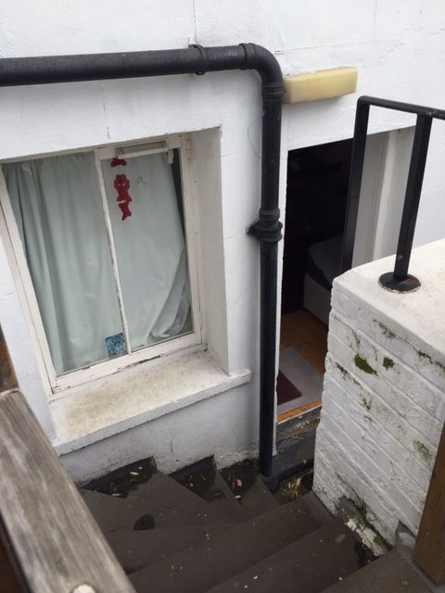

Design
The stairs would allow to get direct access to the garden. The actual work required is minimal and doesn’t involve endless disturbance for the neighbours. The balcony is planned to have a metal structure with metal railings to echo the one already in place in the stairs coming from bedroom 3.
The balcony is set to be 2.75m wide which the width of the house and therefore looks completely integrated to the building. It comes out 2m.
The bacony sits 1.30m above the garden.
On the balcony we are planning to put planters giving privacy to us and to the neighbours and designed as a response to the garden setting. A treillis should also be fitted (like the one on the opposite side) from the floor (1m from the top of the brick wall) and planted with beautiful climbers providing flowers and that way keeping the local butterflies and bees happy.
The door fiitted to replace the window will be timber with double glazed panels keeping the goergian style.
The railing should be metal, simple and blending with the rest.
The design is taking into consideration paragraph 3.5 of the planning policy guidance 15. This is why we are planning to keep the design simple and chose the materials listed above (metal railing, metal structure) to keep its original architectural features.

Proposed rear balcony+door
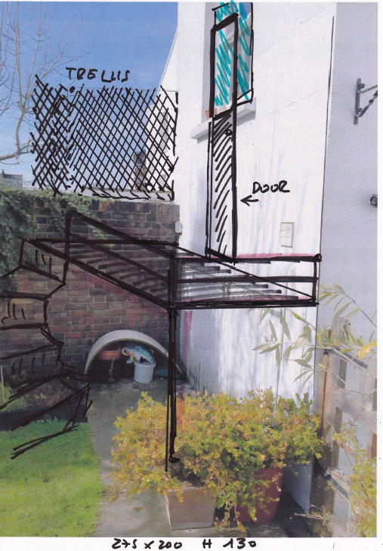

Current rear
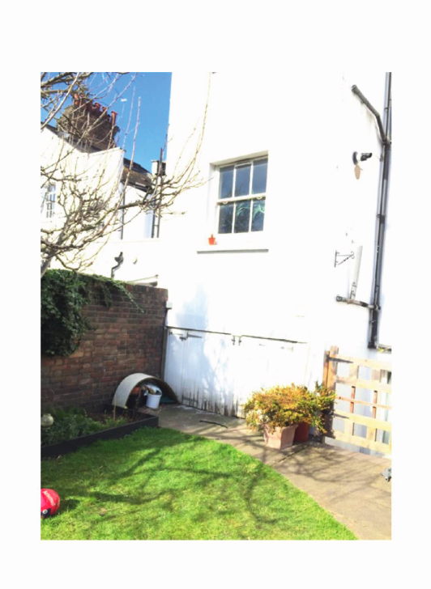
Current 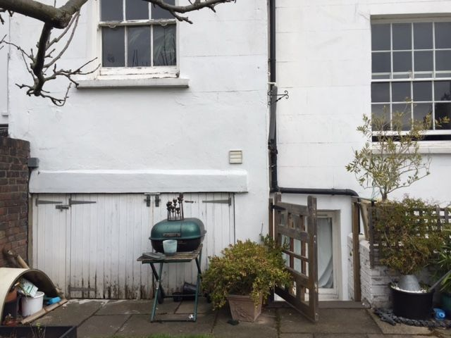

Access
The entrance of the site will be via our front door on 26A Leighton road which is the entrance used whenever we or the neighbours had some work done in our respective flats. The site itself will be the garden of which we have sole use and the front door will only be used for the builders to come in and materials to be dropped off.

