Design and Access Statement 18.05.15

For and on behalf of the families who are jointly lodging this self-build planning application:
Sarabhai (No.4b), Maclean (No.4a) Patel (No.4), Coventry (No.2b), Wolman (No.2a) and Hayman (No.2)

Reference: See attached renders and photographs of site and neighbouring buildings on document: (15exist_photos.pdf)

Principles: A self build development for the addition of living space in a low rise terrace overlooked by much larger neighbours. The new addition is set back to preserve the unified facade of the terrace. New rear extension to house 4b to match the design of no.4a. The replacement of current rear extension on no.4 with an extension to match 4a (granted planning permission in 2010)

Concept: The creation of a sympathetic addition to the existing terrace.
Sustainability: All replacement and additional glazing to be fully insulated. New roof to be fully insulated to modern standards with the preferable addition of solar power at individual owner’s initiative.

Use: Additional bedrooms and bathrooms.

Layout: All existing rooms retain their current usage. bedrooms on the top floor provide additional accommodation. Each top floor can benefit from an additional bathroom. There is no change to the public spaces.

Scale: The current buildings form a 2 storey terrace. All the neighbouring buildings (both old and new) are at least 4 storeys and in some cases 5 or 6 storeys. see (15exist_photos.pdf) The roof extension is set back from the front of the terrace to reduce its scale. The daylight study demonstrates that the extension does not deprive the neighbours of daylight.

Appearance: see photographs (15_exist_photos.pdf)

Existing: see (06_A0_exist_stelev1_50.pdf)
The existing buildings feature brick, painted render and either steel frame glazing or PVC to the front facade. The rear facades have steel or PVC glazing, brick and brick with a white render finish to the upper floor. Internal walls are constructed form breezeblock. There are also wooden and glass doors to front and rear.
Proposed: see (07_A0_prop_stelev_1-50.pdf)
The new build would use complimentary materials: double glazed steel frame windows (W20) finished charcoal grey. The new roof extension facade would be zinc with crittal style double glazing (W20) on the 2nd floor. The new party walls on the second floor will be of lightweight breezeblock. The end of the terrace at east and west elevations would be clad in zinc. The rear façade would also be clad in zinc. Each alternate west interior wall would be sound insulated.

Landscaping: The front of the existing buildings will remain unchanged.

Access: Access to the building will remain unchanged.

IMAGES (late afternoon, summer) For other renders see Daylight Study.
3d computer model rendering BEFORE

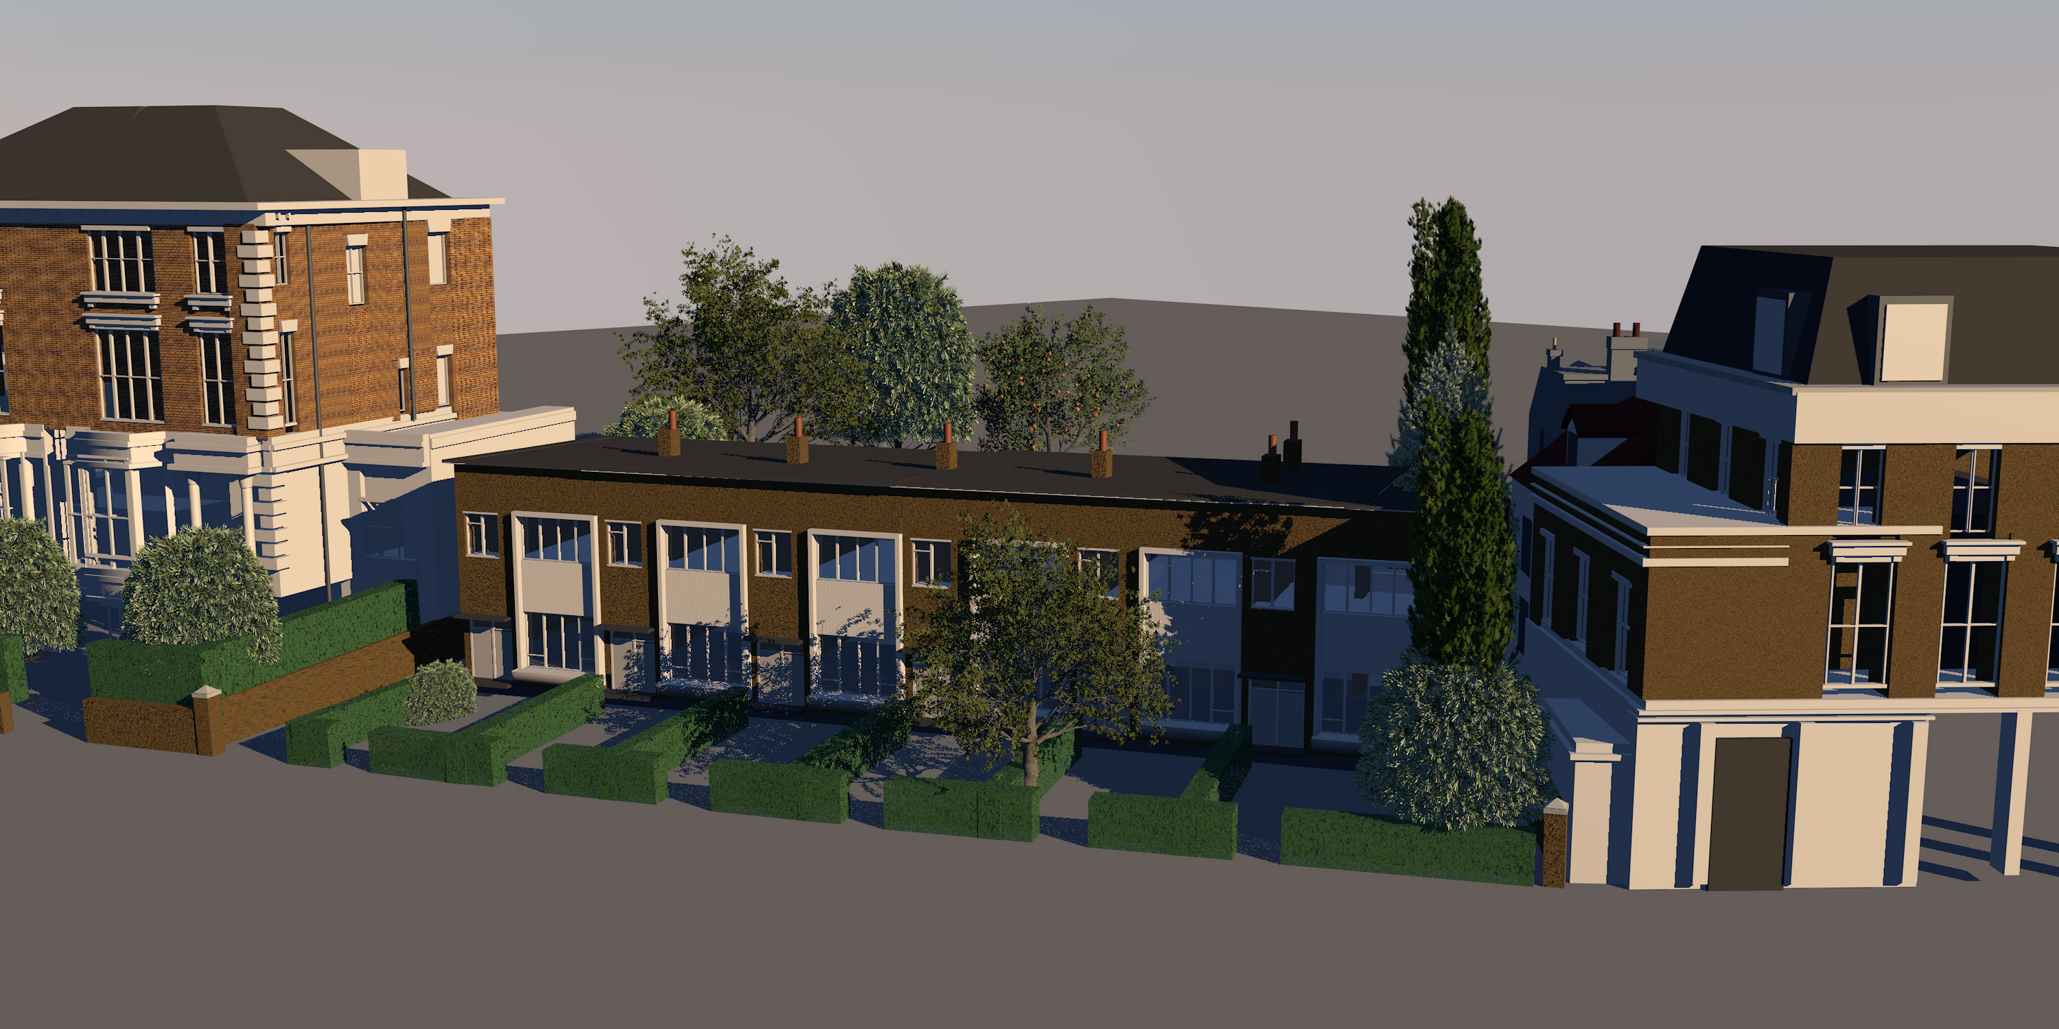

3d computer model rendering AFTER

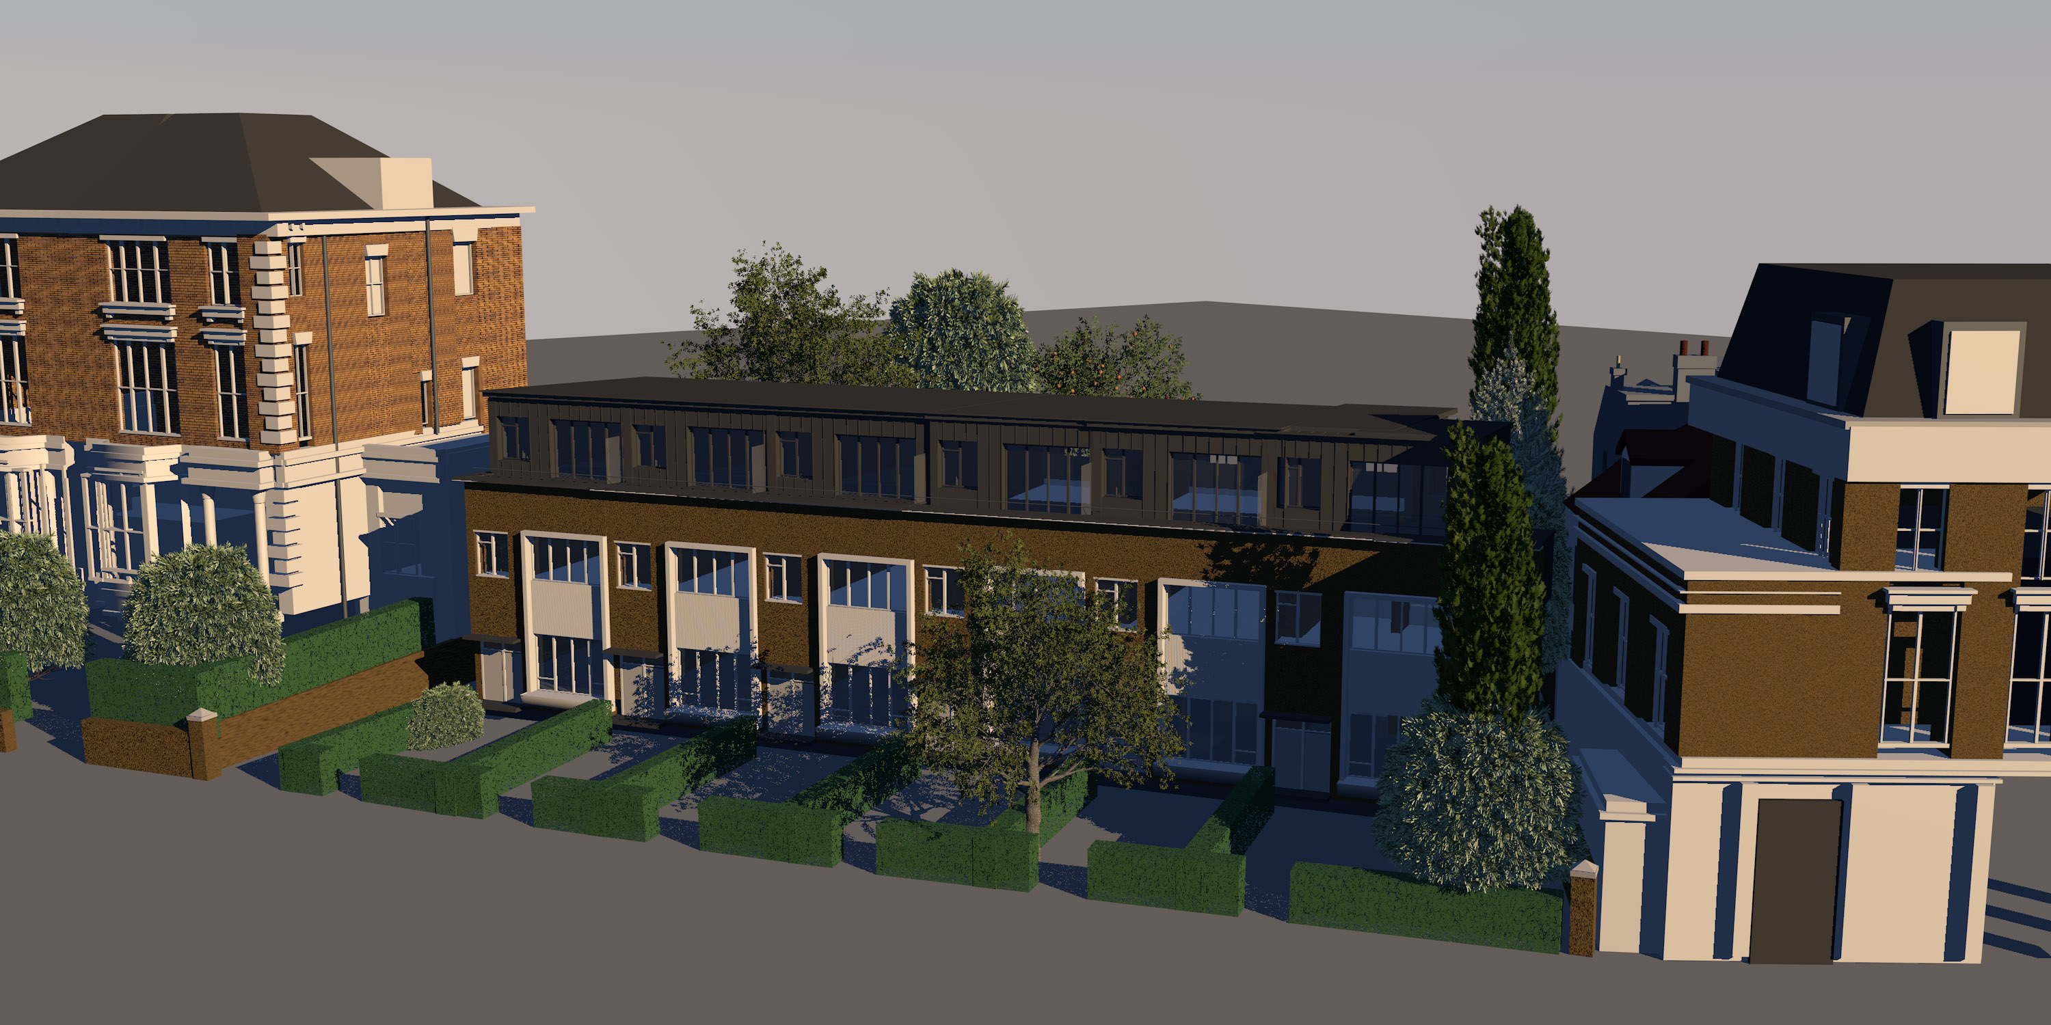

Alex Maclean, 4A Upper Park Road, Belsize Park, London NW3 2UP.
Tel 07973 669 748

For and on behalf of the families who are jointly lodging this self-build planning application:
Sarabhai (No.4b), Maclean (No.4a) Patel (No.4), Coventry (No.2b), Wolman (No.2a) and Hayman (No.2)

