***Objection to application 2015-1858-P at 253 Royal College Street***

1. **The pre-ap advice lacked attention to the proposed change of use**

The application form Pre-Ap advice (11/09/2014) stated:

*I can confirm that providing that you application is not contrary to planning policies and guidance*

This appears to have been incorrect advice from the Council. No attention has been given to Camden’s policies for protecting local business.

Compare, for example, the refusal (2012/0289/P, 182-DN-2986972.pdf) of 182 Royal College Street (in Camden Broadway Conservation Area) which says:

Reason(s) for Refusal

“The proposed change of use from Class B1 business to Class C3 residential, by reason of the loss of a commercial unit and the introduction of an inappropriate non-retail use within a town centre and the consequent creation of an inactive frontage, would be detrimental to the local character, function, viability and vitality of the Royal College Street Neighbourhood Centre. The proposal is therefore contrary to policy CS7 (Promoting Camden's centres and shops) of the London Borough of Camden

Local Development Framework Core Strategy and policy DP12 (Supporting strong centres and managing the impact of food, drink, entertainment and other town centre uses) of the London Borough of Camden Local Development Framework Development Policies.”

[Change of Use by prior approval was subsequently given in 2013 for this property, but this was an incorrect decision under the then existing legislation, see EN15/0300, and now contrary to Camden’s change of use policies.]

2. **Camden Road neighbourhood**

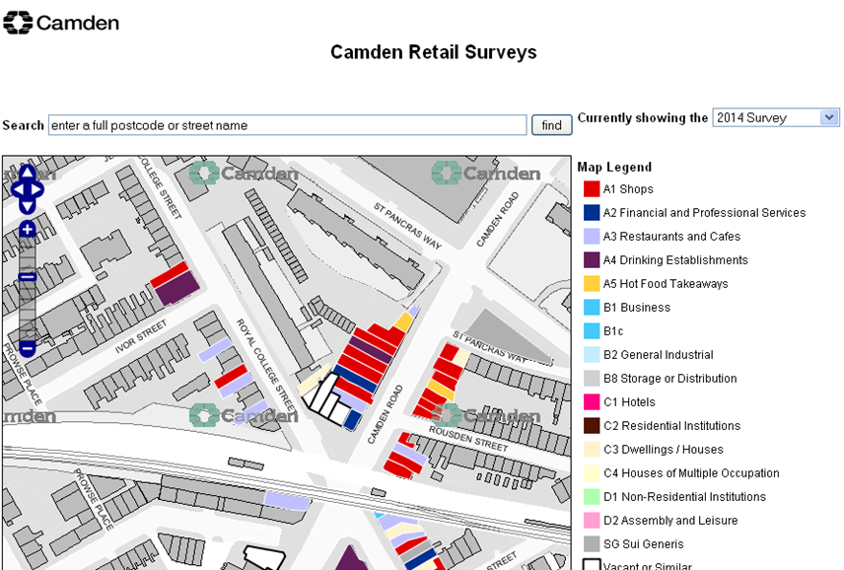

The property lies within Camden Road neighbourhood centre and is designated A1.

Camden’s Retail and Town Centre Study in 2013 noted:

* The Government supports community involvement in the redesigning of their high streets to reinvigorate areas of decline, to increase footfall and encourage people to live in their town centres.
* The London Plan requires LPAs to identify town centre boundaries, primary and secondary shopping areas and set out policies for each type of centre, and also identify smaller centres to provide neighbourhood centres to serve day to day shopping needs. Declining centres should be managed proactively, considering the scope for consolidating and strengthening centres and promoting diversification.
* The GLA Town Centres SPG encourages town centres to develop their strengths to fulfil their strategic role and potential. Where retail assessments identify retail capacity, local plans should facilitate the extension of the retail offer.
* Policy DP10 sets out the Council’s ambition to encourage the provision of small shops. Independent occupiers must be encouraged through affordable rents. Councils will also resist granting planning permission for the net loss of retail floorspace outside designated centres.

3. The property is within Camden Town place planning area

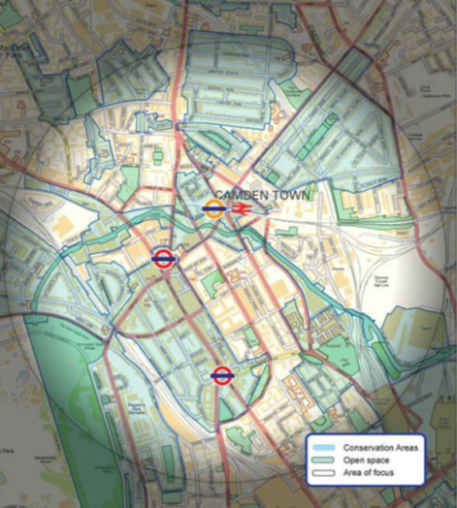

Camden Town Place Plan (2010, 2013) emphasises the importance of Camden town for the economy (22 000 jobs), its role for retail shopping and also its heritage assets.

The area is characterised by a varied built environment with a large number of historic buildings and built heritage.

*Maintaining a balance of uses and activities is essential to retaining the area’s attractiveness as a place to live, work and visit*

Camden Town Unlimited area includes the northwest side of Royal College Street.

**4. Camden’s own policies support independent shops.**

CPG5. Camden will use planning conditions and / or s106 planning obligations / legal agreements to support the provision of affordable shop premises suitable for small or independent retailers. The priority will be for shops in the A1 use class.

In Camden’s **Draft Local Plan** (TC2)

d. *support and protect Camden’s Neighbourhood Centres, markets and areas*

*of specialist shopping, local shops*;

*We will resist schemes that would result in more than three consecutive premises being in non-retail use*.

*We will also take into account any history of vacancy in shop units and the prospect of achieving an alternative occupier for vacant premises*.

In Policy TC3 Protecting shops outside of centres

*The Council will seek to protect shops outside centres.*

*We will only granting planning permission for development that involves loss of a*

*shop outside designated centres provided:*

*b. there is clear evidence that the current use is not viable;*

5. **Heritage.**

Royal College Street, laid out 200 years ago before Camden Road, is historically the centre of Camden Town. The 1850 station was originally called Camden Town, and current maps (see Camden’s Place map above) show Camden Town at this point.

In the Conservation Area Statement, 253 Royal College Street is included in the list of buildings that make a positive contribution to the Conservation Area (p17).

As a shopping street, the houses *did not have front lightwells*. Some have been subsequently introduced, but this has been contrary to Camden’s policy for Jefferys Conservation Area. Entry to the lower ground floor (eg at the back) should be by the ground floor entrance – ie the shop entrance.

The Conservation Area Statement says

JS1 Extending into basement areas will only be acceptable where it would *not involve harm to the character of the building or its setting.*

This is locally important, as character has been an accepted criterion for refusal of lightwells in adjacent Camden Broadway conservation area.

6. **The application is inadequate**

The Application claims that the shop’s net tradable area to be lost is 24.5sqm and ‘other’ non-residential floorspace of 60.5sqm, with a total site area of 110sqm. This does not seem right. The two upper floors are already residential; the ground and lower floors are for the shop.

No evidence is provided that the site is not commercially viable. The shop was trading as a newsagent in 2014 and shows on Camden’s Retail Survey. *There has been no attempt to let the property commercially.*

It is proposed to lower the existing storage to form a new basement for habitation. No consideration is made of Camden’s basement policies (eg basement impact assessment requirement), nor is there any building schedule – it is likely that there are no existing deep foundations in this Georgian building.