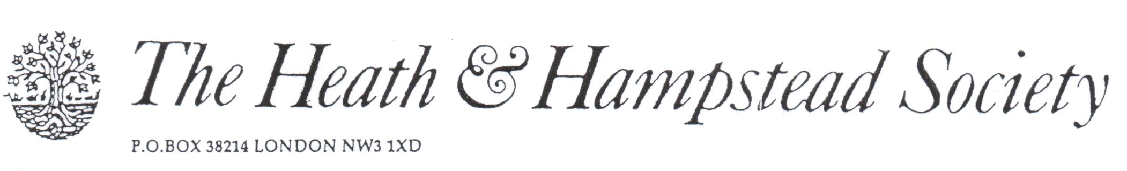
The Society examines all Planning Applications relating to Hampstead, and assesses them for their impact on conservation and on the local environment.

To London Borough of Camden, Development Control Team

Planning Ref: 2015/2264/P
Address: 77a Fitzjohns Avenue, NW3
Description: Roof terrace.
Case Officer: Ian Gracie Date 6 May 2015

This proposal is unacceptable, for these reasons:

1. Roof terraces customarily lead to objectionable overlooking of neighbouring properties, and this is no exception. It would cause loss of privacy and noise pollution to houses, school premises and gardens to the South of the site, in contravention of LDF Policy DP26. The size of the terrace is such that quite large numbers of people could use it, for parties and similar noisy activities.

2. It would harm the architecture of this particularly interesting Locally Listed house, destroying the symmetry and general composition of its South East and South West elevations.
Part of the house’s interest is in its unusual narrow-guage brickwork. Such bricks are not made as standard these days, and would need to be sourced specially. There is no mention of this necessary fact in the application.

Please refuse.

