Historical report and design statement for Ye Olde Swiss Cottage Public House, 98 Finchley Road, St John’s Wood, London, NW3 5EL.
SWISS COTTAGE AND ITS HISTORY
The Hampstead portion of the St. John's Wood or Eyre estate, low-lying and not easily accessible, never attracted seats as Belsize had done and even the farm buildings lay on the Marylebone side of the border. The Eyre family was, however, always anxious to promote building and in 1794 a plan was drawn up on the model of Bath, with a crescent, circus, and square. The plan was never executed, probably blighted by the French wars, but from 1802 development on the Eyre estate was directed by John Shaw, a young architect inspired by the town-planning ideals of the late 18th century. In 1803-4 he exhibited views of a projected circus and in 1807 building began on the Marylebone portion. In 1819 Col. Eyre began the first of several attempts to promote the construction of a public road through his estate, ultimately successful in the Finchley Road Act of 1826. Finchley New Road and Avenue Road, the southern part of which existed by 1824, thrust northward into the Hampstead portion of Eyre's land and were built by 1829.
Swiss Cottage is a district of the London Borough of Camden in London, England. The district is located 3.2 miles (5.1 km) north-west of Charing Cross. It is centred on the junction of Avenue Road and Finchley Road and is the location of Swiss Cottage tube station.
The district formed part of the ancient parish of Hampstead. It developed following the Finchley Road Act 1826, which authourised construction of Finchley New Road and Avenue Road, with The Swiss Tavern built at the junction of the new roads. The neighbourhood around Finchley Road and Avenue Road was redeveloped in 1937 and 1938 with the opening of an Odeon cinema and the Regency Lodge flats. After World War II, local authority housing was constructed by the London County Council in the area.
YE OLDE SWISS COTTAGE PUBLIC HOUSE
“Probably the best known bit of Switzerland in Britain”, the Swiss Cottage pub was built in about 1830 by T. Redmond, a former prize fighter. His family owned the premises until about 1880. The building stood next to a toll gate which took money from coaches and other travellers wishing to use the Finchley Road who would stop to be refreshed at the tavern whilst waiting to pay their fees.
From 1840 onwards the area as we know it literally grew up around the pub. In 1850 it became the northern terminus of the General Omnibus Company’s line to London Bridge. In 1868 an underground railway station was opened and named after the pub.
There had been a gabled building on the site called Lausanne Cottage, which is said to have been used by Charles II as a hunting lodge.
The Swiss chalet look, with low pitched roofs and decorative arching gables, had been made popular in the first half of the nineteenth century by an opera, “The Chalet”, which became a great favourite of Queen Victoria. This type of exotic, picturesque building enjoyed a short-lived fashion. Prince Albert built a full-sized chalet in the grounds of Osborne House, on the Isle of Wight, where his children were taught carpentry or cookery and entertained visitors to tea.
By 1902 the pub had become known as Ye Olde Swiss Cottage.
The building was reconstructed in 1965 in the style of a Swiss chalet or cottage. The road to Finchley in Barnet passes through here and the area is usually referred to as Finchley Road and has also given that name to the nearby tube station.

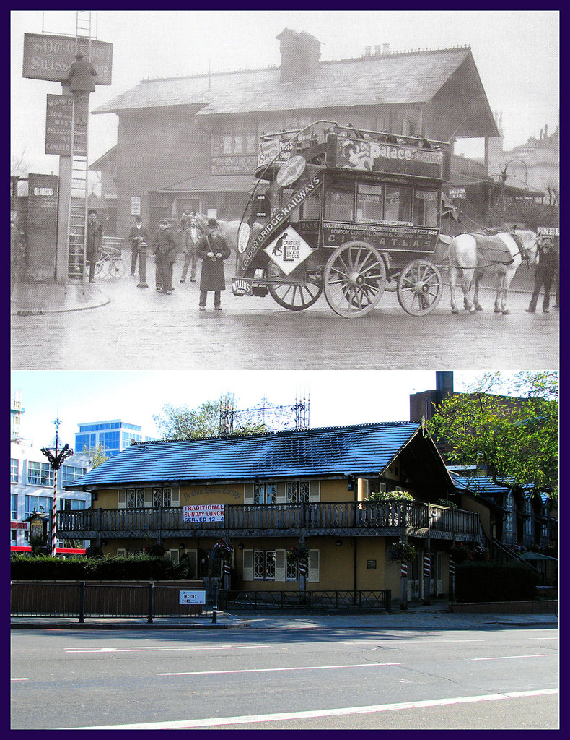
Ye Olde Swiss Cottage 1902 ( top ) and current view (bottom ).
The existing photograph (bottom ) shows the existing use of grey concrete roof tiles.

History of welsh slate use in London
There are many documents that talk about the “Hay Days” of Welsh Slate. London was the biggest domestic market driven by the mass migration from the countryside to the city and the following population boom at the end of the 18th Century. Welsh Slate was a light weight roofing material requiring far less timber than a clay roof, it was more fire retardant than thatch or timber shakes therefore ideally suited to roof a rapidly expanding city. The peak of production was probably around 1870 but serious volumes were being shipped around the coast to London from 1765 onwards. From 1790 a Duty was charged on slates being shipped around the coast and although this was initially an ad velorem tax it later became a 20% tax based on weight which is why the imperative for the London market became thin (4 to 6mm) large format slate i.e. 18” and bigger. When the duty was removed in the 1840’s the standard slate type for London was continued but thicker slates (7 to 10mm) did come in to the market.
From the 1890’s slate became less popular as clay tiles with different colours became more fashionable and more available through the developing railway network.
Proposed new works.
The proposal is the remove all the existing grey concrete roof tiles and ridge tiles that have over the years become too heavy for the structure of the building. To re-instate welsh slate tiles and grey fleurs de lys ridge tiles as depicted in the photograph of 1902. The ridge height to the single storey structure ( thought to be a later addition) as seen on the Avenue Road elevation is to be raised to meet the appropriate fall required for the installation of welsh slate.
Subsequently one existing casement window is to be replaced, this is noted on drawing no’s E004 and P004, style and finish of which is to match existing.
It is hoped that all documentation and historical evidence provided proves the original existence of welsh slate tiles and fleurs de lys ridge tiles to the existing roofs, and our application to reinstate the same meets with the approval of the local conservation committee , the conservation team and the planners at Camden Council.

