30 Swinton Street London WC1X 9NX

PLANNING, DESIGN & ACCESS STATEMENTS

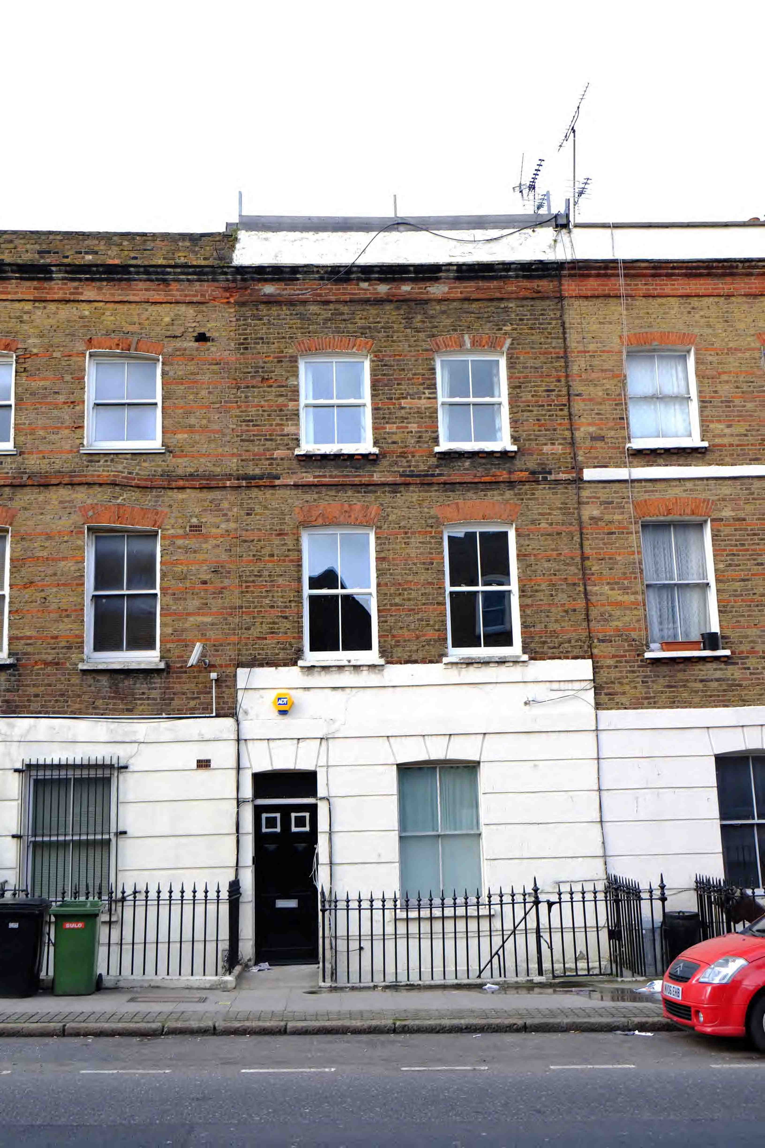

LOCATION & CONTEXT

30 Swinton Street is a terraced house south-east of Kings Cross Station and on the edge of Bloomsbury. It is in sub area 14 of the Bloomsbury conservation area.

PLANNING ISSUES

In this area the most significant development was between 1801 and 1844. Acton Street and Frederic Street to the south were built to the designs of William and Thomas Cubitt and are largely characterised by an overall consistency in height with features such as balconies, mansard roofs and dormer windows. The typology seen in Swinton Street largely conforms to this format but has been interrupted by post WW2 building to the western end.

Swinton Street has been defined in the Camden Planning Guidence as an area vulnerable to negative change and lack of maintenance as a result of the increased traffic from the busy thoroughfares of the westbound gyratory system between Kings Cross St Pancras and Gray’s Inn Road.

A number of other similar properties in the street have mansard roof extensions which are visible at street level.

The existing building whilst forming part of a streetscape is not listed or of any heritage value. The former London roof was converted to a flat roof terrace in the 1970s and was never expressed as such on the elevations.

PROPOSED WORKS

The proposal consists of a roof extension to the existing roof terrace to add an additional bedroom. A new mansard roof and dormer windows with openings aligned with the existing windows will be located at the rear of the extension. The front façade is set back from the road and out of the line of view from the street to avoid disruption to the consistency of the existing height of the terrace and, as it is not visible from the street, is of a more contemporary design.

The existing roof terrace is lawful as it may have been granted permission in 1978 but also because it has been in place for more than 4 years.

PLANNING HISTORY

Application number: 2011/3267/P
Date Registered: 07-07-2011
Description: Erection of a single storey rear extension and alterations to door, window and stair access to the front elevation of existing basement flat (Class C3)
Decision: Granted

Application Number: L15/12/D/27781
Date Registered: 14-12-1978
Description: Alterations to the roof to provide a flat roof in place of the existing valley roof.
Decision: Granted

DESIGN
The design is broadly traditional in character to the rear where is can be seen. The front which cannot be seen from a public place is more modern. It addresses issues of sustainability by having a green roof terrace and the new wall adjacent to the glazed doors to the front being a planted ‘green’ wall albeit on a small scale.

DISABLED ACCESS

The proposals do not affect disabled access.

CONCLUSION

The proposed extension is inconspicuous and is not apparent to the front of the building from the street. The roof was converted to a flat roof terrace in the 1970s and therefore the original butterfly roof element is not being lost.

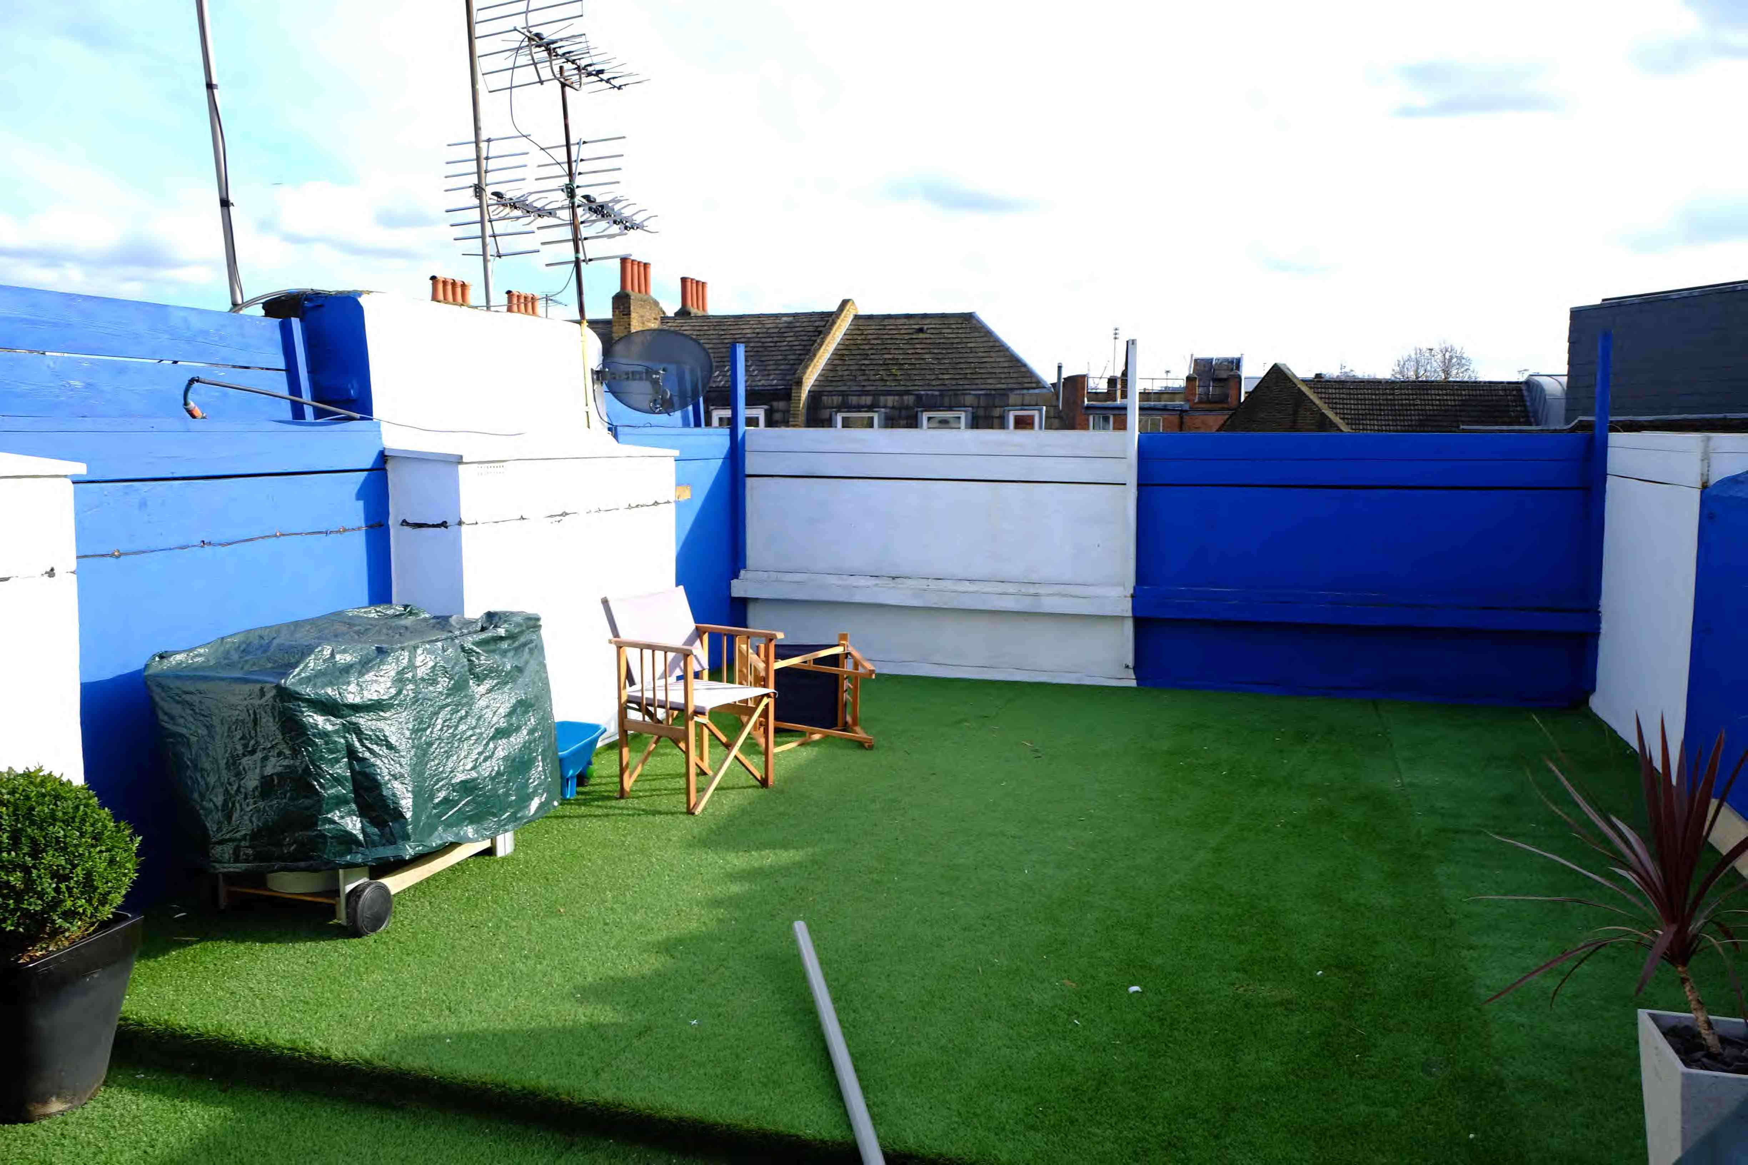
View of existing terrace

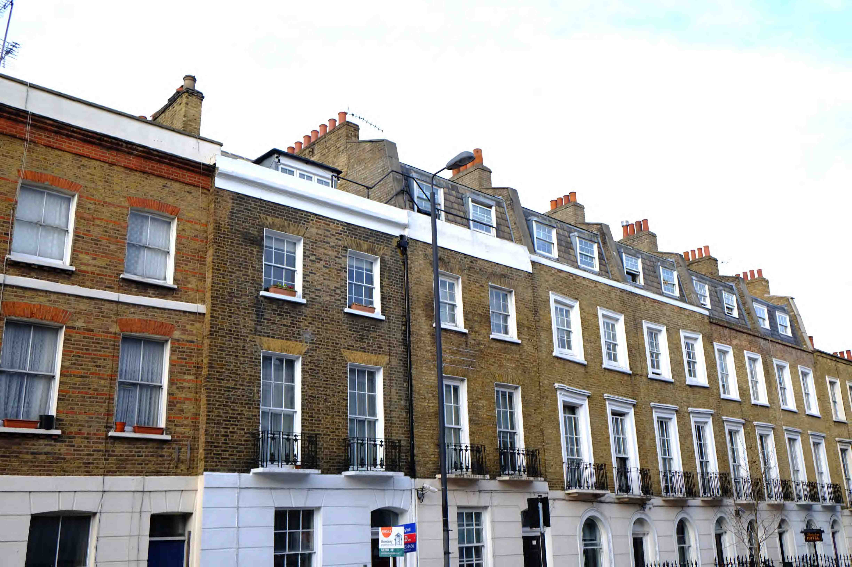
View along street

