PBA

DESIGN & ACCESS STATEMENT accompanying householder planning application for 65 PATSHULL ROAD, LONDON NW5 2LE

As far as they apply, this statement has been prepared in accordance with the headings and guidelines issued by DC-CABE.

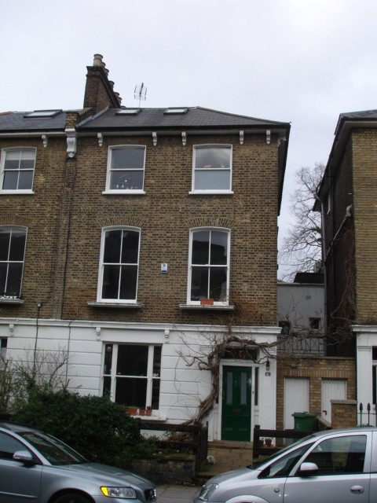

www.peterbradesarchitects.co.uk tel: 020 7226 3884
Peter Brades Architects, 42 Colebrooke Row, London N1 8AF

- USE

  - This is half of a semi-detached pair of houses typical of the street, in the Bartholomew Estate conservation area.

  - The proposal is to take down the existing rear extension and construct a new, full width rear extension at garden level and a half-width extension above. It is similar in overall shape and size to that approved at number 41, ref: 2012/4212/P.

  - There are some associated internal alterations and a side extension hidden behind the existing front screen and door. No changes to the street frontage are proposed.

- AMOUNT

  - The existing rear extension to be demolished is approximately 27.5 sqm internally; the proposed ground floor and 1st floor extensions are 65.5 sqm.

- LAYOUT

  - The overall layout of the house is retained. A new kitchen is formed on the ground floor and the extension is a ‘family’ room. The first floor extension above is for a new bedroom and shower room.

- SCALE

  - The scale is in keeping with its neighbours.

- LANDSCAPE

  - The main garden is not affected by the proposals. The areas infilled at the rear and in the front side passage are of low amenity value.

- APPEARANCE

  - The ground floor rear extension is subordinate to the main house and steps down at the boundary with number 63, to minimize its impact on that house. The fist floor extension makes use of the blank and somewhat forbidding side wall to number 67; its own side wall is enlivened by a blind window feature. The main material will be brickwork, to match the original house.

  - The large flat rooflight over the ground floor extension will incorporate blinds, to prevent light pollution.

  - The extension into the front side passageway is an extension to the utility area; it is single-storey and finished in white render, again to match that portion of the main house.

- ACCESS

  - Unaffected by the proposals.

Photograph follows of rear elevation.

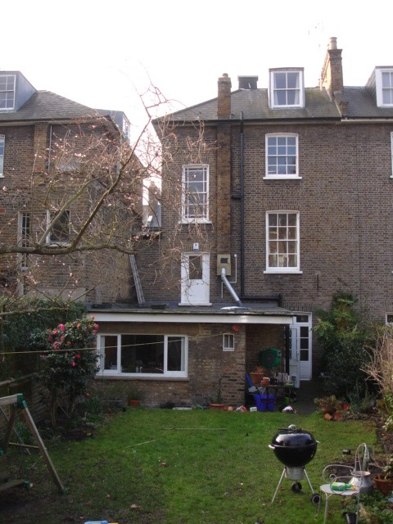

1683/PEB/March 2015

