**New Windows For 7B Greenland Road**

The proposed replacement windows are to be single glazed in order to replicate the existing.

7B Greenland Road has been made a grade 2 listed building due to the front of the building's ground floor cast-iron window guard, upper floors architrave with cornices to 1st   
floor along with cast-iron balconies to 1st floor windows and stucco cornice and blocking course.

The desire to leave this as it is with the least amount of change is paramount. My application to update the rotten and decaying white wooden sash windows is to help reduce the amount of noise and cold air which enters into the flat.

This will help with the environment (noise levels, energy efficiency). As Camden becomes increasingly popular and there is an the increase level of traffic and noise pollution, the desire to insulate the top floor rear bedroom from this is important and it is for this reason I am entering this application.

The plan would be to employ the <http://www.sashwindow.com/about-us> who are specialists in creating single glazed sash windows and will tailor make the window to be identical to the current windows.

**List Entry Summary**

**This building is listed under the Planning (Listed Buildings and Conservation Areas) Act 1990 as amended for its special architectural or historic interest.**

**Name: NUMBERS 7 TO 41 AND ATTACHED RAILINGS**

**List Entry Number: 1271387**

**Location**

NUMBERS 7 TO 41 AND ATTACHED RAILINGS, 7-41, GREENLAND ROAD

The building may lie within the boundary of more than one authority.

**County:**Greater London Authority  
**District:**Camden  
**District Type:**London Borough  
**Parish:**

**National Park: Not applicable to this List entry.**

**Grade: II**

**Date first listed: 14-Apr-1974**

**Date of most recent amendment: Not applicable to this List entry.**

**Legacy System Information**

The contents of this record have been generated from a legacy data system.

**Legacy System: LBS**

**UID: 477891**

**Asset Groupings**

This List entry does not comprise part of an Asset Grouping. Asset Groupings are not part of the official record but are added later for information.

**List Entry Description**

**Summary of Building**

Legacy Record - This information may be included in the List Entry Details.

**Reasons for Designation**

Legacy Record - This information may be included in the List Entry Details.

**History**

Legacy Record - This information may be included in the List Entry Details.

**Details**

CAMDEN  
  
TQ2983NW GREENLAND ROAD  
798-1/77/701 (North side)  
14/05/74 Nos.7-41 (Odd)   
and attached railings   
  
GV II  
  
Terrace of 18 houses. Mid C19, restored c1976 as a GLC   
renovation scheme. Yellow stock brick with rusticated stucco  
ground floor and plain stucco 1st floor band. Nos 11-21 and   
31-43 slightly projecting. 3 storeys and basements. 2 windows  
each. Square-headed, recessed doorways with pilaster-jambs   
carrying cornice-heads; fanlights and panelled doors. Recessed  
sashes; ground floor of No.7 with good cast-iron window guard,  
upper floors architraved: Nos 7 & 9 with cornices to 1st   
floor. Cast-iron balconies to 1st floor windows. Stucco   
cornice and blocking course except Nos 9, 19 & 21 and 37-41   
where the cornices have been cut back.   
INTERIORS: not inspected. SUBSIDIARY FEATURES: attached   
cast-iron railings with bud finials to areas.   
  
  
  
Listing NGR: TQ2904483935

**Selected Sources**

Legacy Record - This information may be included in the List Entry Details.

**Map**

**National Grid Reference: TQ 29051 83937**

The below map is for quick reference purposes only and may not be to scale. For a copy of the full scale map, please see the attached PDF - [1271387.pdf](http://gisservices.english-heritage.org.uk/printwebservicehle/StatutoryPrint.svc/247812/HLE_A4L_Grade%7CHLE_A3L_Grade.pdf)

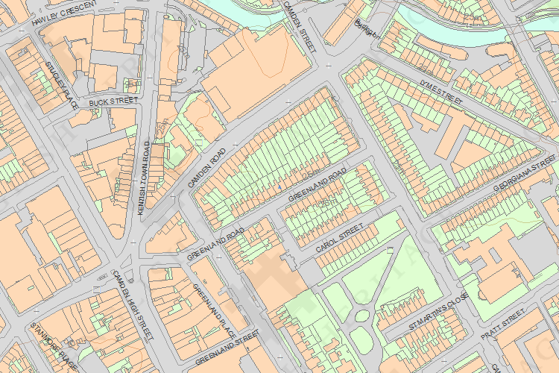  
© Crown Copyright and database right 2012. All rights reserved. Ordnance Survey Licence number 100019088.  
© British Crown and SeaZone Solutions Limited 2011. All rights reserved. Licence number 102006.006.

This copy shows the entry on 18-May-2013 at 09:59:52.