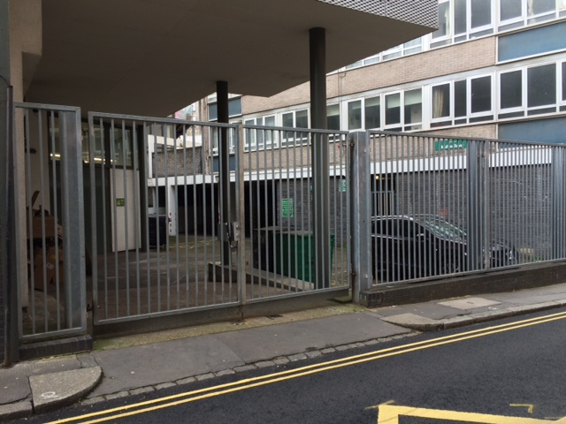
Photo 1 – General View of the Rear Car Park Area from Laystall Street
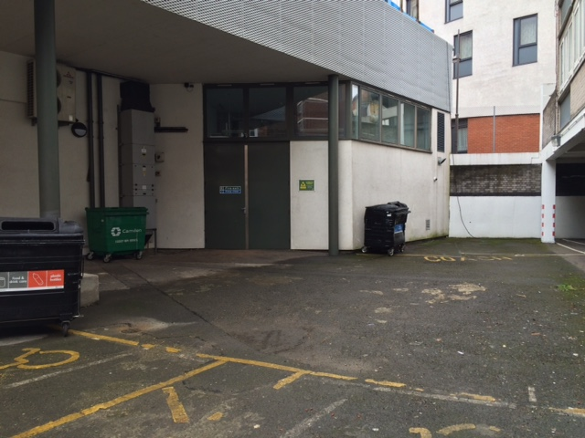
Photo 2 – Proposed location of the new buggy shelter, within the ‘Coach’ parking space

