2 Walham Court

111 Haverstock Hill

London NW3 4SD

March 9th 2015

West Area Team

Regeneration and Planning

6th Floor

Camden Town Hall Extension

Argyle Street

London WC1H 8EQ

**FAO: Mr Olivier Nelson**

**Town and Country Planning Act 1990**

**Application by CISCO Property Limited**

**England’s Lane Residence, England’s Lane, London, NW3 4XY**

**Application Reference 2014/7803/P**

Dear Sir

I am writing to register my strongest possible objections to the proposed development of the Englands Lane Residence (ELR), as described in the above planning application.

I support all of the points made by Roger Birtles, of Simply Planning, in his letter of objection of February 20th, pointing out the many discrepancies between the proposals and national and local policies and guidance. Many objections and comments made by local residents raise matters ignored or skipped over by the planning application which still require clarification.

First I would like to review some matters of particular concern to myself.

**Inadequate Public Consultation**

**Site Notices:**

The site notices which were intended to alert local residents and business people to the planning application were placed, or slipped, into locations where they would not be noticed by passers-by. (see photos below)

I had not seen the site notices locally and emailed the case officer to enquire. He replied with their exact locations, and I photographed them the next day, March 3rd. They are dated January 16, with 21 days to respond, meaning the response date was already three weeks overdue before I had even seen the site notices

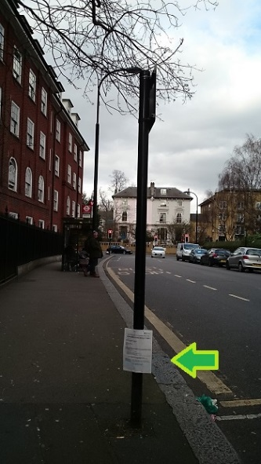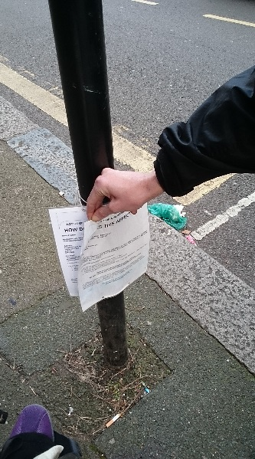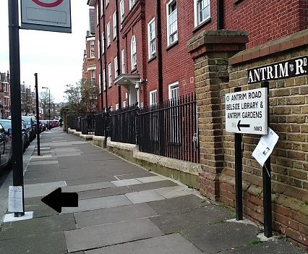

Englands Lane Englands Lane – 2 Antrim Road – fallen to pavement level

18in from ground copies one post

**Lack of Local Awareness**

An informal survey of local residents and business people on the afternoon and evening of Friday March 6th on Englands Lane and Antrim Road found that most people were not aware of the planning application. Almost all were willing to sign a petition requesting an extension or new start to the public consultation. Many said they could not use the internet sufficiently confidently to approach the Camden Planning website. Most said in any case they could not read plans.

**Lack of Consultation with Property Owners**

The notices of the planning application sent by Camden to local residents dated 9/1, were addressed to Owner/Occupier. Occupants of Walham Court and Antrim Mansions are primarily tenants, unlikely to pass on the letter to a landlord they are unlikely to know, or to the rental agency which manages their tenancy.

I myself either did not receive such a letter, or discarded it as junk mail. Many people must have acted similarly. Head leaseholders, landlords and rental agencies are too various and dispersed to have been directly informed of the proposals. Those we found through Land Registry records knew nothing of the planning application.

The fact that there are only sixteen individual responses on the Camden website to a planning application which would affect the entire Belsize Park area and the lives and property of hundreds of local residents is evidence not of lack of public interest, but of a flawed public consultation exercise, one which does not reflect the huge change from owner/occupancy to investment/rentals over the last twenty or so years.

**The property developers spent months in discussion with planners. Busy local residents have three weeks to get up to speed on the project and submit comments.**

**Residents of Englands Lane Residence**

The residents of the ELR received letters from your department, alongside questionnaires for them to complete. Not one comment or completed questionnaire from a resident of ELR has appeared on Camden’s website. Apparently a meeting was held but few people attended and no one we spoke to could or would say what it was about.

An informal survey of about twenty five residents of ELR held on Saturday March 7th revealed that:

* Many of the residents of ELR do not have English as a first language.
* Most do not have adequate access to the internet to review planning documents.
* The primary concern of the residents we spoke to is to live somewhere adequate to their needs. Their only interest in ELR, even people who have been there four or five years, is to leave. Those who are aware of the planning application have not responded, for the reasons given above, or because they expect it to lead to their being rehoused elsewhere in Camden. This is contrary to what I understand from the planning documents and from correspondence with the case officer, to be the case.

According to a comment on the Camden website from a resident of Stanbury Court:-



**Lack of Hostel Management Plan**

The arrangements for decanting perhaps thirty families, including many young children at a time, whilst others remain to live on a building site, seem ill thought out, and any questions as to the fate of ELRs families attract vague responses.

“Will Camden continue to lease the rebuilt/refurbished rooms to house homeless families? *As far as I am aware the extension to the original building is proposed to continue to rehouse people who use the hostel.*

Are they expected to stay there while the work is carried out? *It’s a phase development in order to reduce as much disruption as possible.*

*The re-provision of the hostel rooms has been done in order to provide suitable accommodation for the existing homeless persons who use the site.”*

**nb**

This is as far as I can get for now, and I am sending my unfinished comments. As I understand, further comments will be taken into account if received before March 19th.

Sincerely

Eve Grace