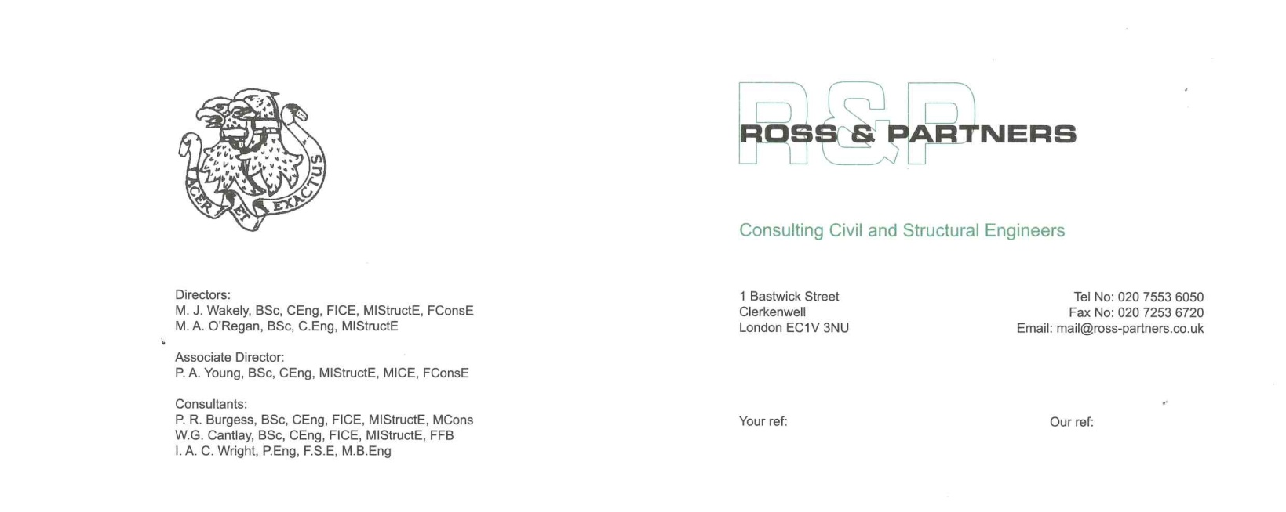
Planning Department 23-02-15
London Borough of Camden
Town Hall
Judd Street
London WC1H 8ND

Dear Sirs

106 ALBERT STREET, LONDON NW1 7NE
PLANNING APPROVAL Ref 2014/2836/P

We write in application for approval under condition 8, to confirm that

Ross and Partners
Structural Engineers
Managing Director:
Mike Wakely
B.Eng (Hons.), C.Eng, FICE, MIStructE
are appointed as consultant engineers to inspect approve and monitor the implementation on site of both permanent and temporary basement structural works from commencement through to completion, and to ensure compliance with the design as checked and approved by Building Control.
We look forward to receiving your approval of this information as being compliant with the condition.

Best wishes,
Mike Wakely
ROSS & PARTNERS; Consulting Civil & Structural Engineers

Cc Gareth Gerner; Arcdesign

