DESIGN AND ACCESS STATEMENT September 2015

Bellgate studio, Bellgate mews, London NW5 1SW

APPLICANT: Mr Jonathan White.

DESIGN
Use: Residential [as existing]

Amount: Increase of internal floor area of 11 Sq Metres to ground floor by enclosing part of walled courtyrd

Layout: Addition of glazed roof and one elevation to form a new conservatory area to the existing walled courtyard. Also, the replacement of the existing lean to roof with a flat roof terrace. NB; The adjacent commercial properties on Chetwynd Rd have all built over their gardens and formed roof terraces which abut Bellgate Studio at the same vertical level

The owners and occupants of the sole property that may be overlooked from the proposed terrace, [No 33 York rise NW5 1SW] have no objection to these proposals.

Scale: To match existing 19th century streetscape.

Landscaping: N/a

Appearance: Elevation to typical Victorian/ Edwardian painted timber joinery details. Patent double/triple glazed roof system on timber roof joists

ACCESS
Parking: N/A

Disability access: No change. Access for ambulant disabled [as existing property].

Refuse: Arrangements as existing

Planning Statement: This is a small domestic Studio, tucked away in a cul de sac off York rise. Originally a modest brick built Victorian light industrial building which has been used for various purposes. According to hearsay and chronology, these include use as a milk parlour, an iron foundry, and an Architects office and for the last 12 years. residential premises. The present owner and occupant, a long time resident of the neighbourhood, wishes to quite simply glaze over a part of the walled courtyard to increase and brighten his living area during those many days and months of transitional weather that the year holds

ILLUSTRATIONS ON FOLLOWING PAGES.
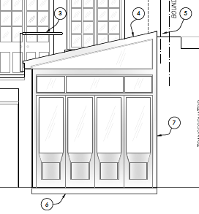
FRONT OF PROPOSED CONSERVATORY AREA [part of drawing No BS/01/11A]
Showing typical ‘gunstock stile’ glazed doors of the 19th century period

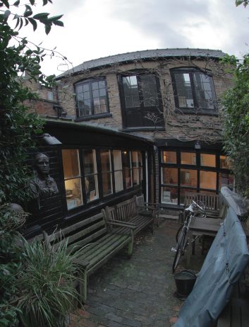
GENERAL VIEW AS EXISTING FROM THE SAME ASPECT

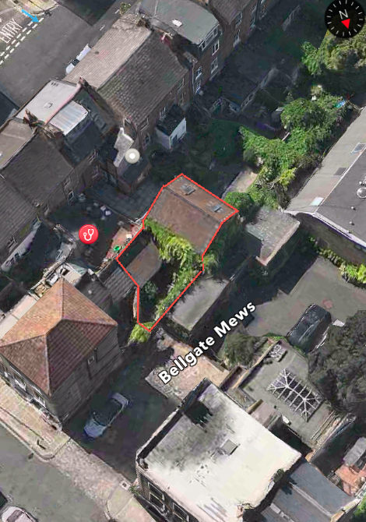
SATELITE VIEW SHOWING ADJACENT 1ST FLOOR LEVEL TERRACES
A.WISE. [Agent to the applicant] March 2015

