


Bristol
Exeter
Teddington
Bournemouth
HERITAGE STATEMENT

FOR
THE REFURBISHMENT OF
THE KHALILI LECTURE
THEATRE IN
THE PHILLIPS BUILDING
THORNHAUGH STREET
RUSSELL SQUARE
LONDON
WC1H 0XG

ON BEHALF OF

THE SCHOOL OF ORIENTAL AND AFRICAN STUDIES
UNIVERSITY OF LONDON

Kendall Kingscott Limited
Sandford House
1B Claremont Road
Teddington
Middlesex
TW11 8DH

Prepared By: | John Alexander | Date: | March 2015
Checked By: | Gavin Cowling | Job No: | 130305-600

1.00 Introduction

This Heritage Statement is submitted in support of a listed building consent application, which is submitted by Kendall Kingscott Ltd on behalf of The School of Oriental and African Studies (SOAS), which is part of the University of London. The application relates to the Khalili Lecture Theatre in the Phillips Building, which is located on Thornhaugh Street. The building is a grade II listed building.

This statement comprises a review of the building and its heritage, the principles and justification for the proposed works, what works are proposed and the impact that the works will have on the existing fabric.

This application relates to the proposed refurbishment of the Khalili Lecture Theatre on the Lower Ground Floor of the Phillips Building. The works are to include fitting new suspended ceilings, flooring, seating and lighting and to renew the the plasterboard and timber cladded walls to the Lecture theatre and lobby/ foyer entrance.

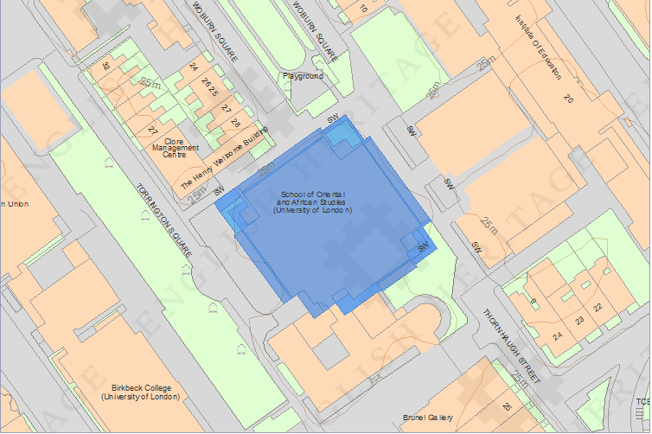

2.00 Planning Policy Statement (PPS) 5

Planning Policy Statement (PPS) 5 : Planning for the Historic Environment was published in March 2010 by the Department for Communities and Local Government. The document sets out the Government’s over arching objective is that “the historic environment and its heritage assets should be conserved and enjoyed for the quality of the life they bring to this and future generations” (DCLG, 2010).

The document states that “to deliver sustainable development by ensuring that policies and decisions concerning the historic environment recognise that intelligently managed change may sometimes be necessary if heritage assets are to be maintained for the long term” (DCLG, 2010).

As part of formulating this Heritage statement guidance has been obtained form PPS 5 and PPS5 Planning for the Historic Environment: Historic Environment Planning Practice Guide as produced by English Heritage et al.

3.00 The Building And Its Heritage

Located on Thornhaugh Street just off of Russell Square is the SOAS Phillips Building. The building was listed as Grade II listed on 20 May 2011 with the following information as the buildings listed description which has been obtained from the Camden Council web site.

“The Philips Building at the School of Oriental and African Studies (SOAS) has its origins in the London University spinal development plan of 1959, devised by the renowned LCC architects Sir Leslie Martin and Trevor Dannatt. It was Martin who recommended Denys Lasdun (1914-2002) as the architect for the new buildings at SOAS which were to form part of the development of the central area of the University's Bloomsbury site. The University had moved its principal headquarters (at Charles Holden's iconic Senate House, now designated Grade II*) and some of the smaller institutes, such as SOAS, to Bloomsbury in the 1930s although the war prevented implementation of the ambitious (and forbidding) masterplan that would have marched a linear spine of buildings north through Bloomsbury. SOAS was established in Finsbury Circus in order to train people working in Asia and Africa, and it received its London University Charter in 1913. Its original building was housed in the building of 1940, purpose-built also by Holden to hold what was by then a well-established school. This building was designated at Grade II just 29 years after it was built.
Lasdun accepted the commission for the SOAS library in 1960 and full planning approval was granted in 1968. The chosen site, to the north of the Holden building, infringed on the small but well-formed Woburn Square. This prompted a conservation fight of the type emerging in London at this time. It was long enough after the war for Londoners to have views on what should be preserved in the face of new building, and students, faculty and local residents protested the demolition of the increasingly-appreciated Georgian town houses. A London University Special Committee narrowly rejected the calls to preserve the square and demolition began in July 1969. The building contract officially began in January 1970 and was completed in May 1973.
Lasdun's design changed the concept that Martin and Dannatt had promoted in their master plan for the site. This resulted from his brief to create more pedestrian areas, as well as being a response to the truncated nature of the scheme when financial and conservation issues emerged. He implemented the envisioned dominant 'spine' in his impressive Institute of Education (to the east along Bedford Way, and designated Grade II*) and instead turned the library into a distinct 'pavilion' that formed part of a new pedestrianised square. The library was designed at about the same time as the library in his major scheme for the University of East Anglia (UEA).
Denys Lasdun is one of the most distinctive and creative of post-war architects. He is one of the few to have begun practicing before WWII, when he worked for Wells Coates, and after a distinguished military service he joined Lubetkin and Tecton, and Fry and Drew, before establishing his own practice in 1960 when his own style emerged. This was a synthesis of 1930's modernism with a strong horizontality derived from Frank Lloyd Wright (whose planning he came to admire in the 1950s) and an interest in expressing services that makes for comparison with another American architect, Louis Kahn. Perhaps of all British architects, Lasdun's work best demonstrates the cool, four-square and intellectually rigorous qualities of Kahn's work. Most of Lasdun's surviving buildings in England are now designated, many at high grades, such as the Royal College of Physicians at Grade I, and the nearby London University Institute of Education, the UEA Ziggurats, Keeling House and the National Theatre at Grade II*.”

4.00 The Proposed Works

4.01 New Plasterboard Partition to ‘Screen Wall and Lobby/ Foyer

A new plasterboard partition ‘screen wall’ is to be installed on metal studs incorporating an access door extending from floor level to the underside of the ceiling soffit. A new plasterboard partition is to be installed to the lobby area formed with an enclosure/ recess to display an existing bronze bust extending from floor level to the underside of the structural ceiling soffit.

4.02 Renewal of Plasterboard and timber cladding wall linings

New plasterboard wall lining is to be fixed over the block work wall to elevations 2 and 4 and the timber cladding to the lobby area is to be carefully removed and ******** before re fixing the ******* wall cladding.

4.03 New suspended ceilings to Khalili Lecture Theatre and Access Corridors 1 and 2

A new suspended ceiling is to be formed throughout the Khalili Lecture Theatre and to Access corridors 1 and 2 using 600 x 600 ceiling tiles.

4.04 Raised Timber Decking/ Platform to the front of the stage

In order to provide a larger stage space a new raised timber platform is to be fitted to the front raised to the level of the bottom staircase step. Another timber platform is to be installed to the rear of the lecture theatre to accommodate a wheelchair space.

4.05 New floor finishes

The refurbishment is to include finishing the stage decking/ platform area with new timber plank flooring and new carpet tiles to the rest of the lecture theatre.

4.05 New seating

The lecture theatre is to have the current 145no. seats removed and replaced with 136no. intermediate row chairs with writing ledges and 10no. row chairs without ledges.

4.06 Inclined Platform Lift

To improve accessibility to the lecture theatre the existing ramp is to be removed and replaced with 2no. inclined platform lifts. The lifts are to be installed to the side of the Khalili Lecture Theatre to transfer wheelchairs from the rear of the theatre to the front stage area. The lifts are to incorporate a fold-down seat for ambulant disabled users and the floor to the platform to have non-slip raised silver studs.

4.06 Replacement of Doors

As shown in the drawings the proposed works include replacing doors DK.02, DK.04, DK.05 with fire resistant doors incorporating vision panels and door DK.01 with a fire resistant door without a vision panel.

5.00 THE PRINCIPLES AND JUSTIFICATION FOR THE PROPOSED WORKS

Justification for the proposed works can be briefly summed up by stating that the works are to be carried out to meet the changing demands of the University, which the building was built and designed to be. We do not feel that any of the works will compromise the importance of this heritage asset. All works undertaken would be fully reversible at a later date without impacting or damaging the heritage asset.

6.00 THE IMPACT OF THE PROPOSED WORKS

The impact on the historical significance of the building will be extremely limited by the proposed works. In terms of visual impact all works are to be undertaken and finished in a ‘like for like’ basis and as such will have minimal visual impact.

7.00 SUMMARY AND CONCLUSIONS

All of the proposed works take into account the principles set out within PPS5 and fully consider the impact of the proposals to the building in terms of the impact to the significance of the heritage and the appearance of the building in terms of context with adjacent buildings.

The proposed works will not impact on the buildings important significance.

APPENDIX A

PHOTOGRAPHS

