


Bristol
Exeter
Teddington
Bournemouth
HERITAGE STATEMENT

FOR

23/24 THE FABER BUILDING
THORNHAUGH STREET
RUSSELL SQUARE
LONDON
WC1H 0XG

ON BEHALF OF

THE SCHOOL OF ORIENTAL AND AFRICAN STUDIES
UNIVERSITY OF LONDON

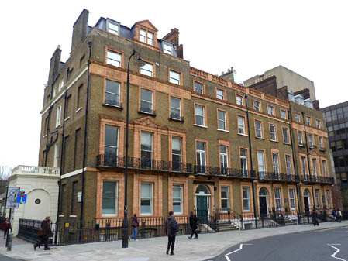

Kendall Kingscott Limited
Sandford House
1B Claremont Road
Teddington
Middlesex
TW11 8DH

Prepared By: | John Alexander | Date: | 20 February 2015
Checked By: | Gavin Cowling | Job No: | 140638-600

CONTENTS

1.00 INTRODUCTION

2.00 PLANNING POLICY STATEMENT (PPS) 5

3.00 THE BUILDING AND ITS HERITAGE

4.00 THE PROPOSED WORKS

5.00 THE PRINCIPLES AND JUSTIFICATION FOR THE PROPOSED WORKS

6.00 THE IMPACT OF THE PROPOSED WORKS

7.00 SUMMARY AND CONCLUSIONS

1.00 INTRODUCTION

This Heritage Statement is submitted in support of a listed building consent application, which is submitted by Kendall Kingscott Ltd on behalf of The School of Oriental and African Studies (SOAS), which is part of the University of London. The application relates to the Faber Building which is located on Thornhaugh Street and is a grade II listed building.

This statement comprises a review of the building and its heritage, the principles and justification for the proposed works, what works are proposed and the impact that the works will have on the existing fabric.

This application relates to the proposed refurbishment works to a number of rooms on the lower ground floor. The works consist of the refurbishment of rooms including replacement of suspended ceiling tiles, new MF plasterboard ceilings and the demolition of internal walls to rooms FB08 and FB09. The works also consist of constructing a new partition wall in FB04 to form two smaller rooms and the stripping out and refurbishment of the toilets in FB16.

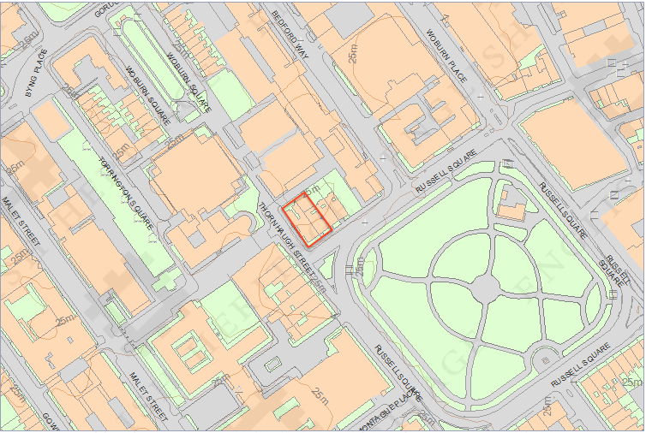

2.00 PLANNING POLICY STATEMENT (PPS) 5

Planning Policy Statement (PPS) 5 : Planning for the Historic Environment was published in March 2010 by the Department for Communities and Local Government. The document sets out the Government’s over arching objective is that “the historic environment and its heritage assets should be conserved and enjoyed for the quality of the life they bring to this and future generations” (DCLG, 2010).

The document states that “to deliver sustainable development by ensuring that policies and decisions concerning the historic environment recognise that intelligently managed change may sometimes be necessary if heritage assets are to be maintained for the long term” (DCLG, 2010).

As part of formulating this Heritage statement guidance has been obtained form PPS 5 and PPS5 Planning for the Historic Environment: Historic Environment Planning Practice Guide as produced by English Heritage et al.

3.00 THE BUILDING AND ITS HERITAGE

Located on Thornhaugh Street just off of Russell Square is the SOAS Faber Building. The building was listed as Grade II* listed on 14 May 1974 with the following information as the buildings listed description which has been obtained from the Camden Council web site.

“Terrace of 4 houses, formerly a symmetrical terrace similar to Nos 52-60 (qv). One surviving projecting end bay (No.24) and central bay (No.21). c1808. By James Burton, altered c1898 possibly by PE Pilditch. Yellow stock brick with later terracotta dressings. Slate mansard roofs with dormers to Nos 21 and 24.

EXTERIOR: 4 storeys, attics and basements. 3 windows each. No.24 with 4-window return, blind except those above portico, to Thornhaugh Street. Round-arched doorways in square-headed terracotta surrounds with fanlights, side-lights and panelled doors, except No.24 with prostyle, rusticated stucco portico with balustrade. Recessed, architraved sash windows; 1st floor, some casements, with cornices and centre windows on projecting bays pedimented. Continuous cast-iron balconies to 1st floor windows. Cornice at 3rd floor level, projecting bays with enriched frieze. Parapets; Nos 22 and 23 with balustraded parapet. Centre dormer to No.24 with terracotta pediment; No.21 with pedimented dormers, the central one semicircular.

SUBSIDIARY FEATURES: attached mid C19 cast-iron railings to areas.

HISTORICAL NOTE: No.21 was the home of Sir Samuel Romilly, law reformer (plaque). The Duke of Bedford was inspired to add terracotta dressings to these houses following the building of The Russell Hotel (qv).”

4.00 THE PROPOSED WORKS

4.01 Proposed Sub-Division of FF04 on the Lower Ground Floor

SOAS have identified that they require two smaller rooms to be used as a meeting room and filing storage and as such are proposing to sub-divide existing storage room FB04 into two smaller rooms.

The works are to consist of:

  - The construction of new MF stud partition walls.
  - The creation of a new door opening from room FB03 into proposed room FB04A.
  - The installation of a new suspended ceiling to both subdivided rooms.

The installation of new MF stud partitions will allow the creation of the proposed sub-divided rooms. It is proposed to use 75mm metal studs centred at 600mm with metal stud head and sole plates. It is proposed to fix plywood sheeting to both faces and then fix plasterboard. It is the intention that all finishes are to match the existing finishes.

The proposed new opening is to be made through a masonry wall. Works are to be carried out in accordance with all structural engineers instructions and it is to be finished to match the other openings into room FB03.

  - Proposed Demolition of a block work wall between rooms FB07 and FB08 on the lower ground floor.

As part of the office refurbishments it is proposed to remove the walls to FB07/FB08 to form two separate rooms. The room is now required to be a single room and as such it is proposed to remove this wall.

The works to rooms FB07 and FB08 are highlighted on drawing 140638 L(0)02B.

  - Proposed demolition of a block work wall in room FB09 on the lower ground floor.

As part of the refurbishment it is proposed to remove the partition wall inside FB09 to form an open space room. The room is no longer required as a plant room and is instead to be used as a small meeting room.

  - Proposed installation of secondary glazing to lower ground floor windows 1, 2, 3, 4, 5 and 6 as shown in drawing 140638 L(0)04. The units are to be fixed internally and will not be visible externally.

  - Proposed increase in size to window openings W12 and W13 in room FB14. Lowering the cill to suit the new size and installing new timber sash windows to match existing windows to the building.

  - Proposed strip out and refurbishment of the existing male and female toilets in room FB16.

The proposal is to provide 2no. male toilet cubicles and 3no. female cubicles approximately 1600 x 1400 in size and each with their own WC, sink and hand dryer.

4.07 Generic Refurbishment Elements

Other works proposed to be undertaken are the replacement to ceilings as shown on the drawing 140638 L(0)05B. In particular rooms FB09, FB14 and FB16 are to have new MF plasterboard ceilings with access panels.

5.00 THE PRINCIPLES AND JUSTIFICATION FOR THE PROPOSED WORKS

Justification for the proposed works can be briefly summed up by stating that the works are to be carried out to meet the changing demands of the University. We do not feel that any of the works will compromise the importance of this heritage asset.

6.00 THE IMPACT OF THE PROPOSED WORKS

The impact on the historical significance of the building will be extremely limited by the proposed works. In terms of visual impact all works are to be undertaken and finished in a ‘like for like’ basis and as such will have minimal visual impact. In respect of the proposed use of MF and brickwork partition walls it would be possible to revert rooms back to there original status should this be required at a later date with minimum disruption to the existing finishes.

7.00 SUMMARY AND CONCLUSIONS

All of the proposed works take into account the principles set out within PPS5 and fully consider the impact of the proposals to the building in terms of the impact to the significance of the heritage and the appearance of the building in terms of context with adjacent buildings.

The proposed works will not impact on the buildings important significance.

