


Bristol
Exeter
Teddington
Bournemouth
DESIGN AND ACCESS STATEMENT

FOR

THE COLLEGE BUILDING
THORNHAUGH STREET
RUSSELL SQUARE
LONDON
WC1H 0XG

ON BEHALF OF

THE SCHOOL OF ORIENTAL AND AFRICAN STUDIES
UNIVERSITY OF LONDON

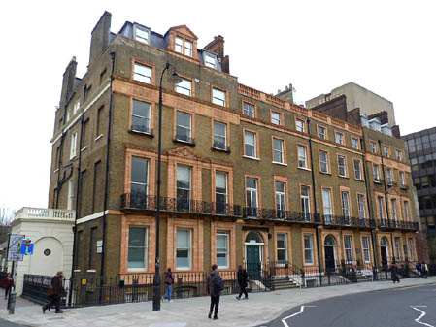

Kendall Kingscott Limited
Sandford House
1B Claremont Road
Teddington
Middlesex
TW11 8DH

Prepared By: | John Alexander | Date: | 20 February 2015
Checked By: | Gavin Cowling | Job No: | 140638-600

CONTENTS

1.00 USE

2.00 LAYOUT/ SCALE

3.00 LANDSCAPING

4.00 APPEARANCE

5.00 ACCESS

1.00 USE

SOAS would like to refurbish and carry out works to SOAS, College Building on Russell Square. The works will include the removal of the access ramp to the Research Building reinstating the building fabric, including parapet wall. The works will also provide a new external double door opening from the lower ground floor of the College Building to the Moat Area and to make improvements to the external Moat Area.
Ramp
The building currently has a large steel ramp used to access the Research Centre building. The works propose removing the ramp to eliminate any obstacles to the area immediately outside of the student union. The ramp is currently connected to the Research Centre but is no longer necessary and is not required for fire egress. A concrete platform extends from the surrounding footpath and forms a level walkway onto the existing ramp. This platform will be broken up and removed so that a new sub base can be formed and landscaped to tie in with surrounding. In addition, the gap in the wall where the platform leads to the ramp will be infilled to exactly match the surrounding walls including extending the existing coping and handrail.
The ramp is currently supported by large steel beams that are bolt fixed to the external wall of the College Building and to the adjacent ‘moat’ retaining wall, when the ramp has been removed, the walls will be made good and tiles replaced as necessary.
Window Replacement
In order to provide access into the new outdoor space, an existing window will be removed, the height of the opening extended to floor level and a new Critttall double door installed. This will match the existing exit doors that have recently been replaced to the external building façade, including an insulated sub frame.
Walkway
Following the removal of the ramp, a new walkway surface is required. New Yorkstone paving is to be installed to match the adjacent courtyard with 150mm shingle gulleys formed to both sides of the new walkway.

The works are being proposed to provide enhanced facilities for the use of SOAS students. There is one window being replaced with a double door entrance and a large steel ramp being removed.

2.00 LAYOUT/ SCALE
Below are the existing and proposed plans for the removal of the steel ramp.

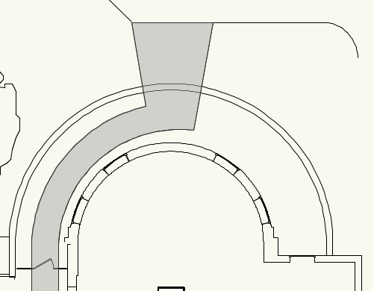

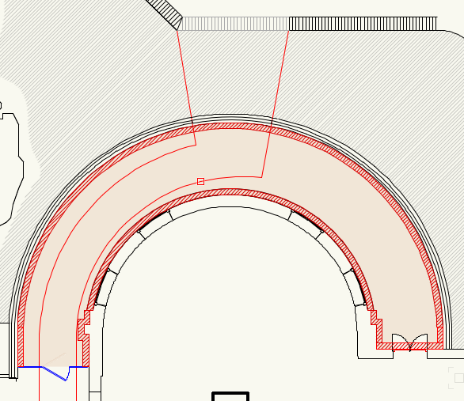

Below are the existing and proposed elevations showing the window that is to be replaced with a double door.

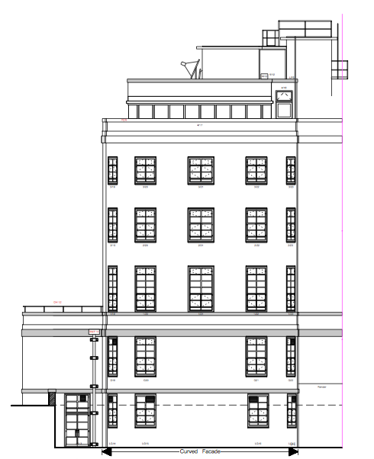
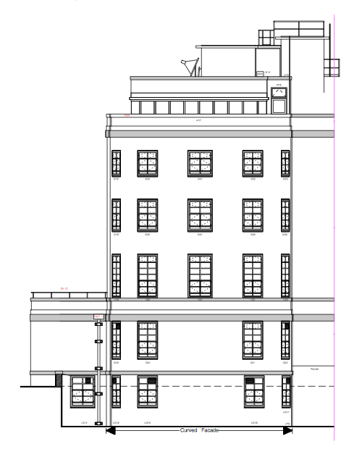

3.0 LANDSCAPING
The current platform to the ramp will be removed and a new sub base formed. The area can then be landscaped to tie in with the surrounding area.

4.0 APPEARANCE
The works are proposed to the lower ground level of the building, the double door that will replace the window will be designed to match existing double doors in the building. The ramp was not an existing feature of the building and therefore by removing it, the building is being restored to its previous appearance before it was installed.

5.0 ACCESS
The removal of the ramp will not affect the access to the building and is not required for the egress.

