**Photos – 2014/4145/P – 20 Thurlow Road**

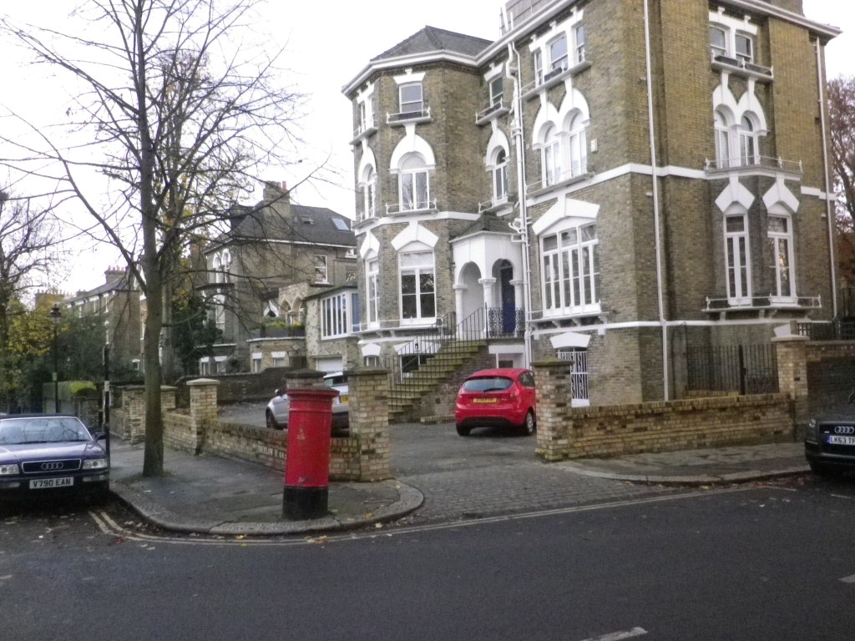

View – Rebuild boundary walls on Thurlow Rd & Lyndhurst Terrace.

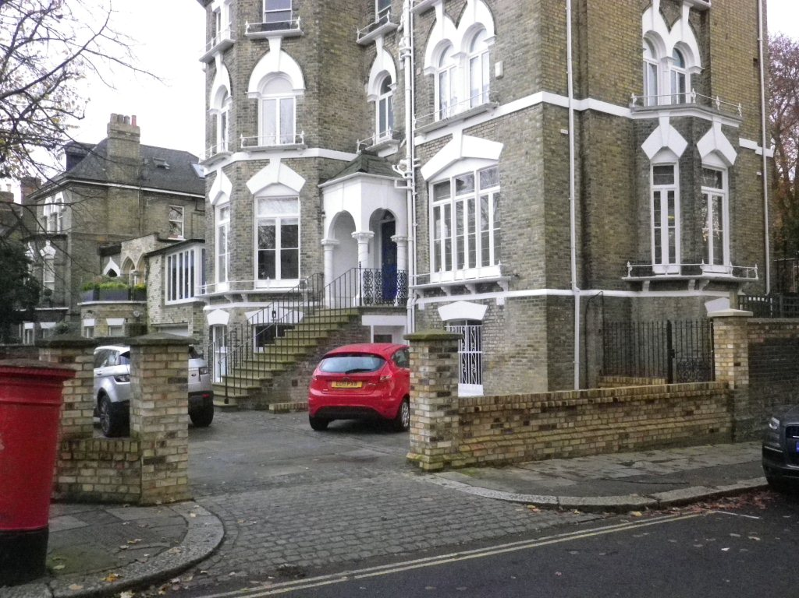

View – Rebuild boundary walls on Thurlow Rd & Lyndhurst Terrace.