Design and Access Statement

46 Spencer Rise NW5 1AP

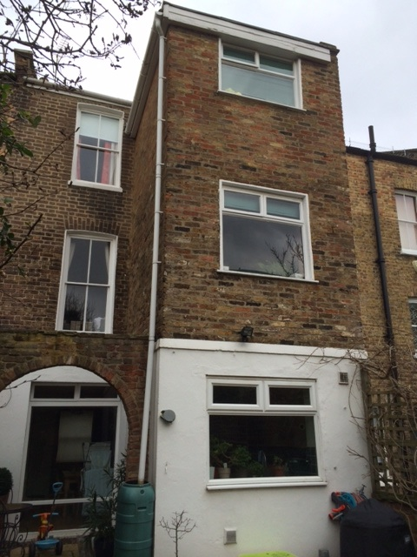

THE EXISTING PROPERTY

46 Spencer Rise is a Victorian era property on 3 floors within a conservation area.
The rear of the property is at the lower ground floor level built as such to accommodate what would have been a sloping site.

The street contains a variety of similar aged properties which have been modified in an ad hoc manner.

The property has been modified at the rear with a 3 storey extension which is unlikely to be part of the original property. Internally the core of the property has had numerous modifications including the addition of a spiral staircase. The addition of this staircase has resulted in the removal and relocation of many of the original internal walls and at present bears little resemblance to the original house.

THE DESIGN

This proposal is for a new velux window on the rear roof slope which will allow access to the flat roof over the rear extension. The existing velux window does not afford safe access to the flat roof

THE CHARACTER OF THE PROPERTY

The new velux will have minimal impact as it is replacing an existing roof window and will be in a similar style and finish although slightly larger than the existing window.

Roger Connolly Architect
March 2013

