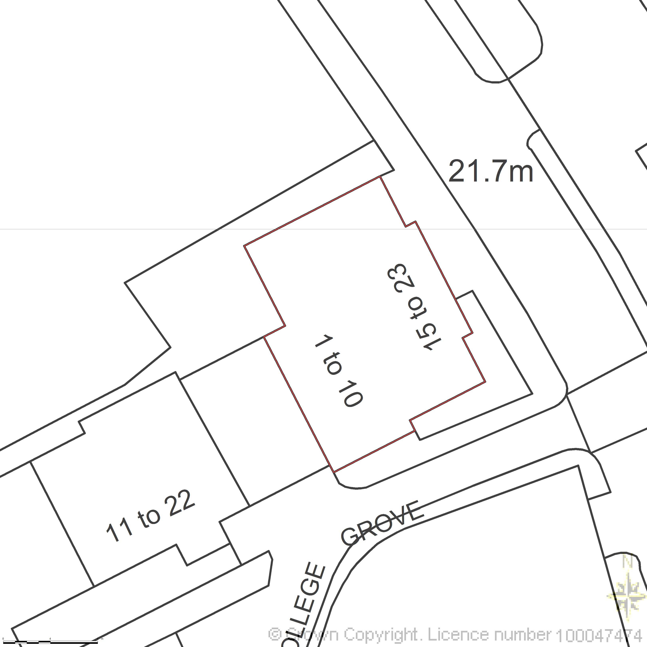
BLOCK PLAN
AREA 55m x 55m A3
SCALE 1:200
CENTRE COORDINATES: 529543, 183792


Supplied by Streetwise Maps Ltd
www.streetwise.net
Licence No: 100047474
30/07/2026 04:45:15

