**HERITAGE STATEMENT FOR PLANNING CONSENT FOR LISTED BUILDINGS**

**Flat 71A Rowley Way** Document 04 **Heritage Statement** including reference to Design and Access Listed building consent application

**Design and Access Statement**

There are no changes to the access to the flat which remains as originally designed. The Design is described below

**Statement of Significance**

Designed in 1968 and built between 1972 and 1978 by the London Borough of

Camden Architects Department, Alexandra Road Estate is one of the most

ambitious examples of the innovative new social housing emerging from the

Department at this time and of new housing in Britain. Its architect was Neave

Brown. The street is the dominant element in the design and seen as a modern translation of the traditional London Street, where the sum of the whole exceeds the individual parts in creating a meaningful urban space. All dwellings are entered directly from the streets, which are freed of traffic by the parking garage provided at low level. At Alexandra Road, Rowley Way can be seen as one of the most successful examples of the segregation of traffic and the pedestrian, and it remains a successful social space. No changes are proposed to the exterior.

**Description of works to be carried out**

Theflat is a split level maisonette comprising an entrance hall, kitchen and living area on the entrance floor. On the lower floor a bathroom, lavatory, corridor and two bedrooms are situated (see floor plan as pdf document showing the existing layout of the flat).

A listed building consent application is submitted along with this document, after extensive consultation with conservation officers (Mr. David Glasgow – Senior Planning Office, London Borough of Camden).

The flat has previously been rented to Camden Council tenants and was vacated in a lamentable condition. We found it was not possible to retrieve any of the remaining items in the kitchen. The cabinets were found to be completely broken and the doors hanging off and held together with rags (see photographs 1 and 2). This state of squalor necessitated an entirely new kitchen to be installed, hence this request for consent.

The consent is particularly relevant to the existing kitchen worktop. This worktop is significant as it is considered part of the original fabric of the house as well as an integral part of the special interest of the listed building The kitchen units installed by the previous owners (see photos 3-8) covered this original feature. We propose to retain this feature and incorporate it into the design of the new kitchen. The reason for removing the worktop is that it is located slightly lower than worktops today which allow for standard white goods such as fridges, washing machines and ovens to be fitted below.

The applicant hopes the view of the Council officers will be that it is reasonable to allow a new worktop height in this case to accommodate these items, i.e. a worktop 900mm above floor level. This view is reinforced by the original architect of the estate, Neave Brown, who has stated that the original kitchens in the flats were designed purely to be functional, employing certain dimensions to accommodate the appliances of their time.

The reinstated concrete worktop and the kitchen in general will be in the spirit of the original and will be tiled using white quarry tiles (confirmed and approved by Mr. David Glasgow in writing on the 10th of December, 2014 in accordance with the conservation department of the London Borough of Camden). We propose raising the worktop around 9cms as illustrated in Photograph 9.

Photographs 3-8 show the concrete worktop to which this document refers. The applicant hopes that raising it slightly and rebuilding it tastefully in the good quality white quarry tiles, the kitchen will be able to accommodate modern appliances as well as keep the special interest of the property. Please also find two pdf documents containing the section drawings of the proposed changes to the kitchen (outlined in red), which contemplate the raising of the worktop.

**Photo 1 – non retrievable kitchen**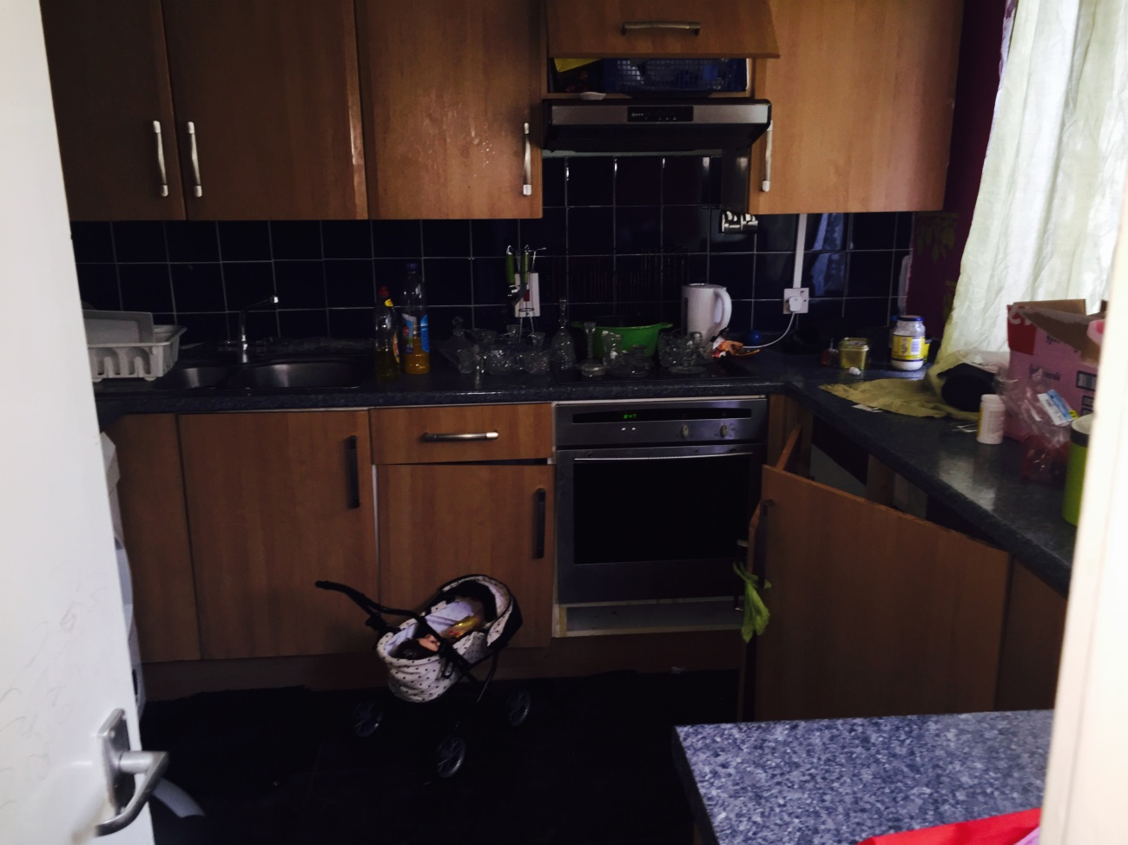

**Photo 2 - Broken kitchen unit doors**

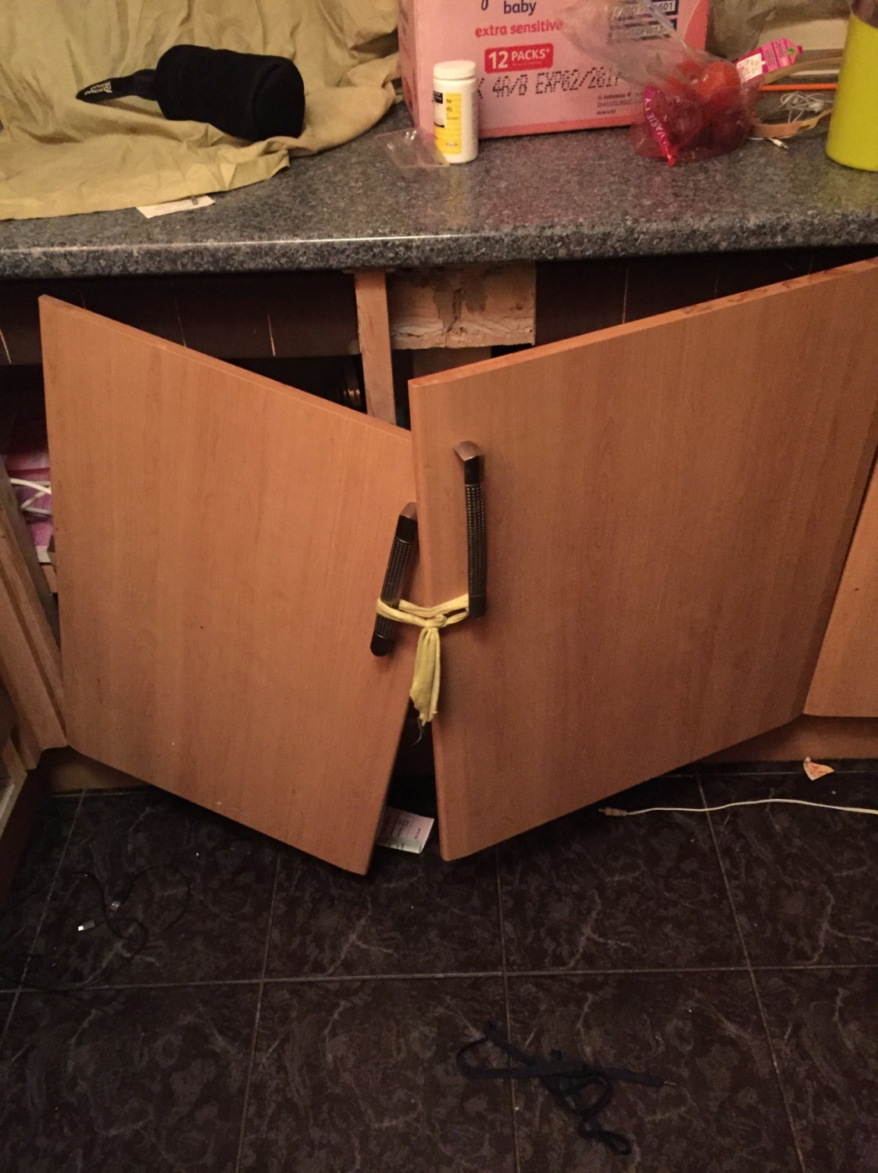

**Photo 3 - hidden (covered) worktopPhoto 4 Kitchen with original worktop** 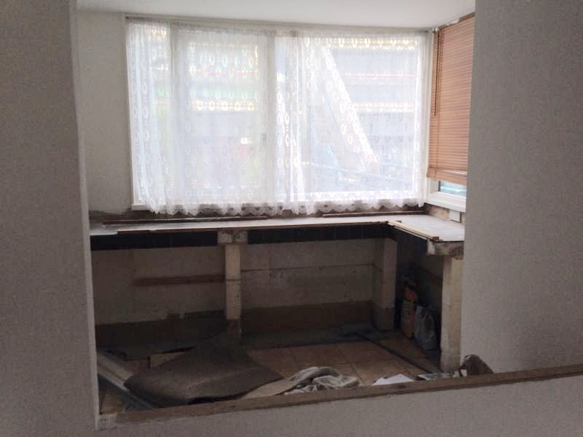

**Photo 4 Kitchen with close up of original worktop**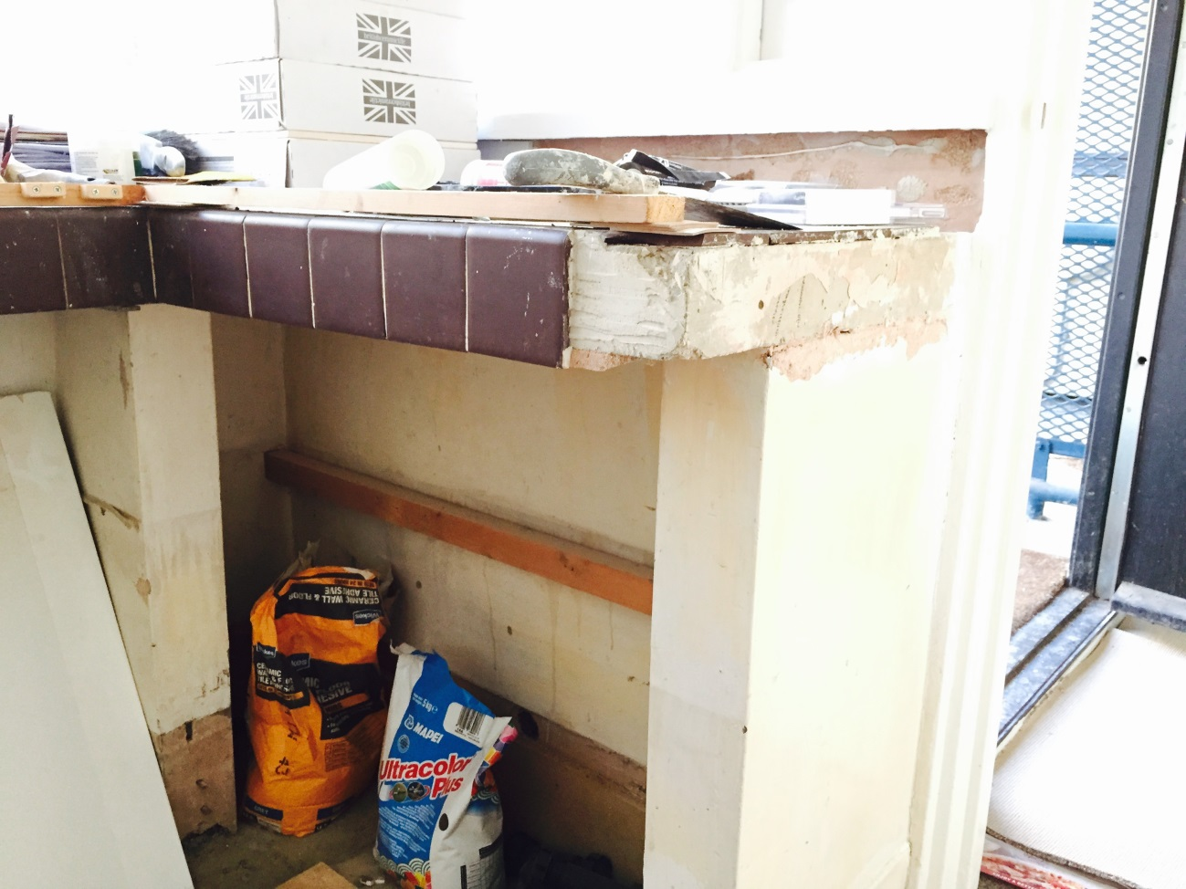

**Photo 5 Kitchen with original worktop** 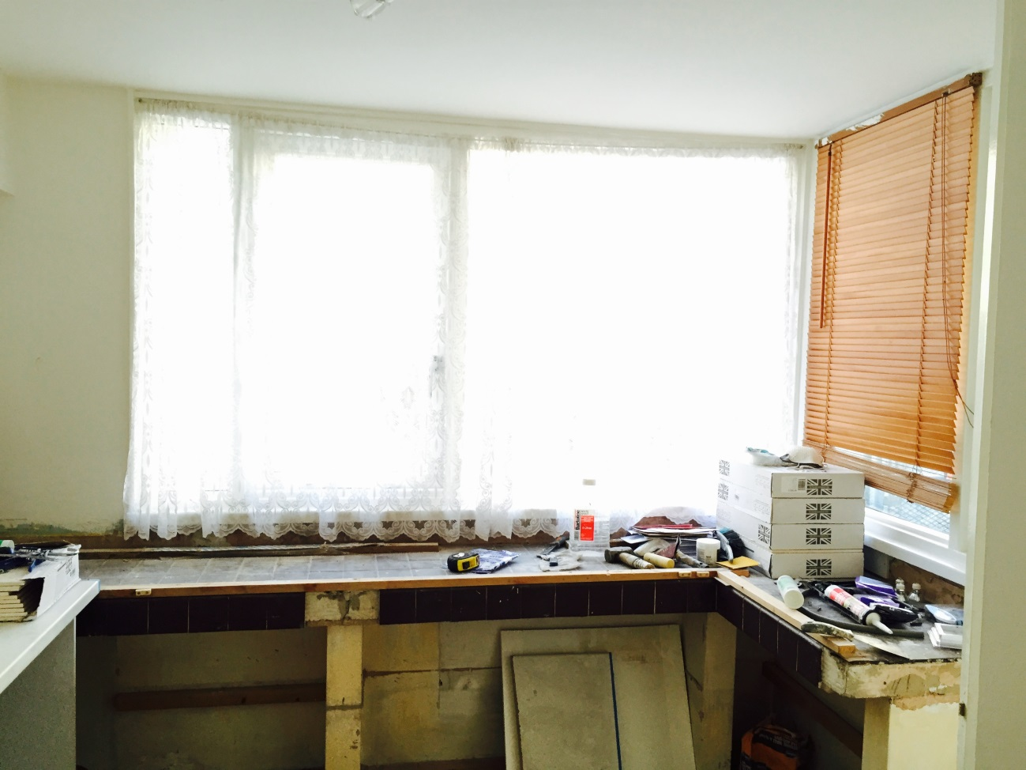

**Photo 6 Kitchen with original worktop –view from kitchen door**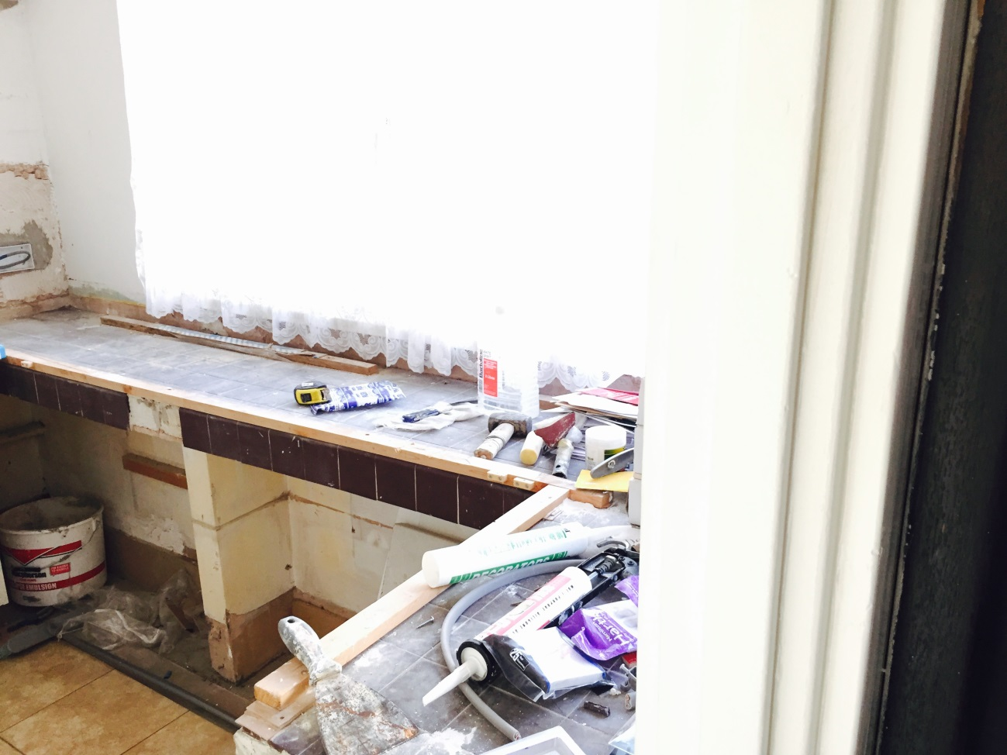

**Photo 7 Close up of original worktop –covered with modern worktop**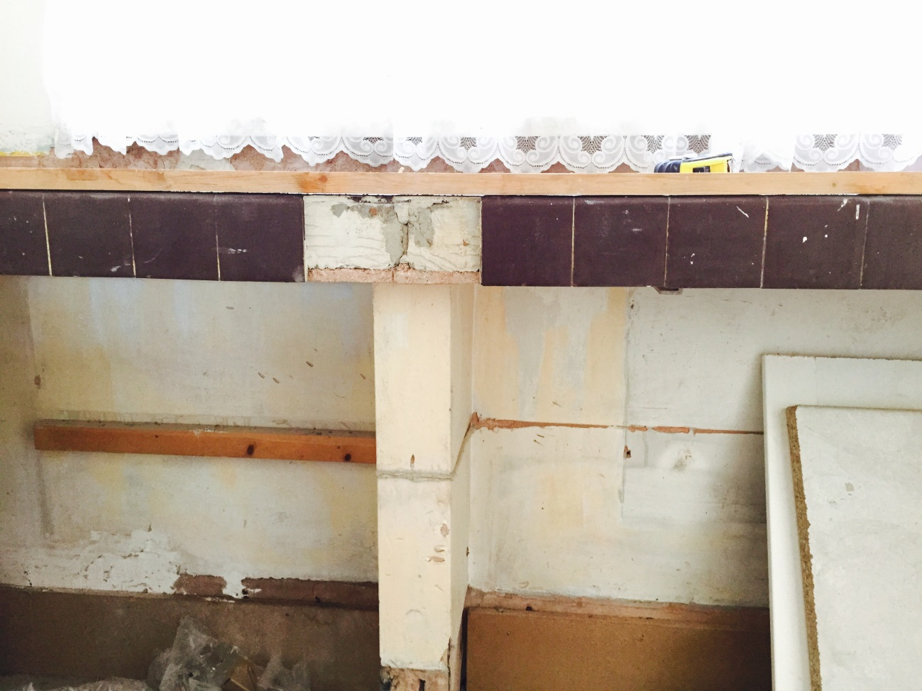

**Photo 8 view of kitchen looking on to front door**

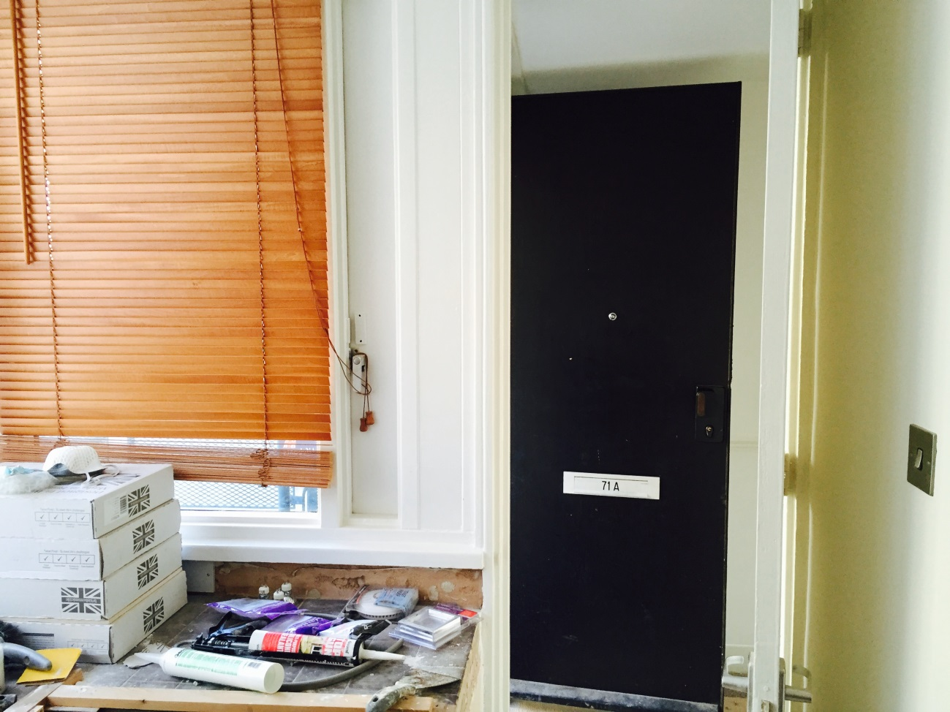

**Photo 9 – distance we propose raising worktop to accommodate washing machine**