MORFIELD EVEREST

CHARTERED BUILDING SURVEYING

Our ref: CamdenCouncil10.rm
Your ref:
22nd December 2014

Planning Department
London Borough of Camden
2nd Floor, 5 Pancras Square
c/o Town Hall, Judd Street
London, WC1H 9JE

Dear sirs,

Re: 15 Akenside Road, London, NW3 5BT
Application for planning permission for external gates and fencing within entrance drive and replacement single gate off Akenside Road, new bin store and cycle lockers adjacent main entrance, external lighting alterations and macadam paving of entrance drive and car park area

Planning and Design / Access Statement

I detail below the Planning and Design / Access Statement for the above proposed works.

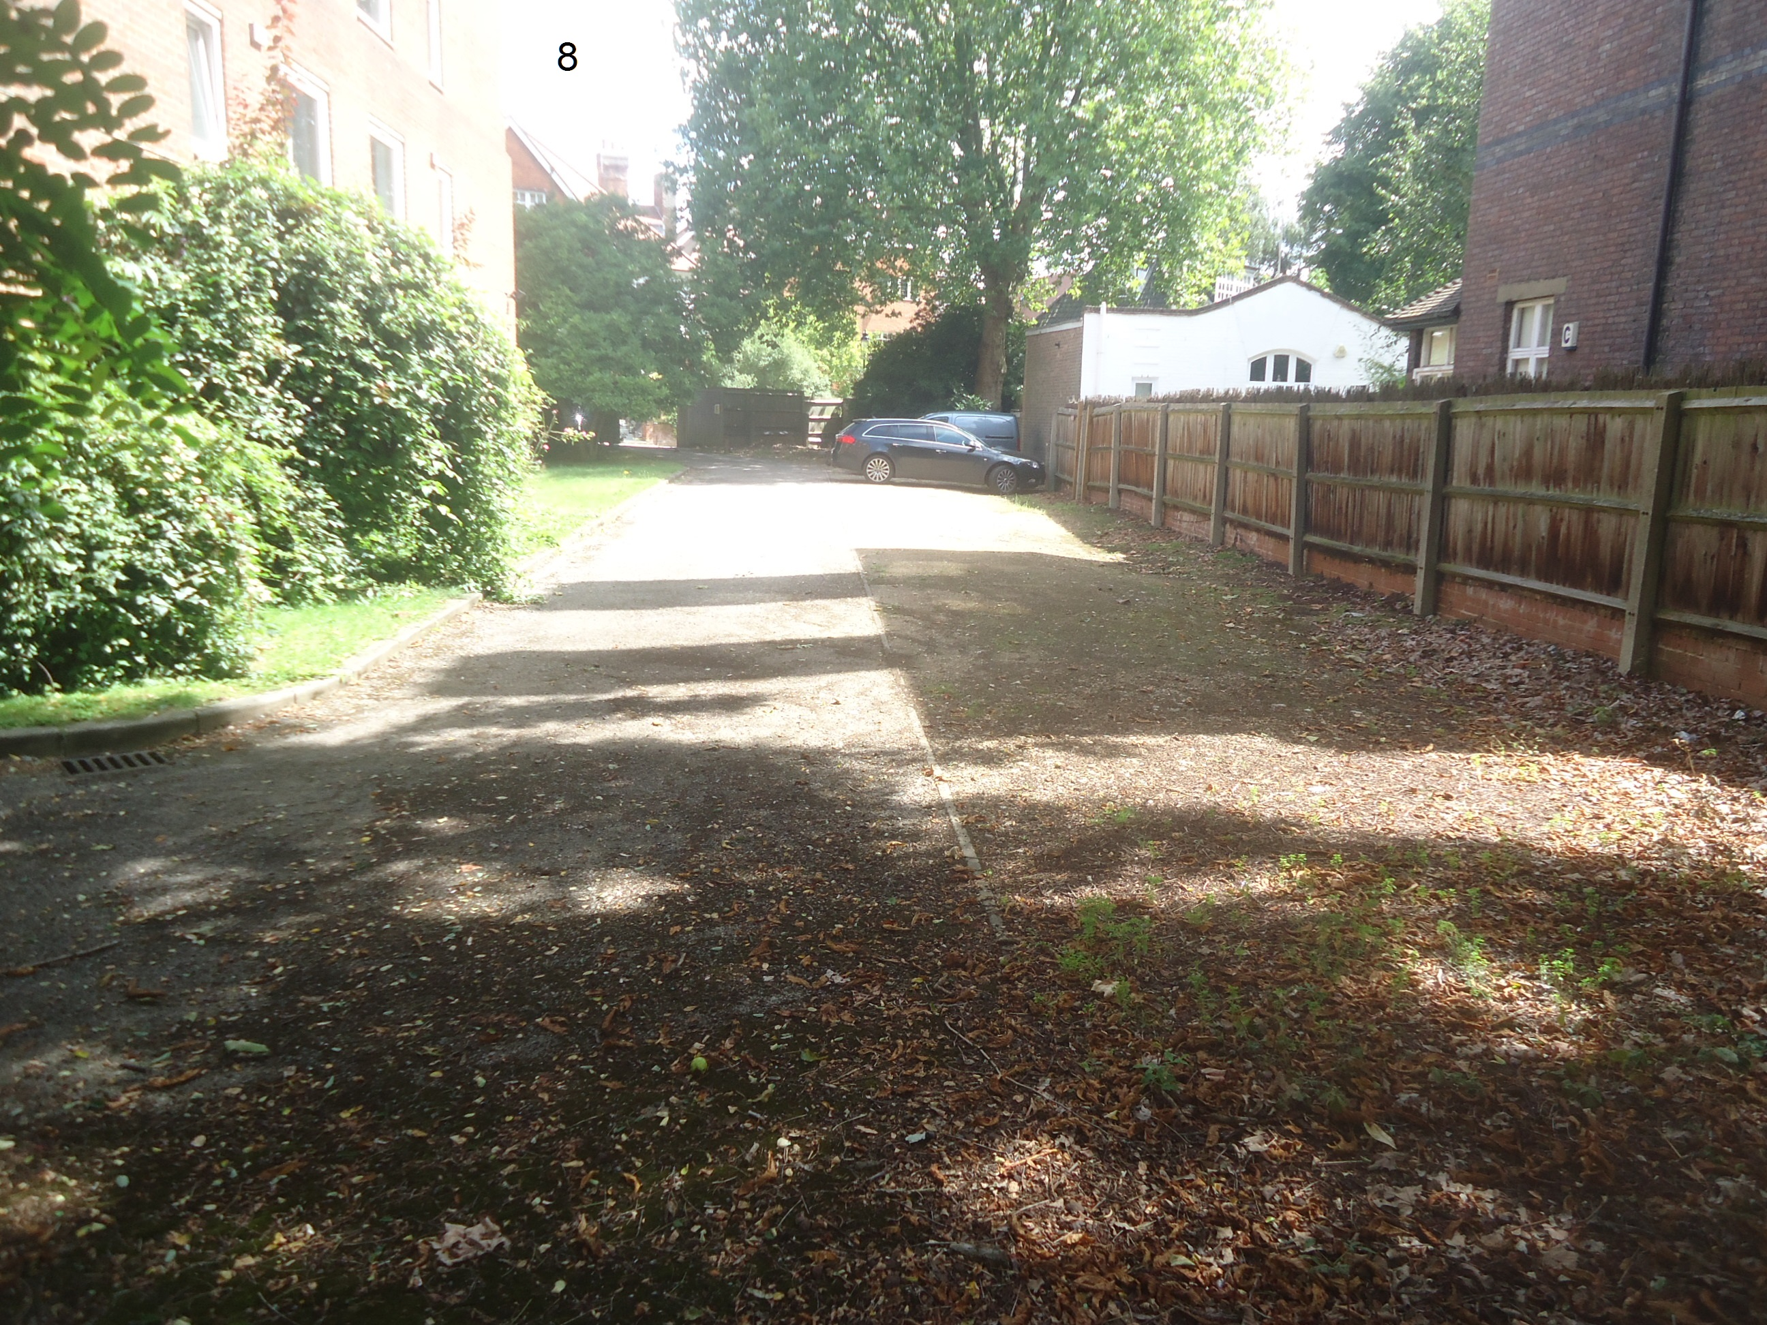

15 Akenside Road comprises a four storey block of 14 flats situated on a large plot with access off Akenside Road.

The entrance drive and car parking are is in poor condition and requires re-paving.

External lighting is dilapidated and is proposed to be replaced.

The single entrance gate has reached the end of its economic life and now requires replacement with new.

It is the intention of the owner to improve the security to the site and stop people wandering on to the grounds and sometimes using the car parking area without permission. To this end it is proposed to install fencing and double gates to the entrance drive.

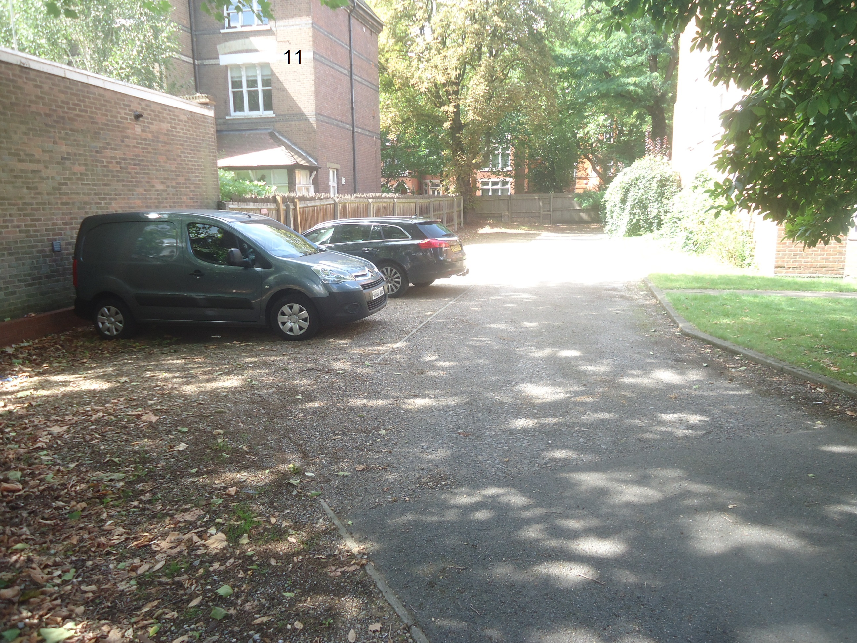

As part of the proposed repairs and improvements, it is planned to relocate the bin store (which is currently accessed externally within a store to the rear of the block) to within the site adjacent to the main entrance drive. This will allow the bins to be accessed easily from Akenside Road without having to come on to the site.

In addition, it is proposed to install 16 coated green metal paneled cycle lockers adjacent to the entrance drive, as shown on the proposed site plan.

The planning design and access statement has been assessed as above and as follows:

Assessment

Physical - The materials used are sympathetic to the local area and
Environment.

The above proposals will be non-detrimental to the existing buildings, landscape features and movement routes. The proposed works will be inconspicuous in relation to the neighbouring buildings, and no part of the development site is significantly overlooking or being overlooked by any neighbour.

Social - People in the area will not be adversely affected by these
works.

Economic - The development proposals will have no impact on the
local economy or value of the land, and will not affect any other development options.

Planning - The development proposals are consistent with Development
Policy Plan policies.

Involvement - The proposed works will improve and smarten up the areas
proposed.

I trust the above provides sufficient explanation for this planning application, but please do not hesitate to contact me if you have any queries.

Yours sincerely,

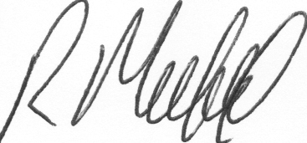

Robert Morfield
Morfield Everest

