Hampstead Heath Pond Project

Assessment of Design Flood

City of London Corporation

Final

25 March 2013

Notice

This document and its contents have been prepared and are intended solely for ’s information and use in relation to the HAMPSTEAD HEATH POND PROJECT

ATKINS LTD assumes no responsibility to any other party in respect of or arising out of or in connection with this document and/or its contents.

This document has 51 pages including the cover.

Document history

|  |  |  |  |  |  |  |
| --- | --- | --- | --- | --- | --- | --- |
| Job number: | | | Document ref: 62/DG/049 | | | |
| Revision | Purpose description | Originated | Checked | Reviewed | Authorised | Date |
| 1 | FINAL incorporating Client Comments on 5117039/62/DG/36 | CG/IS/MA | MA/TB | TB/LB | MJW | 11/03/2103 |
| 2 | FINAL incorporating Client Comments on 5117039/62/DG/040 | CG/IS/MA | MA/TB | TB/LB | MJW | 14/03/2013 |
| 3 | FINAL incorporating clarification on Table 5.7 in 5117039/62/DG/044 | CG/IS/MA | MA/TB | TB/LB | MJW | 21/03/2013 |
| 4 | FINAL Amendment to Table 5-7 in 5117039/62/045 | CG/IS/MA | MA/TB | TB/LB | MJW | 25/03/2013 |
|  |  |  |  |  |  |  |
|  |  |  |  |  |  |  |
|  |  |  |  |  |  |  |
|  |  |  |  |  |  |  |

Table of contents

Chapter Pages

Executive Summary 7

Rainfall Depths 7

Percentage Run-off 7

Flood Estimates 8

Flood Routing 9

Outline Approach to Dealing with the Probable Maximum Flood 11

1. Introduction 13

1.1. Structure of the report 13

2. Study Area Background 15

2.1. Location and Land Use 15

2.2. Ponds 15

2.3. Geology and Soils 15

3. Review of Previous Studies 17

4. Hydrology 21

4.1. Methodology 21

4.2. Sources of Data 21

4.3. Catchment Boundaries 22

4.4. Catchment Descriptors 25

4.5. Rainfall Analysis 27

4.6. Hydrograph Generation 30

4.7. Hydrological Modelling Results 31

5. Hydraulic Modelling 33

5.1. Study Output 33

5.2. Modelling Methodology and Assumptions 33

5.3. Hydraulic Modelling Results 36

5.4. Summary of Model Results 37

6. Conclusions and Recommendations 45

Glossary 47

Appendices 49

Appendix A. References 51

Tables

Table 4‑1 Catchment Areas and Pond Area 23

Table 4‑2 Catchment Descriptors 25

Table 4‑3 Hampstead Heath Descriptors for all Catchments 25

Table 4‑4 Hampstead Heath Design Rainfall Depths 28

Table 4‑5 Hampstead Scientific Society Rainfall Gauge Depth Frequency Curves 29

Table 4‑6 Highgate No. 1 and Hampstead No. 1 Ponds - Critical Storm Duration and Peak Flow 31

Table 4‑7 Comparison of Hampstead Heath Peak Flows Haycock (2010) and Atkins (2013) 32

Table 5‑1 Pond Top Water Level and Surface area 34

Table 5‑2 Dam Minimum Crest Level, Length and Connections 34

Table 5‑3 Confirmation of Critical Storm Duration 36

Table 5‑4 PMF Summary Results 37

Table 5‑5 1 in 10,000 year Summary Results 38

Table 5‑6 1 in 1,000 year Summary Results 38

Table 5‑7 Assessment of pond storage capacity with respect to the PMF 39

Table 5‑8 1 in 5 year Summary Results 40

Table 5‑9 1 in 20 year Summary Results 40

Table 5‑10 1 in 50 year Summary Results 41

Table 5‑11 1 in 100 year Summary Results 41

Table 5‑13 Summary of PMF Peak Velocity on Outside Slope 42

Figures

Figure 4‑1 Hampstead and Highgate FEH Catchment Boundary Map 22

Figure 4‑2 Highgate Chain Catchment Boundary Map 24

Figure 4‑3 Hampstead Chain Boundary Map 24

Figure 4‑4 Hampstead Heath Scientific Society Rainfall Gauge Depth Frequency Curves 29

Figure 4‑5 24-hour Rainfall Depth Frequency Curves 30

Figure 5‑1 Model screen shot showing ponds (blue striped polygons), 2D floodplain (black netted polygon) and inflows (small purple circles) 36

Figure 5‑2 Flood map around the ponds for the PMF event 39

Executive Summary

This document reports on the findings of the fundamental review and problem definition for Hampstead Heath Pond Project. It is the first technical element of the project, as it is essential to defining the problem. The key output of this assessment is an estimation of the Probable Maximum Flood (PMF) and other design floods, and an assessment of the overtopping risk under these floods at each dam. The main aim of the assessment is to estimate the overtopping depth at each dam under the extreme floods (PMF, 10,000 year, 1,000 year), and to estimate the current standard of protection of each dam. A key feature of our assessment is the use of industry standard methods and software, ensuring that the work is in line with current industry best practice. This report has been prepared in line with the Design Review

Method Statement approved under Hampstead Heath, Highgate Wood & Queens Park Committee, Delegated Decision – Standing Order No. 41 (B) signed by the Town Clerk on 18th December 2012.

## Rainfall Depths

Design Rainfall Depth

The Flood Estimation Handbook (FEH) CD-ROM provides Depth-Duration-Frequency (DDF) curves for a 1km2 grid covering the whole of the UK. Design rainfall depths were extracted for the four grid squares covering Hampstead Heath for a range of storm durations and rainfall events up to the 1 in 1,000 year. Rainfall depths for the 1 in 10,000 year and PMP events were extracted from the Flood Studies Report (FSR) as is recommended by Defra. A summary of the total rainfall depth for selected durations is shown in the table below.

| Event | Rainfall Depth (mm) for varying storm durations | | | |
| --- | --- | --- | --- | --- |
| 1.5 hours | 2.5 hours | 4.5 hours | 9.5 hours |
| 1 in 5 | 20.4 | 25.9 | 30.7 | 38.0 |
| 1 in 20 | 36.0 | 40.8 | 47.3 | 56.9 |
| 1 in 100 | 60.8 | 67.5 | 76.3 | 89.0 |
| 1 in 1,000 | 127.7 | 137.8 | 150.3 | 167.8 |
| 1 in 10,000 | 135.0 | 150.0 | 164.0 | 183.1 |
| Probable Maximum Precipitation (PMP) | Not required | 187.9 | 208.5 | 235.0 |

## Percentage Run-off

The amount of rainfall that appears as run-off (percentage runoff) that has to be stored and / or passed through the chain of ponds was estimated using industry best practice. This was done using the Flood Estimation Handbook soils information taking into account that certain parts of the Heath might be compacted due to pedestrian traffic adjacent to the existing footpaths. The hard nature of the footpaths was also taken into account. The estimate also takes into account the soil conditions prior to the rainfall event and the magnitude of the rainfall event itself.

The percentage run-off estimated for Hampstead Heath was as follows:

* For estimation of the Probable Maximum Flood 76%
* For estimation of the 100 year flood 53%

The earlier work by Haycock, based on a small number of infiltration tests, suggested a value of 80% to 90%.

The percentage runoff of a catchment will vary from one event to the next depending on the soil moisture conditions prior to the event (that is, how wet the ground is at the start of the event) and the size of the event (very large events will have larger percentage runoff as less of the rain will be able to infiltrate). Hence it would be expected that the largest events are more likely to occur when initial soil moisture conditions are saturated, and rainfall will be less able to infiltrate the ground, particularly as the rainfall increases and uses up ground water storage as the event progresses.

## Flood Estimates

On the basis of the above percentage run-off, using current Defra Guidance on extreme flood estimation and the Flood Estimation Handbook for return periods from 5 years to 100 years, the following peak flows were estimated.

| Pond Catchment | Maximum Flow (m3/s) | | | | | |
| --- | --- | --- | --- | --- | --- | --- |
| 1 in 100 year | | 1 in 10,000 year | | Probable Maximum Flood (PMF) | |
| Haycock | Atkins | Haycock | Atkins | Haycock | Atkins |
| **Highgate Chain** | | | | | | |
| Stock | 2.34 | 2.74 | 14.49 | 6.86 | 28.98 | 15.54 |
| Ladies Bathing | 2.85 | 3.63 | 18.15 | 9.10 | 36.30 | 20.35 |
| Bird Sanctuary | 3.76 | 5.82 | 24.14 | 14.53 | 48.28 | 31.88 |
| Model Boating | 4.15 | 6.15 | 31.23 | 15.65 | 62.46 | 33.71 |
| Men’s Bathing | 4.48 | 6.57 | 34.13 | 17.02 | 68.26 | 36.48 |
| Highgate No 1 | 4.79 | 7.02 | 36.84 | 18.44 | 73.68 | 39.10 |
| **Hampstead Chain** | | | | | | |
| Vale of Health | 1.64 | 0.57 | 4.67 | 1.45 | 9.34 | 3.32 |
| Viaduct | 0.85 | 0.31 | 6.04 | 0.78 | 12.08 | 1.78 |
| Mixed Bathing | 2.49 | 2.46 | 22.80 | 6.31 | 45.60 | 14.15 |
| Hampstead No 2 | 2.58 | 2.81 | 25.62 | 7.27 | 51.24 | 16.14 |
| Hampstead No 1 | 2.78 | 3.34 | 26.30 | 8.49 | 52.60 | 18.82 |

The Table above shows that the flood peaks estimated using current industry best practice are 30% to 50% of the flood peaks estimated by Haycock. However, the Table below also shows that current overflow arrangements are inadequate to pass the flood flows without overtopping the embankments.

Reasons for the differences between the Atkins and Haycock flood estimates

As can be seen from the table above, when the flood estimates derived by Haycock Associates in 2010, using methods incorporating bespoke elements and those by Atkins in 2013, using industry best practice are compared the estimates prepared by Atkins, are 30% to 50% less than those estimated by Haycock. The estimates in both studies included the contribution of the area around the grounds of Kenwood House.

However, it is important to understand why the estimates differ and the implications of these differences.

It is also important to understand that these conditions are still not acceptable in terms of reservoir safety and that therefore intervention measures will be needed to reduce the remaining breach risk.

The key factors that have influenced the estimates are:

* The amount of rainfall that runs off the ground and enters the ponds i.e. percent run-off
* The data and the duration of the rainfall events i.e. how many millimetres fall during the storm and how long the storm lasts
* The method adopted by Haycock to convert the rainfall to the rate of flow into the ponds
* The method adopted by Haycock to determine the Probable Maximum Flood.

Assessment of pond storage capacity with respect to the PMF

To put the size of the flood into context, the Table below shows the proportion of the Probable Maximum Flood volume that can be accommodated above the existing overflow pipe.

|  |  |  |  |  |  |  |  |
| --- | --- | --- | --- | --- | --- | --- | --- |
| **Chain** | **Pond** | **Total PMF volume in (m3) including spills from the upstream pond** | **Min. Crest Level (m AOD)** | **Top Water Level TWL (m AOD)** | **Pond Surface Area m2** | **Available storage (m3) above TWL** | **% of inflow PMF can be stored** |
| **Highgate** | Stock | 114,438 | 81.65 | 81.06 | 4,401 | 2,597 | 2 |
| Ladies Bathing | 153,055 | 76.87 | 76.00 | 6,926 | 6,026 | 4 |
| Bird Sanctuary | 171,407 | 72.57 | 71.95 | 7,694 | 4,770 | 3 |
| Model Boating | 116,765 | 71.62* | 71.35 | 16,280 | 4,379 | 4 |
| Men’s Bathing | 217,067 | 68.16 | 67.59 | 18,250 | 10,403 | 5 |
| Highgate No 1 | 275,972 | 63.50 | 62.45 | 13,660 | 14,343 | 5 |
| **Hampstead** | Vale of Health | 25,539 | 105.44 | 105.04 | 8,646 | 3,458 | 14 |
| Viaduct | 13,444 | 89.97 | 89.50 | 3,329 | 1,565 | 12 |
| Mixed Bathing | 67,020 | 75.46 | 74.95 | 7,148 | 3,645 | 5 |
| Hampstead No 2 | 89,542 | 74.91 | 74.39 | 10,910 | 5,673 | 6 |
| Hampstead No 1 | 117,819 | 70.91 | 69.39 | 15,190 | 23,089 | 20 |

*This is the minimum level of the auxiliary spillway.

The Table above shows that Highgate No.1 can absorb only 5% of the volume of the Probable Maximum Flood from its natural catchment including overflow from upstream reservoirs with the rest passing over and around the dam. Hampstead No 1 is shown to be able to store 20% of the PMF from its catchment and the overflow from the upstream ponds. The percent of the inflow PMF that can be stored is the volume available between the reservoir Top Water Level (TWL) and the dam crest level. The outflow pipes will be discharging flow downstream, but may not be able to do so to match the rate of the inflow. Hence this storage provides a buffer, or a delay (attenuation) in the outflow until the water level reaches the dam crest and the reservoir begins to discharge over the top of the dam.

## Flood Routing

Floods with various return periods were routed through the reservoir systems and the results of this work are shown in the Table below:

Summary of Current Standard of Protection

|  |  |  |  |  |  |  |  |
| --- | --- | --- | --- | --- | --- | --- | --- |
| Pond | 5 year | 20 year | 50 year | 100 year | 1000 year | 10,000 year | PMF |
| **Highgate Chain** | | | | | | | |
| Stock |  |  |  |  |  |  |  |
| Ladies Bathing |  |  |  |  |  |  |  |
| Bird Sanctuary |  |  |  |  |  |  |  |
| Model Boating |  |  |  |  |  |  |  |
| Men’s Bathing |  |  |  |  |  |  |  |
| Highgate No 1 |  |  |  |  |  |  |  |
| **Hampstead Chain** | | | | | | | |
| Vale of Health |  |  |  |  |  |  |  |
| Viaduct |  |  |  |  |  |  |  |
| Mixed Bathing |  |  |  |  |  |  |  |
| Hampstead No 2 |  |  |  |  |  |  |  |
| Hampstead No 1 |  |  |  |  |  |  |  |

|  |  |
| --- | --- |
|  | Overtopped |
|  | Not overtopped |
|  | Auxiliary Spillway Overtopping |

The above Table shows the following Standards of Protection:

* 1 No. Up to 5 year Standard
* 3 No. 5 year to 20 year Standard
* 1 No. 20 years to 50 year Standard
* 3 No. 50 years to 100 year Standard
* 2 No. 100 years to 1,000 year Standard
* 1 No. 1,000 years to 10,000 year Standard

The Probable Maximum Flood was routed through the ponds using a hydraulic model. The results of this exercise are shown below with the equivalent results from the Haycock study.

PMF Summary Results of Flood Routing

| Pond | Peak Water Level (m AOD) | Flood Rise (m) | Maximum Dam Overtopping Depth (m) - Atkins | Maximum overtopping depth (m) – Haycock 2010 |
| --- | --- | --- | --- | --- |
| **Highgate Chain** | | | |  |
| Stock | 82.10 | 1.04 | 0.45 | 0.66 |
| Ladies Bathing | 77.11 | 1.11 | 0.24 | 1.31 |
| Bird Sanctuary | 73.02 | 1.07 | 0.45 | 0.71 |
| Model Boating | 72.24 | 0.89 | 0.37 | 0.49 |
| Men’s Bathing | 68.54 | 0.95 | 0.38 | 0.6 |
| Highgate No 1 | 64.12 | 1.67 | 0.62 | 0.7 |
| **Hampstead Chain** | | | |  |
| Vale of Health | 105.59 | 0.55 | 0.15 | 0.48 |
| Viaduct | 90.09 | 0.59 | 0.12 | 0.5 |
| Mixed Bathing | 75.77 | 0.82 | 0.31 | 1.08 |
| Hampstead No 2 | 75.18 | 0.79 | 0.27 | 0.59 |
| Hampstead No 1 | 71.10 | 1.71 | 0.19 | 0.59 |

The Table above shows that the depths of flow over the embankments (overtopping depth) are generally less than those suggested by the Haycock Report.

The velocity of the flow on the downstream slope of the embankments has been estimated. As the crests of the embankments are not level, there will be tendency for flow to concentrate at the low spots. The estimated velocities of the flow on the slopes are shown in the Table below.

Summary of Peak Velocity on Downstream Slope

|  |  |  |  |  |  |  |  |
| --- | --- | --- | --- | --- | --- | --- | --- |
| Chain | Pond | Peak overtopping discharge (m3/s) | Crest length (m) | Slope | Maximum depth of overtopping (m) | Peak velocity, over existing embankment (m/s) | Overtopping duration (hrs) |
| Highgate | Stock Pond | 10.95 | 43 | 0.30 | 0.45 | 5.07 | 9.25 |
| Ladies Bathing Left Bank | 2.99 | 46 | 0.18 | 0.24 | 2.66 | 2.08 |
| Bird Sanctuary | 17.01 | 100 | 0.17 | 0.45 | 3.73 | 6.75 |
| Model Boating | 16.09 | 78 | 0.32 | 0.37 | 4.72 | 6.17 |
| Men’s Bathing | 30.74 | 147 | 0.25 | 0.38 | 4.12 | 7.42 |
| Highgate No 1 | 32.18 | 100 | 0.24 | 0.62 | 5.42 | 8.75 |
| Hampstead | Vale of Health | 2.13 | 130 | 0.24 | 0.15 | 2.34 | 4.00 |
| Viaduct | 1.40 | 55.5 | 0.44 | 0.12 | 2.75 | 3.75 |
| Mixed Bathing | 7.28 | 44 | 0.22 | 0.31 | 3.38 | 4.92 |
| Hampstead No 2 | 9.13 | 100 | 0.22 | 0.27 | 3.15 | 3.83 |
| Hampstead No 1 | 7.60 | 112 | 0.31 | 0.19 | 3.07 | 3.33 |

The Table above shows that velocities close to 5.5m/s could occur on the downstream slope during overtopping. At the speeds estimated in the above Table, standard guidance suggests that the dam slopes would need reinforcement to prevent erosion which could lead to a breach of the dam. The velocities shown are based on a uniform surface; in reality the outer slopes are uneven with trees and other coarse vegetation which will contribute to locally greater speeds. In addition coarse vegetation is readily pulled out by flowing water. These factors will exacerbate erosion damage to the slope which emphasizes the need to either to prevent flow over the crest by channelling flow around the dams or where this is not possible, to reinforce the slope using “soft” engineering techniques such as reinforced grass.

The duration of the overtopping event are estimated to be up to 9.5 hours and this could be long enough to cause significant saturation of the downstream shoulder of the dam. The influence of saturation on the stability of the embankment slopes will be taken into account in the detailed design and also emphasizes the need to avoid flow over the crests and over the outer slopes.

## Outline Approach to Dealing with the Probable Maximum Flood

The approach to the work into the future will look at the system as a whole and identify the sites at which the most benefit, in terms of flood attenuation, can be achieved.

Atkins believes that there is the potential to limit the overall impact of the works on the Heath by limiting the number of dams on which work will be undertaken and to make use of ‘soft’ engineering solutions – based on reinforced grass. The flow of water around the dams, using spillways in areas out of the general view of the public will be the favoured approach.

# Introduction

This document reports on the findings of the fundamental review and problem definition for Hampstead Heath Pond Project. It is the first technical element of the project, as it is essential to defining the problem. The key output of this assessment is an estimation of the Probable Maximum Flood (PMF) and other design floods, and an assessment of the overtopping risk under these floods at each dam. The main aim of the assessment is to estimate the overtopping depth at each dam under the extreme floods (PMF, 10,000 year, 1,000 year), and to estimate the current standard of protection of each dam. A key feature of our assessment is the use of industry standard methods and software, ensuring that the work is in line with current industry best practice.

The study involved the following elements:

1. Review of the previous studies. Of particular interest was the review of the methods and hydrological parameters used to derive the PMF and other design floods. Previous work by Haycock used percentage runoff values of 90% while industry-standard flood studies suggested values much less than this. The aim of our review was to examine the source of Haycock’s percentage runoff and determine the most appropriate value to take forward in our estimation of the PMF and design flows for this study.
2. Development of hydrological and hydraulic models of the Heath catchments and ponds using industry standard methods and software
3. Assessment of the current standard of protection (SoP) of each dam, or the event that would not result in overtopping of the dams

This report sets out in detail the methodology adopted for the re-calculation of rainfall and runoff events on the Heath for a number of flood events, the routing of these rainfall profiles and runoff hydrographs through hydraulic reservoir routing modelling to determine the performance of the existing structures during ‘normal’ and extreme flood events.

## Structure of the report

The report is organised into the following sections:

1. Study area background
2. Review of previous studies
3. Hydrological Modelling
4. Hydraulic Modelling
5. Overtopping Assessment
6. Current Standard of protection
7. Conclusions and Recommendations

.

# Study Area Background

This Chapter provides background information on the location and land use for the Heath, a description of the ponds and a discussion of the local geology and soils.

## Location and Land Use

Hampstead Heath is the largest area of open space in north-west London and comprises 275 hectares located to the north-east of Hampstead and to the south-west of Highgate. The City of London Corporation is responsible for the management and protection of the Heath, and for making it available as open space in accordance with The Hampstead Heath Act 1871. There are two statutory committees; The Management Committee which is responsible for the implementation of policies and programmes and The Consultative Committee which makes representations to the Management Committee about Heath matters. The adjacent 45 hectare Kenwood Estate, including Kenwood House, is owned and managed by English Heritage.

The Heath attracts in excess of 7 million visitors per annum including walkers, cyclists and swimmers. The area is characterised by a wide range of habitats and landscape features (including woodland, scrub, grassland, Heathland and standing water) which support an abundance of wildlife, including rare and protected species.

## Ponds

There are four chains of ponds on Hampstead Heath. To the north there is the Golders Hill Park chain in the designed landscape of the former Golders Hill Mansion, and the Heath Extension chain (also known as the Seven Sisters chain). These two chains were not included in the scope of the current study and are therefore not discussed further. To the south are the Hampstead and Highgate pond chains, the former of which was constructed by the Hampstead Heath Water Company in the late 18th century for the supply of water to north London. The Hampstead chain consists of five ponds: Vale of Health Pond, Viaduct Pond, Mixed Bathing Pond, Hampstead No. 2 Pond and Hampstead No. 1 Pond. The Highgate chain consists of eight ponds: Wood Pond, Thousand Pounds Pond (both located in Kenwood Park and owned by English Heritage), Stock Pond, Kenwood Ladies Bathing Pond, Bird Sanctuary Pond, Model Boating Pond, Highgate Men’s Bathing Pond and Highgate No. 1 Pond. All of the Hampstead and Highgate chain ponds (with the exception of the two owned by English Heritage) are the subject of the current study.

## Geology and Soils

The Heath Geology is composed mainly of Bagshot Beds, underlain by Claygate Members, in turn underlain by London Clay.

Bagshot Beds are present on the ridge to the north between north east and south west flowing streams of the Heath. London Clay is exposed at the lower elevations within the Heath and is the dominant geology over which most of the ponds are built. Hampstead Heath and Highgate chain tributaries start on Claygate Beds before flowing into London Clay. Highgate Pond, Wood Pond and Concert Pond are on Claygate Beds.

Bagshot Clay is across-laminated yellow, orange-brown and brown fine grained sand which has a basal bed of coarse grit and sub-rounded flint pebbles. The Claygate Member consists of alternating beds of clayey silt, very silty clay, sandy silt and silty fine sand. Claygate and Bagshot formations were both deposited in marine conditions shallow enough to be influenced by tidal sequences although supply of sediments during deposition of Bagshot formations is thought to have been higher than the Claygate Member. Claygate Member is mainly comprised of quartz (up to 50%) then clays (mainly montmorillonite, kaolinite and chlorite), which have a tendency to swell and shrink from wet to dry conditions. Bagshot is mainly comprised of quartz with montmorillonite and kaolinite clays. Clays are more common than silts in the Bagshot formation and Bagshot sands are fine grained.

The shear strength of the Bagshot formation can vary quite appreciably reflecting the variability of the constituents of the formation. The strength of the material is affected by the amount of cementation and compaction of the interlocking grains. The sand in the Bagshot formation and Claygate Member make them relatively permeable compared to London Clay, allowing water to flow through them readily. The water within these strata is recharged at the surface from precipitation which, owing to the relatively high porosity of the deposits, is stored within the matrix of the strata and forms a local aquifer. At the junctions of the Bagshot formation with the Claygate Member, and the Claygate Member with the London Clay, spring lines form at the ground surface. Areas overlaying Terrace Deposits and the Claygate Member/Bagshot formation are designated as ‘Secondary A’ aquifers by the Environment Agency, meaning permeable layers capable of supporting water supplies at a local rather than strategic scale, and in some cases forming an important source of baseflow to rivers.

The vegetation of the Heath can give an indication of the dominant soils on the Heath and in conjunction with the soils, plays an important role in the permeability of the Heath. The presence of gorse or broom is a strong indication that locally, soils are light, well-drained and probably quite loose in texture. There is little broom on the Heath which suggest that this is unlikely to be a reliable indicator of soil types or that soils are not loose in texture. At the junction between sands and clays the main springs come to the surface. The presence of the Old sand quarry near Kenwood House is also an indication of the presence of sand. The Old Quarry in North Wood has been designated a Regionally Important Geological Site (RIGS) by Natural England. The sands within the quarry are fine grained and free-running rather than gritty and extend several metres deep.

# Review of Previous Studies

The Chapter outlines the findings of the review of the previous studies and includes:

* Lists of the key documents reviewed;
* Explains earlier method of derivation of the peak flows;
* Describes the distributed rainfall-runoff hydrology model; and
* Describes the reservoir routing model used.

The key previous studies reviewed as part of this project were as follows:

1. Haycock, 2010 - Hydrology Improvements Detailed Evaluation Process (HiDEP): Hydrology and Structure Hydraulic and Recommendations,
2. Haycock 2006 – Hydrological and Water Quality Investigation and Modelling of the Hampstead Heath Lake Chains and associated Catchments

In 2010 Haycock undertook a review of the hydrology and hydraulics of Hampstead Heath with the stated aim of determining the current operation of the dams and their compliance with the Reservoirs Act (1975) and the upcoming Flood and Water Management Act (2010). Their 2010 review built on their 2006 study which examined the existing hydrological competency of the flow structures and provided recommendations for their management with respect to floods and water quality, as well as the reservoir Panel Engineer inspection reports of 1987, 1997 and 2007. In 2007, Haycock also undertook a dam breach study of the Heath, to examine the flood risk due to the failure of the two bottom ponds in the Hampstead and Highgate chains; this risk was revisited in their 2010 study. In addition, CARES Limited undertook a dam breach and consequence assessment of the Heath in 2009 to assess the risk to properties downstream. A full review of the dam breach and consequence assessment work will be provided when we undertake our dam breach and consequence assessment as part of this project. However both studies showed that in the event of a breach, there will be significant flooding to downstream property, and potential loss of life.

The Haycock 2006 approach to modelling the hydrology of the Heath catchments can be summarised as follows:

**Derive peak flows using ‘standard’ flood studies methods**

Haycock used the following equations to estimate flow peaks:

Qmean = 0.373*(catchment area)0.7 * ((stream junctions/km sq)0.52)* ((1+%Urban area)0.25) [1]

Q100 = Qmean*3.2 (where 3.2 is taken from the FSR regional rating curves. [2]

QPMF = (catchment area0.397)*(S10850.328)*(SAAR0.319) [3]

All other T-year floods are based on the Qmean multiplied by the appropriate regional growth curve factor.

The equation for a rough estimate of the PMF that is provided in Floods and Reservoir Safety is:

QPMF = 0.454A0.937*S10850.328*SAAR0.319

[4]

Using equation 4 assumes that the catchment soils are impermeable and that there is no urban area in the catchment (it is assumed that Haycock’s power factor for the area term in equation 3 is a typo in their report and should be 0.937 rather than 0.397 in equation [3] above (which is quoted as stated in Haycock’s report))). It is not clear why the 0.454 multiplier on the AREA term has been dropped by Haycock. Equation 4 is taken from Institute of Hydrology 114 – Reservoir Flood Estimation: Another Look (1992) report (IH114) and in its full form is:

QPMF = 0.454A0.937*S10850.328*SOIL0.475*(1+URBAN)2.04*SAAR0.319 [5]

Which, when the SOIL term is assumed to be 1 and URBAN assumed to be zero, results in equation 4. The IH114 report states that although the rapid method (i.e. Equation 5) provides a good initial estimate of the PMF peak inflow, the full method needs to be used to obtain the complete inflow hydrograph for subsequent routing through the reservoir.

**Distributed rainfall-runoff hydrology model**

Haycock used a bespoke distributed rainfall-runoff model to derive the reservoir inflow hydrographs (referred to as the Haycock Model from now on), developed by Haycock ,instead of using the FSR rainfall-runoff method.

Haycock describe the model as a distributed model which seeks to route rainfall through or over the soil, apportion flow into groundwater, account for groundwater discharges and then route surface flows through the drainage network. The model undertakes these calculations at a 10m x 10m grid for the whole landscape enabling changes to land cover and associated infiltration values and the roughness of the surface routes.

The model takes as input data (gleaned from a description in the report, but uncertain of the specific parameters within the model representing these datasets).

1. Observed rainfall depth. Using hourly rainfall data from (Hampstead Heath Scientific Society (HHSS) from which Haycock developed rainfall intensity plots of observed events.
2. Elevation of the Aquitard (impermeable layer below which no water enters) – defined with reference to the BGS Geology data, geology memorandum notes and additional catchment on spring locations and associated elevation
3. Starting elevation of the water table (ensuring permanent springs give effective indication of the low water table levels. It was assumed that the water table ranged from 0 to 0.1m below the surface for most of the catchment except for the London Clays where the water table was assumed to be 0.4m below ground level to the springs. For the 2002 event the distribution of water table levels was initially unsaturated for most of the soils but saturated locally at springs and the main channel. In addition to this configuration, they also considered a situation of completely saturated soils at the start of the events modelled
4. Channel geometry and roughness. Basic parameters required for application of Manning’s flow routing.
5. Land cover classification and land cover merged with geology.
6. Footpath network – derived from aerial photos and DEM. Infiltration rates on the footpaths and 1m, 5m and 10m offsets from the footpath centreline. Infiltration rates for the footpaths were adjusted to examine different scenarios of footpath permeability.

Haycock state that the model simulates ‘real events’ and ‘enables scenarios to be built around real rainfall events’

Haycock stated that they used the bespoke distributed hydrological model as they wanted to examine four major configurations of land cover for the Heath, and that the flood studies methods do not have the versatility to do this. The FEH and FSR methods do make allowance for changes to the terms that represent soil permeability which can be used to assess changes in landuse and this can be used to examine different landuse scenarios, for example different permeability of the footpaths. As will be seen in our assessment, the standard percentage runoff factor has been adjusted in this manner in the current study.

The data requirements and derivation of the parameters required for the Haycock model seem extensive for a study which, ultimately is aiming to estimate the most extreme floods which themselves are associated with a degree of uncertainty. Perhaps the most important element of the hydrograph estimation lies in the representation of percentage runoff and the resultant peak flow, regardless of the rainfall-runoff model used. We discuss the issues of percentage runoff in more detail in Section 4.4. Haycock used a percentage runoff of 80-90% based on a small number of infiltration tests undertaken on the Heath. We have used the FEH and FSR facilities to adjust standard percentage runoff to account for low infiltration rates on the footpaths, which have resulted in percentage runoff values lower that those used by Haycock.

**Reservoir Routing Model**

Haycock used the output of the Haycock model as input to a reservoir routing model to route flow through the structures. The reservoir routing model used is Stella, which we believe allows for a ‘level pool’ representation of the reservoirs with flow routed from one to the next via the overflow pipes and over the dams. While the Stella model would represent the flood rise, it may miss important processes such as overflow of the sides of the reservoirs (in addition to the dam itself) and routing of that flow to the downstream reservoir via overland flow paths. Hence, for the reservoir, water level may increase faster and higher than would occur in reality and reservoirs will effectively ‘glasswall’ predicting higher than expected water levels. To get around this, a linked 1Dimensional and 2Dimensional (1D-2D)[1] representation of the reservoirs and the overland floodplain between the reservoirs, would provide a better representation. This is what has been done in our assessment.

In 2010 Haycock, after collating all available data and modelling attempts to derive the hydrology of the Heath, re-confirmed their view that the ‘standard methodology’ for calculating the PMF was ‘severely underestimating’ the flow that the structures of the Heath should be able to cope with. They stated that ‘*based on the ambiguity of the standard Qpmf methodology, it was agreed that Haycock would design spillways on each pond to the 10,000 year rainfall event’*. They further stated that the dam structures would be designed and armoured to safely pass the PMF which they estimate as double the 10,000 year flow. We compare and contrast the values used by Haycock in more detail in the hydrology section, but would point out the Haycock estimate of the PMF as double the 10,000 year event is based on a rapid assessment method which should be replaced with the full PMF method for more accurate flood estimation required for structure design.

# Hydrology

This Chapter describes the following aspects of the hydrology study carried out by Atkins:

* Methodology;
* Sources of Data;
* The catchment boundaries and pond areas;
* The catchment descriptors for the hydrology model, including the percentage run-off;
* Rainfall Analysis including a discussion on the 1975 rainfall event;
* Generation of the flood hydrographs; and
* Presents the results of the hydrological modelling;

## Methodology

Hydrological modelling was undertaken to provide input to the hydraulic model and was generated using current industry-standard best practice. The design flood events modelled are the ‘standard’ extreme events for reservoir safety studies (1 in 1,000 year, 1 in 10,000 year and the Probable Maximum Flood (PMF)) as defined by the Guidance on Floods and Reservoir Safety, and a range of lower return period events (1 in 5 year, 1 in 20 year, 1 in 50 year and 1 in 100 year) which were examined for the purpose of determining the current Standard of Protection (SoP) of each dam.

The assessment is based on a combination of the Flood Estimation Handbook (FEH)[2] and Flood Studies Report (FSR)[3] rainfall-runoff methods and is in line with all the appropriate current industry guidelines on normal and extreme flood estimate including:

1. Floods and Reservoir Safety, 3rd Edition, ICE, 1996
2. Floods and Reservoir Safety: Revised Guidance for Panel Engineers, Defra, 2004
3. URBEXT2000 - A new FEH catchment descriptor. Calculation, dissemination and application. R&D Technical Report FD1919/TR
4. Flood Estimation Handbook (FEH) Manuals Vols., 1-5, IOH, 1999

## Sources of Data

The following sources of data were used for the Hampstead Heath hydrology and hydraulic modelling:

* Digital Elevation Model (DEM) obtained from the City of London Corporation, Infoterra, 2006;
* Hampstead Scientific Society Daily Rainfall records 1910 – 2009;
* Hydrological and Water Quality Investigation and Modelling of the Hampstead Heath Lake Chains and Associated Catchments, Haycock Associates Limited, 2006;
* Hydrology Improvements Detailed Evaluation Process (HiDEP): Hydrology and Structure Hydraulics, Haycock Associates Limited, 2010;
* Flood Estimation Handbook (FEH), Centre for Ecology & Hydrology, 1999;
* FEH CD-ROM Version 3;
* Flood Studies Report (FSR) maps, 1975.
* Hampstead Heath Dam 3D Topographic Survey, Plowman Craven, 2010;
* Haycock Hampstead Heath Stella model, 2010; and
* Hampstead Heath Reservoirs On-Site Emergency Response Plan for Reservoir Dam Incidents. City of London, November 2012.

## Catchment Boundaries

Catchment boundaries for each individual pond in the Hampstead and Highgate chains were initially obtained using the FEH CD-ROM. The FEH boundaries however rely on coarse topographic data (based on a 50m resolution DEM) that is less suited to accurately determining boundaries for such small catchments. illustrates the FEH catchment boundaries for the Hampstead and Highgate chains.

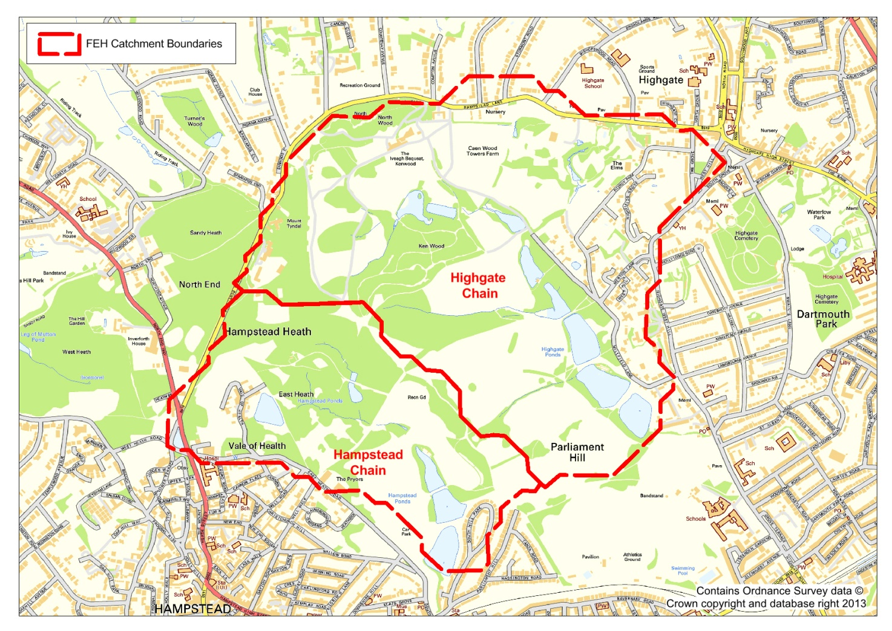

Figure 4‑1 Hampstead and Highgate FEH Catchment Boundary Map

Haycock (2006) derived catchment boundaries using the Digital Land Elevation Model of Hampstead Heath. As part of the Atkins study, these boundaries were verified using the topographic data and where appropriate, minor modifications made. These modifications made no significant difference to the overall catchment areas. These catchment boundaries and areas were consistent with the FEH-derived catchments and were used in place of those derived from the FEH CD-ROM and are illustrated in and .

Several of the catchments, particularly those for the Highgate chain include the urban areas adjacent to the Heath. Surface water runoff from these urban areas is likely to drain into the surface water sewer system. Sewers are however designed to convey only low return period events (typically up to the 1 in 30 year event) and would therefore take an insignificant proportion of the runoff during an extreme event (for example the 1 in 1,000 year and the PMF) before becoming overwhelmed. The remaining runoff will be routed over the natural topography and would therefore contribute to flows in the whole topographic catchment. Given the relatively low proportion of the total flow that can be carried in storm sewers,the industry-standard assumption is that any surface water sewers are already overwhelmed by the time a storm of this magnitude arrives. Furthermore, while roof tops, guttering and roads will drain to surface water sewers, there are some parts of urban areas (for example property gardens) which will allow for some infiltration. This part of urban rainfall that does not runoff into the sewer system will become overland / subsurface flow and will be routed according to the natural topographic catchment throughout the event. For these reasons, the full topographic catchment areas were used for subsequent flow estimation, with no exclusion of the urban areas.

documents the total upstream topographic catchment area for each Hampstead Heath pond included in this study, the total pond surface area in these catchments and the catchment area excluding all pond surfaces. The latter was taken forward for use in flow derivation. The impact of rain falling directly on the pond surfaces has been included as direct rainfall boundaries in the hydraulic model (with no loss component to the rainfall). This will ensure that the effect of reservoir routing and storage will be included only in the hydraulic model and will not be double counted in both the hydrology and hydraulics. It will also account for the fact that no rainfall is lost to interception, infiltration or evaporation when it falls directly over the pond surface.

Table 4‑1 Catchment Areas and Pond Area

| Catchment | Topographic Catchment Area (km2) | Cumulative Pond Area (km2) | Hydrological Catchment Area (km2) |
| --- | --- | --- | --- |
| **Highgate Chain** | | | |
| Stock | 0.63 | 0.02 | 0.61 |
| Ladies Bathing | 0.78 | 0.02 | 0.76 |
| Bird Sanctuary | 1.18 | 0.03 | 1.15 |
| Model Boating | 1.27 | 0.05 | 1.22 |
| Men’s Bathing | 1.43 | 0.07 | 1.36 |
| Highgate No 1 | 1.56 | 0.08 | 1.48 |
| **Hampstead Chain** | | | |
| Vale of Health | 0.08 | 0.01 | 0.07 |
| Viaduct | 0.13 | < 0.01 | 0.13 |
| Mixed Bathing | 0.58 | 0.02 | 0.56 |
| Hampstead No 2 Pond | 0.67 | 0.03 | 0.64 |
| Hampstead No 1 Pond | 0.72 | 0.05 | 0.67 |

Note: The two most upstream ponds on the Highgate chain (Wood Pond and Thousand Pound Pond) are not included in this table but the contribution of the catchment areas has been taken into account as described below.

Kenwood Pond has not been modelled explicitly in this study as it was judged that any the additional storage available was negligible. However, its catchment contributes to flow into Stock Pond and so has been accounted for as part the Stock Pond catchment area.

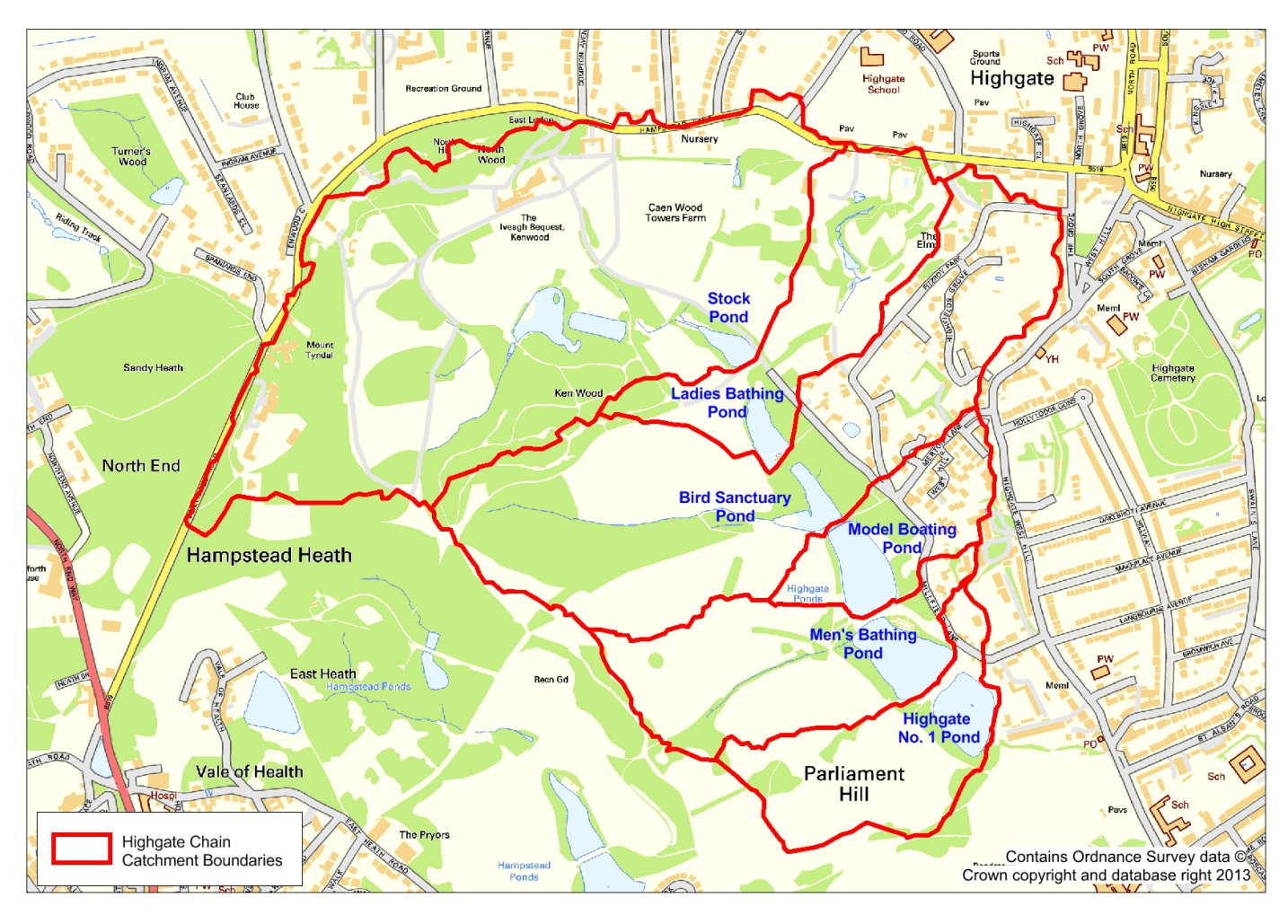

Figure 4‑2 Highgate Chain Catchment Boundary Map

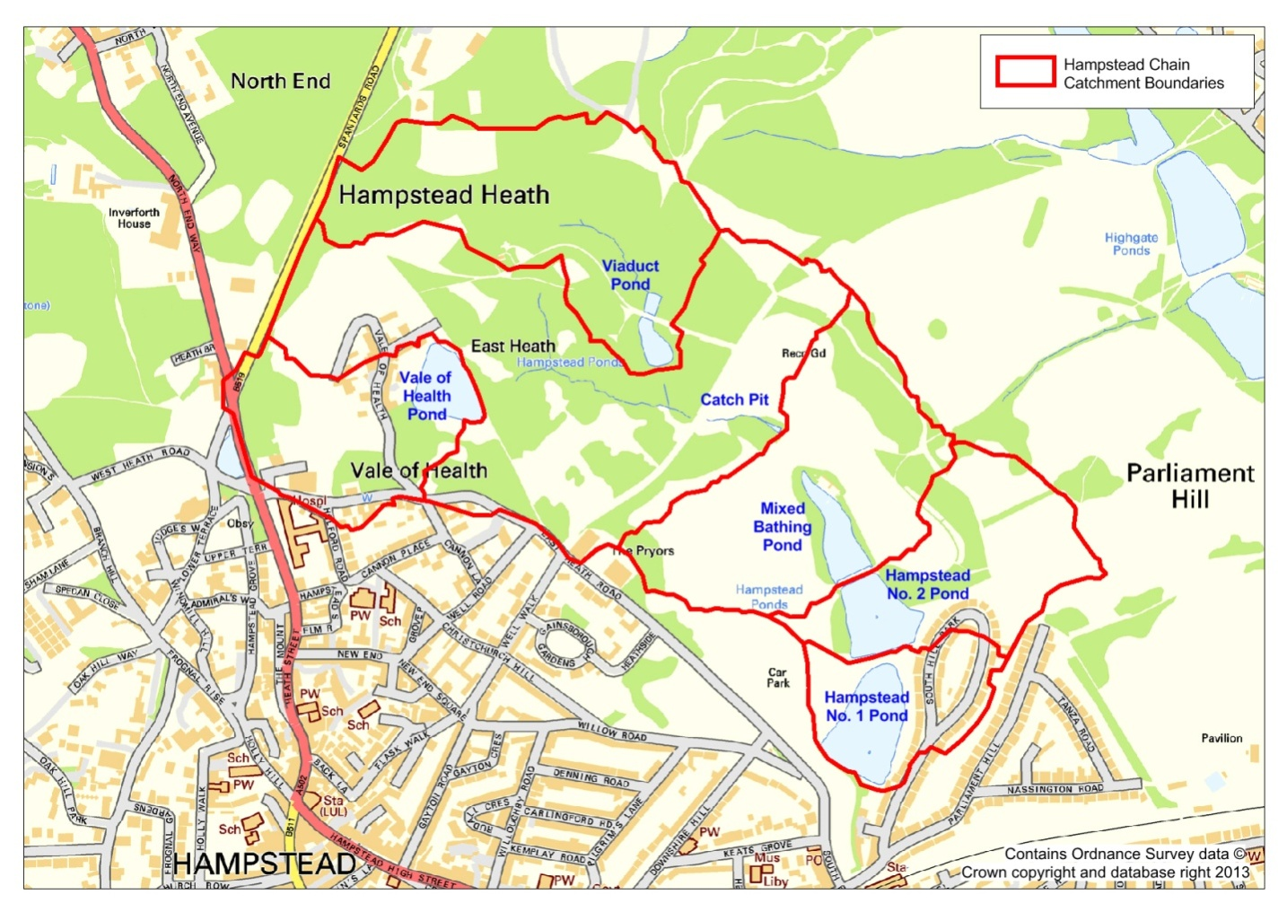

Figure 4‑3 Hampstead Chain Boundary Map

## Catchment Descriptors

Catchment descriptors were obtained from the FEH CD-ROM for the FEH catchment and from the FSR maps. Catchment area was established using the method described above. The catchment descriptors used in the subsequent hydrological assessment are provided in and . Further details of the derivation of urban extent values and the Standard Percentage Runoff (SPR) are given below. The FEH Manual (Centre for Ecology and Hydrology, 1999) provides descriptions of all the catchment parameters.

Table 4‑2 Catchment Descriptors

| Catchment | Area (km2) | URBEXT | Urban Fraction | SAAR (mm) | DPLBAR (km) | DPSBAR (m/km) |
| --- | --- | --- | --- | --- | --- | --- |
| **Highgate Chain** | | | | | | |
| Stock | 0.61 | 0.079 | 0.162 | 682 | 0.64 | 67.7 |
| Ladies Bathing | 0.76 | 0.113 | 0.231 | 682 | 0.77 | 66.3 |
| Bird Sanctuary | 1.15 | 0.133 | 0.273 | 681 | 0.83 | 68.7 |
| Model Boating | 1.22 | 0.151 | 0.308 | 680 | 1.00 | 69.4 |
| Men’s Bathing | 1.36 | 0.144 | 0.296 | 680 | 1.04 | 68.7 |
| Highgate No 1 | 1.48 | 0.149 | 0.306 | 679 | 1.15 | 69.0 |
| **Hampstead Chain** | | | | | | |
| Mixed Bathing | 0.56 | 0.075 | 0.153 | 669 | 0.73 | 83.4 |
| Hampstead No 2 | 0.64 | 0.084 | 0.172 | 668 | 0.80 | 82.2 |
| Hampstead No 1 | 0.67 | 0.126 | 0.259 | 668 | 0.89 | 82.9 |

Table 4‑3 Hampstead Heath Descriptors for all Catchments

| Descriptor | All Catchments |
| --- | --- |
| PROPWET (dimensionless factor) | 0.29 |
| SPR (%) | 53 |
| Em-2h (mm) | 185 |
| Em-24h (mm) | 270 |
| Em-25d (mm) | 370 |
| M5-2d (mm) | 50.5 |
| M5-25d (mm) | 20.5 |
| Jenkinson’s r (ratio) | 0.43 |

Urban Extent

The FEH CD-ROM provides values for the URBEXT1990 and URBEXT2000 to describe the level of urbanisation of a catchment. These two descriptors were derived using different methods and are therefore not directly comparable (Defra, 2006). Methods for hydrological estimation developed using URBEXT1990 should therefore not be applied with URBEXT2000 (Defra & Environment Agency, 2006). The FEH method was developed for the URBEXT1990 parameter and can therefore only be used with the URBEXT1990 parameters, with an adjustment made for changes to urbanisation since 1990. Hence, for this study, the URBEXT1990 values from the FEH CD-ROM were extracted for all catchments and updated using the FEH (volume 5) equation 6.8 (p53) to take into account estimated development over the last two decades. The resulting descriptors were used directly in the FEH Rainfall Runoff (RR) analysis of flood events.

Flood estimation using the FSR rainfall-runoff methodology requires input of an urban fraction, which has been calculated from the updated URBEXT1990 using the FEH (volume 5) equation 6.4 (p48).

Percentage Run-off

The percentage run-off of a catchment is the percentage of the total rainfall that becomes direct runoff. Estimation of percentage runoff is the most important part of flood estimation using the FSR/FEH rainfall-runoff methods as it has a direct scaling influence on the magnitude of the resulting rapid response runoff. It is also the most uncertain part of the runoff estimation, as it is reliant on a number of datasets that are difficult to collect including catchment type, catchment state and storm variability.

Previous hydrological studies for Hampstead Heath have used a variety of methods for determining the percentage runoff and these have resulted in widely ranging flow estimates for the catchments. The 1987 flood studies report (Binnie and Partners) utilised a runoff percentage of 27%. In contrast, and following a small number of infiltration tests, Haycock (2006) suggested that a runoff percentage of 80 – 90% should be expected during an extreme event given the highly compacted nature of the soils on the Heath, particularly adjacent to the footpaths. Included in the scope of this study was therefore a detailed consideration of the most suitable runoff percentage to apply to the catchments.The FSR/FEH rainfall-runoff methods apply the unit hydrograph and losses model, which assumes that the percentage runoff is constant throughout an event and is applied to each block of total rainfall hyetographs i.e. a constant proportional loss model. However, in reality, percentage runoff will not be constant, but will increase as deficits are made up and soils become saturated.

The Percentage Runoff is made up of the SPR (Standard Percentage Runoff) which represents the normal capacity of the catchment to generate runoff, and dynamic terms representing the variation in runoff depending on catchment antecedent conditions (i.e. the state of the catchment prior to the event, due to previous rainfall events. Hence the calculation takes account of the average rainfall that could have fallen for the 5 days prior to the event) and the storm magnitude itself.

PR = PRRURAL(1-0.615URBEXT) + 70(0.615URBEXT) [4.1]

Where PRRURAL = SPR + DPRCWI + DPRRAIN  [4.2]

DPRCWI = 0.25(CWI-125) [4.3]

${DPR}_{RAIN}= \left\{\begin{aligned}0 for P≤40mm \\ {0.45(P-40)}^{0.7} for P >40mm \end{aligned}\right.$ [4.4]

The urban adjustment of the PR assumes that 61.5% of the urbanised area is impervious and gives 70% runoff, whilst the other 38.5% of the urbanised area acts as a natural (open area of the Heath and gardens i.e. rural) catchment. It should be noted that impervious surfaces are likely to incorporate localised depressions which will store some of the rainfall. This stored water will be lost by evaporation rather than run-off and therefore the value of 70% takes account of depression storage in urban areas. The adjustment reflects the mixed natural and impervious areas that occur within urbanised areas, and makes the effect of the urbanisation dependent on the underlying soils. On Hampstead Heath the urban percentage is small and the calculation for urban adjustment will have little impact on the percentage runoff.

SPR is fixed for all storms for the catchment, while the DPR allows the percentage runoff to vary between different storm events and different catchment antecedent conditions.

SPR can be derived by a number of methods:

1. From concurrently observed rainfall and discharge records. The SPR is derived for several events (of different sizes) and an average value obtained;
2. Derived from the baseflow index using the equation SPR=72.0-66.5BFI. BFI can be derived from flow records, using baseflow separation, and is a measure of a watercourse’s long-term discharge from stored sources.
3. In the absence of observed records, SPR can be estimated from catchment descriptors using the following equation:



Where HOSTi is the percentage of the catchment covered by HOST types 1 to 29 and SPR is the percentage runoff assigned to each class, taken from Table 2.2 in FEH Volume 4 (Plate C.1 of FEH Volume 4 is the HOST map for the UK). The Hydrology of Soil Type classification allows SPR to vary from 2% to 60% and reflects runoff from different soil types.

Deriving an adjusted SPR for Hampstead Heath

Haycock, in 2006, undertook infiltration tests on the Heath and found that the footpaths had lower infiltration rates than the underlying soil type, due to compaction from being heavily trafficked. They also concluded that a 10m buffer either side of the footpaths would be similarly compacted. Based on a limited number of infiltration tests, Haycock concluded that a runoff rate of 90% should be applied to the entire Heath.

We have examined the effect of the footpaths, by utilising FEH methods for deriving a revised SPR value.

The FEH CD-ROM provides a SPR value calculated from the HOST (Hydrology of Soil Types) classification of around 30% for the Hampstead Heath catchments. This reflects the balance between the less permeable soils (HOST 25) overlying the London Clay geology and the more permeable soils (HOST 2) overlying the Claygate Beds and the Bagshot Beds. The low SPR will result in correspondingly low runoff estimates, with the risk that these will significantly underestimate flows in the catchments, especially during extreme events.

Haycock (2006) calculated the total length of paths on the whole of Hampstead Heath to be 105km. Based on an even distribution of the path network, including desire lines, it has been assumed that the Highgate catchments have 40km of paths and the Hampstead catchment has 18.4km of paths. Adopting Haycock’s assumption of a 10m path width representative of the heavy use of the Heath and for the path lengths set out above, a calculated 26% of the Hampstead and Highgate catchments consist of compacted path areas. The SPRHOST for these areas was increased to the maximum SPR value of 60% which, when combined with the remaining areas results in a revised SPR of 46%. Judgement was then used to further increase the value to 53% to account for drying / cracking of the soil during the summer. When compared with the theoretical output from the industry methods, this is consistent with the minimum value recommended in the recognised PMF methodology. In our opinion therefore the value of SPR=53% can be justified on the basis of science and site specific conditions.

The chosen SPR value of 53% was applied to all catchments and for all flood events. The actual Percentage Runoff (PR) is calculated separately and will vary with flood event (as described by equations 4.1 and 4.2 above). When used to calculate the PMF for example, an SPR of 53% will result in a PR of around 76% and a PR of 54% for a 100 year event.

## Rainfall Analysis

Methodology

The methodology for the generation of design rainfall events was consistent with Defra’s (2004) recommendations to Panel Engineers namely:

* The use of the Flood Studies Report (FSR)[4] for estimating the Probable Maximum Precipitation (PMP);
* The use of the FSR design rainfall method for the 1 in 10,000 year event;
* The use of both the FEH and FSR design rainfall methods for the 1 in 1,000 year event and the most extreme of the rainfall depths used in the subsequent flood assessment. For Hampstead Heath, the FEH method was found to provide significantly higher design rainfall depths for this flood event compared with the FSR method; and
* The use of the FEH design rainfall method for all other smaller return period events.
* The use of the Revitalised FEH (ReFH) methodology was considered for lower return period events but the FEH methodology was favoured by the Panel Engineer as ReFH only provides reliable estimates up to the 1 in 193 year rainfall event. Given the focus of this study on the extreme flood events, and for consistency, the FEH method was adopted for all design rainfall events with the exception of the PMP and 1 in 10,000 year events. This is widely accepted as the current best practice methodology for reservoir flood hydrology.

Design Rainfall Depth

The FEH CD-ROM provides Depth-Duration-Frequency (DDF) curves for a 1km2 grid covering the whole of the UK. Design rainfall depths were extracted for the four grid squares covering Hampstead Heath for a range of storm durations and rainfall events up to the 1 in 1,000 year. An average of these depths was taken and where necessary interpolated using logarithmic regression relationships to provide values for intermediate storm durations.

Current Defra Guidance (Defra, 2004) states that use of the FEH DDF curves is not an appropriate way to calculate design rainfall depths for the 1 in 10,000 year event or the PMP used to estimate the PMF. Rainfall depths for the 1 in 10,000 year event were therefore derived using the FSR methodology for all storm durations in line with the guidance. The PMP was similarly derived from the FSR.

A summary of the total rainfall depth is provided in for selected storm durations. The appropriate rainfall depth was applied to each individual catchment to reflect the likelihood that over this small area, a single storm event could occur over the whole Heath.

Table 4‑4 Hampstead Heath Design Rainfall Depths

| Flood Event | Rainfall Depth (mm) for varying storm durations | | | |
| --- | --- | --- | --- | --- |
| 1.5 hours | 2.5 hours | 4.5 hours | 9.5 hours |
| 1 in 5 | 20.4 | 25.9 | 30.7 | 38.0 |
| 1 in 20 | 36.0 | 40.8 | 47.3 | 56.9 |
| 1 in 100 | 60.8 | 67.5 | 76.3 | 89.0 |
| 1 in 1,000 | 127.7 | 137.8 | 150.3 | 167.8 |
| 1 in 10,000 | 135.0 | 150.0 | 164.0 | 183.1 |
| PMP | Not calculated | 187.9 | 208.5 | 235.0 |

Observed Rainfall Depths

The Hampstead Heath Scientific Society owns and maintains a weather station close to the south-west corner of Hampstead Heath, about 1km from Hampstead No. 1 pond. The Society has been collecting daily rainfall data for the last 100 years and the digitised gauged record was provided for use in this study (Atkins is grateful to the Hampstead Heath Scientific Society for allowing access to this data). An Annual Maximum (AMAX) series was derived, consisting of the maximum 24-hour duration rainfall depth observed in each water year. A total of 99 AMAX records were derived ranging from a minimum of 17.8mm in September 1998 to a maximum of 170.8mm in August 1975. The latter resulted in a well documented flood event on Hampstead Heath.

A statistical analysis was then undertaken on this dataset to derive a site-specific depth-frequency curve for the 24-hour storm duration. A range of statistical distributions was investigated, two of which are presented in below (see for a graph of other distributions). shows that different distributions give widely different curves for return periods greater than about 50 years. However, the Generalised Logistic distribution appears to give the best fit to the observed data at higher return periods.

Table 4‑5 Hampstead Scientific Society Rainfall Gauge Depth Frequency Curves

| Return Period (1 in T years) | 24-hour Rainfall Depth (mm) | |
| --- | --- | --- |
| Log Normal Distribution | Generalised Logistic Distribution |
| 1 in 5 | 48.96 | 43.46 |
| 1 in 20 | 73.32 | 66.28 |
| 1 in 50 | 90.05 | 88.15 |
| 1 in 100 | 103.27 | 110.14 |
| 1 in 1,000 | 151.60 | 239.92 |
| 1 in 10,000 | 207.95 | 543.70 |

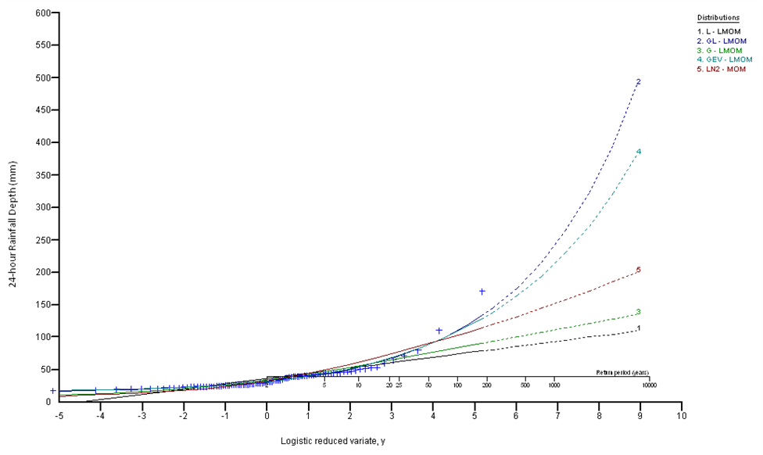

Figure 4‑4 Hampstead Heath Scientific Society Rainfall Gauge Depth Frequency Curves

The analysis of the HHSS gauge provides site-specific information that can be compared with the FEH and FSR DDF curves. Consistent with industry best practice recommendations (Defra, 2004) however, the data from the HHSS gauge was not used in this design storm statistical assessment. Instead the DDF rainfall, which is based on a larger number of rain gauges, was used. The graph below provides a comparison between the 24-hour DDF curve from FEH (for each of the 4, 1km2 squares covering the Heath), and that generated by the GL distribution for the HHSS single point gauge data (up to the 1,000 year event). It shows that the HHSS curve is much steeper than the FEH DDF curve for large return period events.



Figure 4‑5 24-hour Rainfall Depth Frequency Curves

While the HHSS rainfall gauge data provides a useful local record of rainfall for an extended period of 100years, from a statistical perspective, it cannot be used to provide design rainfall depths for the very large return period events being considered in this study. To do so would involve excessive extrapolation of the data beyond its useful and reliable limit. As can be seen, the 24-hour DDF curve derived from the HHSS gauge has given rise to much higher rainfall depths for events above the 100 year event and the curve is much steeper that the FEH DDF. Hence, if the HHSS curve is extrapolated further, it will give increasingly divergent and higher rainfall depths, resulting in very large predicted flood peaks. It should be noted that, while the HHSS data cannot be used within the statistical analysis, it will be used to provide the depths for observed events such as the 1975 and 2002 events which will be modelled later on to examine how the system performed under these storms.

Design Rainfall Profiles

Design rainfall profiles have been examined for both the summer and winter events. The summer rainfall profiles resulted in higher peak flows for all events. Hence the summer storm profile was carried forward for the rest of the analysis

## Hydrograph Generation

The methodology for the generation of flood hydrographs was consistent with Defra’s (2004) recommendations to Panel Engineers namely:

* The use of the PMF option in the ISIS software FEH RR unit. This derives Time to Peak (Tp), Percentage Runoff (PR) and Baseflow (BF) using FEH catchment descriptors, but retains the FSR-calculated PMP;
* The use of the ISIS software FSSR16 unit to derive hydrographs for the 1 in 10,000 year event, using the FSR rainfall depths described above; and
* The use of the ISIS software FEH RR unit to derive hydrographs for all other return periods (up to and including the 1 in 1,000 year event), using the FEH rainfall depths described above.

For each event a variety of storm durations was tested and hydrographs calculated to determine the critical hydrological storm duration. These were run in the hydraulic model to confirm the critical duration for the two Hampstead Heath pond chains.

Hydrographs were calculated for each total catchment down to the respective pond outflow. For all events and durations, the upstream catchment hydrograph was then subtracted from the total catchment hydrograph to derive hydrographs for the intervening catchment areas. These formed the inflows to each pond in the hydraulic model. This approach was used as the FEH / FSR methods are less reliable for flow calculation for the very small intermediate catchments less than 0.5km2 in area.

Vale of Health pond and Viaduct pond have very small contributing catchment areas (0.08km2 and 0.13km2 respectively). Hydrographs were therefore derived for the larger upstream Hampstead catchment (to the Catch Pit which has an area of 0.45km2) and were scaled by catchment area to provide three separate inflows to the respective ponds within the hydraulic model.

These flow hydrographs exclude the contribution of rain falling on the ponds. The rainfall profiles derived for each event / storm duration have been converted to flow-time hydrographs and inserted as inflows to the pond areas in the hydraulic model.

## Hydrological Modelling Results

provides the peak inflows derived for the two downstream catchments (total catchment to Highgate No. 1 Pond and Hampstead No. 1 Pond) for the (varying) hydrological critical storm durations[5] for the range of flood events.

Table 4‑6 Highgate No. 1 and Hampstead No. 1 Ponds - Critical Storm Duration and Peak Flow

| Flood Event  (1 in T year) | Highgate No. 1 Pond | | Hampstead No. 1 Pond | |
| --- | --- | --- | --- | --- |
| Critical Duration (hours) | Peak Flow (m3/s) | Critical Duration (hours) | Peak Flow (m3/s) |
| 1 in 5 | 2.3 | 2.49 | 2.3 | 1.18 |
| 1 in 20 | 2.7 | 3.96 | 2.7 | 1.87 |
| 1 in 100 | 2.3 | 7.02 | 2.1 | 3.34 |
| 1 in 1,000 | 1.9 | 16.08 | 1.5 | 7.72 |
| 1 in 10,000 | 1.9 | 18.44 | 1.9 | 8.49 |
| PMF | 9.5 | 39.10 | 9.5 | 18.82 |

provides a comparison between the peak flows for the total catchments to each of the Hampstead Heath ponds, as calculated by Haycock (2010) and Atkins (2013). This illustrates that the flows calculated by Atkins for the 1 in 10,000 year and the PMF events are significantly lower than those previously calculated by Haycock, largely as a result of the lower SPR / PR values used for the Atkins analysis. In contrast however, the 1 in 100 year event calculated by Atkins has mostly higher peak flows compared with the Haycock analysis. As noted above, it is believed that Haycock derived the T-year flood peaks by deriving the Qmean from the FSR equation using catchment descriptors, and then applied the FSR regional growth curve to derive the other T-year peaks. This will give results that are different to using FEH for deriving the T-year hydrographs, as we have done. When comparing the 10,000 year and the PMF flows, the following should also be noted:

* Haycocks used a storm duration of 4.4 hours for all events. The Atkins flows listed in the table below are for the calculated hydrological critical storm duration for each catchment. This was found to vary between 1.9 and 2.7 hours for the 5, 20, 100, 1,000 and 10,000year return period events, and to be 9.5 hours for the PMF;
* The Atkins peak flow values in Table 4-7 were calculated by summing the total runoff from non-pond areas of the catchment and the flow resulting from rain falling directly on the pond surfaces; The Haycock (2010) PMF was calculated as an approximation by doubling the calculated 1 in 10,000 year event peak flow wthe Atkins PMF was calculated using the appropriate deterministic approach underlying the PMP rainfall applied to the FSR/FEH rainfall-runoff model. Table 4-7 illustrates that the Atkins ratio of the 1 in 10,000 year and PMF peak flow is 2.1 for Highgate 1 and 2.2 for Hampstead 1.
* Haycock used a percentage runoff of 80-90% while Atkins percentage varied from 53% for the 1 in 100 year event to 60% for the 10,000 year event and 76% for the PMF.

Table 4‑7 Comparison of Hampstead Heath Peak Flows Haycock (2010) and Atkins (2013)

| Pond Catchment | Peak Flow (m3/s) | | | | | |
| --- | --- | --- | --- | --- | --- | --- |
| 1 in 100 year | | 1 in 10,000 year | | PMF | |
| Haycock | Atkins | Haycock | Atkins | Haycock | Atkins |
| **Highgate Chain** | | | | | | |
| Stock | 2.34 | 2.74 | 14.49 | 6.86 | 28.98 | 15.54 |
| Ladies Bathing | 2.85 | 3.63 | 18.15 | 9.10 | 36.30 | 20.35 |
| Bird Sanctuary | 3.76 | 5.82 | 24.14 | 14.53 | 48.28 | 31.88 |
| Model Boating | 4.15 | 6.15 | 31.23 | 15.65 | 62.46 | 33.71 |
| Men’s Bathing | 4.48 | 6.57 | 34.13 | 17.02 | 68.26 | 36.48 |
| Highgate No 1 | 4.79 | 7.02 | 36.84 | 18.44 | 73.68 | 39.10 |
| **Hampstead Chain** | | | | | | |
| Vale of Health | 1.64 | 0.57 | 4.67 | 1.45 | 9.34 | 3.32 |
| Viaduct | 0.85 | 0.31 | 6.04 | 0.78 | 12.08 | 1.78 |
| Mixed Bathing | 2.49 | 2.46 | 22.80 | 6.31 | 45.60 | 14.15 |
| Hampstead No 2 | 2.58 | 2.81 | 25.62 | 7.27 | 51.24 | 16.14 |
| Hampstead No 1 | 2.78 | 3.34 | 26.30 | 8.49 | 52.60 | 18.82 |

# Hydraulic Modelling

This Chapter describes the following aspects of the hydraulic modelling:

* The output provided by the hydraulic modelling;
* Modelling methodology and assumptions;
* The hydraulic modelling results including confirmation of the critical storm durations; and
* The depths of flow over the crests of the dams and as assessment of the implications of these flows on the performance of the ponds during extreme floods.

## Study Output

The following was required as output from the hydraulic model:

* Flow-time hydrographs over each dam crest;
* Flow-time hydrographs through each pond outfall pipe; and
* Stage-time relationships for each pond.

These times series were then used to determine the following:

* Maximum flood rise for each pond (peak water level minus starting water level); and
* Maximum dam crest overtopping depth (peak water level minus minimum crest level).

The design flood events used in the modelling were the standard extreme events for reservoir safety studies (1 in 1,000 year, 1 in 10,000 year and the Probable Maximum Flood (PMF)) and a range of lower return period events (1 in 5 year, 1 in 20 year and 1 in 100 year) for the purpose of determining the current SoP of each dam.

## Modelling Methodology and Assumptions

A linked 1D-2D hydraulic model of Hampstead Heath was constructed using InfoWorks RS modelling software, version 12.0.3. As discussed in Section 3, the representation of reservoir as 1-dimentsional units linked to the overland flow routes all the way around the perimeter of the reservoir will best represent the overflow from the reservoirs during extreme flood events. This is the approach that was taken here to good effect, and the following sections summarise the modelling methodology, key assumptions and results of the modelling.

### Model Inflows

Flow-time boundary nodes were used to provide each modelled pond with two hydrological inflows:

* A flow hydrograph representing the event runoff from the catchment to each pond (i.e. runoff from land draining into the pond); and
* A flow hydrograph representing the volume of rainfall that would enter the pond directly from rainfall falling onto the pond surface.

### Ponds

Storage Area

The five ponds on the Hampstead chain (Vale of Health, Viaduct, Mixed Bathing, Hampstead 2 and Hampstead 1) and the six ponds on the Highgate chain (Stock, Ladies Bathing, Bird, Model, Men’s Bathing and Highgate 1) were modelled in the one dimension (1D) as storage areas. This means that they have been presented as frictionless buckets that fill up and then discharge when the water level reaches the overflow pipe and dam crest levels. The starting water level in each pond was set to the invert level of the respective overflow pipe (pond Top Water Level – TWL). These values were obtained from the Haycock Stella Model (2010) and confirmed using data from the Emergency Response Plan (City of London, 2012) and are listed in .

Table 5‑1 Pond Top Water Level and Surface area

|  |  |  |
| --- | --- | --- |
| **Pond** | **Top Water Level (TWL)**  **(m AOD)** | **Surface area @ TWL(km2)** |
| **Highgate Chain** |  |  |
| Stock | 81.06 | 0.00440 |
| Ladies Bathing | 76.00 | 0.00693 |
| Bird Sanctuary | 71.95 | 0.00769 |
| Model Boating | 71.35 | 0.01628 |
| Men’s Bathing | 67.59 | 0.01825 |
| Highgate No 1 | 62.45 | 0.01366 |
| **Hampstead Chain** | | |
| Vale of Health | 105.04 | 0.00865 |
| Viaduct | 89.50 | 0.00333 |
| Mixed Bathing | 74.95 | 0.00715 |
| Hampstead No 2 | 74.39 | 0.01091 |
| Hampstead No 1 | 69.39 | 0.01519 |

The surface area of each pond at top water level was determined from mapping. The level-area relationship above this level was abstracted from the DEM.

Dam Crest

The dam crests were modelled using spill units, with elevations taken from the topographic survey (Plowman Craven, 2010). A weir coefficient value of 1.5 was used to represent the grassed nature of the embankments and steep downstream slopes. Infoworks RS recommends a value of 1.0 to 1.7 for spills representing broad crested weir flow as would occur for the embankments. A value of 1.5 was chosen on the basis of guidance given in CIRIA Report No. 116 for flow over embankments such as the Hampstead Heath dams. The spill units were connected to the upstream pond and either directly to the downstream pond or to the 2D floodplain area. Table 5-2 provides the modelled minimum dam crest level, the modelled dam length and the downstream connection unit.

Table 5‑2 Dam Minimum Crest Level, Length and Connections

| Pond | Minimum Crest Level (m AOD) | Crest Length (m) | Downstream Connection |
| --- | --- | --- | --- |
| **Highgate Chain** | | | |
| Stock | 81.65 | 60 | 2D Floodplain |
| Ladies Bathing | 76.87 | 54 | 2D Floodplain |
| Bird Sanctuary | 72.57 | 61 | Model Boating Pond |
| Model Boating | 71.87 | 75 | Men’s Bathing Pond |
| Men’s Bathing | 68.16 | 124 | Highgate No 1 Pond |
| Highgate No 1 | 63.50 | 130 | 2D Floodplain |
| **Hampstead Chain** | | | |
| Vale of Health | 105.44 | 130 | 2D Floodplain |
| Viaduct | 89.97 | 65 | 2D Floodplain |
| Mixed Bathing | 75.46 | 70 | Hampstead No 2 Pond |
| Hampstead No 2 | 74.91 | 105 | Hampstead No 1 Pond |
| Hampstead No 1 | 70.91 | 121 | 2D Floodplain |

Pond Banks

The right and left banks of the ponds upstream of the dams were also defined using spill units, but the elevations were taken from the DEM. A weir coefficient value of 1.0 was used to represent the grassed nature of the pond edges. Infoworks RS recommends a value of between 0.7 and 1.0 for overbank spills representing side or lateral spills of this nature. The spill units were connected to the pond and the neighbouring 2D floodplain area. This enabled flows to pass to and from the 1D and 2D parts of the model.

Overflow Pipes

Most of the pond outfall pipes were included in the model as Flow-Head Control Weirs. These had a defined crest level and a flow-head relationship derived based on the number, length and diameter of the pipes. The pipe details were obtained from the Haycock Stella Model (2010) and confirmed using data from the Emergency Response Plan (City of London, 2012).

The weirs connected the upstream pond with either the downstream pond or the 2D floodplain area, consistent with the connection information provided for the dam spills in Table 5-2. Where the pipe length was less than 10m, the outfall pipes were instead modelled using ‘short conduit’ orifices. This applied to the outfall pipes from Bird Pond and Mixed Bathing Pond. The orifice units had defined invert, soffit & sill levels, and bore areas. This information was also obtained from the Haycock Stella Model (2010) and confirmed using the Emergency Response Plan (City of London, 2012).

### Floodplain

Flows across the floodplain were modelled in 2D using a 2D simulation polygon with a maximum triangle size of 150m2. All ground elevations were taken from the DEM, with no changes made. Some areas surrounding the ponds have dense vegetation / tree cover. Examination of the DEM data provided suggested that the method that was used for determining ground levels in these locations, which would have involved interpolation across areas where tree elevations would have been removed, may have been less effective resulting in potentially poorer quality elevation data in these areas. This reduced quality data may affect floodplain flow routes in these locations. A universal Manning’s n roughness value of 0.02 was used for the entire modelled floodplain area. This is a widely recognised value for short-grassed areas with relatively deep flowing water as would be the case in the extreme floods. All channels and the catch pit on the Hampstead Chain were modelled in the 2D domain. is the Hampstead Heath Infoworks Model schematic.

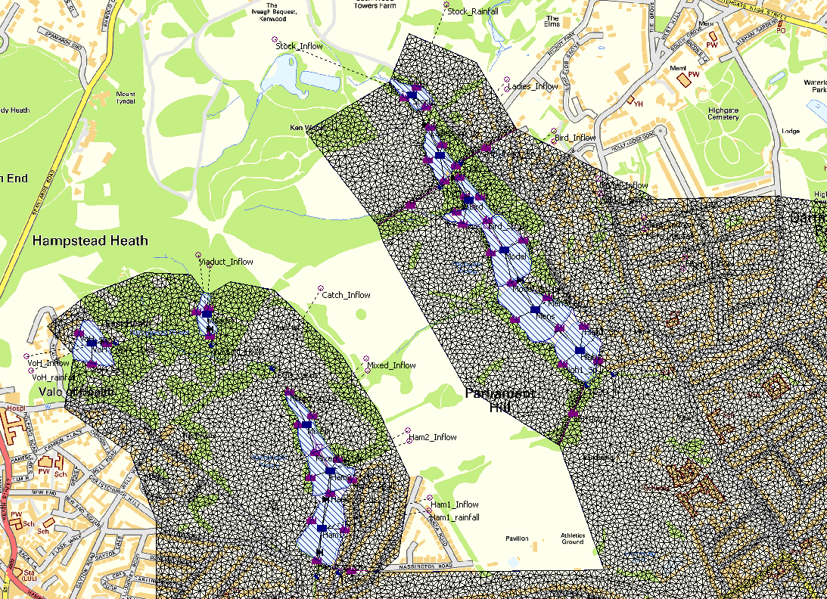

Figure 5‑1 Model screen shot showing ponds (blue striped polygons), 2D floodplain (black netted polygon) and inflows (small purple circles)

## Hydraulic Modelling Results

### Confirmation of Critical Storm Duration

Each flood event was run in the hydraulic model with four different storm durations centred around the storm that was found to give the largest peak flow in the hydrological model (i.e. the hydrological critical duration). The results were then extracted from the storage areas to determine the peak water level in each pond. The hydraulic critical storm duration was assessed at each pond and the overall system critical duration was determined to be the duration which resulted in the highest water levels at the greatest number of ponds or the critical duration of the lowest pond in the chain if different from that of the other ponds. The results demonstrated that hydrological critical storm duration was confirmed as the critical duration after running through the hydraulic model. This is largely because the ponds provide little storage, particularly for the larger storm, which is the main factor that could attenuate the inflow and result in a longer hydraulic critical duration. The final durations selected for use in the modelling are listed in .

Table 5‑3 Confirmation of Critical Storm Duration

| Flood Event | Critical Storm Duration (hours) |
| --- | --- |
| 1 in 5 year | 3.9 |
| 1 in 20 year | 2.9 |
| 1 in 50 year | 2.9 |
| 1 in 100 year | 3.9 |
| 1 in 1,000 year | 1.9 |
| 1 in 10,000 year | 2.3 |
| PMF | 9.5 |

## Summary of Model Results

### Overtopping Assessment

to provide a summary of the depth of overtopping assessment model results. This information will be used to determine the performance and safety of the existing structures. provides a comparison to the Haycock 2010 overtopping depths for the PMF which shows that, in general, overtopping depths produced by the current study are lower than those produced by the 2010 study, with as much as a 1m reduction in depth over the Ladies Bathing Pond dam and 770mm reduction in depth over Mixed Bathing Pond. The ponds that show very little difference in overtopping depth are likely to have very limited storage capacity above TWL relative to the volume of the inflow. Hence a flood of any magnitude will result in overtopping of these ponds, resulting in similar overtopping depths. This appears to be the case with Stock Pond, Model Boating and Highgate 1. Table 5‑7 is an assessment of the storage capacity of each pond relative to the inflow PMF from its natural catchment (i.e. not including any outflow from the upstream reservoirs either over the dam or through the outflow pipes). It shows that Stock Pond can store 2% of the PMF, Model Boating 27% and Highgate 1, 56%. However Highgate 1, at the bottom of the chain will have a much smaller storage capacity than this, after all overflowing spills into it from upstream are account for. The table shows that Hampstead 1 can store 138% of its natural catchment PMF, but similar to Highgate 1, will also need to accommodate overflow from all upstream reservoirs. The volume of storage at the Kenwood ponds was investigated and judged to be insignificant.

Figure 5‑2 shows the flood map for the PMF event. It shows that for many of the ponds, there is overbank flow out of the sides of the reservoirs in addition to flow over the dam crest. An examination of the 2D flow velocities and flows over the spills revealed a very dynamic interaction between the reservoirs and the floodplain. The flood maps also show that there could be significant flooding to properties downstream during the PMF due to overtopping alone.

Table 5‑4 PMF Summary Results

| Pond | Peak Water Level (m AOD) | Flood Rise (m) | Maximum Dam Overtopping Depth (m) - Atkins | Maximum overtopping depth – Haycock 2010 |
| --- | --- | --- | --- | --- |
| **Highgate Chain** | | | |  |
| Stock | 82.10 | 1.04 | 0.45 | 0.66 |
| Ladies Bathing | 77.11 | 1.11 | 0.24 | 1.31 |
| Bird Sanctuary | 73.02 | 1.07 | 0.45 | 0.71 |
| Model Boating | 72.24 | 0.89 | 0.37 | 0.49 |
| Men’s Bathing | 68.54 | 0.95 | 0.38 | 0.6 |
| Highgate No 1 | 64.12 | 1.67 | 0.62 | 0.7 |
| **Hampstead Chain** | | | |  |
| Vale of Health | 105.59 | 0.55 | 0.15 | 0.48 |
| Viaduct | 90.09 | 0.59 | 0.12 | 0.5 |
| Mixed Bathing | 75.77 | 0.82 | 0.31 | 1.08 |
| Hampstead No 2 | 75.18 | 0.79 | 0.27 | 0.59 |
| Hampstead No 1 | 71.10 | 1.71 | 0.19 | 0.59 |

Table 5‑5 1 in 10,000 year Summary Results

| Pond | Peak Water Level (m AOD) | Flood Rise (m) | Maximum Dam Overtopping Depth (m) |
| --- | --- | --- | --- |
| **Highgate Chain** | | | |
| Stock | 81.97 | 0.91 | 0.32 |
| Ladies Bathing | 77.06 | 1.06 | 0.19 |
| Bird Sanctuary | 72.86 | 0.91 | 0.29 |
| Model Boating | 72.11 | 0.76 | 0.24 |
| Men’s Bathing | 68.42 | 0.83 | 0.26 |
| Highgate No 1 | 63.96 | 1.51 | 0.46 |
| **Hampstead Chain** | | | |
| Vale of Health | 105.53 | 0.49 | 0.09 |
| Viaduct | 90.04 | 0.54 | 0.07 |
| Mixed Bathing | 75.65 | 0.70 | 0.19 |
| Hampstead No 2 | 75.08 | 0.69 | 0.17 |
| Hampstead No 1 | 70.97 | 1.58 | 0.06 |

Table 5‑6 1 in 1,000 year Summary Results

| Pond | Peak Water Level (m AOD) | Flood Rise (m) | Maximum Dam Overtopping Depth (m) |
| --- | --- | --- | --- |
| **Highgate Chain** | | | |
| Stock | 81.96 | 0.90 | 0.31 |
| Ladies Bathing | 77.05 | 1.05 | 0.18 |
| Bird Sanctuary | 72.84 | 0.89 | 0.27 |
| Model Boating | 72.10 | 0.75 | 0.23 |
| Men’s Bathing | 68.40 | 0.81 | 0.24 |
| Highgate No 1 | 63.93 | 1.48 | 0.43 |
| **Hampstead Chain** | | | |
| Vale of Health | 105.52 | 0.48 | 0.08 |
| Viaduct | 90.04 | 0.54 | 0.07 |
| Mixed Bathing | 75.64 | 0.69 | 0.18 |
| Hampstead No 2 | 75.06 | 0.67 | 0.15 |
| Hampstead No 1 | 70.84 | 1.45 | - 0.07 |

Table 5‑7 Assessment of pond storage capacity with respect to the PMF

|  |  |  |  |  |  |  |  |
| --- | --- | --- | --- | --- | --- | --- | --- |
| **Chain** | **Pond** | **Total PMF volume in (m3) including spills from the upstream pond** | **Min. Crest Level (m AOD)** | **Top Water Level TWL (m AOD)** | **Pond Surface Area m2** | **Available storage (m3) above TWL** | **% of inflow PMF can be stored** |
| **Highgate** | Stock Pond | 114,438 | 81.65 | 81.06 | 4,401 | 2,597 | 2 |
| Ladies Bathing | 153,055 | 76.87 | 76.00 | 6,926 | 6,026 | 4 |
| Bird Sanctuary | 171,407 | 72.57 | 71.95 | 7,694 | 4,770 | 3 |
| Model Boating | 116,765 | 71.62* | 71.35 | 16,280 | 4,379 | 4 |
| Men’s Bathing | 217,067 | 68.16 | 67.59 | 18,250 | 10,403 | 5 |
| Highgate No 1 | 275,972 | 63.50 | 62.45 | 13,660 | 14,343 | 5 |
| **Hampstead** | Vale of Health | 25,539 | 105.44 | 105.04 | 8,646 | 3,458 | 14 |
| Viaduct | 13,444 | 89.97 | 89.50 | 3,329 | 1,565 | 12 |
| Mixed Bathing | 67,020 | 75.46 | 74.95 | 7,148 | 3,645 | 5 |
| Hampstead No 2 | 89,542 | 74.91 | 74.39 | 10,910 | 5,673 | 6 |
| Hampstead No 1 | 117,819 | 70.91 | 69.39 | 15,190 | 23,089 | 20 |

*This is the minimum level of the auxiliary spillway.

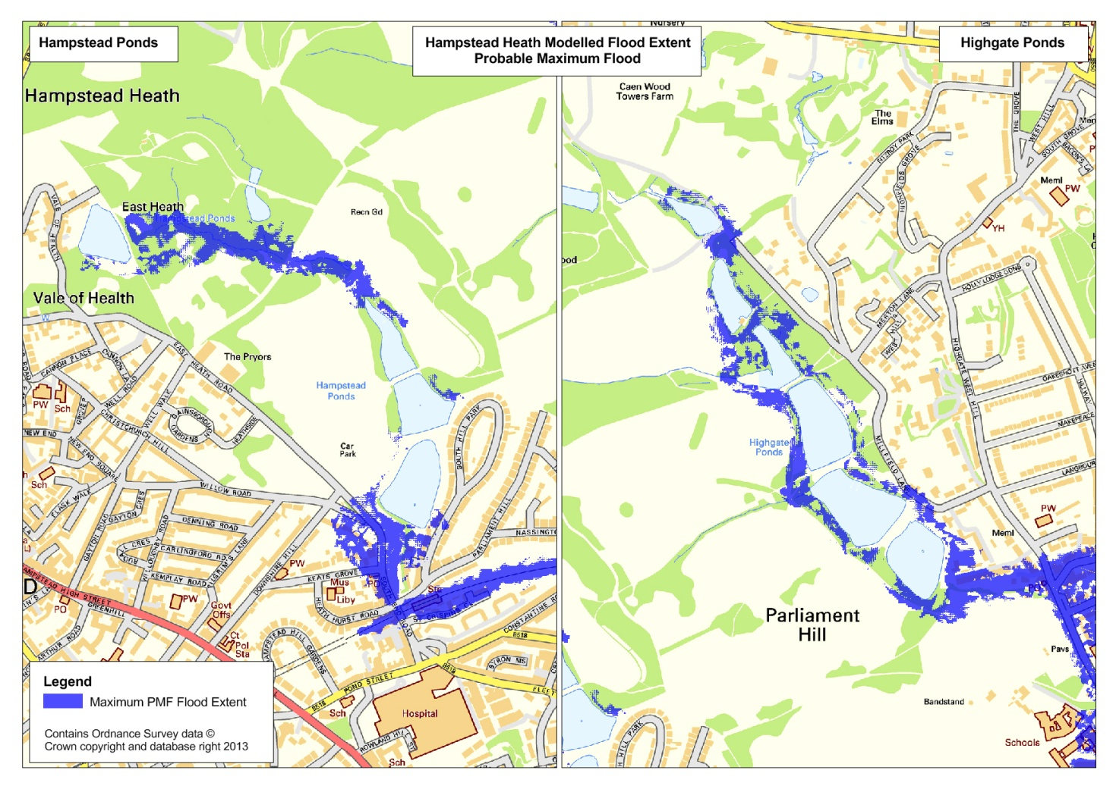

Figure 5‑2 Flood map around the ponds for the PMF event

### Standard of Protection Assessment

The four lower return period events were run through the hydraulic model to estimate the current standard of protection of each dam in the chain. to provide the depths of overtopping for the 5, 20, 50 and 100 year events. These results were used to estimate the approximate SoP for each pond as presented in .

Table 5‑8 1 in 5 year Summary Results

| **Pond** | **Peak Water Level (m AOD)** | **Maximum flood rise (m)** | **Maximum Dam Overtopping Depth (m)** |
| --- | --- | --- | --- |
| **Highgate Chain** |  |  |  |
| Ladies Bathing | 81.80 | 0.74 | 0.15 |
| Bird Sanctuary | 76.79 | 0.79 | -0.08 |
| Model Boating | 72.44 | 0.49 | -0.13 |
| Men’s Bathing | 71.35 | 0.00 | 0.52 |
| Highgate No 1 | 67.59 | 0.00 | -0.57 |
| Ladies Bathing | 62.45 | 0.00 | -1.05 |
| **Hampstead Chain** |  |  |  |
| Vale of Health | 105.11 | 0.07 | -0.33 |
| Viaduct | 89.50 | 0.00 | -0.47 |
| Mixed Bathing | 74.95 | 0.00 | -0.51 |
| Hampstead No 2 | 74.39 | 0.00 | -0.52 |
| Hampstead No 1 | 69.39 | 0.00 | -1.52 |

Table 5‑9 1 in 20 year Summary Results

|  |  |  |  |
| --- | --- | --- | --- |
| **Pond** | **Peak Water Level (m AOD)** | **Maximum flood rise (m)** | **Maximum Dam Overtopping Depth (m)** |
| **Highgate Chain** |  |  |  |
| Ladies Bathing | 81.83 | 0.77 | 0.18 |
| Bird Sanctuary | 76.89 | 0.89 | 0.02 |
| Model Boating | 72.62 | 0.67 | 0.05 |
| Men’s Bathing | 71.84 | 0.49 | - 0.03 |
| Highgate No 1 | 67.86 | 0.27 | - 0.30 |
| Ladies Bathing | 62.45 | 0.00 | - 1.05 |
| **Hampstead Chain** |  |  |  |
| Vale of Health | 105.24 | 0.20 | -0.20 |
| Viaduct | 89.67 | 0.17 | -0.30 |
| Mixed Bathing | 75.08 | 0.13 | -0.38 |
| Hampstead No 2 | 74.39 | 0.00 | -0.52 |
| Hampstead No 1 | 69.49 | 0.01 | -1.42 |

Table 5‑10 1 in 50 year Summary Results

| **Pond** | **Peak Water Level (m AOD)** | **Maximum flood rise (m)** | **Maximum Dam Overtopping Depth (m)** |
| --- | --- | --- | --- |
| **Highgate Chain** |  |  |  |
| Stock Pond | 81.85 | 0.79 | 0.20 |
| Ladies Bathing | 76.93 | 0.93 | 0.06 |
| Bird Sanctuary | 72.68 | 0.73 | 0.11 |
| Model Boating | 71.94 | 0.59 | 0.07 |
| Men’s Bathing | 68.25 | 0.66 | 0.09 |
| Highgate No 1 | 63.42 | 0.97 | - 0.08 |
| **Hampstead Chain** |  |  |  |
| Vale of Health | 105.34 | 0.30 | - 0.10 |
| Viaduct | 89.76 | 0.26 | - 0.21 |
| Mixed Bathing | 75.27 | 0.32 | - 0.19 |
| Hampstead No 2 | 74.41 | 0.02 | - 0.50 |
| Hampstead No 1 | 69.58 | 0.19 | - 1.33 |

Table 5‑11 1 in 100 year Summary Results

|  |  |  |  |
| --- | --- | --- | --- |
| Pond | Peak Water Level (m AOD) | Maximum flood rise (m) | Maximum Dam Overtopping Depth (m) |
| **Highgate Chain** |  |  |  |
| Stock | 81.87 | 0.81 | 0.22 |
| Ladies Bathing | 76.95 | 0.95 | 0.08 |
| Bird Sanctuary | 72.72 | 0.77 | 0.15 |
| Model Boating | 71.98 | 0.63 | 0.11 |
| Men’s Bathing | 68.30 | 0.71 | 0.14 |
| Highgate No 1 | 63.70 | 1.25 | 0.20 |
| **Hampstead Chain** |  |  |  |
| Vale of Health | 105.42 | 0.38 | - 0.02 |
| Viaduct | 89.90 | 0.40 | -0.07 |
| Mixed Bathing | 75.54 | 0.59 | 0.08 |
| Hampstead No 2 | 74.97 | 0.58 | 0.06 |
| Hampstead No 1 | 69.99 | 0.60 | -0.92 |

below indicates whether overtopping occurs at each reservoir for each return period storm. It shows that the standard of protection (SoP) is generally higher on the Hampstead chain than in the Highgate chain. Stock pond has a SoP of less than 1 in 5 year, while Highgate 1 has a SoP of between 1 in 50 and 1 in 100 year. Model Boating overtops via its auxiliary spillway for the 1 in 20 year, but the main embankment has a SoP of between a 1 in 20 and a 1 in 50 year event. On the Hampstead chain Mixed Bathing and Hampstead 2 have a SoP of between the 1 in 100 and 1 in 1,000 year event, while Vale of Health and Viaduct have a SoP of between 1 in 50 and 1 in 100 year event. Hampstead 1 has a SoP of between the 1 in 1,000 and 1 in 10,000 year event.

Table 5‑12 Summary of current Standard of Protection

|  |  |  |  |  |  |  |  |
| --- | --- | --- | --- | --- | --- | --- | --- |
| Pond | 5 year | 20 year | 50 year | 100 year | 1000 year | 10,000 year | PMF |
| **Highgate Chain** | | | | | | | |
| Stock |  |  |  |  |  |  |  |
| Ladies Bathing |  |  |  |  |  |  |  |
| Bird Sanctuary |  |  |  |  |  |  |  |
| Model Boating |  |  |  |  |  |  |  |
| Men’s Bathing |  |  |  |  |  |  |  |
| Highgate No 1 |  |  |  |  |  |  |  |
| **Hampstead Chain** | | | | | | | |
| Vale of Health |  |  |  |  |  |  |  |
| Viaduct Pond |  |  |  |  |  |  |  |
| Mixed Bathing |  |  |  |  |  |  |  |
| Hampstead No 2 |  |  |  |  |  |  |  |
| Hampstead No 1 |  |  |  |  |  |  |  |

|  |  |
| --- | --- |
|  | Overtopped |
|  | Not overtopped |
|  | Auxiliary Spillway Overtopping |

The Table above shows that eight of the eleven ponds are likely overtop before or during a 100 year flood. This frequency of overtopping with the attendant risks described below is unacceptable for ponds which pose a significant risk to the urban area below the Heath.

### Implications of overtopping for Dam Stability

The velocity of the flow on the downstream slope of the embankments has been estimated. As the crests of the embankments are not level, there will be tendency for flow to concentrate at the low spots. The estimated velocities of the flow on the slopes are shown in the Table below.

Table 5‑13 Summary of PMF Peak Velocity on Outside Slope

|  |  |  |  |  |  |  |  |
| --- | --- | --- | --- | --- | --- | --- | --- |
| Chain | Pond | Peak overtopping discharge (m3/s) | Crest length (m) | Slope | Maximum depth of overtopping (m) | Peak velocity, over existing embankment (m/s) | Overtopping duration (hrs) |
| Highgate | Stock | 10.95 | 43 | 0.30 | 0.45 | 5.07 | 9.25 |
| Ladies Bathing Left Bank | 2.99 | 46 | 0.18 | 0.24 | 2.66 | 2.08 |
| Bird Sanctuary | 17.01 | 100 | 0.17 | 0.45 | 3.73 | 6.75 |
| Model Boating | 16.09 | 78 | 0.32 | 0.37 | 4.72 | 6.17 |
| Men’s Bathing | 30.74 | 147 | 0.25 | 0.38 | 4.12 | 7.42 |
| Highgate No 1 | 32.18 | 100 | 0.24 | 0.62 | 5.42 | 8.75 |
| Hampstead | Vale of Health | 2.13 | 130 | 0.24 | 0.15 | 2.34 | 4.00 |
| Viaduct | 1.40 | 55.5 | 0.44 | 0.12 | 2.75 | 3.75 |
| Mixed Bathing | 7.28 | 44 | 0.22 | 0.31 | 3.38 | 4.92 |
| Hampstead No 2 | 9.13 | 100 | 0.22 | 0.27 | 3.15 | 3.83 |
| Hampstead No 1 | 7.60 | 112 | 0.31 | 0.19 | 3.07 | 3.33 |

The Table above shows that velocities close to 5.5m/s could occur on the downstream slope during overtopping. At the speeds estimated in the above Table, standard guidance suggests that the dam slopes would need reinforcement to prevent erosion which could lead to a breach of the dam. The velocities shown are based on a uniform surface; in reality the outer slopes are uneven with trees and other coarse vegetation which will contribute to locally greater speeds. In addition coarse vegetation is readily pulled out by flowing water. These factors will exacerbate erosion damage to the slope which emphasizes the need to either to prevent flow over the crest by channelling flow around the dams or where this is not possible, to reinforce the slope using “soft” engineering techniques such as reinforced grass.

The duration of the overtopping event are estimated to be up to 9.25 hours and this could be long enough to cause significant saturation of the downstream shoulder of the dam. The influence of saturation on the stability of the embankment slopes will be taken into account in the detailed design and also emphasizes the need to avoid flow over the crests and over the outer slopes where practicable.

# Conclusions and Recommendations

* The report presents a review of current overtopping risk associated with the Hampstead Heath ponds.
* It examines the previous work done and concludes that the previous work was based on non industry-standard methods, and a percentage runoff, based on limited field measures, which was greater than values calculated using current industry standard methods. The use of very high percentage runoff values for the Heath is the main reason for PMF peak flows that are on average twice that obtained using industry standard methods.
* Using industry standard methods, a reasonable revision of the SPR was obtained based on FEH methods, which resulted in Percentage Runoff values that were less that those used in the Haycock model and more reasonable for the catchment.
* Reservoir routing resulted in generally lower overtopping depths than those predicted by Haycock.
* Complex overland flow paths around the dams have been modelled and these will need to be considered in an assessment of dam stability and risk of erosion of the dams
* It can be concluded that the current study has been robust and utilised best available data and industry best practice and software, and has resulted in flows and overtopping depths with a reasonable degree of confidence. It is of the appropriate level of detail for the detailed design of options for upgrading the dams to pass the PMF.
* The problem definition assessment has revealed that all dams are overtopped during the PMF and that the current standard of protection of the dams ranges from less than 5 years to between 1 in 1,000 and 1 in 10,000 years. The Highgate chain has a generally lower standard of protection (less than 1 in 5 to below the 1 in 100 years) while the Hampstead chain has a SoP in excess of 1 in 50 years (and as high as between the 1 in 1,000 years and 1 in 10,000 year).

Floods estimated by Atkins were generally 30% to 50% lower than those estimated by Haycock Associates. Even with reduced flood volumes water will still flow over the dam crests during the design flood (PMF)**.** The speeds of the flow on the outer face are estimated to be in the range 2.3m/s to 5.5m/s with durations from 2 hours to 9.5 hours. Flows at these speeds and duration on the outer slope, in conjunction with the uneven nature of the slopes with coarse vegetation, are such that the embankments are likely to suffer erosion damage which in some cases could lead to a breach.

This means that to reduce the risk of breaching, improvements will need to be made to some of the dams to enable them to cope with the design flood (PMF), although the extent of the work needed should be less than that proposed by Haycock.

# Glossary

|  |  |
| --- | --- |
| Terminology | Definition |
| Annual Maximum (AMAX) series | The maximum observed rainfall or flow for a given gauging station within each water year. In this report the term is used in reference to the 24-hour duration rainfall depth observed in each water year of the Hampstead Heath Scientific Society rainfall record. |
| Antecedent conditions | The ‘wetness’ of the catchment prior to the event, due to previous rainfall events. |
| BFI (Base flow Index) | Base flow is the proportion of a river’s flow which is not related to rainfall runoff contributions i.e. the proportion of flow which would flow in the rivers when no rainfall has occurred. |
| Catchment | The area which drains to a specified point/outflow. |
| Critical Storm Duration | The rainfall storm duration which results in the peak flow or level at a given point of interest. All durations longer or shorter than the critical duration, will result in lower peak flow and level at the point of interest |
| Depth-Duration-Frequency (DDF) Curves | A curve which defines the rainfall depth as a function of duration for given return periods. |
| Digital Elevation Model (DEM) | A digital model of the terrain or surface elevation of the land. |
| DPLBAR (m/km) | Mean drainage path length. The mean distance of all drainage paths in the catchment. |
| DPRCWI | Dynamic Percentage Runoff which is dependent on the catchment wetness index (CWI) and allows the percentage runoff to vary based on the state of the catchment prior to the storm |
| DPRRAIN | Dynamic Percentage Runoff which is dependent on storm depth, and allows the percentage runoff to vary between different storm based on storm magnitude |
| DPSBAR | Mean drainage path slope. The mean slope between pairs of nodes in the catchment, based on the steepest route of decent between nodes. |
| Em-2h | FSR parameter. Maximum 2 hour precipitation. |
| Em-24h | FSR parameter. Maximum 24 hour precipitation. |
| Em-25d | FSR parameter. Maximum 25 day precipitation. |
| Flood Estimation Handbook (FEH) | FEH is the standard UK method for estimating rainfall, and flood frequency and flows. |
| Flood Studies Report (FSR) | The FSR was the first UK-wide flood estimation method developed in 1975. FEH largely supersedes the FSR. |
| Flood Studies Supplementary Report 16 (FSSR16) | A supplementary report to the FSR published in 1985. |
| Flow | The discharge of a river, measured in metres cubed per second (m3/s or cumecs). |
| HHSS | Hampstead Heath Scientific Society |
| HOST | Hydrology of Soil Type classification. UK soils have been delineated according to their hydrological properties and then grouped into the HOST classification. There are 29 classifications. |
| Hydrograph | A graph showing the flow of a river over a period of time, often in response to a rainfall event, this may be called a Storm or flow Hydrograph. |
| ISIS software | Modelling software used to assist in the estimation of rainfall and flood hydrographs as per the FEH, FSR and ReFH methods. |
| Jenkinson’s r | The ratio of M5-60min to M5-2D where M5-60min is the maximum rainfall depth for a 5-year event of 60min duration and the M5-2D is the maximum rainfall depth for a 5-year event of 2days duration. |
| M5-2d | FSR parameter. 1 in 5 year rainfall event 2 day maximum precipitation. |
| M5-25d | FSR parameter. 1 in 5 year rainfall event 25 day maximum precipitation. |
| Percentage Runoff | The percentage of the total rainfall that becomes direct runoff after account for losses (such as infiltration, interception, evaporation). |
| Probable Maximum Flood (PMF) | The largest flood that may reasonably be expected to occur from the most severe combination of critical meteorologic and hydrologic conditions that are possible in a catchment. |
| Probable Maximum Precipitation (PMP) | The largest rainfall event that may reasonably be expected to occur from the most severe meteorologic conditions over a catchment. |
| PROPWET | Index of the proportion of time that soils are wet. |
| Rainfall Hyetograph | A graph showing the distribution of a storm with depth over time i.e. mm per hour. |
| Revitalised Flood Hydrograph (ReFH) model | A lumped conceptual rainfall-runoff model, which has been developed for modelling flood events and is considered to be an improvement over the models used within FSR/FEH. |
| Return Period | The return period of an event is a statistical measure of the rarity of the event. The return period can be expressed as an annual chance or annual exceedence probability. For example a 1 in 100 year flood can also be described as a flood with a 1 in 100 annual chance or with an annual exceedence probability of 1% i.e. in any given year there is a 1% chance of the event occurring. |
| Rainfall Runoff (RR) | The conversion of rainfall over a catchment into the water which flows within river channels. Takes into account the losses which occur i.e. through infiltration into the ground. |
| SAAR | Standard Average Annual Rainfall. The average of all annual rainfall depths over a specified period (the FEH includes SAAR for the period 1941-1970 and for 1961-1990 for Great Britain and Northern Ireland. |
| S1085 (m/km) | The slope of the stream between points 10% and 85% of the length from the lowest point on the mainstream. |
| Spill and orifice unit (in hydraulic model) | A structure within a hydraulic model which allow water to be transferred (or spill) along a length of bank (e.g. a reservoir embankment or the side banks of the reservoir). |
| SPR | Standard Percentage Runoff. The normal capacity of the catchment to generate runoff. |
| SPRHOST | Standard Percentage Runoff from the Hydrology of Soil Types Classification. |
| Standard of Protection (SoP) | The flood event to which a structure is designed to withstand flooding (normal expressed as a return period. Hence a reservoir has a standard of protection of 20 years if its dam is not overtopped during floods of the 1 in 20 year magnitude or less. |
| Summer vs. Winter rainfall profiles | In modelling seasonal rainfall profiles depth and duration remain the same, summer profiles have a higher peak depth, whereas winter profiles the depth is more evenly spread across the duration. |
| Time to Peak (Tp) | The time between the start of an event and the time when the flow or rainfall reaches its peak. |
| TWL | Top Water Level. The invert level of the outflow pipes. Hence the level above which outflow from the reservoir will start |
| Unit hydrograph | A tool for converting a given depth of rainfall over a catchment, during a specified duration, into a Storm Hydrograph. |
| Urban fraction | FSR index of fractional urban extent. |
| URBEXT | FEH descriptor to describe the level of urbanisation of a catchment. |
| Water Year | In the UK the water year runs from the 1st October to 31st September of the following year. This coincides with the start of the ‘wetter’ season and the recharge of groundwater supplies. It ensures the flood peaks of each year are independent statistically. |
| Weir Coefficient value (in hydraulic model) | Enables the model to represent the surface and therefore the resistance water will encounter and impact on flow when flowing across or through the surface/object. |

Appendices

This page is left blank for double-sided printing.

###### References

Centre for Ecology & Hydrology, 1999. Flood Estimation Handbook (FEH)

City of London, November 2012. Hampstead Heath Reservoirs On-Site Emergency Response Plan for Reservoir Dam Incidents. Defra Reservoir Safety Working Group, March 2004, Floods and Reservoir Safety: Revised Guidance for Panel Engineers

Defra & Environment Agency, March 2006. URBEXT2000 - A new FEH catchment descriptor. Calculation, dissemination and application. R&D Technical Report FD1919/TR

Haycock Associates Limited, 2006. Hydrological and Water Quality Investigation and Modelling of the Hampstead Heath Lake Chains and Associated Catchments

Haycock Associates Limited, 2010. Hydrology Improvements Detailed Evaluation Process (HiDEP): Hydrology and Structure Hydraulics

Haycock Associates, 2010, Hampstead Heath Stella Model.

Plowman Craven, April 2010, Hampstead Heath Dam 3D Topographic Survey.

Construction Industry Research and Information Association (CIRIA). 1987, Design of Reinforced Grass Waterways.

**Mike Woolgar**

Atkins

Woodcote Grove, Ashley Road, Epsom, Surrey KT18 5BW

**mike.woolgar@atkinsglobal.com**

1. 1D-2D refers to the different dimensions within which flow can be modelled. 1D models simulate flow in one direction from upstream to downstream, for example into and out of the Hampstead Heath ponds. In this instance, the 1D aspect of the model has been used to calculate water levels in the ponds and the flow passing over the pond embankments and through the connecting pipes. In contrast, 2D models simulate flow in multiple directions according to the ground topography. They are commonly used to model flows over a floodplain. In this instance, the 2D aspect of the model has been used to define the overland flow between the ponds, and in the downstream valley.
2. The Flood Estimation Handbook (FEH) is the current standard UK method for estimating rainfall, and flood frequency and flows, developed by the Centre for Ecology and Hydrology in 1999.
3. The Flood Studies Report (FSR) was the first UK-wide flood estimation method developed in 1975 by IoH. FEH largely supersedes the FSR.
4.
5. Critical Storm Duration is the rainfall storm duration which results in the peak flow or level at a given point of interest. All durations longer or shorter than the critical duration, will result in lower peak flow and level at the point of interest