Hampstead Heath Ponds Project
Modelled flows over the ground surface downstream of Highgate No. 1 Pond October 2014
1 in 10,000 year Existing
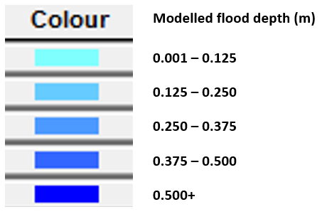
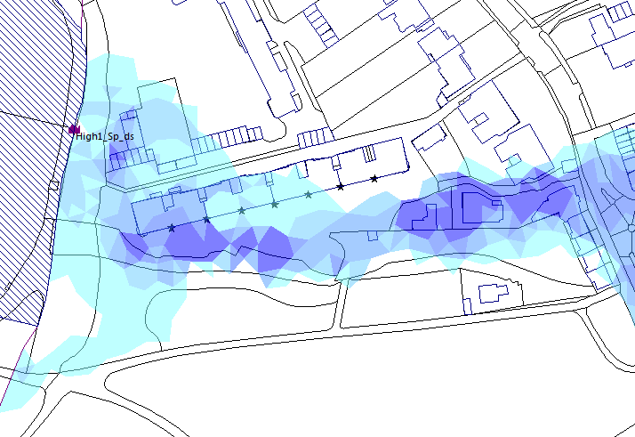
Peak rate of overtopping: 15.9m³/s
Volume of water that overtops in a 14-hour modelled period: 82,000m³
In the existing situation, during the 1 in 10,000 year event, the water level in Highgate No. 1 Pond rises above the dam crest level. Water then flows over the dam crest. Water can also flow over the southern pond bank and around the dam following the ground slope.

1 in 10,000 year Proposed
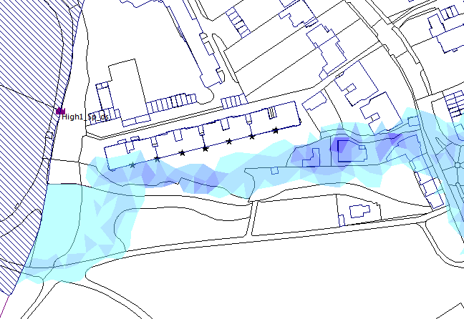
Peak rate of overtopping: 4.9m³/s
Volume of water that overtops in a 14-hour modelled period: 26,800m³
In the proposed situation, during the 1 in 10,000 year event, the water level in Highgate No. 1 Pond rises above the crest level of the new spillway. Water then flows down the spillway. No water overtops the raised dam crest. The rate and volume of water flowing down the spillway is lower than the rate and volume of water flowing over the dam crest in the existing situation. This is because of the additional storage created in the Highgate chain of ponds under the proposed situation.

In both the existing and the proposed situation, the water from the pond will collect in low spots and flow over the ground surface following the slope of the land. In such an extreme event, it is likely that the downstream drainage system would be full and so this water would remain on the ground surface for some time before it can drain away.
Hampstead Heath Ponds Project
Modelled flows over the ground surface downstream of Highgate No. 1 Pond October 2014
PMF Existing
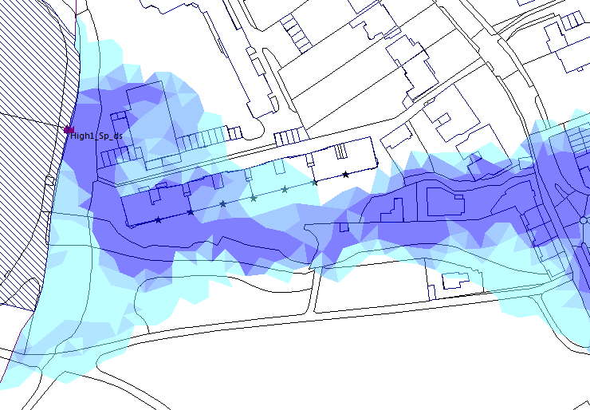
In the existing situation, during the PMF event, the water level in Highgate No. 1 Pond rises above the dam crest level. Water then flows over the dam crest. Water can also flow over both the northern and the southern pond banks and around the dam following the ground slope.

Peak rate of overtopping: 34.8m³/s
Volume of water that overtops in a 14-hour modelled period: 199,300m³

PMF Proposed
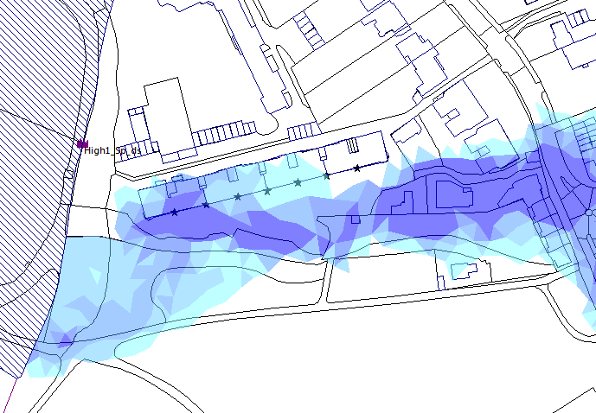
Peak rate of overtopping: 30.8m³/s
Volume of water that overtops in a 14-hour modelled period: 157,500m³
In the proposed situation, during the PMF event, the water level in Highgate No. 1 Pond rises above the crest level of the new spillway. Water then flows down the spillway. No water overtops the raised dam crest. The rate and volume of water flowing down the spillway is lower than the rate and volume of water flowing over the dam crest in the existing situation. This is because of the additional storage created in the Highgate chain of ponds under the proposed situation.

In both the existing and the proposed situation, the water from the pond will collect in low spots and flow over the ground surface following the slope of the land. In such an extreme event, it is likely that the downstream drainage system would be full and so this water would remain on the ground surface for some time before it can drain away.

