Objection to Application 2014/6410/P
Bruges Place, 15 - 20 Baynes Street NW1 0TF

The site, Bruges Place, is located directly adjacent to Camden Broadway Conservation Area with its entrances on Randolph Street and Baynes Street. The map below shows the boundaries of the conservation area, and highlights the site in red.

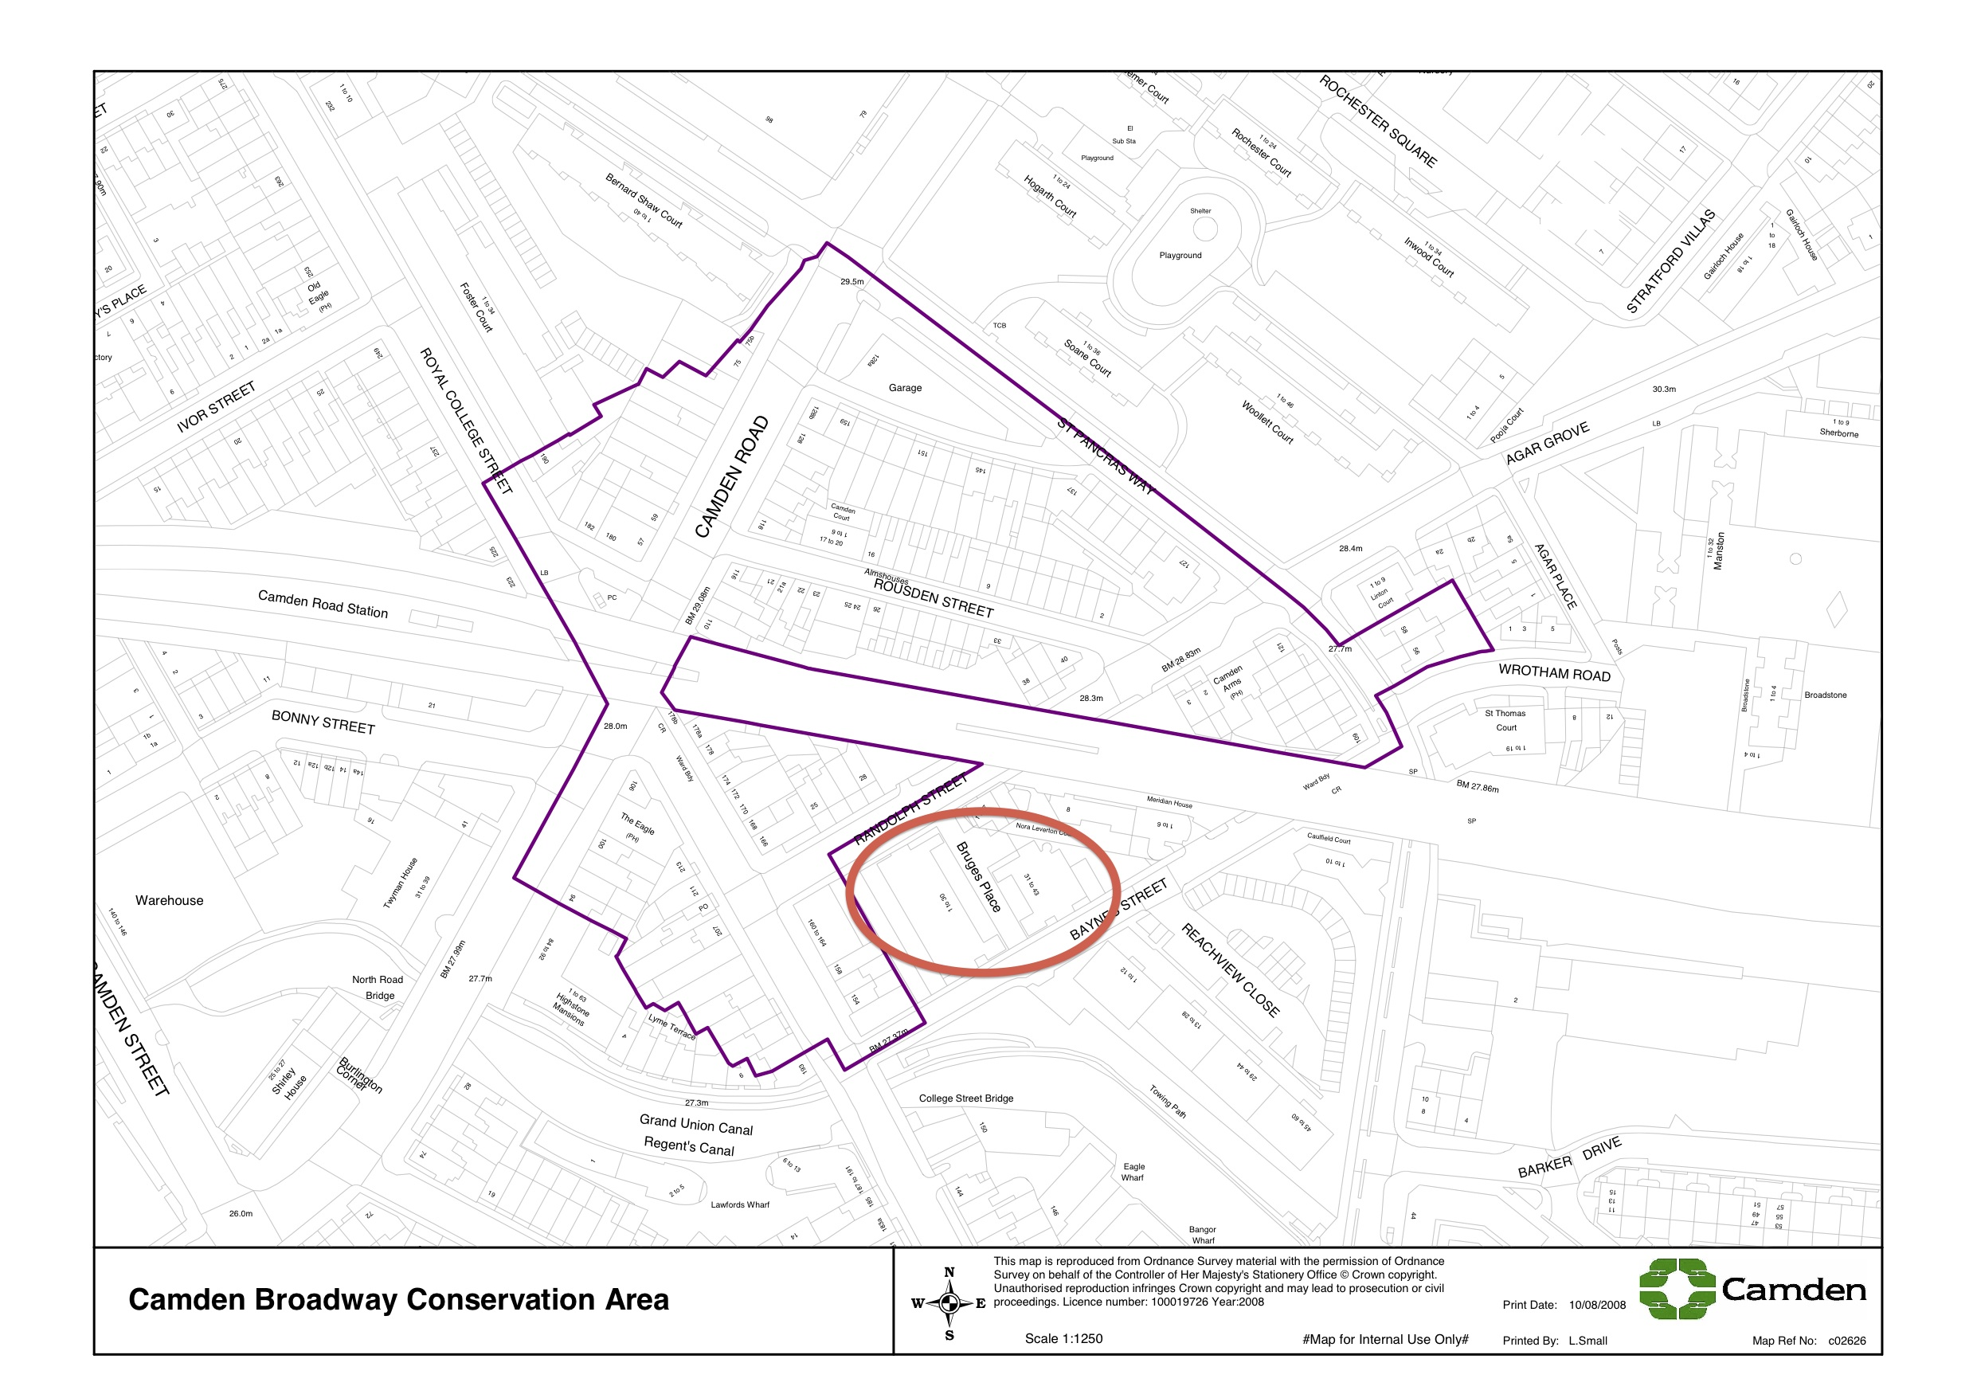

1. Level of Detail of the Planning Application
The level of the detail of the documents accessible online is very lim ited. No Design and Access Statement could be found, and the floorplans are of such little detail that it is unclear how each unit is laid out or where the kitchens and bathrooms will go (regarding the associated extractor fans).

2. Impact of amendments to Bruges Place on the site itself
Purpose-built in 1987-9 by Jestico & Whiles, it has featured in publications such as "The buildings of England" (London 4: North by Bridget Cherry and Nikolaus Pevsner), "Industry in the City" (Witherford Watson Mann for Design for London), AJ (15/7/87), B, Housing Design Awards 1989, and "The RIBA Book of British Housing: 1900 to the present day" as a positive example of vertically mixed business and residential uses:

"Bruges Place demonstrates that light industrial uses and housing can be combined, provided access to both is carefully organised. The former Second World War bombsite was zoned by the planners for industrial use even though it was surrounded by housing. They preferred two-storey industrial development but the architects successfully argued that the urban grain of the area dictated the development should be of mixed use and four storeys in height." (The RIBA Book of British Housing: 1900 to the present day, p.64)

The irreversible change of such a valuable precedent into the exact opposite of what it was design for would be a big loss to the area, both architecturally and characterisically. The whole design and layout of the site is founded on the principle of combining 2 storeys of commercial floorspace with residential units above whilst segregating access and amenity so successfully that the very different uses don't interfer with each other. The proposed floor plans significantly compromise this clarity in layout, creating a weak compromise that doesn't do justice to the original and well-published building.

3. Proposed Design Changes
- From the little that one can see, the units look tiny and often very inefficient (especially in the East Block). It seems as if they are all studio flats, but again no detail has been provided.
- The introduction of inset balconies is inappropriate for the coherence of the building design and at odds with the area.
- The same applies to the proposed render facade. There is a predominance in rendered ground floors and brick upper floors in the vicinity of the site, which is part of the valued and protected character of Camden Broaway Conservation area.
- To reverse this and leave the ground floor brick whilst rendering the first floor only (East and West Elevations, both blocks) or to even render all upper floors (North and South Elevations) would introduce an untypical feature to the area and impact negativey on the otherwise coherent setting of the conservation area.
- The introduction of new elements (to accommodate bicycle storage, refuse storage and plant space) complicated the ground floor layout, further obliterating the much-praised and recorded original design by Jestico & Whiles.

