DESIGN AND ACCESS STATEMENT

231 Goldhurst Terrace
London NW6 3EP

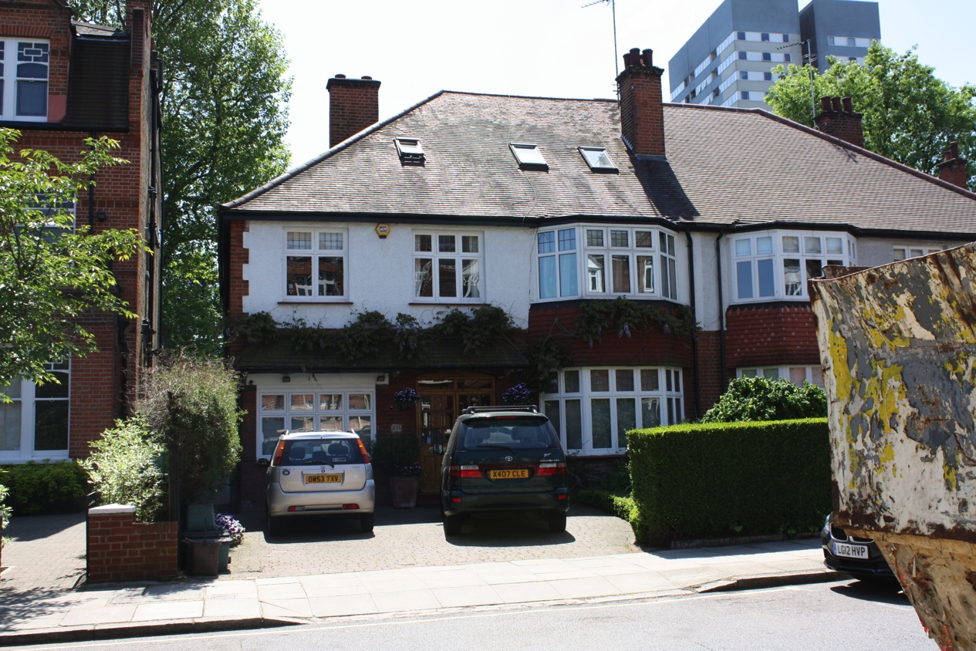

231 Goldhurst Terrace is a large semi-detached house sitting on a generous plot and set 8.5 metres back from the road. There is a large south facing back garden; the plot is 11 metres wide by 48 metres long. The drive can accommodate up to four cars. The ground slopes towards the back of the house such that to the rear the house sits approximately one metre above the garden.

The house was built in the 1920’s and typical of houses of that period the elevation facing the road is solid brick construction to the ground floor and pebble dash render on solid brick to the first floor with brick quoins on the corner. The render to both 231 and 233 is painted white. To the side and rear elevations the walls are brick with no render. Lintels to the rear are formed with brick arches in a contrasting red brick. The roof is covered with plain red clay tiles; the roof is hipped with plain semi round tiles. There is a flat-roofed two storey three-sided bay window to the front with tile hanging between the ground and first floor windows. The windows are largely original and single glazed with the exception of the first floor bay window which is uPVC. There is a small hipped porch to the front extending from the corner of the house to the bay. Both 231 and 233 originally had small integral garages. In both houses these have been converted sympathetically in to habitable space.

Goldhurst Terrace is a road of large three storey red brick Edwardian semi -detached and terraced houses with large mansard roofs. The houses numbered 231 to 245 are different: 231 to 237 are typical 1920’s semi-detached houses while 239 to 245 are a slightly earlier pair of semi-detached houses more typical of late Edwardian design. All the houses numbered 231 to 245 have a lower ridge line than the adjoining Edwardian houses.

The current owners have lived in the house since 1986. Prior to their buying the house the attic had been converted to provide two additional rooms plus a small shower room. With the exception of the conversion of the internal garage to a habitable room and the addition of a deck to the rear the owners have undertaken no significant works. They have carried out minor internal changes and upgrades.

The owners would now like to extend the house to cater for the needs of a large family and a disabled son. They are anxious that the proposed development should be sympathetic to the age and style of the house and that it should blend in rather than draw attention to any changes.

The house in its current layout has some serious drawbacks. The existing kitchen is very small and there is no utility room so the washing machine and drier are located in a small cramped larder (see photograph).

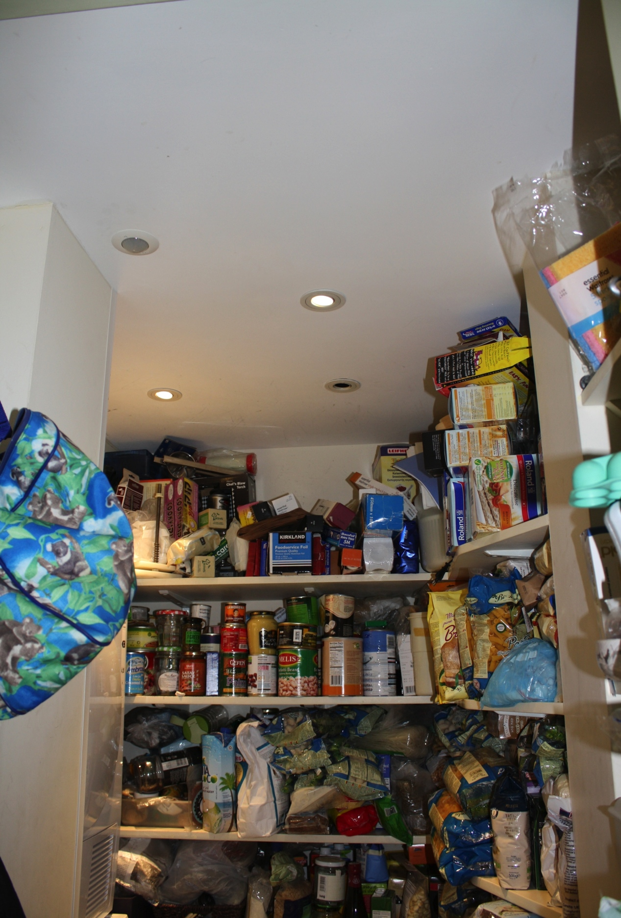

Despite the size of the house there is little storage for food and the freezer is located in a small original lean-to structure on the back of the house that can only be accessed from the side alley (see photograph).

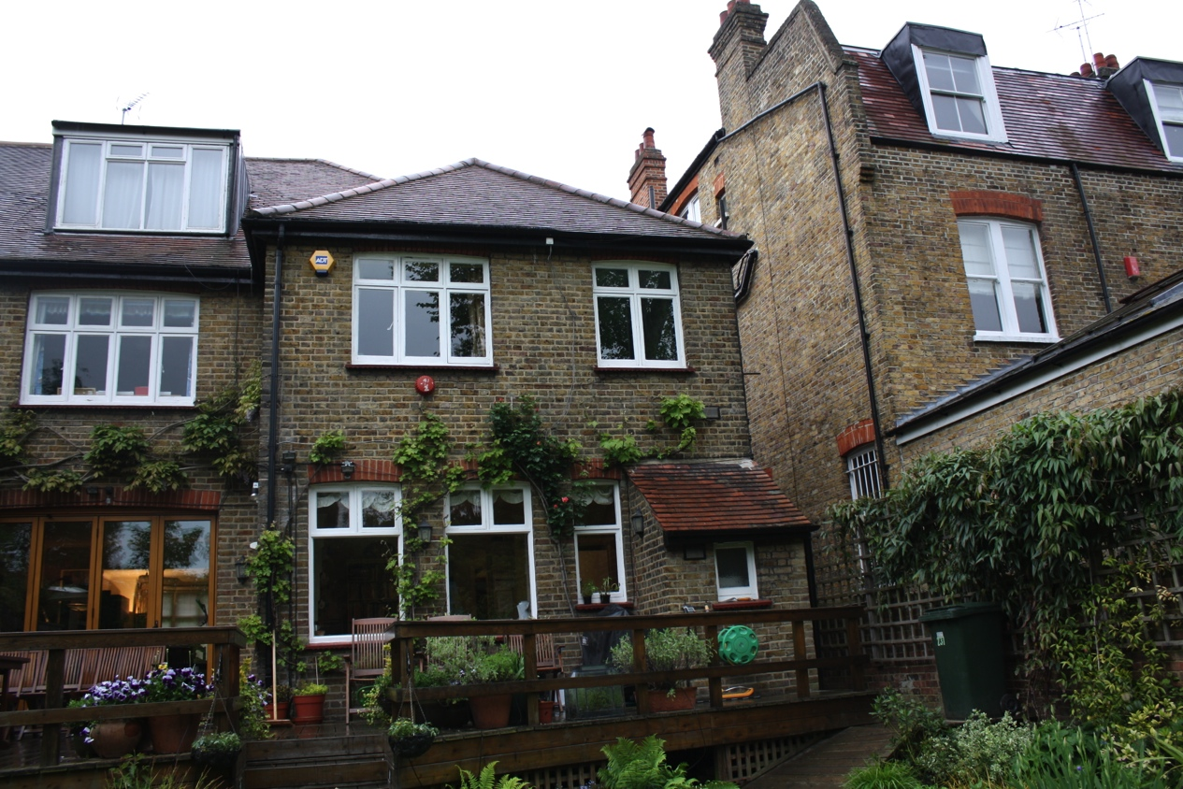

At first floor level there is only one bathroom serving five bedrooms and no en-suite facilities. The hot water cylinder is completely inaccessible as it was placed in the undercroft below the front hallway where it sits in a pit dug in to the ground (see photograph)

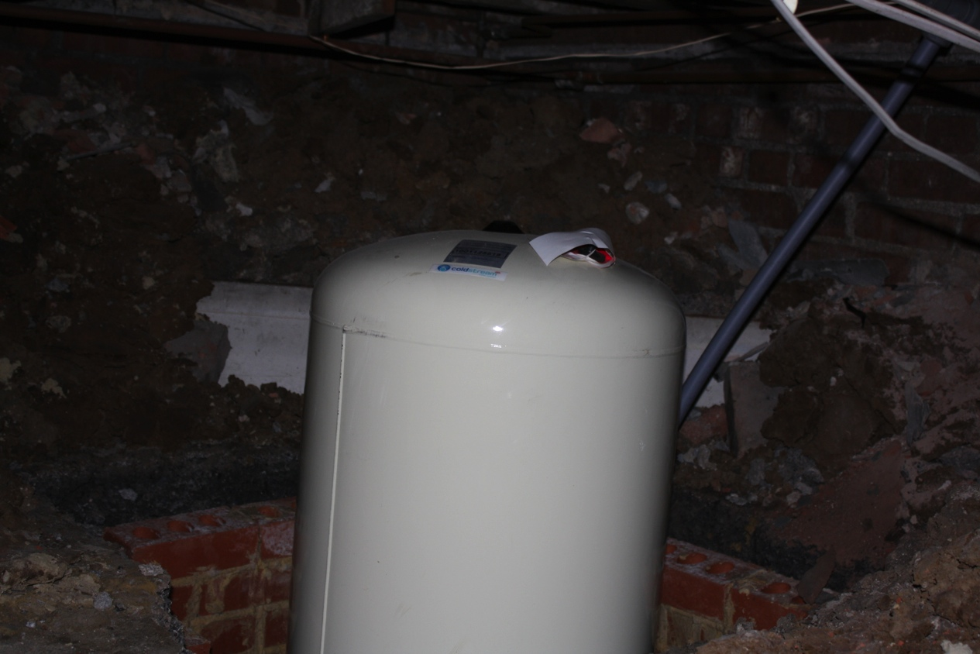

In addition to wanting to address the various limitations of the house the owners would also like to provide the possibility of independent living for their twenty one year old son with disabilities. The attached report below gives an outline of his disabilities.

As the parents of a disabled son who has reached adulthood the owners need to look at how they can best provide for their son’s needs. They understand that he cannot live independently away from the home; he needs a full time carer and the carer needs accommodation within the house.

The proposed scheme therefore addresses both the issue of the various limitations of the existing house and also the need for independent living for a disabled young man within the house.

It is proposed to extend the existing two storey back extension by three metres. This will give the necessary increase in floor area to provide a large kitchen/ morning room at ground floor level and an en-suite master bedroom at first floor level. It is proposed that there will be a central south facing flat roofed bay to this extension to add detail and to mirror the existing bay on the north elevation. It is also proposed to build a single storey extension to give added length to the rather limited dining room. The family regularly has meals with up to twenty people and they cannot currently be accommodated. The single storey extension would be 2.5 metres long and would not breach the 45-degree angle from the adjoining property. It is proposed that these extensions be built in brick to match the existing and while being of cavity construction to comply with current Part L standards snapped headers will be used to match the existing Flemish Bond. The single storey extension would have a parapet with stone coping and a lead roof with wood cored rolls in the direction of fall and draining to hoppers.

It is proposed to take advantage of the fact that the house is raised above the rear garden to form a lower ground floor that would have direct access from within the house but also from the front and back gardens. It is intended that the lower ground floor should include an area for independent living that would include a small kitchen area, a bathroom and the possibility for the room to be separated to give two separate rooms, one to be used by the carer. It is also intended that the lower ground floor should include a larder, a utility room and an entrance from the front garden where various pieces of equipment such as a three-wheeler tricycle can be stored.

It is proposed that there should be a small platform lift in the front garden, hydraulically operated, to allow for the son or any visiting disabled friends to have direct access to the flat with no need to use the stairs. The type of lift proposed would have a glass enclosure 900mm high and the existing area of plants and trees would be adjusted to ensure that the lift was entirely surrounded by vegetation and not visible from the road. To the rear it is proposed to provide stepped terraces with planting to slope the ground back up to the level of the garden.

Internally it is proposed to move the current stair to the outside wall. At present the kitchen is approached behind the back of the stair that runs across the width of the house; due to the lack of headroom it is not possible to have a full architrave around the door (see photo) and the entrance is rather cramped.

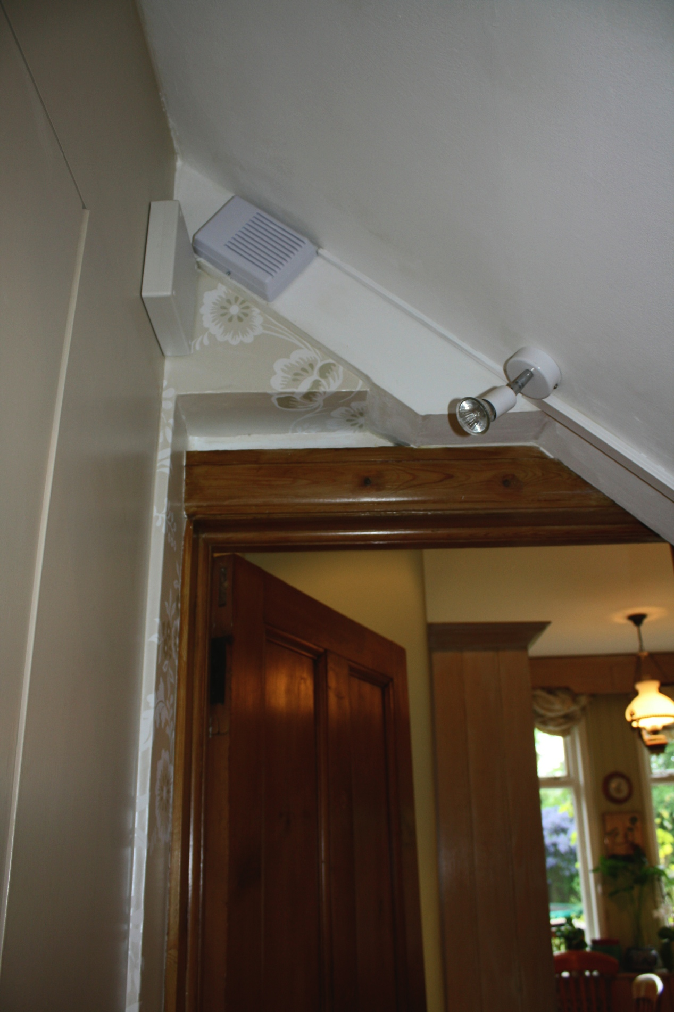

Furthermore with the stair in its current position it is not possible achieve the necessary headroom for a stair down in to the basement below the existing stair. By moving the stair to the outside wall it allows direct access from the front door to the kitchen, it unifies the different levels around an open stair and it also introduces natural light from the side wall in to what is currently a rather dark hallway. The clients would like to take the opportunity of moving the attic stair to above this relocated stair. To achieve the necessary headroom this requires a dormer roof to the side – east – elevation.

Finally it is proposed to upgrade the existing rear flat roofed dormer. This was constructed by the previous owners and is poorly built, with limited to no insulation, and single glazed windows. It would be re-built to the same size and shape but to current Part L standards, with lead cheeks and face and double glazed hard wood windows to match the original windows in the house.

The intention with the proposed development is to rectify shortcomings in the existing layout and accommodation. The house is a large and valuable property but it does not have the level of provision that would be expected of a house of this size. At the same time the intention is to provide an area for disabled living for the owners’ disabled son and his carer. The intention is that the scale of the development should respect the size and style of the original house. The materials will be selected to match the existing materials. Where any new materials are introduced, such as the coping to the single storey extension, they will be from real stone rather than a concrete imitation.

The relationship of number 231 Goldhurst Terrace with the adjoining properties means that the proposed extension will have minimum impact on the neighbours. The proposed single storey extension comes within the 45-degree line with number 233. Number 231 was extended in 1998 and the 1 ½ storey back extension sits 4.8 metres above the finished ground level in the side alley and extends 3.1 metres beyond the proposed rear extension to number 231.

The proposed extensions and alterations will not affect the parking arrangements in any way. The hard standing area remains unchanged. The owners of the house place great importance on planting and care of the gardens. The planting to the front will be adjusted to form a green screen around the platform lift. The dwarf hazel tree will be retained but relocated to a central position in the planted area. The mature wisteria to the front elevation will not be touched. To the rear the terraces down to the lower ground patio will be planted to maximize rain run off and to create a view of planting from the lower ground room. A wisteria will be replanted to the rear of the property to replace the one that will be lost with the construction of the single storey extension. The intention is that the proposed works will enhance a very attractive 1920’s house while providing the accommodation necessary to enable the family to continue to live here for many years to come.

November 2014

Saul’s disabilities

Saul has a complex chromosomal abnormality with missing chromosomal material on chromosome 12 called Gonathodiaphyseal Dysplasia (‘GDD’), which has led to the development of autism, severe learning difficulties and a large number of illnesses and serious medical conditions.

Saul’s needs are complex and require the involvement of a range of professionals and agencies. Saul has many medical conditions, behavioural and learning difficulties.

Saul has two areas of major difficulty in his life, and although these problems are separate, they interact with each other and impact upon the way he can receive treatment and support. It also makes the interpretation of symptoms extremely challenging for people who do not know him well, including medical professionals. The main areas of functional difficulty are: Autism, learning difficulties and behavioural problems. Saul has significant communication difficulties as set out in detail below and altered pain perception, impeding the ability of Saul and of others to assess when Saul is in distress or pain. His autism is accompanied by severe learning difficulties and behavioural problems including anxiety.

Saul has serious medical conditions, that require daily medicines, given 5 times per day
- gastro-intestinal difficulties including gastro-eosophageal reflux disease,
- gluten intolerance
- double incontinence
- cyclical vomiting syndrome
- autonomic neurological disorder
- gross and fine motor difficulties including congenital hypotonia
- multiple visually impaired including optic nerve hypoplasia, septo-optic dysplasia, cortical visual impairment, and a right divergent squint
- respiratory allergies
- hearing difficulties with supersensitive hearing ‘Hyperacusis’ but some hearing loss as well.
- These conditions require constant monitoring and medication throughout the day. Managing these medical conditions and treating them appropriately is impossible without an understanding of Saul’s autism and learning difficulties.
- As a result of his autism and learning difficulties, Saul has complex communication problems. He can communicate verbally in a limited way, depending on his health and energy levels, usually using single words or phrases. It is extremely difficult to understand his speech, particularly for someone who does not know him well. This is because he suffers from oral dyspraxia which causes articulation problems
- Saul is very anxious and sensitive and shows us when he is upset.
- As described below, Saul has many different medical problems which require frequent medication and treatment throughout the day. However his learning difficulties and autism have an effect upon the way that these various illnesses present themselves. For example, his hyperacusis (noise sensitivity) can trigger the onset of his gastric reflux and cyclical vomiting syndrome. Furthermore, his learning difficulties can have an impact upon the way in which his medical conditions can be treated. For example, treating his reflux involves a very specific approach in helping him to swallow food, calm him down, and prevent it from getting worse by escalating to vomiting episodes. This requires a degree of medical knowledge, but also an understanding of Saul as a person.
- Saul also has unnaturally slow healing which causes him to bleed excessively and for prolonged periods of time.
- Saul also has gross and fine motor difficulties including congenital hypotonia, which is low muscle tone and causes him to slump. He needs constant encouragement to remain upright and to limit the effect that this has. This is compromised by his state of health, tiredness and anxiety. His poor motor skills mean that he is compromised in carrying out his own personal care needs, and is at risk of falling over. Saul moves very slowly with poor saving reactions. His visual impairment further affects his moving around his environment, especially in unfamiliar places due to a lack of perception of depth and being frightened of falling over. As an example, climbing in an out of the bath or getting in and out of a car required training and particular intervention is required when Saul is tired or unwell.
- Saul also has an altered pain perception. This has a big impact upon the way in which we manage Saul’s various conditions. He has a reduced sensation of pain, or sometimes he does not communicate about pain at all due to his autism. Therefore it is crucial for us to interpret Saul’s behaviour, to assess whether it appears as though he is in pain, and to make decisions about what medication or help he needs to overcome this. It is hard to know when Saul is in pain or feeling ill.
- Saul becomes anxious very easily and this causes a variety of his symptoms to worsen, such as his GRD and CVS. He also gets very upset around new people and it takes a while for him to get used to anything new.
- Saul’s medical problems will not improve over his adult life and it is important that these continue to be monitored effectively. New medical problems continue to become apparent and need assessment and appropriate treatment.
- A detailed understanding of Saul’s autism and learning difficulties is crucial in order to be able to care for Saul and to ensure that his medical needs, personal care and social needs are all met.

Thanks

Susan Zur-Szpiro

