**SUPPLEMENTARY AGENDA**

**Agenda Item 7 (4)**

**Address: Parker Tower, 43 – 49 Parker Street, London, WC2B 5PS (Ref: 2014/0176/P)**

On 04/11/14 the applicant submitted revised plans amending the window design for the 2nd floor north elevation of the new building. It was previously proposed to incorporate vertical fins to minimise overlooking to Thurstan dwellings; it is now proposed to provide a triangular window, with the western pane being frosted glass, seen below. The applicant has outlined that this amendment has been made following further meetings with residents of Thurstan dwellings.

Previously proposed with vertical fins Now proposed with frosted glass

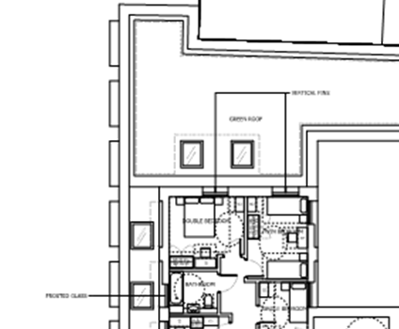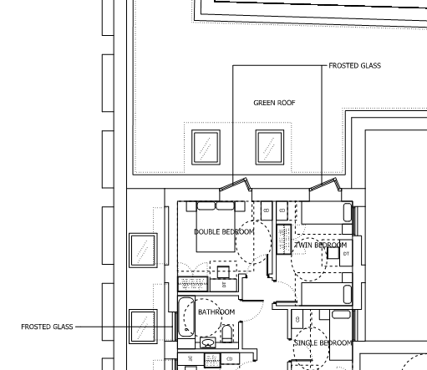

As such, paragraph 6.67 of the committee report is updated accordingly:

*6.67 With regard to the new building, no windows are proposed on the north elevation at ground or first floor level. Meanwhile the second floor is set back 17m from Holland and Thurstan and includes ~~vertical fins~~* ***frosted glass*** *to minimise overlooking. The west side elevation windows on the new block are at such an angle that instances of overlooking would not be possible, except at acute angles.*

This amendment is not considered to result in any additional amenity impacts for nearby occupiers. The following plans will be amended on the decision notice and condition 19 (approved plans) updated accordingly. No other conditions are impacted by the change:

~~P_02_C645_001 Rev E;~~ **P_02_C645_001 Rev F;** ~~E_N_C645_001 Rev C;~~ **E_N_C645_001 Rev D; 0211347/ADF/04**

On the basis of this an objection from an occupier in Thurstan dwellings (received at the time of the re-consultation in May-June 2014) has been withdrawn (see email enclosed). As such, the table above paragraph 4.6 and paragraph 4.7 is updated accordingly:

|  |  |  |
| --- | --- | --- |
|  | **Original** | **Re-consultation** |
| *Number of letters sent* | 171 | 171 |
| *Total number of responses received* | 3 | 4 |
| *Number of electronic responses* | 0 | 4 |
| *Number in support* | 0 | 0 |
| *Number of objections* | 3 | ~~4~~ **3 (1 later withdrawn)** |

4.7 Re-consultation took place on the application in May-June 2014, as detailed at paragraph 2.3 above. 4 objections were received as part of the re-consultation process. Two each were received from occupiers of the Holland and Thurstan dwellings. **1 from an occupier of Thurstan dwellings was later withdrawn.** A summary of the issues raised were: