Proposed creation of additional floor space
providing 10 additional bedrooms,
St John’s Wood Centre, 48 Boundary Road,
St John’s Wood, London NW8 0HJ

DESIGN AND ACCESS STATEMENT
(REVISION A)

- INTRODUCTION
  - This application concerns proposed alterations to the St John’s Wood Centre, a building for which planning permission was granted for change of use to a C2 Nursing Home in November 1998 (under your reference PW9802564RI ).
  - At that time the top of this flat roofed building was to be used as a roof terrace for the benefit of the residents of the care home. In reality for a number of reasons but including access issues under the Building Regulations it has not proved possible to bring this roof garden into use.
This application thus seeks to re-utilise this space through the creation of 10 additional en-suite bedrooms. This additional accommodation would be facilitated through alterations in the same architectural idiom and utilising the same materials as the host building.

- SITE DESCRIPTION AND CONTEXT
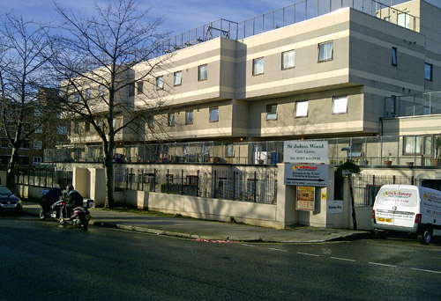

St John’s Wood Centre viewed from Boundary Road

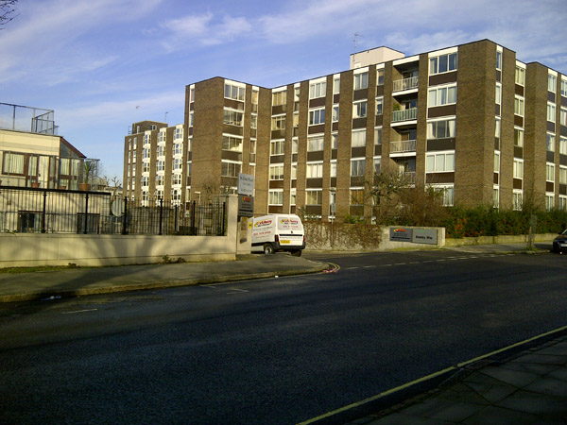
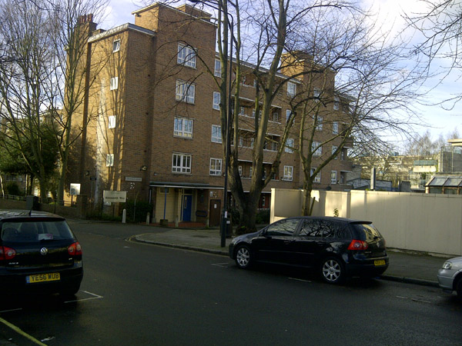
  - 48 Boundary Road is located on the northern side of Boundary Road sandwiched between multi-storey residential flats to the west and east and the Jack Taylor School to the north. The application site forms part of a high density urban environment which was comprehensively redeveloped, primarily by the Council, in the late 1960/early 1970s.
Multi-storey residential to the west and east of No.48 Boundary Road

Whilst the application property, known as the St John’s Wood Centre was developed independently (from the large residential estate to the north), it nevertheless now forms part of the character of the so called Alexandra Road Housing Estate which was designed for and built by Camden’s Architect’s Department in the 1970s. The estate is laid out on a generally east/west axis with the “West Coast Main Line” out of Euston Station defining its northern boundary.
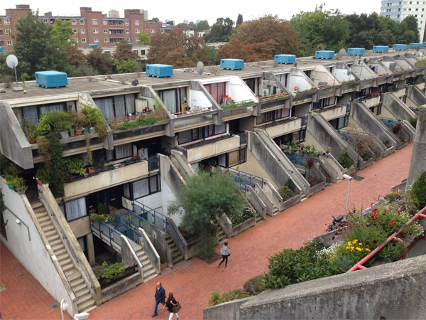

Alexandra Road Housing Estate
Photographer: Andrea Klettner
Source: http://lovelondoncouncilhousing.blogspot.co.uk/

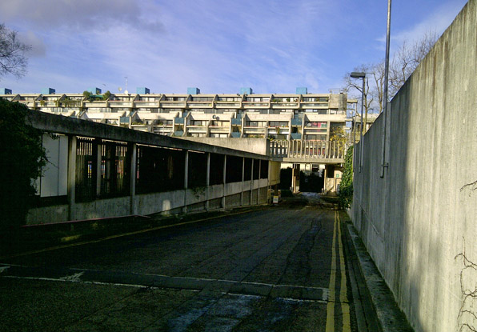

Alexandra Road Housing Estate viewed from Rowley Way and Boundary Road junction

Alexandra Road and Boundary Road which are important highway corridors, run parallel to this railway line but to the south of it. Whilst the residential flats are generally laid out in a ribbon fashion along this same axis, the masterplan provided both for a large area of P.O.S. between the blocks and additionally a significant amount of incidental planting across the estate.
  - The Council’s Conservation area statement says that the Alexandra Road Housing Estate has “a strong geometric quality …. (with) use made in all the blocks of stepped and overhanging sections. Throughout the estate play is made of changes of levels with associated ramps, stairs and lightwells. Much of the estate is constructed of fair-faced white concrete with chamfered arises”.
  - Turning specifically to 48 Boundary Road, the area statement remarks that the building is built of concrete blockwork in ‘stack bond’. It was designed by Evans and Shalev and used initially to house handicapped young people. It was originally commissioned by Camden Social Services. The building currently has 5 storeys although described respectively as lower ground, ground, first, second and third floor. The ‘fourth’ floor provides access via a lift and stairwell to the unused roof terrace. As pointed out earlier, whilst originally built to house handicapped children the St John’s Wood Centre has since 1998 been used as a Residential Care Home. At the ground level the building is roughly 25 metres long (facing Boundary Road) and 12 metres deep. It is roughly 15 metres high. Currently the building has 15 bedrooms on the lower ground floor, 23 on the ground floor, 27 on the first floor, 18 on the second floor and 18 on the third floor. There is parking for 10 vehicles which is accessed via Rowley Way which runs past the property along its eastern gable.

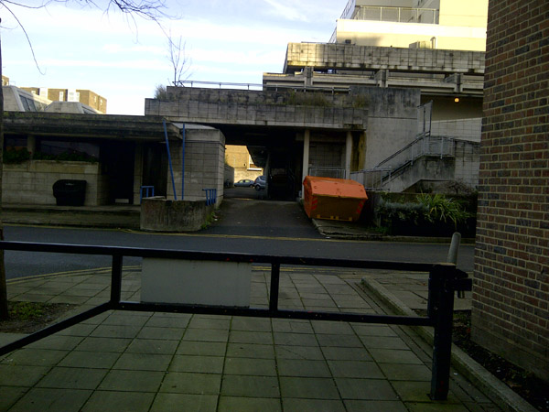
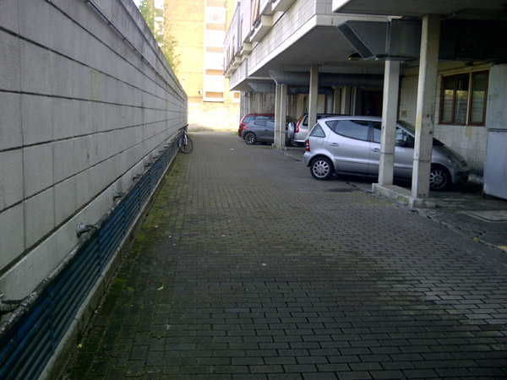
Existing vehicular access taken from Ainsworth Way and the car park area of the existing care home

The Conservation area assessment states that the building has a distinctive character associated with the use of blockwork. It has the same stepped sections on the Alexandra Road Housing Estate itself (a Grade II* listed structure) albeit at a more modest scale.
  - Appended to this Design and Access statement is a copy of the officer’s report in relation to PW9802564RI granted in 1998. Interestingly the officer connects at paragraphs 6.6 and 6.7 as to the vacancy of the building over a 6 year period and of how the grey concrete cladding had weathered badly over the years as a consequence.
The Officer also comments favourably on how the proposed treatment would enhance the character and appearance of the Conservation Area’ (paragraph 6.7). In relation to separation distances he is content that these would be sufficient to protect privacy (paragraph 6.8). The officer is also satisfied that the proposed re-configuration and re-cladding of the building “reflects the design idiom of the existing building” and is the correct approach to use “because of the importance which must be attributed to the setting of the building within the Alexandra Road Conservation Area” (paragraph 6.5).

- PLANNING POLICY
  - The Development Plan comprises, on the one hand, the London Plan adopted in 2011, and on the other the Camden Core Strategy adopted in 2010. In addition regard needs to be given to the National Planning Policy Framework. (NPPF) which was published in March 2012.
  - With regard to the London Plan Policy 2A.1 is concerned with the sustainability criteria of a development proposal. Chapter 3 is concerned to see the optimum use made of previously developed land (pd1), whilst ‘3c’ seeks to promote development which is accessible by public transport. Chapter 4b promotes a design led approach to development proposals. The document’s over-arching strategy can be seen as encouraging the re-use of PDL and the delivery of higher densities residential development in areas of good public transport accessibility.
  - Turning to Camden’s Core Strategy we consider that the following policies are relevant to this proposal.
CS10 – Supporting community facilities and services
This policy states that the Council will work with partners to ensure community facilities and services are provided for Camden’s communities.
CS13 – Tackling climate change through promoting higher environmental standards.
This policy makes it clear that the Council will require all development to take measures to minimise the effects of climate change.
CS14 – Promoting high quality phases and conserving our heritage
The Council will promote development of the highest standard of design that respects local context and character.
  - In addition to the Core Strategy the Council have a range of Development Policies which it also adopted in 2010.
Of relevance are the following:
DP7 – Sheltered Housing and Care Homes for Older People
Whilst the Council do not anticipate a growth in the need for people to move either into sheltered housing or care homes, they nevertheless expect an increasing proportion of older people to require additional nursing support. They go on to say they will commission and support extra care homes as well as supporting selective modernisation and redevelopment of existing premises.
DP16 – The transport implications of development
States that the Council will seek to ensure that development is properly integrated with adequate walking, cycling and public transport links.
DP18 – Parking standards and limiting the availability of car parking
The Council states that they will ensure that development provides the minimum necessary car parking provision.

DP22 – Promoting sustainable design and construction
The Council will require development to incorporate sustainable design and construction measures. These may include a ‘very good’ in BREEAM assessments for non-domestic developments.
DP22 – Securing high quality design
The Council will require all developments including extensions to be of the highest standard of design appropriate to the character, setting and context of neighbouring buildings.
DP25 – Conserving Camden’s heritage
In assessing development within a conservation area the Council state that they will take account of conservation area statements and appraisals in order to ensure development ‘preserves or enhances’ the conservation area.
DP26 – Managing the impact of development on occupiers and neighbours
This states that the Council will only permit development which does not cause harm to the amenity of neighbours and occupiers.
  - Finally the NPPF represents a further material consideration to be weighed in the balance in decision making.
This states that at the heart of decision making is a presumption in favour of sustainable development. It goes on at paragraph 14 to say that proposals which accord with the development plan should be approved without delay. Where relevant development plans are deemed ‘out of date’ permission should be granted unless “any adverse impacts of doing so would significantly and demonstrably outweigh the benefits”.
At paragraph 17 the NPPF says that decision makers should encourage the effective use of land by re-using PDL provided it is not of high environmental value.
With regard to the historic environment it states at paragraph 131 that Councils should take account of “the desirability of sustaining and enhancing the significance of heritage assets and putting them to viable uses consistent with their conservation”. It goes on to say that a further consideration should be “the desirability of new development making a positive contribution to local character and distinctiveness”.

- THE PROPOSAL
Use
  - As explained in the introduction the application property, known as the St John’s Wood Centre, has been in use as a care home (Use Class C2) since the beginning of this century. Unfortunately the upper floor of the accommodation, originally designated as a roof terrace, has not functioned for this purpose since the care home first opened. There are a number of reasons for this to do with health and safety and building regulation compliance which have impacted on access to the roof area as well as balcony heights around it. The Council was party to discussions regarding these matters in 2001.
  - Despite the loss of the garden terrace, amenity space has been available to residents as plan reference L3075-70 illustrates in relation to the ‘Lower Ground Floor’. Given the dis-use of the roof terrace, the care home operator has decided to convert a proportion of the floorspace for additional accommodation to be used in conjunction with the care home. The additional floorspace, illustrated on drawing L3075-71-A, would create 10 further en-suite bedrooms. This accommodation would be accessed by the lift and two staircases which currently serves the roof terrace area.
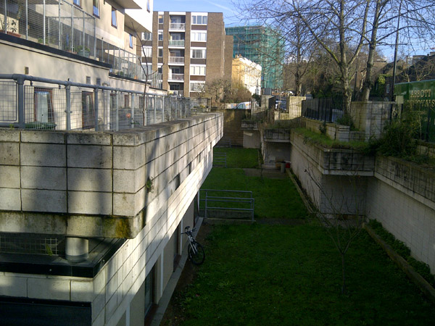

External amenity space at lower ground floor level
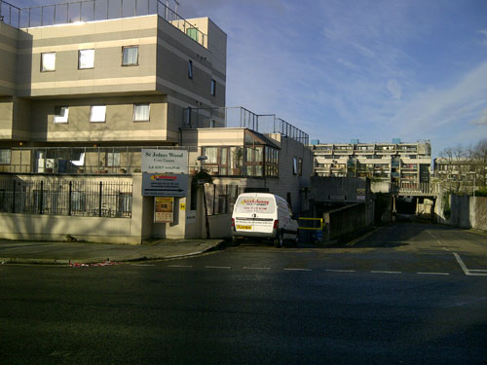

In policy terms we believe the thrust of the London Plan and the Core Strategy supports the formation of additional C2 accommodation within a sustainable brownfield location such as this. Chapter 3 of the London Plan certainly endorses such an approach.
Moving to the Core Strategy we believe Policies DP7 and CS10 support the extension of such specialist accommodation within mature residential environments like this.
Amount
  - Plan reference L3075-71-A illustrates the layout for the newly configured fourth floor. In addition to the 10 new en-suite bedrooms, each with a floor area of 14.3 square metres, there would be day care accommodation, ancillary and staff accommodation. The gross floor area of this accommodation would be 437.8 square metres of which 31.8 square metres would compare the existing floorspace in the form of the lift and staircases.
So far as staffing is concerned with 3 existing shifts, this is as follows:
Total
AM 27 nurses and carers, 11 others 38
PM 24 nurses and carers, 11 others 35
Night-time 13 nurses and carers 13
86

The total number of additional staff required for the 10 beds would be 12 with the maximum on duty at any time of 4.
Layout, Scale and Appearance
  - The existing care home provides 101 bedrooms over 5 floors that is lower ground floor, ground floor, first floor, second and third floor. The proposal, introducing a new fourth floor would furnish an additional 10 beds bringing the total up to 111 beds. The new accommodation would be approximately 33 metres in length by 14 metres wide at its widest point.
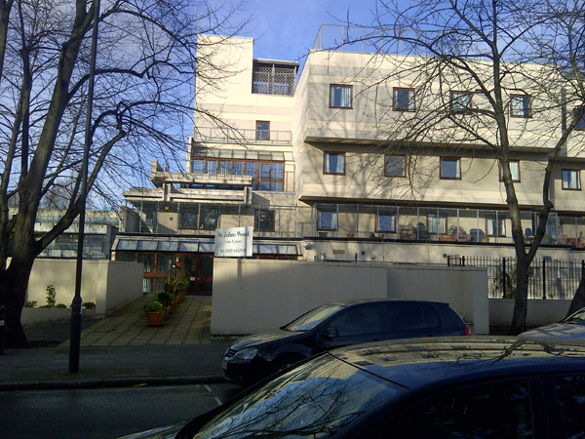

Lift shaft of the existing care home, viewed from Boundary Road

  - As drawing reference L3075-73 shows the new accommodation would be approximately 2.5 metres higher than the existing building although it would not project above the stairwell/lift shaft which remains the tallest element of the structure. At the present time the accommodation has tall metal mesh fencing acting as balconies at a number of levels including the roof terrace. As a part of the proposal, the existing tall mesh fencing at the proposed fourth floor level will be removed, and all the other remaining mesh fencing at lower floors will be replaced by 1.8 metre high glazed panels, which we believe is more sympathetic to this contemporary structure.
  - Taking the proposed floor plan (drawing L3075-70) in conjunction with the proposed elevations (reference L3075-74 and 75), it can be seen that the additional accommodation will be neatly contained within the envelope of the existing care home. As we have said the new floorspace will not exceed the height of the existing stairwells and so not add materially to the scale of the existing building. Importantly, given the original character of the building, utilising overhangs and differing floor plates between floors, the new accommodation will be no closer to neighbouring properties than the existing. Thus the separation distance to properties on the south side of Boundary Road and the school to the north would remain at least 20 metres, and usually more. Equally the distances between the end gables and the neighbouring residential flats (to the east and west) would be of a similar distance although there will be no habitable windows within these gables.
  - Turning to the appearance of the proposal it can be seen that the new floor will be built utilising the same range of materials that is concrete blockwork in a mixture of ivory and beige colours. The pattern of design, location of fenestration and use of a flat roof finish directly follows that of the original building. We believe such an approach is entirely justified given the homogenous character of the conservation area.
It has been a conscious policy of our design to conform to the uncompromising design of this modernist building. Unlike many conservation areas, the Alexandra Road estate clearly follows a pre-determined pattern and one which is unashamedly modern. Given this unifying character which is carried through both in the main residential estate along Alexandra Road, but also within the smaller scale developments along Boundary Road, it became a settled view that conformity was the correct architectural approach.
Access and Landscaping
  - The application site is extremely well served by public transport with two tube stations, Swiss Cottage and St. John’s Wood less than 6 minutes walking distance from 48 Boundary Road. In addition, Finchley Road tube station is only 11 minutes walk away.
Bus routes running to and from Finchley Road station include 113, 13, 187, 268, 82, C11, N113 and N13.
To underscore the argument regarding the sustainability of this location the operators Life Style Care have contended that it is rarely difficult to secure a parking space from the 10 available underneath the building. This is because the vast bulk of staff and visitors to the site arrive and depart by public transport. It is accordingly not the view of the applicant that there would be a problem accessing the care home, as extended, given this background of high public transport usage. As part of this planning application there would be no intention of increasing the number of parking spaces available above and beyond the 10 available. In this sense we believe the proposal is compatible with Policy DP18 of the Core Strategy.
Landscaping
  - Given the nature of this application, that is a proposal to add an additional floor to an existing multi-storey care home within a heavily urban location, it is not proposed to provide any landscaping with regard to the proposal.

Internal Access

  - Internally the proposed fourth floor will be designed to include various colours, textures and aromas to enhance the residents' experience especially those of limited vision. Signs will have raised lettering etc, different floor textures will be adopted at notable areas or areas of transition, contrasting colours will differentiate building functions, etc.

4.11The applicant is aware that the dimensions of the new en-suite bathrooms are not fully compliant with the Part M of the Building Regulations. However, given the nature of the care home operation, the care home residents (including wheelchair users) will be assisted by staff to access en-suite facilities and to transfer to/from their wheelchair, rather than accessing/using the en-suite facilities independently. Given this background, we consider it is not essential for providing a typical 1500mm clear turning circle within the en-suite as other types of care facilities such as independent living units, care apartments, etc. It is also worth noting that although the existing en-suite facilities within the building are of much smaller sizes than that of the proposed new units, they do not impose any adverse impact on the operational needs of the care home. Therefore we consider the size and dimension of the new en-suites would not be unacceptable for the care home operation.

- Conclusion
  - In essence this proposal involves the consolidation of an existing C2 use within a highly sustainable location to the north of the Borough. This care home use was established by virtue of a planning permission in November 1988. Furthermore, as the officer’s report made clear, this change of use with associated alterations enabled the re-use of a building which had remained empty for 6 years. Our proposals would enable a modest extension in accommodation available from 101 to 111 beds.
We believe the built form will strongly follow the form of this highly contemporary late twentieth century building.
We are satisfied that it will preserve the character of the Alexandra Road Conservation Area thus complying with both the NPPF and Policies CS14 and DP25 of the Council’s relevant policies. Furthermore, as we have argued, it will not undermine the standards of amenity of neighbouring properties. It will respond to the need for further C2 accommodation within a location supported by both London Plan and Camden policies.
Finally, the proposed accommodation is to be found within a highly sustainable location wherein access to public transport is of the highest level. Accordingly we would not anticipate difficulties in relation to the existing levels of car parking’
For all these reasons we would urge that planning permission is granted.

