List Entry Summary
This building is listed under the Planning (Listed Buildings and Conservation Areas) Act 1990 as amended for its special architectural or historic interest.

Name: ORIGINAL WORKHOUSE BLOCK AT FORMER NEW END HOSPITAL AND ATTACHED RAILINGS

List Entry Number: 1113159

Location
ORIGINAL WORKHOUSE BLOCK AT FORMER NEW END HOSPITAL AND ATTACHED RAILINGS, NEW END
The building may lie within the boundary of more than one authority.
County: Greater London Authority
District: Camden
District Type: London Borough
Parish:

National Park: Not applicable to this List entry.

Grade: II

Date first listed: 18-Mar-1988

Date of most recent amendment: 11-Jan-1999

Legacy System Information
The contents of this record have been generated from a legacy data system.

Legacy System: LBS

UID: 477583

Asset Groupings
This List entry does not comprise part of an Asset Grouping. Asset Groupings are not part of the official record but are added later for information.

List Entry Description

Summary of Building
Legacy Record - This information may be included in the List Entry Details.

Reasons for Designation
Legacy Record - This information may be included in the List Entry Details.

History
Legacy Record - This information may be included in the List Entry Details.

Details
CAMDEN
TQ2685NW NEW END 798-1/26/1191 Original Workhouse Block at former 18/03/88 New End Hospital and attached railings (Formerly Listed as: NEW END Original 14 bay block of New End Hospital)
GV II
Hampstead parish workhouse, later hospital. 1849. Designed by HE Kendall Jnr. Converted for residential use 1996-98, John Thompson Associates, architects. Brick with stucco dressings and quoins. 3 storeys with projecting 2 storey end pavilions. Symmetrical composition of 14 main bays. Central 4 bays project; central round-arched entrance with keystone and pilasters supporting a cornice, which continues across the front of the buildings, and scroll pediment. Segmental headed sashes with stucco hoods and keystones. Projecting cornice with paired brackets; central bays with pediment containing an oculus with stucco scroll design surround. End pavilions with groups of 3 similar windows at 1st floor level, the centre window taller and surmounted by a ball. Open pediments. Rear elevation, in similar style, of interest. INTERIOR: plain. SUBSIDIARY FEATURES: attached cast-iron railings to areas. HISTORICAL NOTE: the workhouse was turned over wholly to hospital use in 1915 and, until its closure in 1987 was used as a general, and finally as a geriatric, hospital. The former workhouse block forms a notable group with the New End Hospital Circular Ward & attached Water Tower (qv), the Boilerhouse Chimney (qv) and the Infirmary Block (qv), which together demonstrate the history of Poor Law provision for the sick and elderly through the nineteenth century.
Listing NGR: TQ2645885984

Selected Sources
Legacy Record - This information may be included in the List Entry Details

Map

National Grid Reference: TQ 26458 85985
The below map is for quick reference purposes only and may not be to scale. For a copy of the full scale map, please see the attached PDF - 1113159.pdf - Please be aware that it may take a few minutes for the download to complete.
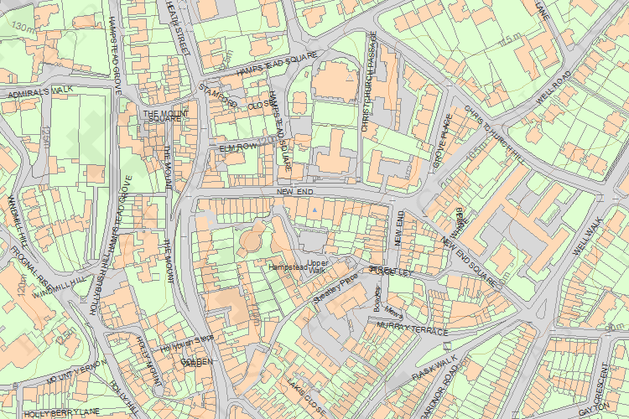
© Crown Copyright and database right 2014. All rights reserved. Ordnance Survey Licence number 100024900.
© British Crown and SeaZone Solutions Limited 2014. All rights reserved. Licence number 102006.006.

This copy shows the entry on 29-Oct-2014 at 03:25:48.

