List Entry Summary
This garden or other land is registered under the Historic Buildings and Ancient Monuments Act 1953 within the Register of Historic Parks and Gardens by English Heritage for its special historic interest.

Name: LINCOLN'S INN FIELDS

List Entry Number: 1000819

Location
The garden or other land may lie within the boundary of more than one authority.
County: Greater London Authority
District: Camden
District Type: London Borough
Parish:
County: Greater London Authority
District: City of Westminster
District Type: London Borough
Parish:

National Park: Not applicable to this List entry.

Grade: II

Date first registered: 01-Oct-1987

Date of most recent amendment: Not applicable to this List entry.

Legacy System Information
The contents of this record have been generated from a legacy data system.

Legacy System: Parks and Gardens

UID: 1813

Asset Groupings
This List entry does not comprise part of an Asset Grouping. Asset Groupings are not part of the official record but are added later for information.

List Entry Description

Summary of Garden
Legacy Record - This information may be included in the List Entry Details.

Reasons for Designation
Legacy Record - This information may be included in the List Entry Details.

History
Legacy Record - This information may be included in the List Entry Details.

Details
C17 public square, developed in the C18 and C19.
HISTORIC DEVELOPMENT
Lincoln's Inn Fields was originally known as Fickett's Field, which was in 1657 divided into two fields; the dividing line ran approximately from the Soane Museum to the Royal College of Surgeons. Described in the C17 as a 'wild-looking place of evil repute, and the scene of bloody execution' (quoted in Taylor 1953), it was the site of the execution of Lord William Russell in 1683, for his part in the Rye House Plot. John Gay recorded the dangers of the Fields in Trivia (1716). A Royal Commission was set up in 1618, with Inigo Jones, the Surveyor General, as one of the Commissioners. The Commissioners proposed a survey of the fields and Jones was asked to draw up a plan for walks in the fields and plans for surrounding houses. Nothing came of it. Between 1629 and 1638 William Newton acquired control of the fields and began to build houses to the west (known as Arch Row) and south (Portugal Row). By 1658(9 houses had been built along the north (Newman's Row), south and west sides, the east side being the property of Lincoln's Inn.
After 1657 the land on the west side was known as Pursefield and that to the east as Cupfield. In the C16 Lincoln's Inn gardens (formerly the gardens of the Earl of Lincoln) were separated from Fickett's Field by a clay embankment, later replaced by a brick wall. Parts of Lincoln's Inn Fields (the area of Cupfield to the east) were laid out with walks c 1659. Morden and Lea's map of 1682 shows diagonal paths crossing the whole rectangular area comprising Pursefield and Cupfield.
By the early C18 'the great Square, now called Lincoln's Inn Fields ... hath for some Years past lain waste and in great Disorder, whereby the same has become a receptacle for Rubbish, Dirt and Nastiness of all sorts ... but also for Want of proper Fences to enclose the same great Mischiefs have happened' (from the preamble to the Act 8 Geo II cap XXVI, 1735). A Bill in 1707 to enhance the Fields had failed but in 1735 a formal layout of grass and gravel walks was authorised. The Fields were enclosed with an iron palisade on a stone plinth and in the centre there was a large basin of water. This layout is shown in Rocque's plan of 1746. The basin was a source of some contention and in 1790 it was filled in. The gardens were closed to the public from 1735 until 1894, when the London County Council obtained possession of the gardens and they were opened to the public. The present layout dates from the early C19, and has not changed significantly since.
DESCRIPTION
LOCATION, AREA, BOUNDARIES, LANDFORM, SETTING Lincoln's Inn Fields, c 4ha, is located to the east of Kingsway and south of Holborn, within the Holborn district of the London Borough of Camden. The gardens are surrounded by Lincoln's Inn to the east and the buildings within the square to the north, west and south. The square is enclosed by steel railings (which replaced the original cast-iron railings removed during the Second World War) and is on a very slight slope from north-west to south-east.
ENTRANCES AND APPROACHES There are seven entrances to the gardens, one in the centre of each side and one in each corner, except the south-west. These are through gates in the cast-iron railings. Immediately outside the north-west and south-east entrances are drinking fountains, the fountain to the south-east, c 1880, commemorating Philip Twells MP (listed grade II).
GARDENS AND PLEASURE GROUNDS The gardens are laid out on a cruciform plan with a perimeter shrubbery and path. The western shrubbery has areas of bedding set into it. The cross paths meet at a large, lozenge-shaped area in the centre of the gardens, with an octagonal pavilion. The quarters to the north-west, north-east and south-east are surrounded by heavy modern fencing. The two northern quarters are open lawns with scattered mature trees. The quarter to the south-west is mostly taken up by tennis courts and a cafe (demolished and being replaced in 1998), with an area of bedding to the north of them. The south-east quarter is lawn with scattered trees, with an area of sub-tropical planting on the east side. The mature trees include Indian Bean trees and very large planes. Other trees include ginkgo, holly, mountain ash, prunus, and laburnum.
Along the northern perimeter walk are various features including the Canada Walk (commemorating the Canadians who died in the Second World War); a memorial seat to Mrs Ramsay MacDonald (c 1911, listed grade II), which consists of a granite alcove seat surmounted by a bronze group (depicting Mrs Ramsay with a group of nine children) by the sculptor R R Goulden; and in the north-east corner a Portland stone pedestal seat to W H Smith, second Viscount Hambledon (1869-1928), (c 1929, listed grade II), originally with bronze bust, missing late C20.
There are views out of the gardens to the surrounding buildings, which include to the north: C18 houses (Nos.1, 2, 5, 6-8, 15, 16, 25(27, all listed grade II), the Soane Museum (Nos.12-14, listed grade I), and some C19 houses (Nos.18, 19, 24, all listed grade II). The buildings on the south side include the Royal College of Surgeons and those on the west side include some C18 houses (Nos.57-58, 65, listed grade II*), an early C19 house (No.64, listed grade II), and some C17 houses (Nos.59-60, listed grade I, and No.66, restored by Lutyens in 1930 (listed grade II* with No.65)). To the east are Lincoln's Inn Hall (listed grade II*), Library (listed grade II*) and gardens.
REFERENCES
Gardeners' Chronicle I, (1895), pp 261-2 J J Sexby, The Municipal Parks ... of London (1905), pp 487-510 E B Cecil, London Parks and Gardens (1907), pp 234-6 LCC, Survey of London III, (1912), pp 3-22, pls 1-8 G Taylor, Old London Gardens (1953), pp 26-8 B Cherry and N Pevsner, The Buildings of England: London 4: North (1998), pp 306-9
Maps Richard Newcourt, Exact Delineation ... of London, 14" to 1 mile, 1658 Morden and Lea, Map of London, 1682 Stow, Map of London (published in Survey of London, 1720 edn) John Rocque, Plan of the Cities of London and Westminster ..., 1744-6 Cary, Plan of London, 1787 Richard Horwood, Plan of the Cities of London and Westminster, 2nd edn 1813
OS 25" to 1 mile: 1st edition surveyed 1873 2nd edition published 1894 3rd edition published 1914
Description written: August 1998 Amended: March 2000 Register Inspector: CB Edited: May 2000

Selected Sources
Legacy Record - This information may be included in the List Entry Details

Map

National Grid Reference: TQ 30773 81385
The below map is for quick reference purposes only and may not be to scale. For a copy of the full scale map, please see the attached PDF - 1000819.pdf - Please be aware that it may take a few minutes for the download to complete.
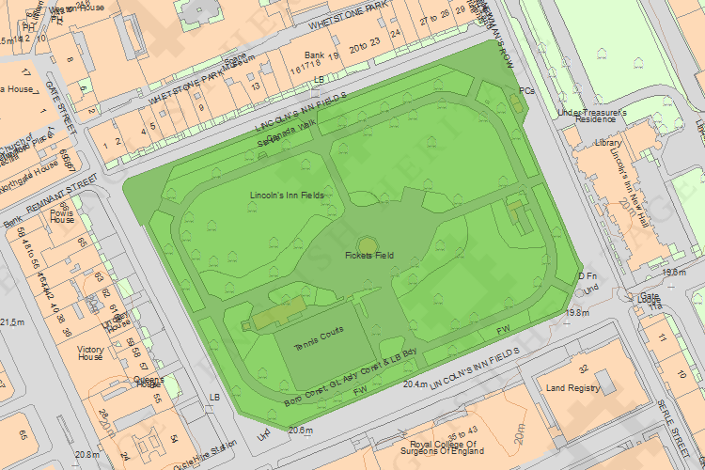
© Crown Copyright and database right 2014. All rights reserved. Ordnance Survey Licence number 100024900.
© British Crown and SeaZone Solutions Limited 2014. All rights reserved. Licence number 102006.006.

This copy shows the entry on 06-Oct-2014 at 11:15:31.

