Design & Access Statement
E011749 – Alidinas, 189 Queen Crescent, London, NW5 4DS

This Design and Access Statement has been prepared on behalf of Cashzone in support of an application submitted for:
The retention of an Automated Teller Machine and Illuminated sign.

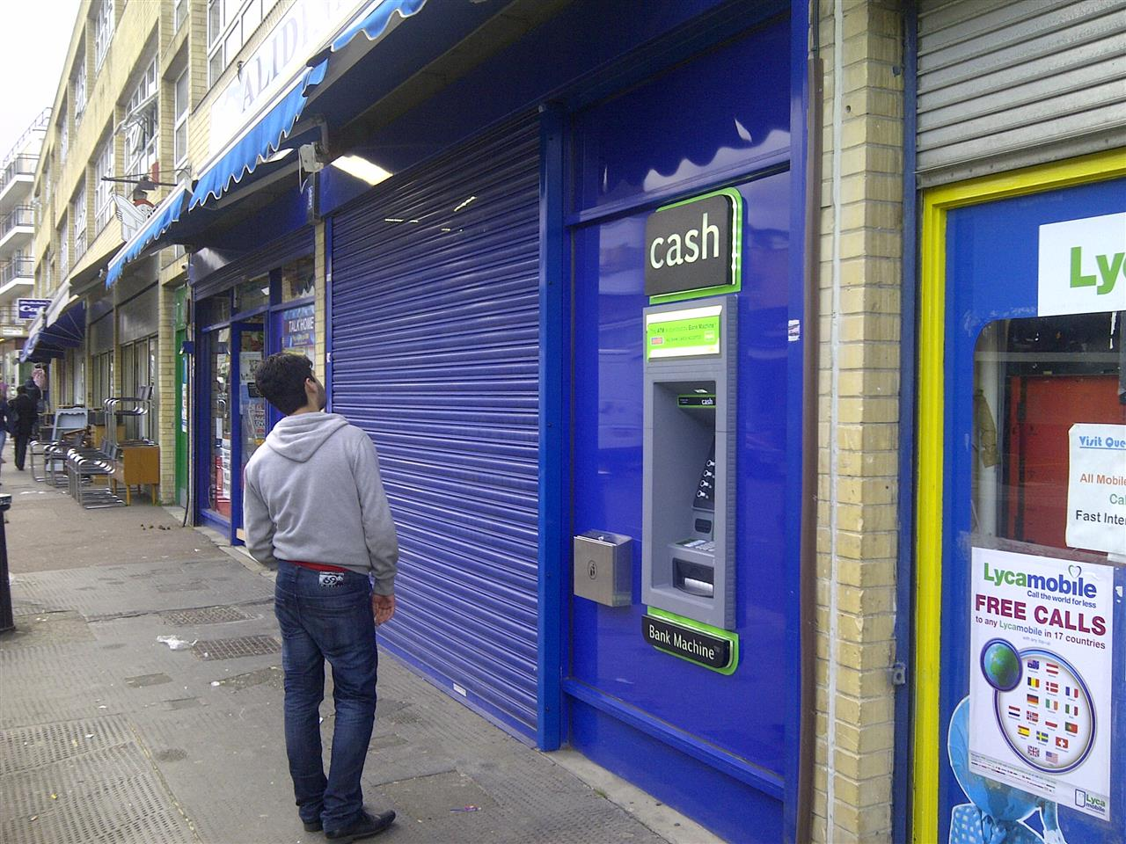

Appearance

The site is located through the far right window of Alidina’s newsagents and convenience store, the shop if located on Queen Crescent, below offices and alongside various other retail units, next door there is an internet café and a disused unit on the other side. The ATM is installed through the far right window to the shop entrance; the window of which the ATM is installed has no special historic or architectural features. There are residential properties in the area but we consider that the installation of an ATM at this location would not be detrimental to them.

Use

The purpose of the installation of this Automated Teller Machine is to provide a 24 hour banking facility for the local community and visitors to the area.

Scale

N/A

Layout

The installation of the ATM has not altered the basic design of the building.
We have removed an existing glazing panel. In the remaining void we have installed (a new mullion and smaller glazing panel) an external security wall (see NW0207 External security wall construction in attachments) with a laminate finish. The colour of this panel is blue and was chosen to best blend with the existing shop front design. An aperture was formed in this for the ATM face.
We consider that this would not be detrimental to the existing street scene.

Amount

This is not a new structure, but the installation of an ATM in an existing shop.

Landscaping

This is not relevant as the installation does not require it.

Design Principals

The ATM is of standard design as located in many areas throughout the UK and is accepted as a necessary facility. There are a number of mandatory standards which apply, relating to the position of the ATM, it’s visibility, ambient lighting, building structure, building security features, ATM anchoring, safe strength.

Designing out Crime

We install and anchor the ATMs in accordance with National Guidelines.

Site approval by the Cash In Transit Company has been obtained. They have considered routes to and from the ATM, ensuring there is protection of their staff and of any staff or customers at the site. Paramount in their review has been the welfare of their staff and the persons they come into contact with.

The area where the ATM has been installed is a well-lit open area in full view of pedestrians aiding natural surveillance.

There are existing road side bollards which will help prevent the threat of ram raiding.

Access

The access to the site and other properties has not been affected.

In designing this application, we have taken into account the needs of able and disabled users. The ATM is set at a height that makes it accessible for all users and has space to the front for a wheel chair.
Key 5 has raised markings for blind persons to identify the centre key.

Car parking availability has been considered: There is parking available in front of the store.

