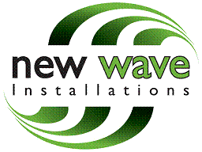

The Mayor & Burgess of the London Borough of Camden
Town Hall
Judd Street
London
WC1H 9LP

New Wave Installations, Hope Street
Rotherham, S60 1LH
Tel: 01709 821 757

10/10/2014

Dear Sir / Madam

Ref: Alidinas, 189 Queen Crescent, London, NW5 4DS
Our Ref: E011749 Planning Portal Ref: PP-03436785

I hereby give notice that New Wave are applying on behalf Cashzone to Camden Council
for planning permission to retain an Automated Teller Machine at the above address.

Should you as an owner or tenant of any part of the land wish to make representation to the council about this application, you should write to the planning officer at:

Camden Council
Development Management
Camden Town Hall Extension
Argyle Street
London
WC1H 8EQ

I trust the above is satisfactory, however if you would like any further information please do not hesitate to contact me.

Yours sincerely,

Amy Powell
Planning Coordinator
NewWave Installations Ltd

