Mr Thomas Langlois
64 Delancey Street
London
NW17RY
64 Delancey Street  London  NW17RY |  | Application Ref: 2014/3155/L
 |  | Please ask for: Antonia Powell
 |  | Telephone: 020 7974 2648
 |  | 8 July 2014

Dear Sir/Madam

DECISION

Planning (Listed Building and Conservation Areas) Act 1990

Listed Building Consent Granted

Address:
64 Delancey Street
London
NW1 7RY

Proposal:
Removal of internal partition to reinstate master bedroom.
Drawing Nos:
OS Extract; Heritage Statement; Document entitled Wall Removal plan/pictures, including plans as existing and proposed.

The Council has considered your application and decided to grant Listed Building Consent subject to the following condition(s):

Conditions And Reasons:

1 | The works hereby permitted shall be begun not later than the end of three years from the date of this consent.  Reason: In order to comply with the provisions of Section 18 of the Planning (Listed Buildings and Conservation Areas) Act 1990.
2 | All new work and work of making good shall be carried out to match the original work as closely as possible in materials and detailed execution.  Reason: In order to safeguard the special architectural and historic interest of the building in accordance with the requirements of policy CS14 of the London Borough of Camden Local Development Framework Core Strategy and policy DP25 of the London Borough of Camden Local Development Framework Development Policies.
3 | The works hereby approved are only those specifically indicated on the drawing(s) referred to above.  Reason: In order to safeguard the special architectural and historic interest of the building in accordance with the requirements of policy CS14 of the London Borough of Camden Local Development Framework Core Strategy and policy DP25 of the London Borough of Camden Local Development Framework Development Policies.

Informative(s):

Reasons for granting listed building consent. [Delegated]

The proposed development is in general accordance with the London Borough of Camden Local Development Framework Core Strategy, with particular regard to policy CS14 (Promoting high quality places and conserving our heritage); and the London Borough of Camden Local Development Framework Development Policies, with particular regard to policy DP25 (Conserving Camden's heritage). For a more detailed understanding of the reasons for the granting of this listed building consent, please refer to the officer report.

You can find advice about your rights of appeal at:

http://www.planningportal.gov.uk/planning/appeals/guidance/guidancecontent

Yours faithfully
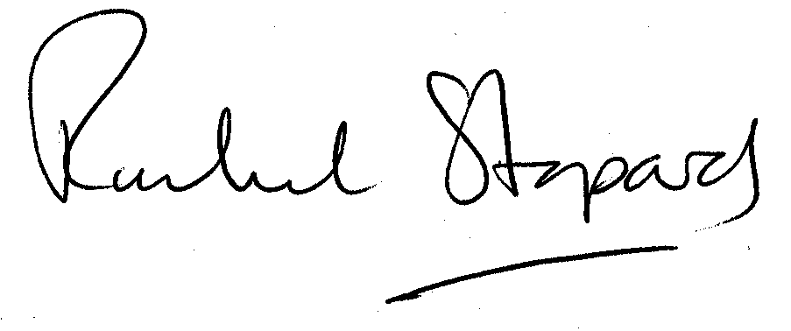
Rachel Stopard
Director of Culture & Environment

