Mr Steve Taylor
Network Rail Infrastructure Ltd
1 Eversholt Street
London
NW1 2DN
1 Eversholt Street  London  NW1 2DN |  | Application Ref: 2013/7437/L
 |  | Please ask for: Antonia Powell
 |  | Telephone: 020 7974 2648
 |  | 28 January 2014

Dear Sir/Madam

DECISION

Planning (Listed Building and Conservation Areas) Act 1990
Planning (Listed Buildings and Conservation Areas) Regulations 1990

Listed Building Consent Granted

Address:
Kings Cross Station
Euston Road
London
N1 9AP

Proposal:
Reconstruction of platform 8/9 canopy, refurbishment of porter's box and lighting.
Drawing Nos: Site location plan; BDG0085/DRG/E002 and E003;
Documents entitled: Design & Access and Heritage Statement, dated 19/11/2013; Document ref: ARC-REP--JMP-PA-SWNS-0027 Platform 8/9 Canopy and Porter's Box, Issue 1.0

The Council has considered your application and decided to grant Listed Building Consent subject to the following condition(s):

Conditions And Reasons:

1 | The works hereby permitted shall be begun not later than the end of three years from the date of this consent.  Reason: In order to comply with the provisions of Section 18 of the Planning (Listed Buildings and Conservation Areas) Act 1990.
2 | All new work and work of making good shall be carried out to match the original work as closely as possible in materials and detailed execution.  Reason: In order to safeguard the special architectural and historic interest of the building in accordance with the requirements of policy CS14 of the London Borough of Camden Local Development Framework Core Strategy and policy DP25 of the London Borough of Camden Local Development Framework Development Policies.
3 | The works hereby approved are only those specifically indicated on the drawing(s) referred to above.  Reason: In order to safeguard the special architectural and historic interest of the building in accordance with the requirements of policy CS14 of the London Borough of Camden Local Development Framework Core Strategy and policy DP25 of the London Borough of Camden Local Development Framework Development Policies.  modifying

Informative(s):

Reasons for granting listed building consent. [Delegated]

The proposed development is in general accordance with the London Borough of Camden Local Development Framework Core Strategy, with particular regard to policy CS14 (Promoting high quality places and conserving our heritage); and the London Borough of Camden Local Development Framework Development Policies, with particular regard to policy DP25 (Conserving Camden's heritage). For a more detailed understanding of the reasons for the granting of this listed building consent, please refer to the officer report.

You are reminded that condition 2 (ref: 2006/3394/L granted 09/11/2007) requires that the Council as local planning authority, is notified immediately, of any hidden historic features which are revealed during the course of works, those features to be retained in situ, work suspended in the relevant area of the building and provision made for their retention or salvage and/or proper recording as required by the council. Specifically historic York stone platform copings.

Your attention is drawn to the notes attached to this notice which tell you about your Rights of Appeal and other information.

Yours faithfully
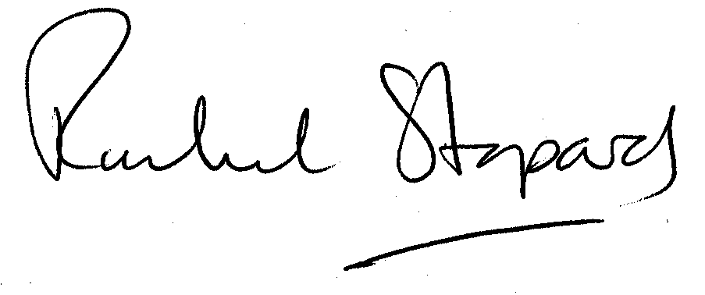
Rachel Stopard
Director of Culture & Environment

It’s easy to make, pay for, track and comment on planning applications on line. Just go to www.camden.gov.uk/planning.
It is important to us to find out what our customers think about the service we provide. To help us in this respect, we would be very grateful if you could take a few moments to complete our online planning applicants’ survey. We will use the information you give us to monitor and improve our services.

