Mr Michael Chester
Michael Chester and Partners LLP
8 Hale Lane
London
NW7 3NX
8 Hale Lane  London  NW7 3NX |  | Application Ref: 2014/3647/L
 |  | Please ask for: Antonia Powell
 |  | Telephone: 020 7974 2648
 |  | 10 September 2014

Dear Sir/Madam

DECISION

Planning (Listed Building and Conservation Areas) Act 1990

Listed Building Consent Granted

Address:
24 Park Village East
London
NW1 7PZ

Proposal:
Underpinning and superstructure repairs caused by subsidence damage
Drawing Nos:

13100/20; 13100/21; 13100/22; 13100/23; 13100/24; 13100/25; 13100/01; 13100/02; 13100/03; 13100/04; 13100/05; 13100/10; 13100/11; 13100/12;
Site Location Plan; Design and Access Statement by Michael Chester & Partners dated 30/05/2014; Drainage Survey dated February 2014; Cover letter and attached Borehole Report by CET dated February 2014; Trial plan and trial pit details by GHG; Laboratory report including soil, root and land reports by MAT Lab Ltd., dated June 2012; Superstructure and drainage repairs and redecorations document by Michael Chester and Partners; Monitor graphs dated 05/12 to 06/13 by GHG; Level results dated 2012 to 2013 by GHG ; Underpinning schedule by Michael Chester and Partners; Site photographs x 11;

The Council has considered your application and decided to grant Listed Building Consent subject to the following condition(s):

Conditions And Reasons:

1 | The works hereby permitted shall be begun not later than the end of three years from the date of this consent.  Reason: In order to comply with the provisions of Section 18 of the Planning (Listed Buildings and Conservation Areas) Act 1990.
2 | All new external and internal works and finishes and works of making good to the retained fabric, shall match the existing adjacent work with regard to the methods used and to material, colour, texture and profile, unless shown otherwise on the drawings or other documentation hereby approved or required by any condition(s) attached to this consent.  Reason: In order to safeguard the special architectural and historic interest of the building in accordance with the requirements of policy CS14 of the London Borough of Camden Local Development Framework Core Strategy and policy DP25 of the London Borough of Camden Local Development Framework Development Policies.
3 | The works hereby approved are only those specifically indicated on the drawing(s) referred to above.  Reason: In order to safeguard the special architectural and historic interest of the building in accordance with the requirements of policy CS14 of the London Borough of Camden Local Development Framework Core Strategy and policy DP24 of the London Borough of Camden Local Development Framework Development Policies.
4 | Any joinery removed during the course of the works shall be protected, retained on site and reused within the scheme unless otherwise agreed in writing by the Council.  Reason: In order to safeguard the special architectural and historic interest of the building in accordance with the requirements of the London Borough of Camden Local Development Framework Core Strategy, Policy CS14 (Promoting high quality places and conserving our heritage); and the London Borough of Camden Local Development Framework Development Policies, Policy DP25 (Conserving Camden's heritage).
5 | Any hidden historic features which are revealed during the course of works should be retained in situ, work suspended in the relevant area of the building and the council as local planning authority notified immediately. Provision should be made for their retention or salvage and/or proper recording as required by the council.  Reason: In order to safeguard the special architectural and historic interest of the building in accordance with the requirements of policy CS14 of the London Borough of Camden Local Development Framework Core Strategy and policy DP24 of the London Borough of Camden Local Development Framework Development Policies.

Informative(s):

Reasons for granting listed building consent. [Delegated]

The proposed development is in general accordance with the London Borough of Camden Local Development Framework Core Strategy, with particular regard to policy CS14 (Promoting high quality places and conserving our heritage); and the London Borough of Camden Local Development Framework Development Policies, with particular regard to policy DP25 (Conserving Camden's heritage). For a more detailed understanding of the reasons for the granting of this listed building consent, please refer to the officer report.

You can find advice about your rights of appeal at:

http://www.planningportal.gov.uk/planning/appeals/guidance/guidancecontent

Yours faithfully
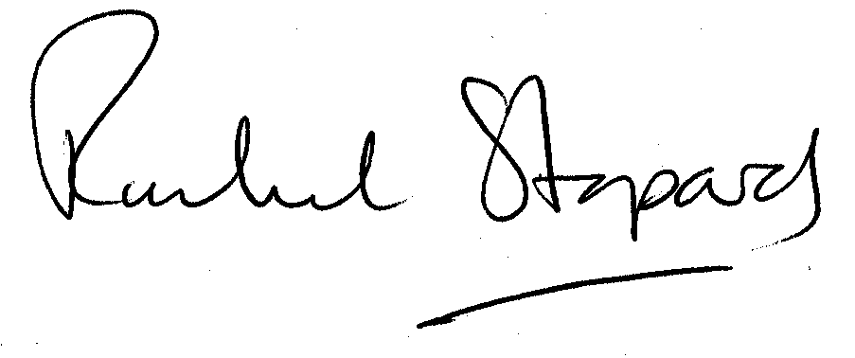
Rachel Stopard
Director of Culture & Environment

