Miss Leanna Boxill
John McAslan + Partners
7-9 William Road
London
NW1 3ER
7-9 William Road  London  NW1 3ER |  | Application Ref: 2014/4420/L
 |  | Please ask for: Antonia Powell
 |  | Telephone: 020 7974 2648
 |  | 16 September 2014

Dear Sir/Madam

DECISION

Planning (Listed Building and Conservation Areas) Act 1990

Approval of Details (Listed Building) Granted

Address:
Friends House
173 Euston Road
London
NW1 2BJ

Proposal:
Details of proposed floor finishes, as required by condition 3h of Listed Building Consent ref 2012/2403/L (dated 17/07/2012) for alterations and installation of plant equipment to Friends House.
Drawing Nos: 1371/ G331-P-B1 rev 01; G300-P00-01 rev 03; G331-P-01 rev 01; G331-P-00 rev 01; G331-P-02 rev 01; G331-P-03 rev 01; Document entitled Friends House Proposed Floor Finishes, by John McAslan & Partners, dated July 2014.

The Council has considered your application and decided to grant Approval of Details (Listed Building) subject to the following condition(s):

Conditions And Reasons:

Informative(s):

Please be advised that Condition 3 d) Details of new north east stair configuration and lift insertion; Condition 3 e) Details of all new and refurbished signage and Condition 3 i) Samples of all new timber joinery including seating to the Main Meeting Hall and panelling, of Listed Building Consent ref:2012/2403/L granted 17/07/2012 which require details to be submitted to the planning authority for approval in writing, remain outstanding.

You can find advice about your rights of appeal at:

http://www.planningportal.gov.uk/planning/appeals/guidance/guidancecontent

Yours faithfully
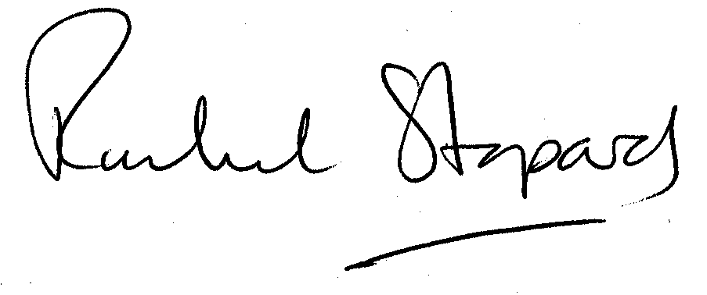
Rachel Stopard
Director of Culture & Environment

