Network Rail Infrastructure Ltd
1 Eversholt Street
London
NW1 2DN
1 Eversholt Street  London  NW1 2DN |  | Application Ref: 2014/3865/L
 |  | Please ask for: Antonia Powell
 |  | Telephone: 020 7974 2648
 |  | 16 September 2014

Dear Sir/Madam

DECISION

Planning (Listed Building and Conservation Areas) Act 1990

Approval of Details (Listed Building) Granted

Address:
Kings Cross Station
Euston Road
London
N1 9AP

Proposal:
Details as required by part condition 8 (Services) and part condition 20Av (Suspended ceilings) of Listed Building Consent ref 2006/3394/L, for alterations, extensions, refurbishment works to King's Cross Station including construction of Western Concourse.
Drawing Nos: Site location plan; Document entitled Platform 8-9 Walkthrough exposed services and basement, ref: ARC-REP-JMP-PA-SWNS-0034;

The Council has considered your application and decided to grant Approval of Details (Listed Building) subject to the following condition(s):

Conditions And Reasons:

Informative(s):

Please be advised that this consent is for the part discharge of Condition 8 (Services) and part Condition 20 Av (Details of suspended ceilings) (ref:2006/3394/L granted 09/11/2007) and relates specifically to the areas between gridlines 31 and 32 of the ground floor and gridlines 32 and 33 basement level of the Western Range.

Further submissions may be required before the relevant conditions are fully discharged.

You can find advice about your rights of appeal at:

http://www.planningportal.gov.uk/planning/appeals/guidance/guidancecontent

Yours faithfully
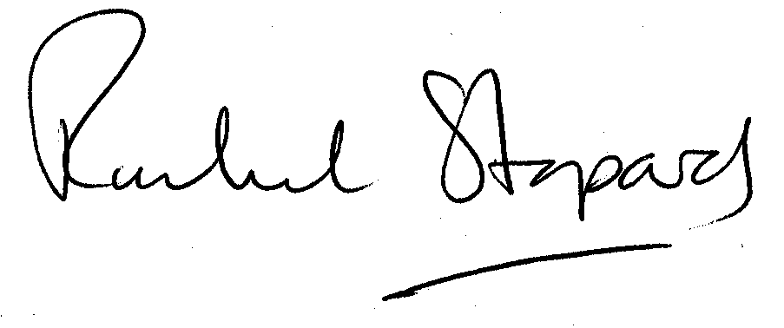
Rachel Stopard
Director of Culture & Environment

