DESIGN AND ACCESS STATEMENT

OCTOBER 2014

PROPOSED REAR EXTENSION AT NO. 22 GLOUCESTER CRESCENT

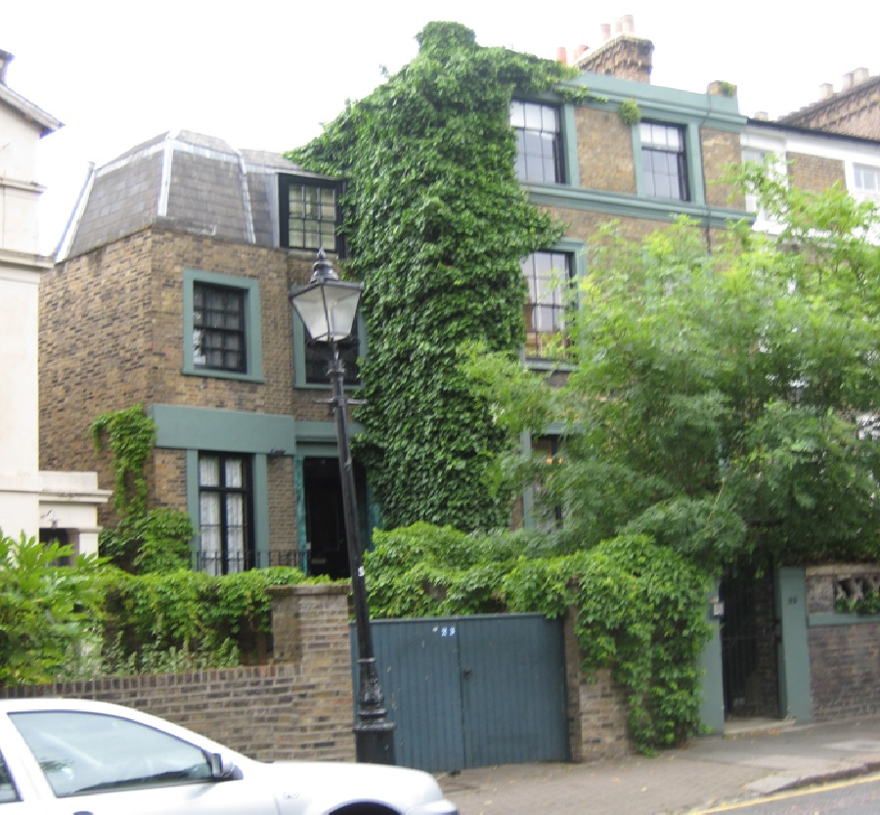

THE PROPERTY

No. 22 is the northern end of curved terrace of 20 houses, constructed between 1840-1845 by Henry Basset, in an italianate style. No's 3 to 22 consecutive are Grade II Listed.
The wall are of Yellow London Stock brick.

Hipped roofs are of slate with lead dressings. Chimney stacks are enriched, and projecting eaves have shaped brackets.

The houses are in an Italianate style of deferring designs forming linked groups.

No22 has been partly rebuilt and altered historically.
The rear in fill in triangular form out lower ground floor is historic, but of an indeterminate age.

AMOUNT OF DEVELOPMENT

The footprint of the house at lower ground floor remain as existing.

The proposal is to partially extend on top of the existing triangular infill at the rear of the building, at ground floor and half landing between ground and first floors.

The property is a single family dwelling occupied by a young family who live and work in the building.
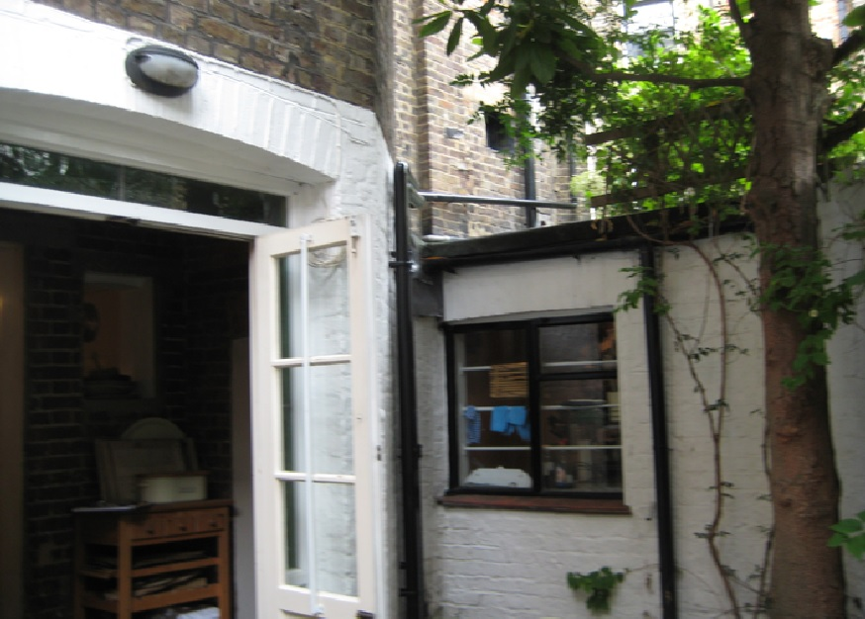 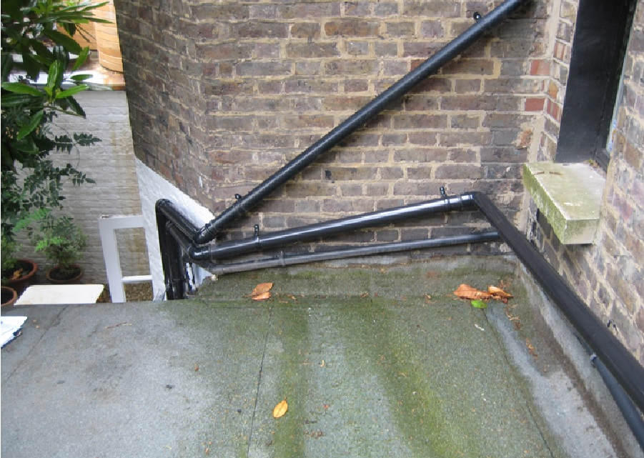 (Rear Extension)

The extension at ground floor is to provide a small home office for the owners.
The extension at first floor is to create a small family bathroom, to serve the three first floor bedrooms.

The present bathroom measures approximately 1.4m x 1.6m, and is inadequate for a growing family.

It is impossible to create a bathroom on this floor without destroying the historic plan shape of the existing three bedrooms.
But by extending to the rear, a serviceable space can be provided, to accommodate a basin, , wc and shower.

LAYOUT

The house compromises lower and raised Ground floors, First and Second floors.

The side annexe (later constructed) has a slate mansard roof at second floor.

The new additions will be located at the rear of the ground and first floor annexes, above an existing triangular infill at lower ground floor., but set behind and subservient to, the existing projecting bay.

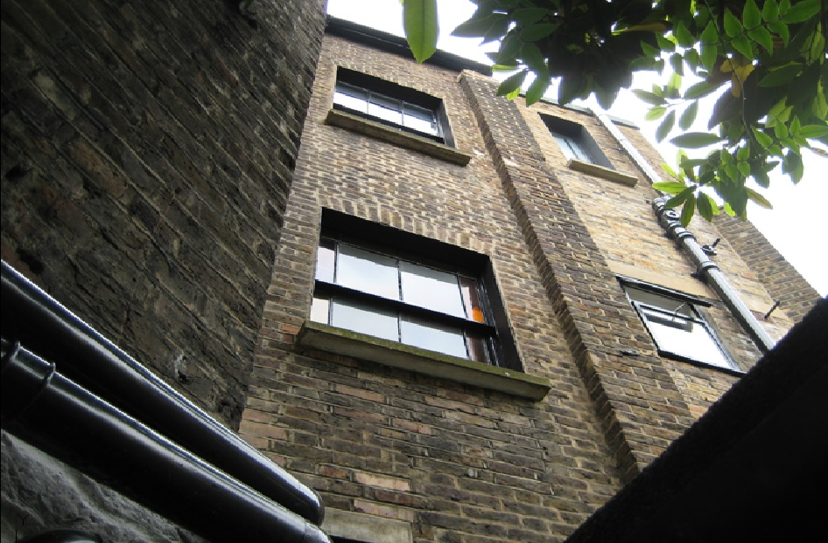 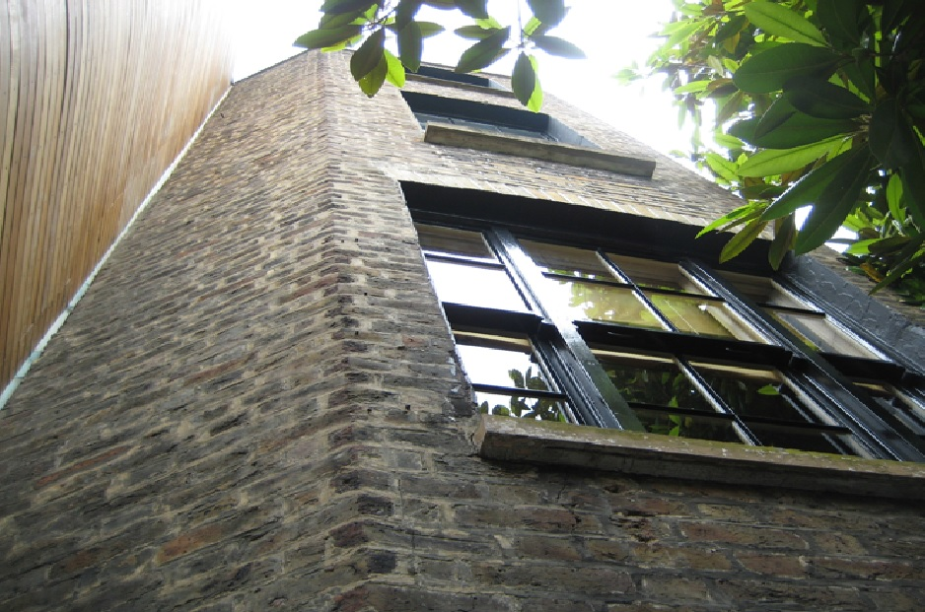 (Rear)

APPEARANCE

The materials proposed are second hand London stock brick, to be laid in Flemish bond, to match existing work,, with a concealed lead flat roof behind a low parapet.

The proposed addition is not visible from the street, or from any public footpath.

DESIGN

Although the house forms part of the Grade II listed Eastern side of Gloucester Crescent, the site is tightly bounded by an eclectic variety of design, styles, and construction methods.

To the rear is the land locked Cavendish school which has a modern extension, topped by a sebum roof, which dominates the rear elevation of no. 22 with a soaring two floor sheer brick wall.

The design of the school is modernist, with transparent full height walls.

The adjoining property at no 21, to the south, was recently granted consent for an unprecedented curved timber extension and stair tower, over four floors. This extension is uncompromisingly modernist, and soars above the rear patio yard of no.22.

The size of the consented extension to the no 21 is larger then the original brick closet wing which is replaced.

This extension sets a precedent for contemporary additions to the rear of the terrace.

ACCESS

There is no change proposed to the existing pedestrian access from Gloucester Crescent.

