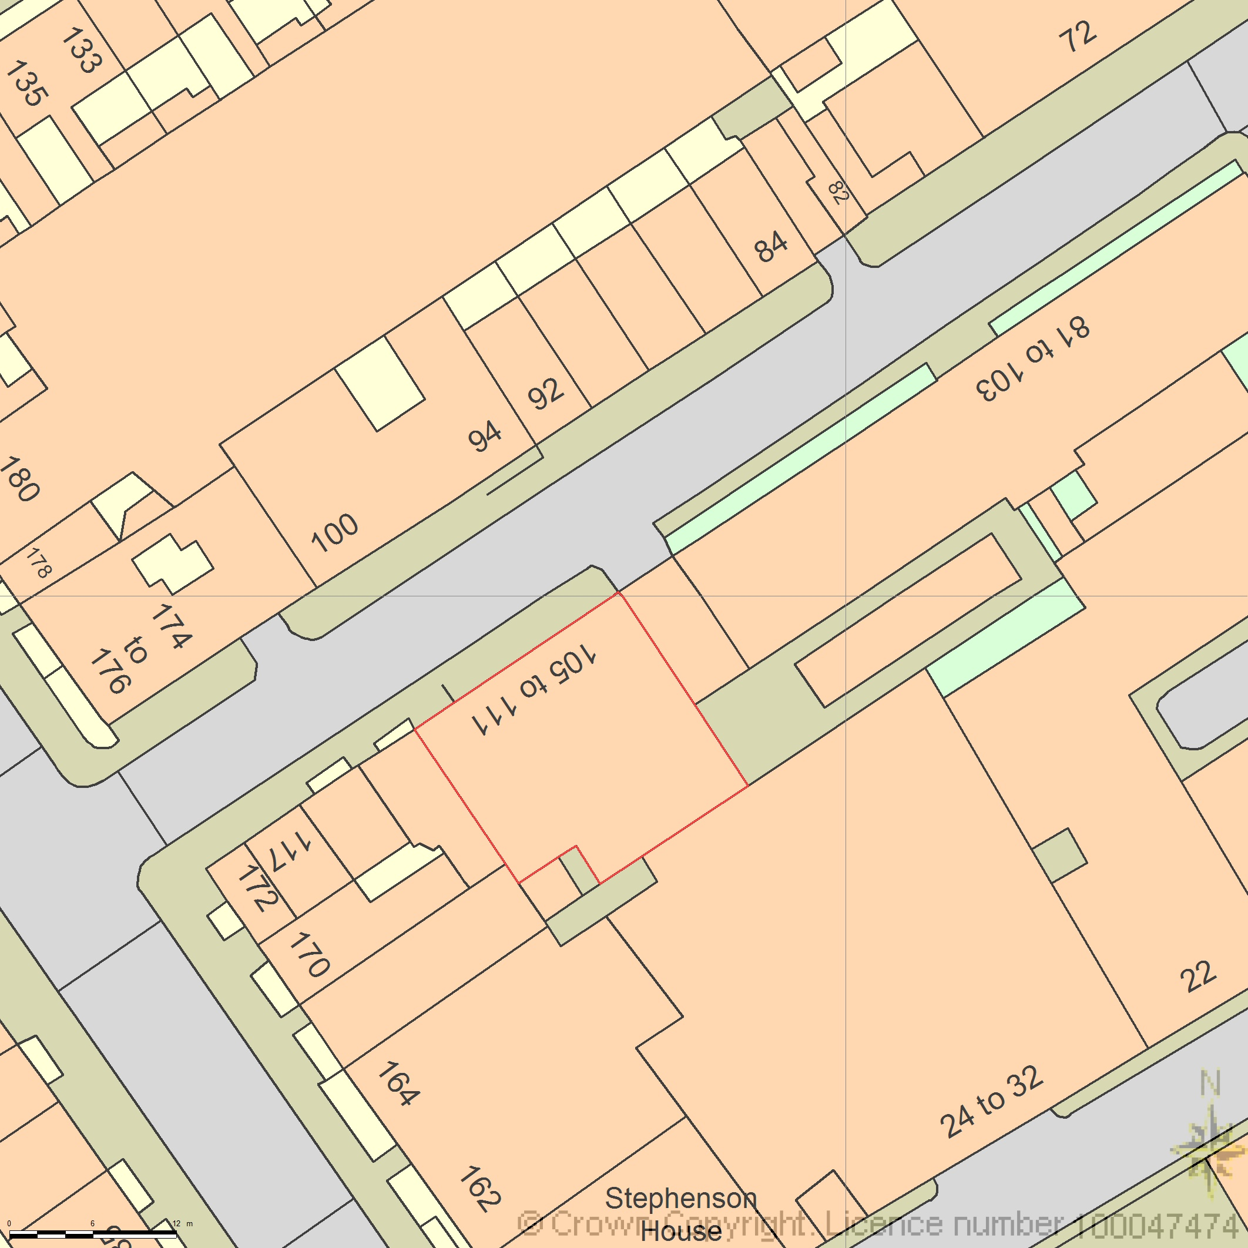
BLOCK PLAN
AREA 90m x 90m
SCALE 1:500 on A4
CENTRE COORDINATES: 529384, 182498



Supplied by Streetwise Maps Ltd
www.streetwise.net
Licence No: 100047474
30/07/2026 07:41:22

