Mr Tamir Addadi
Tamir Addadi Architecture Ltd.
51 Tabley Road
London
N7 0NB
51 Tabley Road  London  N7 0NB |  | Application Ref: 2013/7230/P
 |  | Please ask for: Rachel Miller
 |  | Telephone: 020 7974 1343
 |  | 21 July 2014

Dear Sir/Madam

DECISION

Town and Country Planning Act 1990 (as amended)

Householder Application Granted Subject to a Section 106 Legal Agreement

Address:
11 John Street
London
WC1N 2EB

Proposal:
Excavation of basement extension to the rear and side, demolition of part of the existing rear extension at ground floor level to create two courtyards. Replacement of existing fenestration at ground and second floor level to front elevation. Installation of new door at rear first floor. Removal of existing roof and replacement with dummy mansard roof to accommodate a green roof terrace all in connection with existing dwelling house (Class C3).

Drawing Nos: Siteplan, drawing numbers 1, 2, 3, 4, 5, 6, 6A, 7, 8, 9, 10, 11, 12, 13, 14, 15A, 16A, 17A, 18, 19, 19A, 20A, 21A, 22, 23, 24, 25 and 26.

Supporting documents;
Heritage, Design and Access Statement dated November 2013
HPS Structural Consultants -Structural Appraisal HPSSC/4412 dated November 2013
ESI Basement Impact Assessment ref 61531R1rev1
Soil Consultants Ground Investigation Report ref 9393/AW/TSR-Rev 1 dated 12th November 2013
Soil Consultants Screening and Scoping Report 'Land Stability' ref 9393/AW/TSR-Rev 1 dated 12th November 2013
Method Statement for Basement Excavation dated November 2013

The Council has considered your application and decided to grant permission subject to the following condition(s):

Condition(s) and Reason(s):

1 | The development hereby permitted must be begun not later than the end of three years from the date of this permission.  Reason: In order to comply with the provisions of Section 91 of the Town and Country Planning Act 1990 (as amended).
2 | All new external work shall be carried out in materials that resemble, as closely as possible, in colour and texture those of the existing building, unless otherwise specified in the approved application.  Reason: To safeguard the appearance of the premises and the character of the immediate area in accordance with the requirements of policy CS14 of the London Borough of Camden Local Development Framework Core Strategy and policies DP24 and DP25 of the London Borough of Camden Local Development Framework Development Policies.
3 | The development hereby permitted shall be carried out in accordance with the following approved plans: Siteplan, drawing numbers 1, 2, 3, 4, 5, 6, 6A, 7, 8, 9, 10, 11, 12, 13, 14, 15A, 16A, 17A, 18, 19, 19A, 20A, 21A, 22, 23, 24, 25 and 26.  Reason: For the avoidance of doubt and in the interest of proper planning.
4 | The development hereby approved shall not commence until such time as a suitably qualified chartered engineer with membership of the appropriate professional body has been appointed to inspect, approve and monitor the critical elements of both permanent and temporary basement construction works throughout their duration to ensure compliance with the design which has been checked and approved by a building control body. Details of the appointment and the appointee's responsibilities shall be submitted to and approved in writing by the local planning authority prior to the commencement of development. Any subsequent change or reappointment shall be confirmed forthwith for the duration of the construction works.  Reason: To safeguard the appearance and structural stability of neighbouring buildings and the character of the immediate area in accordance with the requirements of policy CS14 of the London Borough of Camden Local Development Framework Development Policies and policy DP27 (Basements and Lightwells) of the London Borough of Camden Local Development Framework Development Policies.
5 | Full details in respect of the green roof in the area indicated on the approved first floorplan shall be submitted to and approved by the local planning authority before the relevant part of the development commences. Details shall include species, planting density, substrate and a section at scale 1:20 showing that adequate depth is available in terms of the construction and long term viability of the green roof, and a programme for a scheme of maintenance. The extensions shall not be occupied until the approved details have been implemented and these works shall be permanently retained and maintained thereafter.  Reason: In order to ensure the development undertakes reasonable measures to take account of biodiversity and the water environment in accordance with policies CS13, CS15 and CS16 of the London Borough of Camden Local Development Framework Core Strategy and policies DP22, DP23 and DP32 of the London Borough of Camden Local Development Framework Development Policies.
6 | The terrace area shall be restricted only to the area shown on the approved  drawings at first floor level.  Reason: In order to prevent unreasonable overlooking of neighbouring premises in accordance with the requirements of policy CS5 of the London Borough of Camden Local Development Framework Core Strategy and policy DP26 of the London Borough of Camden Local Development Framework Development Policies.

Informative(s):

Your proposals may be subject to control under the Building Regulations and/or the London Buildings Acts which cover aspects including fire and emergency escape, access and facilities for people with disabilities and sound insulation between dwellings. You are advised to consult the Council's Building Control Service, Camden Town Hall, Argyle Street WC1H 8EQ, (tel: 020-7974 6941).

Noise from demolition and construction works is subject to control under the Control of Pollution Act 1974. You must carry out any building works that can be heard at the boundary of the site only between 08.00 and 18.00 hours Monday to Friday and 08.00 to 13.00 on Saturday and not at all on Sundays and Public Holidays. You are advised to consult the Council's Compliance and Enforcement team [Regulatory Services], Camden Town Hall, Argyle Street, WC1H 8EQ (Tel. No. 020 7974 4444 or on the website http://www.camden.gov.uk/ccm/content/contacts/council-contacts/environment/contact-the-environmental-health-team.en or seek prior approval under Section 61 of the Act if you anticipate any difficulty in carrying out construction other than within the hours stated above.

Your attention is drawn to the fact that there is a separate legal agreement with the Council which relates to the development for which this permission is granted. Information/drawings relating to the discharge of matters covered by the Heads of Terms of the legal agreement should be marked for the attention of the Planning Obligations Officer, Sites Team, Camden Town Hall, Argyle Street, WC1H 8EQ.

In dealing with the application, the Council has sought to work with the applicant in a positive and proactive way in accordance with paragraphs 186 and 187 of the National Planning Policy Framework.

You can find advice about your rights of appeal at:

http://www.planningportal.gov.uk/planning/appeals/guidance/guidancecontent

Yours faithfully
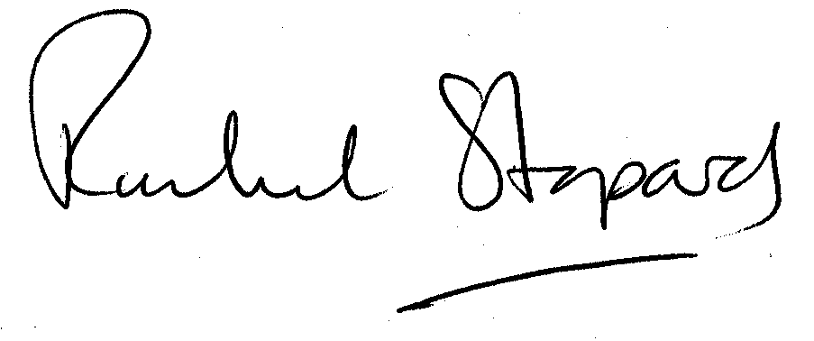
Rachel Stopard
Director of Culture & Environment

